San Diego Association of Governments
Anstine-Audubon Nature Preserve Fencing Project
San Diego Audubon Society
Quarterly Progress Report
Reporting Period: March 7-September 30, 2023
Submission Date: October 20, 2023
SANDAG Contract Number: S1125499

Quarterly Status Report Overview
PLEASE DO NOT CHANGE OR ALTER THE FORMATTING OF THIS DOCUMENT! SANDAG has developed a standardized grant monitoring and tracking program for the Environmental Mitigation Program (EMP) Land Management Grant Program. The purpose is to collect information on individual projects and the grant program as a whole for reporting to the Regional Habitat Conservation Taskforce, SANDAG Policy Advisory Committees, and the SANDAG Board of Directors. SANDAG monitors grantees through invoices, progress reports, performance measures, and designated photograph points. These standardized reporting templates and instructions for submittal are included below.

Work Performed this Period:

Task 1- Project Planning:
San Diego Audubon contracted Urban Corps of San Diego to install a three-pole lodge post fence along the northern boundary of our Anstine-Audubon Nature Preserve in Vista, CA. Forty-five hours have been worked to contract Urban Corps of San Diego, plan the fence installation layout and oversee the start of the project. Project planning is fifty-six percent complete by hours expended. Planning was accomplished throughout the reporting period, starting from the Notice to Proceed (NTP) date of March 7, 2023, although the bulk of the hours were expended starting July 1.

Task 2-Project Implementation
The fence installation began on September 25, 2023 and as of September 30, 2023 fifty-feet of fencing has been installed. Six-percent of the project has been completed. The costs incurred by Urban Corps will be included in the next quarter’s invoice, once their invoice is received.

Task 3-Grant Administration and Reporting
Six hours of time has been worked setting up the project page and completing the quarterly report and invoices. This task is now forty-six percent complete by hours expended. Grant Administration and Reporting work was accomplished throughout the reporting period, starting from the NTP date of March 7, 2023.

Provide the exact work start date, a description of the work completed under each task, and percent complete. Add additional tasks as necessary

Work Anticipated Next Period
This does not need to be task specific but should include a short paragraph or bullet point list of activities anticipated for next quarter.

The fence installation has continued since September 30, 2023 and we are on schedule to have the project completed by the next quarterly invoice and reporting period. Planning work will continue as far as coordinating Urban Corps’ work days and looking forward to project closeout tasks. Less grant administration hours will be required in the next period, as updating our project page will be simpler than setup was.

Issues to Note
Please provide a brief description of any issue(s) encountered during the reporting period and any steps taken to address the issue(s).

No issues have occurred during this project.

Photographs & Figures
Photographs and figures are invaluable! Please include photos in the Quarterly Progress Reports and any figures (if applicable). Both photos and figures may be included throughout the document under corresponding tasks or at the end following the Issues to Note section. Photographs taken at the same place or photographic points (photo-points) can assist SANDAG staff in tracking the project’s progress over time.
It is required that Photographs include:
- A before and after comparison sequence from the start to the completion of the project for photo points.
- A brief description of the corresponding tasks, date, and activity in the photograph.
- A copy of each photograph included in the report submitted in a .jpeg or .png file format.
It is required that Figures include:
- A caption with a brief description.

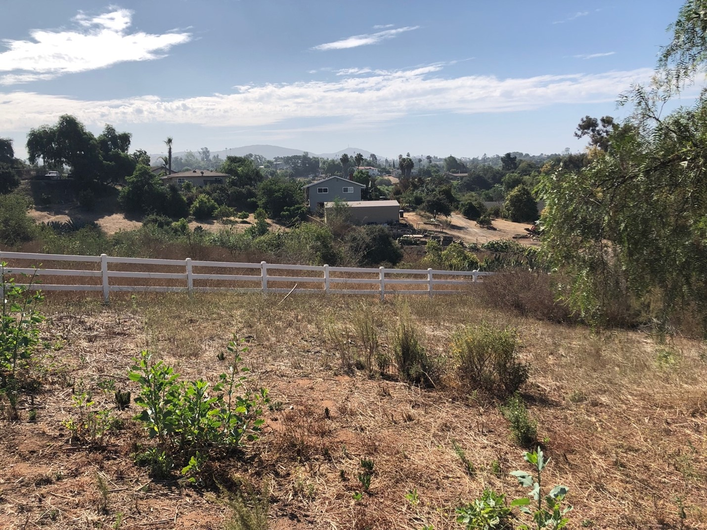

This is the northeast portion of our property prior to the installation of the fence. The white fence is the neighbor’s property and the our new lodge-pole fence will run adjancent to this fence inside our property line. September 8, 2023

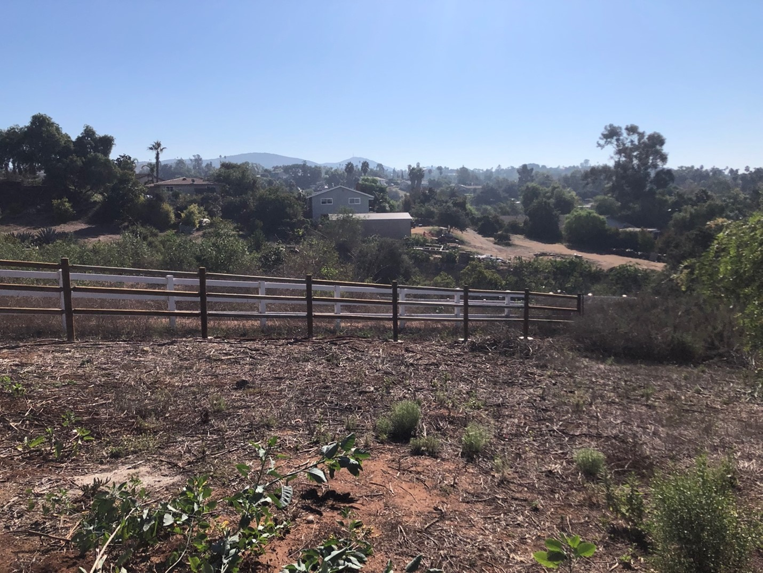

This is the northeast portion of our property with the lodge-pole fence installed. At this point, approximately 50 feet of fence has been installed. September 30, 2023.

SDMMP Project Page
To receive reimbursement for work conducted within the quarter, submission of Quarterly Progress, Annual, and Final Reports must be added to your project’s Project Page on the SDMMP website. Add any necessary photographs to the photo carousal and fill out the photograph information. Please contact Sarah McCutcheon (smccutcheon@usgs.gov) or Emily Perkins (eperkins@usgs.gov) if you are having trouble accessing or editing your project page.

Project Performance Measures Instructions
SANDAG will utilize the SANDAG Performance Measures to document compliance with the Project. Grantee’s performance will be measured against the Performance Measures (Exhibit D) during the term of the project. More details on Performance Measures and Grant Recovery Plans are outlined in the Grant Agreements.
To access the Project Performance Measures Excel Spreadsheet:
- Simply double-click on the Excel icon located under the Project Performance Measures section.
  - An excel sheet will open, please fill out and then click save.
- Once the Excel spreadsheet is saved, please exit Excel and the spreadsheet will automatically update the icon in the Quarterly Progress Report Word document.
When opening the document with the Project Performance Measures Excel Spreadsheet:
- When you first open the Quarterly Progress Report Template, a warning message will open (image of the warning message below)

  - Click Yes to update the links in the document.

Performance Measures
Please include the Project’s Performance Measures for each Quarterly Invoice and Progress Report in order to receive reimbursement.

