San Diego Association of Governments
Anstine-Audubon Nature Preserve Fencing Project
San Diego Audubon Soceity
Final Report
Project Period: March 7, 2023- February 27, 2024
Submission Date: January 18, 2024
SANDAG Contract Number: S1125499

Executive Summary

The goal of this project was to install 855 linear feet of lodge pole fencing along the northern boundary of San Diego Audubon Society’s (SDAS’s) 11.6-acre Anstine-Audubon Nature Preserve (Anstine) in Vista, CA to combat hazardous and non-hazardous dumping and illegal trespassing. The addition of fencing along the northern portion of the property, adjacent to Hidden Lake Lane, will protect the fragile riparian, oak woodland, and endangered coastal sage scrub habitats on the preserve. Urban Corps of San Diego, with SDAS oversight, successfully installed an 855-foot long, five-foot high lodge pole wooden fence along with three access gates on the property in the planned one-year project.

Table of Contents
Executive Summary 1
Project Background 3
Project Goals 3
Work Performed by Task 4
Task 1- Project Planning 4
Task 2-Project Implementation 4
Task 3-Grant Administration and Reporting 4
Conclusions 7
Geographical Information Systems Data 8
SDMMP Project Page 8
Performance Measures 8
Appendices 8
State of Preserve Monitoring 9

Project Background
The Anstine-Audubon Nature Preserve is an 11.6 acre preserve located at 2437 Hutchison St., Vista, CA 92084 and is owned and operated by San Diego Audubon Society. Within its boundaries, Anstine hosts four distinct habitats: coastal sage scrub, oak woodland, mixed riparian and a 1.5 acre pond. The property, which includes mild to moderate hiking trails, observation decks and native plant gardens, is open to the public on weekends, free of charge, and during the week for school groups and special events.
Due to the sensitive nature of the native habitats, flora, and fauna found at the preserve, the installation of a boundary fence was necessary on the north portion of the property to reduce hazardous and non-hazardous dumping and illegal trespassing. The fence reduces green waste, often containing invasive seeds, from being dumped on the property, minimizes trash from entering our creek and prevents illegal parking on the preserve.

Project Goals
The project goal was to install an 855-foot lodge pole fence, with three access gates, along the north portion of the preserve, adjacent to Hidden Lake Lane. The 855-ft fence and three gates project began on September 25, 2023 and was completed on December 6, 2023 by Urban Corps of San Diego.
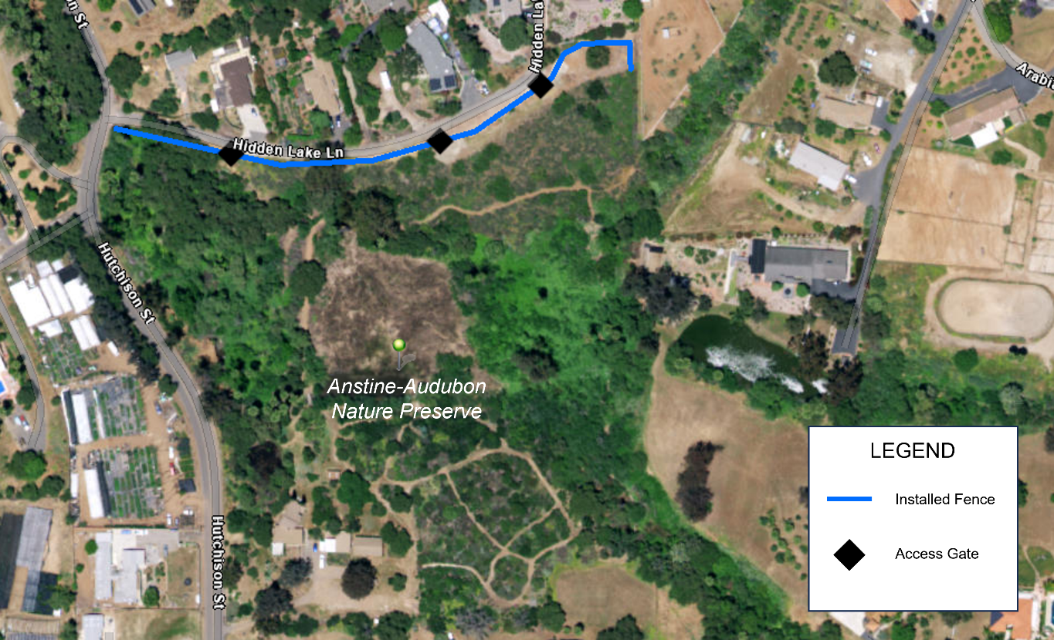
Installed location of fence and access gates along the northern boundary of the preserve. 855 ft of lodge pole fencing and three access gates were installed during this project.

Work Performed by Task

Task 1- Project Planning
Budget: $3,120 (from grant agreement)
Spent: $3,120

San Diego Audubon received our Notice to Proceed on March 7, 2023 and immediately began recruiting contractors to install the fence at our Anstine-Audubon Nature Preserve. Rebekah Angona, the Anstine-Audubon Nature Preserve Manager, met with contractors, compared quotes, and ultimately decided on using Urban Corps of San Diego as our contractor on April 25, 2023. Between July-September, Rebekah met with Urban Corps crew on multiple visits to the preserve and oversaw the beginning stages of fence installation, which began on September 25, 2023. Due to understaffed Urban Corps crews, rain delays, and some reconstruction needed on the gates, the full 855-ft of lodge pole fence and three gates were finally completed on December 6, 2023. A total of eighty hours were spent on this task throughout the project, in line with the budget.

Task 2-Project Implementation
Budget: $44,698 (from grant agreement)
Spent: $44,650
Urban Corps of San Diego installed 855-ft of lodge pole fencing with three access gates along the north portion of the Anstine-Audubon Nature Preserve. The installation began on September 25, 2023 and was completed on December 6, 2023 for a total cost of $44,650. This was $48 less than the budget for the task.

Task 3-Grant Administration and Reporting
Budget: $507 (from grant agreement)
Spent: $507

The Notice to Proceed was received on March 7, 2023 and since that time, 13 hours of Rebekah’s time was spent corresponding with SANDAG staff about grant requirements, completing the progress report and invoice submitted on October 20, 2023 and the final report and invoice submitted on January 18, 2024. Additionally, Rebekah met with SANDAG staff on January 11, 2024 for a site visit to view the fence installation at the preserve.

Photographs & Figures
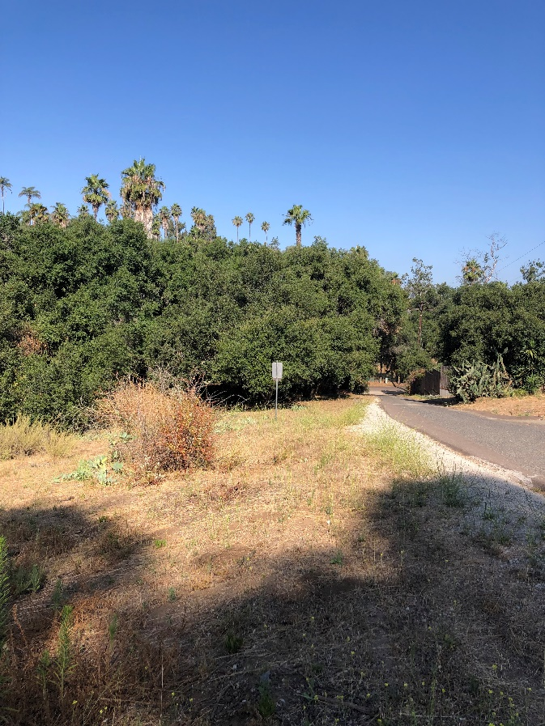  Looking west along Hidden Lake Ln., 7/27/2023 | 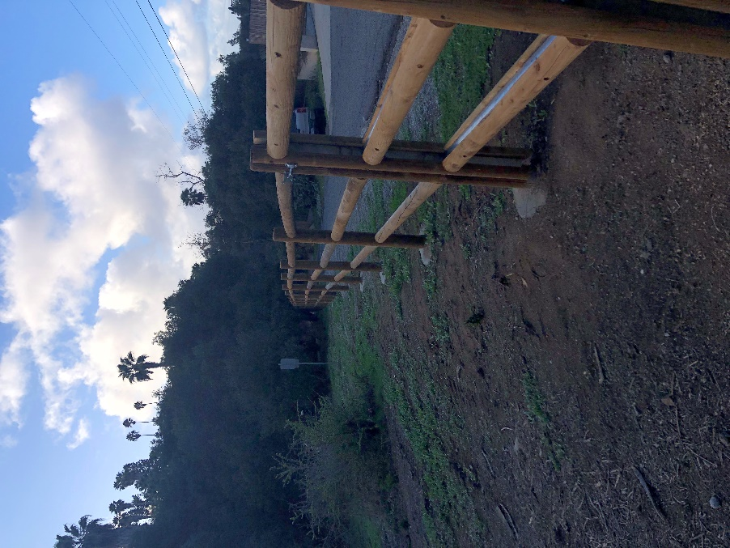  Same view with completed fence, 1/3/2024
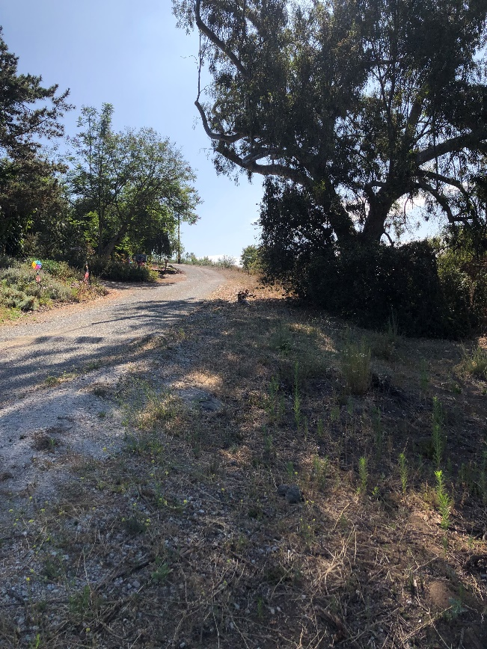  Looking east along Hidden Lake Ln., 7/27/2023 | 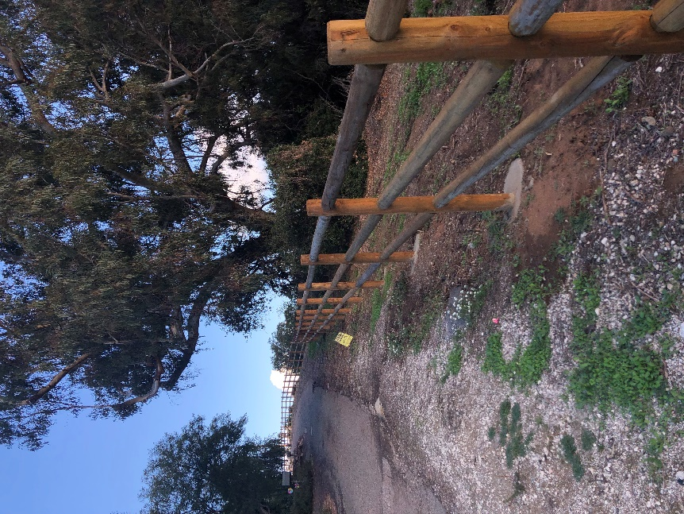  Same view with completed fence, 1/3/2024
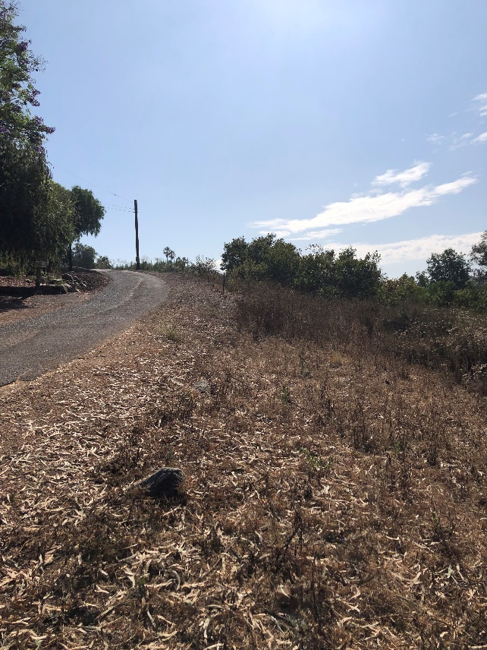  Looking east along Hidden Lake Ln., 7/27/2023 | 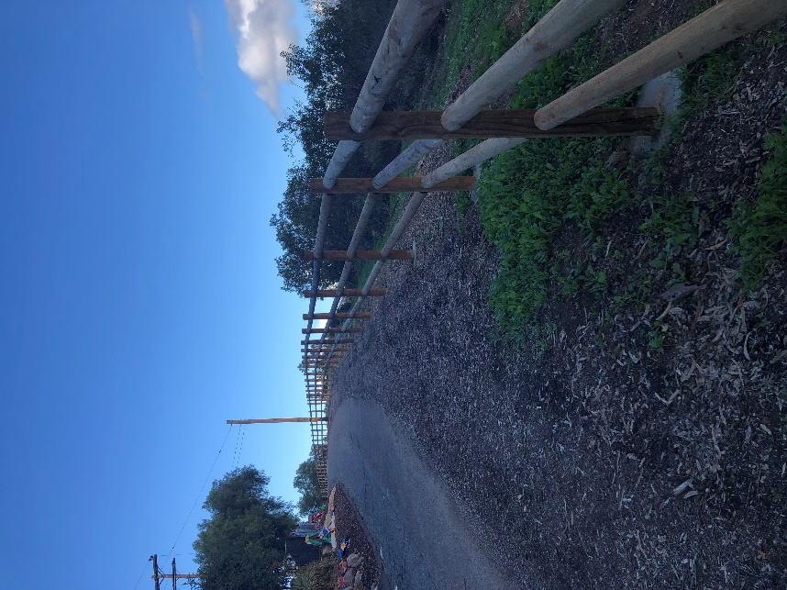  Same view with completed fence, 1/3/2024
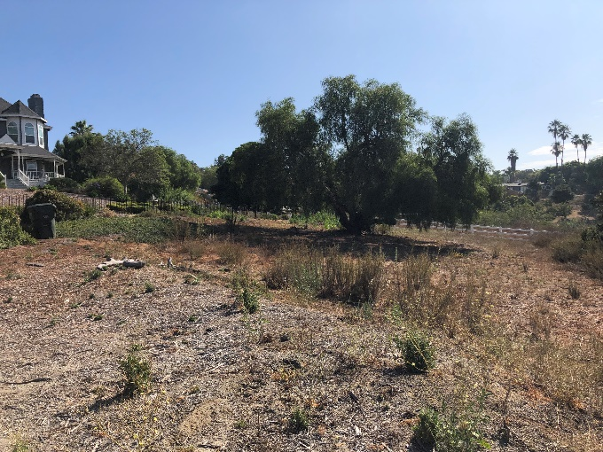  The northeast corner of the preserve, showing neighboring house and fenceline, 7/27/2023 | 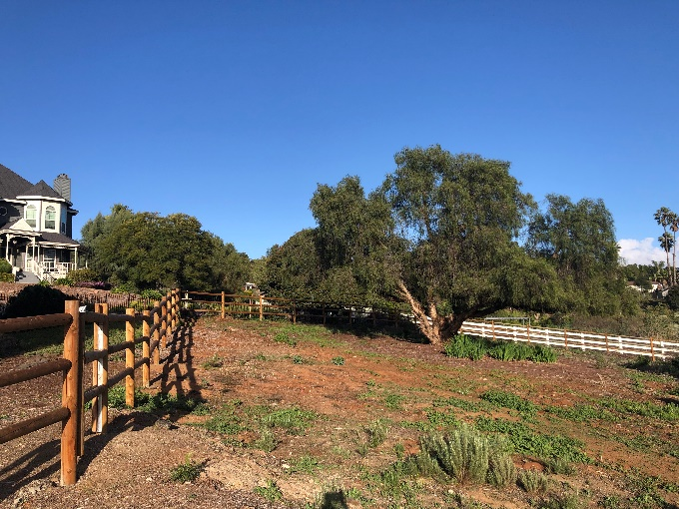  Same view with our completed fence, 1/3/2024
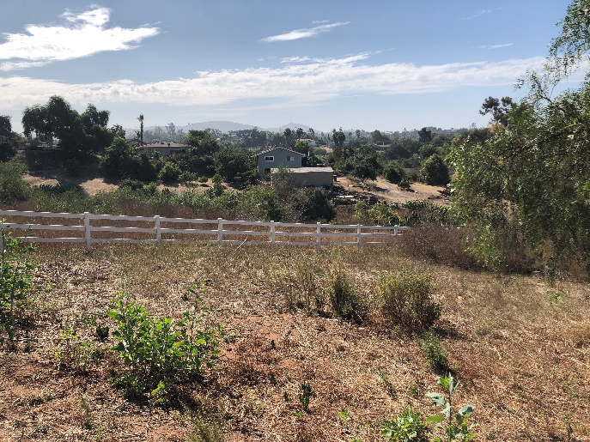  The east edge of the preserve, showing neighboring fenceline, 7/27/2023 | 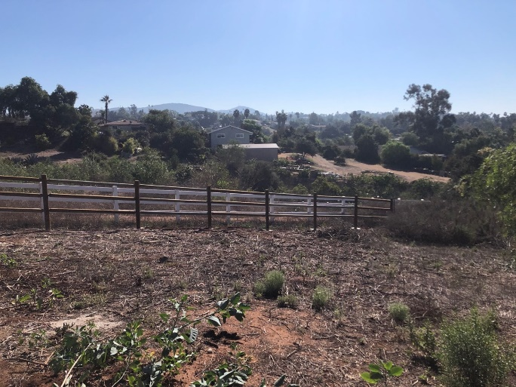  Same view with our completed fence, 1/3/2024

Conclusions
The installation of the 855-ft lodge pole fence and three gates was successful and has provided the Anstine-Audubon Nature Preserve with more safety and security for our native habitats and guests. Since its installation, there has been no hazardous or non-hazardous dumping, trespassing or illegal parking of vehicles on our property. The fence improves native habitat by preventing the spread of invasive plants on the property and ensures our northern boundary is protected from outside influences on the preserve.

Geographical Information Systems Data
A shapefile of the final installed fence is being submitted with this report and uploaded to our SDMMP project page.

SDMMP Project Page
To complete the grant requirements, your Final Report (along with all annual or interim reports) must be added to your project’s Project Page on the SDMMP website. Add any necessary photographs to the photo carousal and fill out the photograph information. Please contact Sarah McCutcheon (smccutcheon@usgs.gov) or Emily Perkins (eperkins@usgs.gov) if you are having trouble accessing or editing your project page.

Performance Measures
Please include the Project’s Performance Measures with the cumulative data from the entire project in order to complete the grant requirements.
*Insert Excel Icon Spreadsheet here*

Appendices
As necessary, please include any additional materials as separate appendices and reference them in the report as needed. Examples may include outreach materials, management plans, data sets, etc.

State of Preserve Monitoring
SDMMP and SANDAG will be collecting specific data from each grant project in order to update the Status of the Regional Preserve System in Western San Diego County. Information collected will become available on SDMMP’s Dashboard.
To access the State of Preserve Monitoring Excel Spreadsheet:
- Please fill out the spreadsheet by simply double-clicking the State of Preserve Monitoring chart.
  - The excel sheet will open up and allow you to input data. Once you are finished inputting the data into the excel sheet, scroll the excel sheet to the top with the headers displayed. Then simply click once on the grey space to the right of the excel sheet to return to the Word document to resume editing.

Definitions
- Management Strategic Plan (MSP): The Management and Monitoring Strategic Plan for Conserved Lands in Western San Diego County: A Strategic Habitat Conservation Roadmap (or simply "MSP Roadmap" or "MSP") is a comprehensive, landscape-scale adaptive management and monitoring framework for prioritized species and vegetation communities in western San Diego County.
- Habitat Type: Please select from one of the MSP listed habitats. If the habitat type is not listed, please do not select from the dropdown and manually type in the habitat type name. Provide acreage by specific habitat types, do not combine multiple habitat types with one acreage calculation.
- Habitat Enhancement through Invasive Species Control (acres): removing invasive plant or animal species to improve ecological function.
- Habitat Created/Restored (acres): establishing habitat where it did not exist before; returning a damaged site to a natural or native state.
- Fencing (feet): fencing installed for grant purposes to lessen a threat or stressor to habitat
- Acres Requiring Management: activities such as vegetation thinning, invasive plant treatment, etc. that are necessary for maintaining previous enhancement, restoration, or creation efforts.
- Acres Requiring Monitoring: any regular monitoring conducted to establish baseline and/or determine success of grant project.
- Sensitive Species: MSP SL, SO and SS Species (https://sdmmp.com/msp_doc.php; Section 2.8 and 2.9; Table V1.1-1) that the management actions of the project are specifically designed to benefit to help ensure the species persists over the long-term on Conserved Lands in the Management Strategic Plan Area.
- Sensitive Species Planted: List any sensitive plant species that were seeded/planted for this project
- Sensitive Species Benefitted: List any other sensitive species that will or already have directly benefitted from the project

