San Diego Association of Governments
San Diego Thornmint Enhancement Project
San Diego Habitat Conservancy
Quarterly Progress Report
Reporting Period: July 1-September 30, 2023
Submission Date: October 20, 2023
SANDAG Contract Number: S1125501

Quarterly Status Report Overview
PLEASE DO NOT CHANGE OR ALTER THE FORMATTING OF THIS DOCUMENT! SANDAG has developed a standardized grant monitoring and tracking program for the Environmental Mitigation Program (EMP) Land Management Grant Program. The purpose is to collect information on individual projects and the grant program as a whole for reporting to the Regional Habitat Conservation Taskforce, SANDAG Policy Advisory Committees, and the SANDAG Board of Directors. SANDAG monitors grantees through invoices, progress reports, performance measures, and designated photograph points. These standardized reporting templates and instructions for submittal are included below.

Work Performed this Period:

Task 1- ACIL Monitoring
SDHC conducted ACIL monitoring on July 5 at Taylor and Carlsbad Raceway Preserves. Other activities included research and planning, two seed collection events on July 11 and August 9, and coordinating with ACIL experts and the Native Plant Seed Bank at San Diego Zoo Wildlife Alliance on seed cleaning and storage. This task is 10% complete.

Task 2- Invasive Control in surrounding ACIL areas
A total of 1.8 acres of invasive control in surrounding ACIL areas was conducted on all three preserves: 0.3-acre at Emerald Point Preserve on June 15, 16, and 19; 0.5-acre at Taylor Preserve on June 19; and 1-acre at Carlsbad Raceway on June 20 and 21. This task is 30% complete. There will be two more invasive removal events over the 1.8 acres during the project period.

Task 3- Reporting and Invoicing
A quarterly progress report and invoice for the April 1-June 30, 2023 reporting period was prepared and submitted on July 19, 2023. The SDMMP website project page was also updated. This task is 15% complete.

Task 4- Administrative
Administrative tasks were performed throughout this reporting period and included internal meetings and coordination and coordinating with contractors. This task is 50% complete.

Work Anticipated Next Period
For the next reporting period, from October 1 to December 31, 2023, we expect to seed the restoration areas with ACIL seed.

Issues to Note
SDHC initially proposed to use ACIL seed collected and bulked by the Native Plant Seed Bank at San Diego Zoo Wildlife Alliance (NSB) on Carlsbad Raceway Preserve in 2020. SDHC was informed by NSB that only four seeds were bulked from the collection. This is not enough seed to complete the enhancement activities and NSB and ACIL experts recommended SDHC collect ACIL from a population in Carlsbad near Palomar Airport that is within a similar genetic cluster. SDHC applied for a permit to collect the seed, completed two seed collection events, and NSB will clean and store the seeds until they are needed.

Photographs & Figures
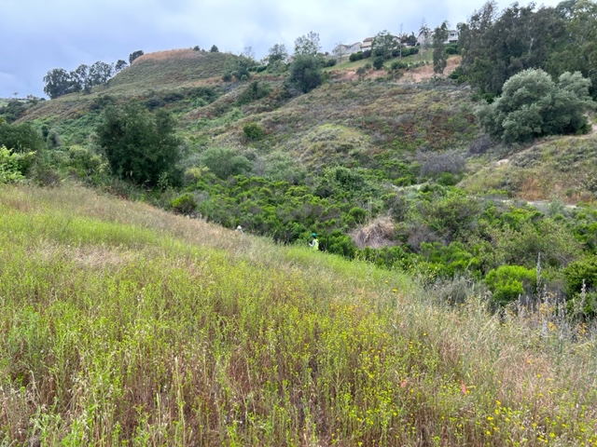
Photo 1. Urban Corps conducting weed removal at Taylor Preserve, June 14, 2023

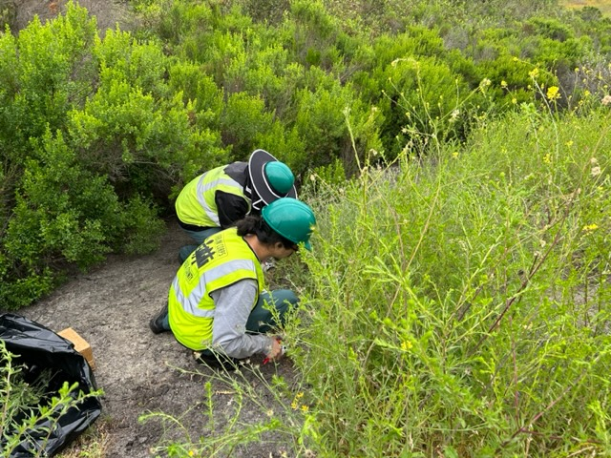

Photo 2. Urban Corps conducting weed removal at Taylor Preserve, June 14, 2023
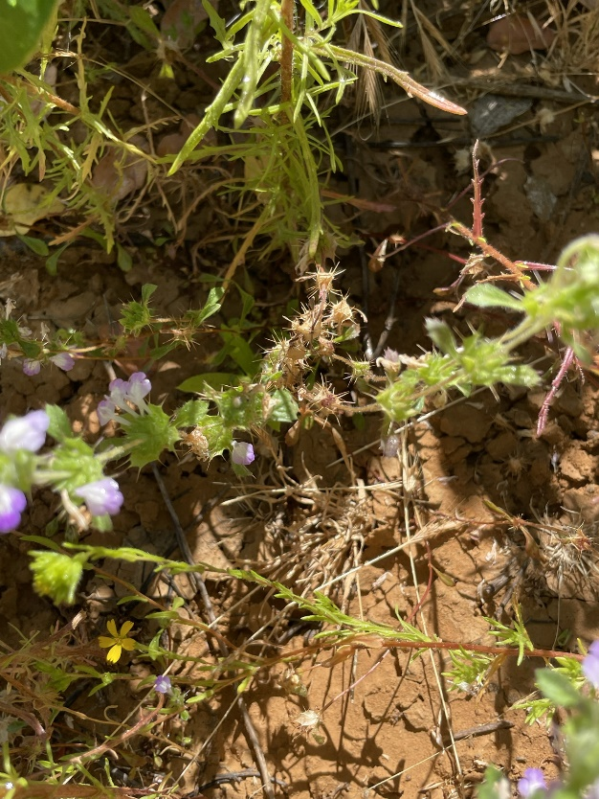
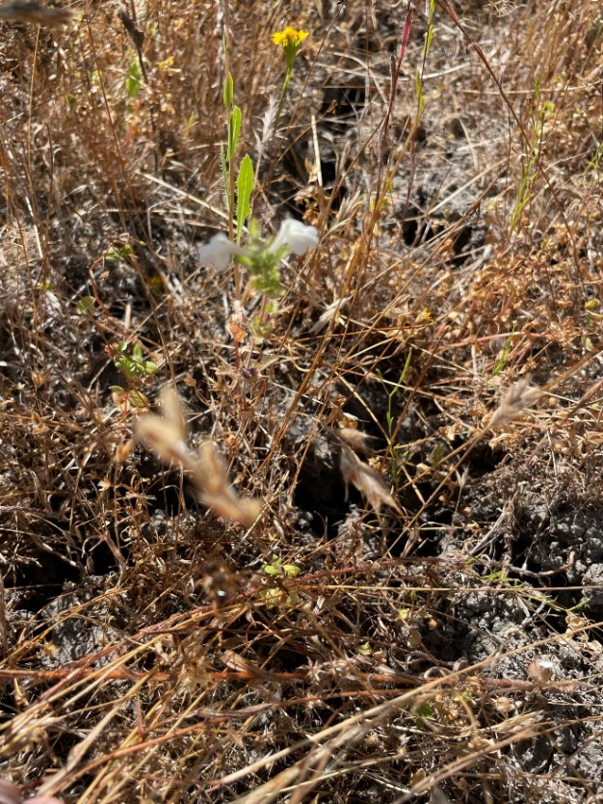
Photo 4. ACIL starting to go to seed at Carlsbad Raceway
Preserve, July 5, 2023Figure

Photo 3. ACIL flowering late in the season at Taylor Preserve, July 5, 2023

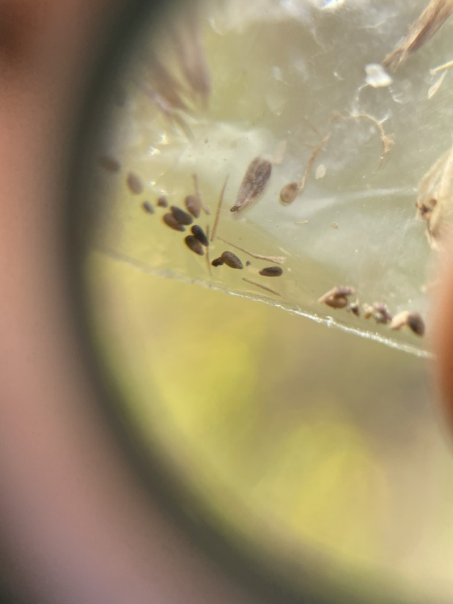
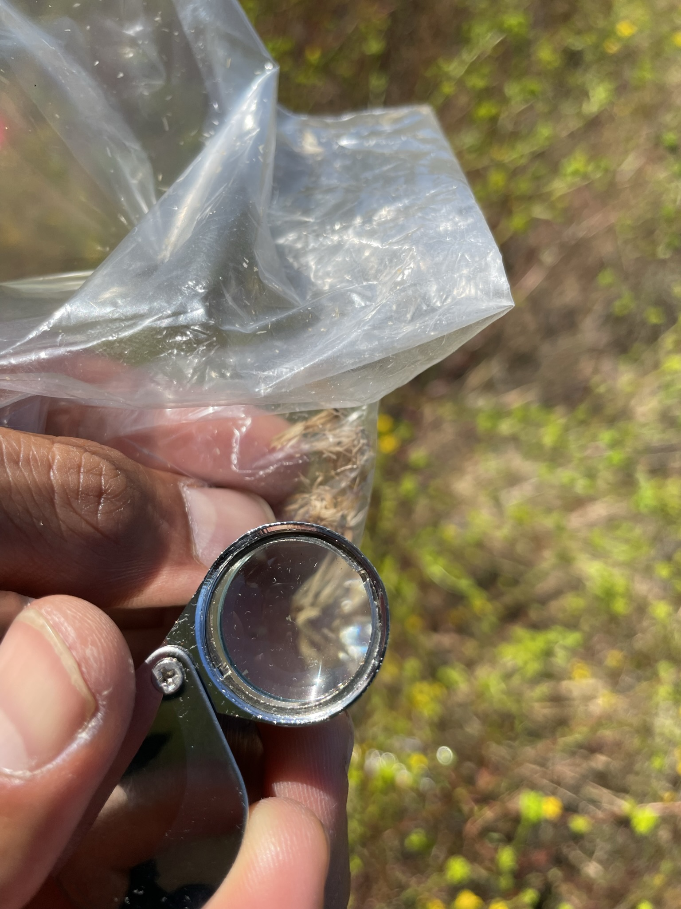
Photo 5. SDHC staff inspecting dried ACIL flowers for seed at the Palomar Airport ACIL population, July 11, 2023

Photo 6. A view of ACIL seed under a magnifying glass, July 11, 2023

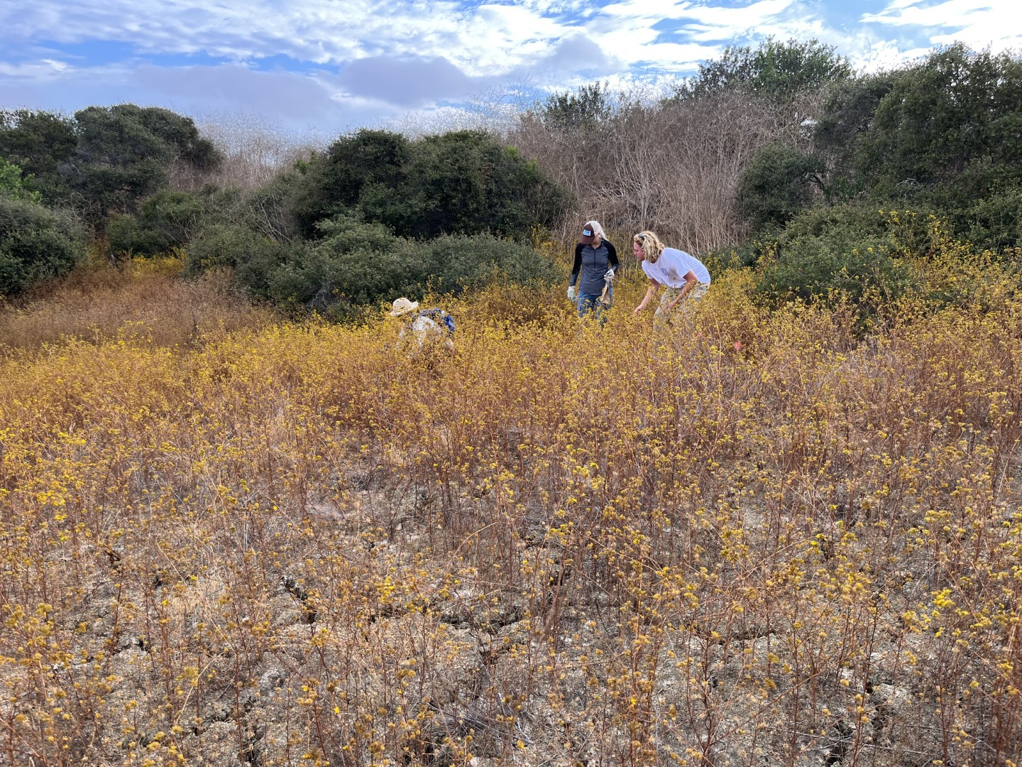
Photo 7. SDHC staff and interns collecting ACIL seed near Palomar Airport in Carlsbad, August 8, 2023

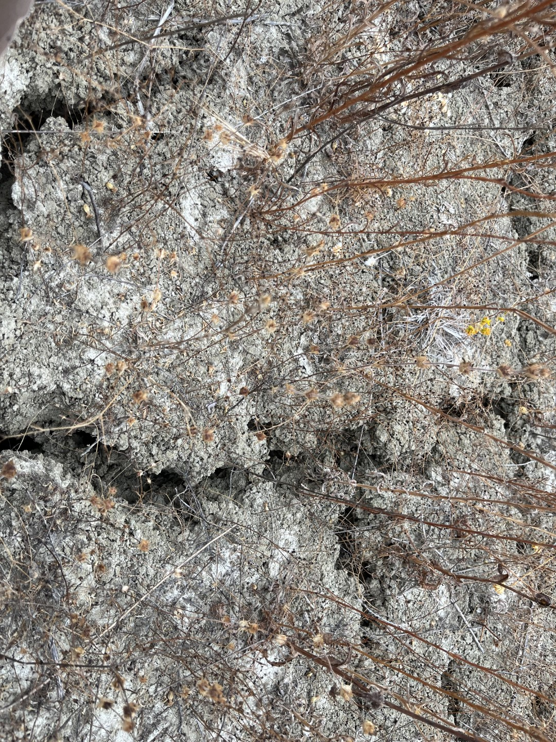
Photo 8. ACIL population that has gone to seed near Palomar Airport in Carlsbad, August 8, 2023

SDMMP Project Page
To receive reimbursement for work conducted within the quarter, submission of Quarterly Progress, Annual, and Final Reports must be added to your project’s Project Page on the SDMMP website. Add any necessary photographs to the photo carousal and fill out the photograph information. Please contact Sarah McCutcheon (smccutcheon@usgs.gov) or Emily Perkins (eperkins@usgs.gov) if you are having trouble accessing or editing your project page.

Performance Measures
Please include the Project’s Performance Measures for each Quarterly Invoice and Progress Report in order to receive reimbursement.

