San Diego Association of Governments
San Diego Thornmint Enhancement Project
San Diego Habitat Conservancy
Quarterly Progress Report
Reporting Period: April 1-June 30, 2023
Submission Date: July 19, 2023
SANDAG Contract Number: S1125501

Quarterly Status Report Overview
PLEASE DO NOT CHANGE OR ALTER THE FORMATTING OF THIS DOCUMENT! SANDAG has developed a standardized grant monitoring and tracking program for the Environmental Mitigation Program (EMP) Land Management Grant Program. The purpose is to collect information on individual projects and the grant program as a whole for reporting to the Regional Habitat Conservation Taskforce, SANDAG Policy Advisory Committees, and the SANDAG Board of Directors. SANDAG monitors grantees through invoices, progress reports, performance measures, and designated photograph points. These standardized reporting templates and instructions for submittal are included below.

Work Performed this Period:

Task 1- ACIL Monitoring
San Diego Thornmint (Acanthomintha ilicifolia, ACIL) monitoring began on April 28, 2023. Activities in this reporting period include site visits to assess the ACIL population, coordination with ACIL experts, and meeting with prospective contractors on site.
This task is 6% complete.

Task 2-Invasive Control in surrounding ACIL areas

No invasive control in the surrounding ACIL was conducted during this reporting period. It is expected this task will start in 2024. This task is 0% complete.

Task 3-Reporting and Invoicing

No reporting or invoicing occurred within the reporting period. This task is 0% complete.

Task 4- Administrative

Task 4 began on April 21, 2023 when SDHC received the Notice-to-Proceed. Activities under this task included project set up, coordinating with potential contractors, meeting with SANDAG, and completing the sole source form. This task is 50% complete.

Work Anticipated Next Period
For the next reporting period from July 1 to September 30, SDHC staff expect to coordinate with an ACIL expert to plan the restoration activities, including but not limited to methods for seeding ACIL on the SDHC Preserves. SDHC will also be completing the quarterly progress report and invoices for the April 1-June 30 reporting period.

Issues to Note
Due to the delay in the notice-to-proceed, SDHC will conduct most of the ACIL monitoring and invasive species removal tasks in early 2024. SDHC expected the project to begin in November 2022 and start the weekly site visits from mid-January to July. The ACIL desiccates and goes to seed in the dryer months and does not require watering or weed removal. The ACIL seed will be sowed in the fall in the enhancement areas prior to the first significant rainfall. The ACIL monitoring and weed removal will start as planned in early 2024. Due to the delay in the NTP, SDHC may require an extension in the period of performance. This will be determined in early 2024.

SDHC planned on receiving ACIL seed to conduct restoration from the Native Seed Bank San Diego Zoo Wildlife Alliance (NSB). However, the seed bulked from SDHC’s seed collection from 2022 only produced four viable seeds. To address this issue, SDHC will collect seed from a population within the same occurrence and genetic cluster at a location in Carlsbad.

Photographs & Figures
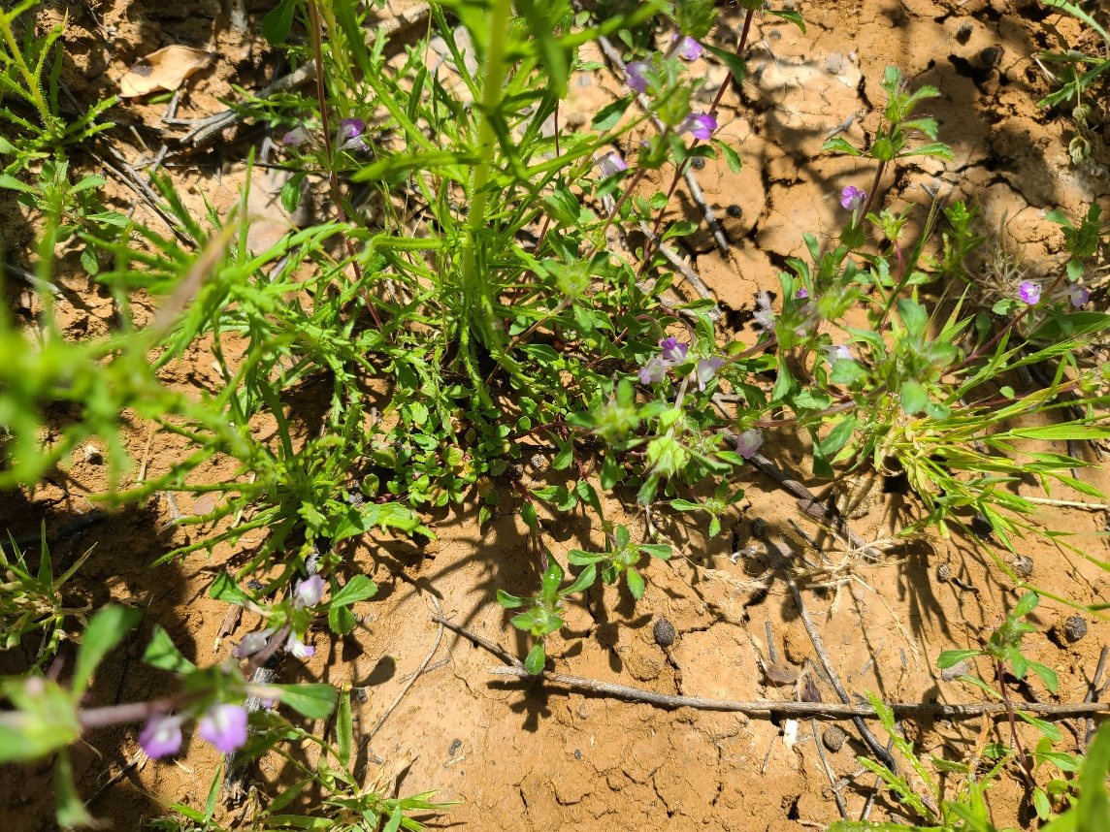
Photo 1. ACIL at Carlsbad Raceway Preserve, May 16, 2023
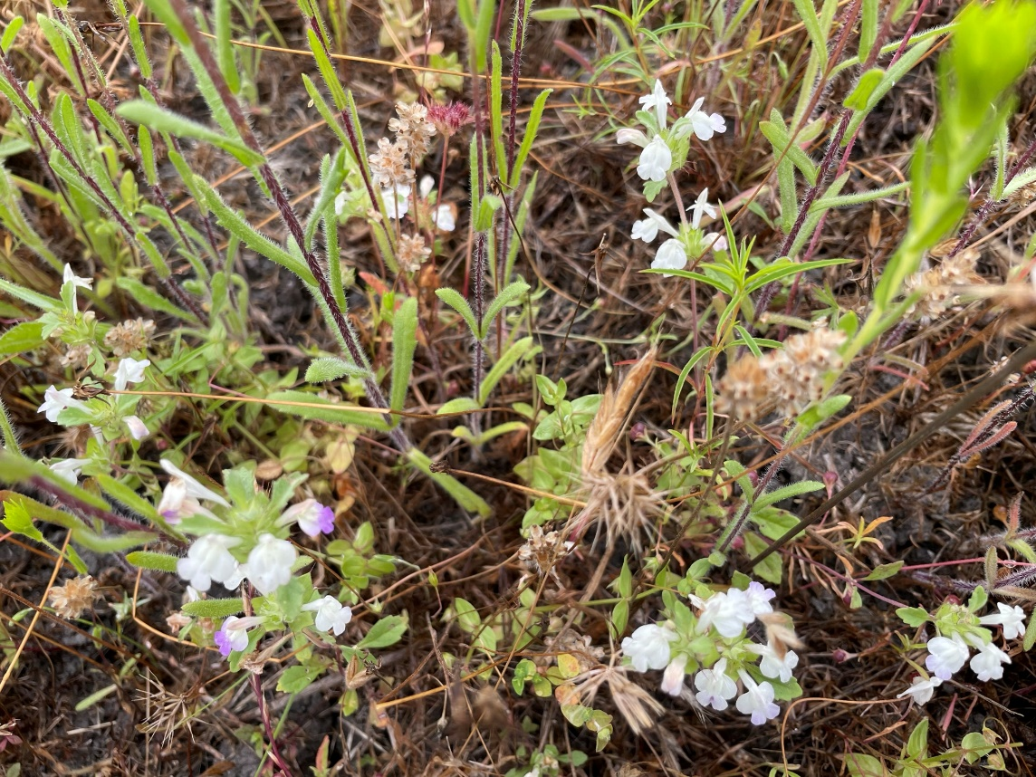
Photo 2. ACIL at Taylor Preserve, May 31, 2023
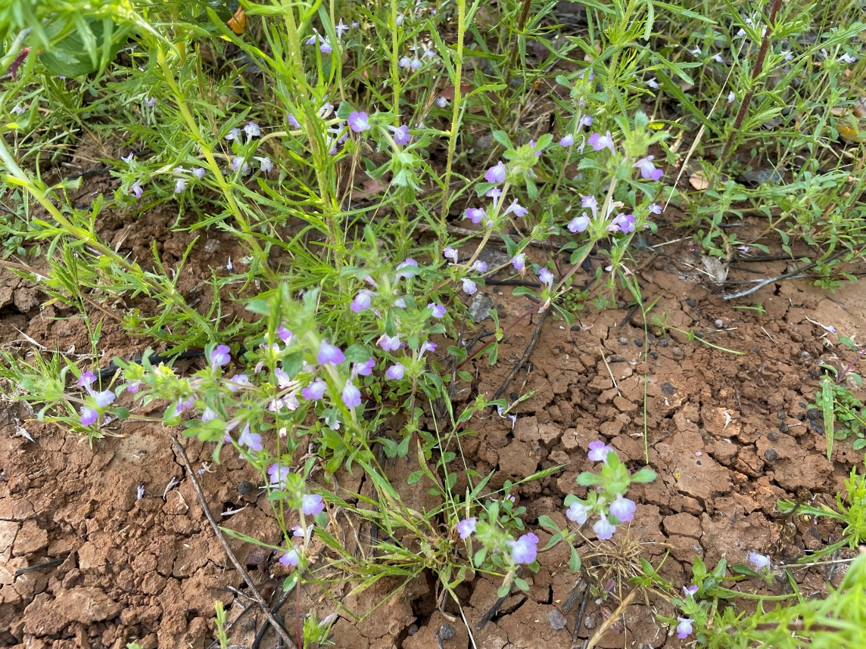
Photo 3. ACIL at Carlsbad Raceway Preserve, May 31, 2023

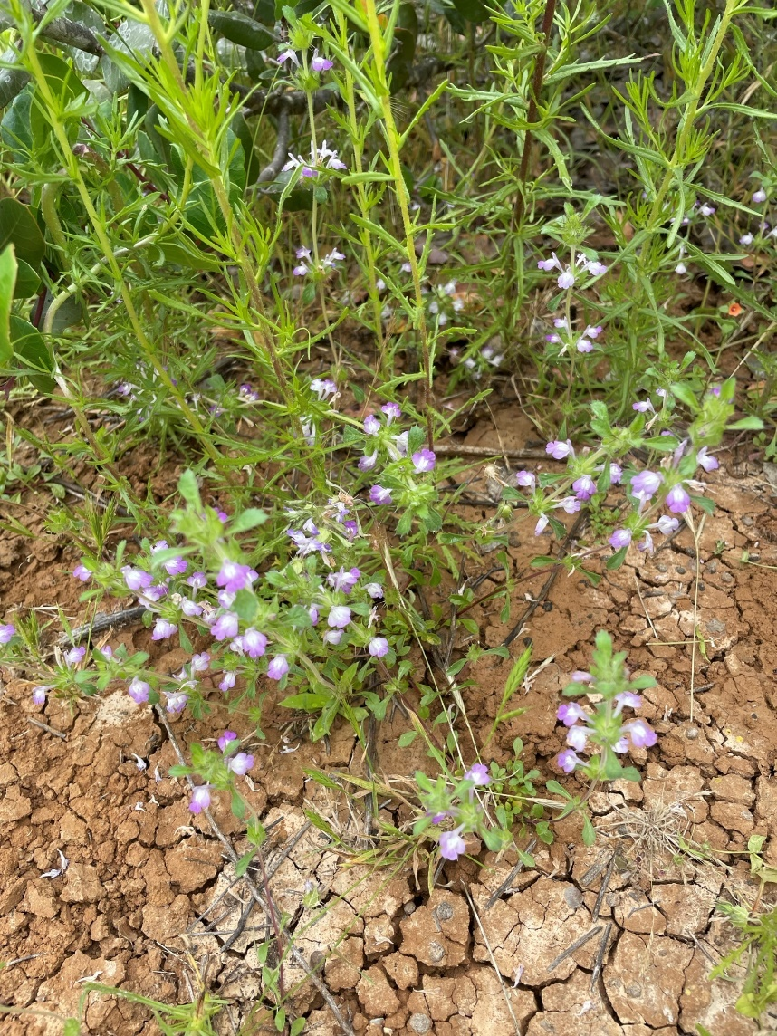
Photo 4. ACIL at Carlsbad Raceway Preserve, June 6, 2023
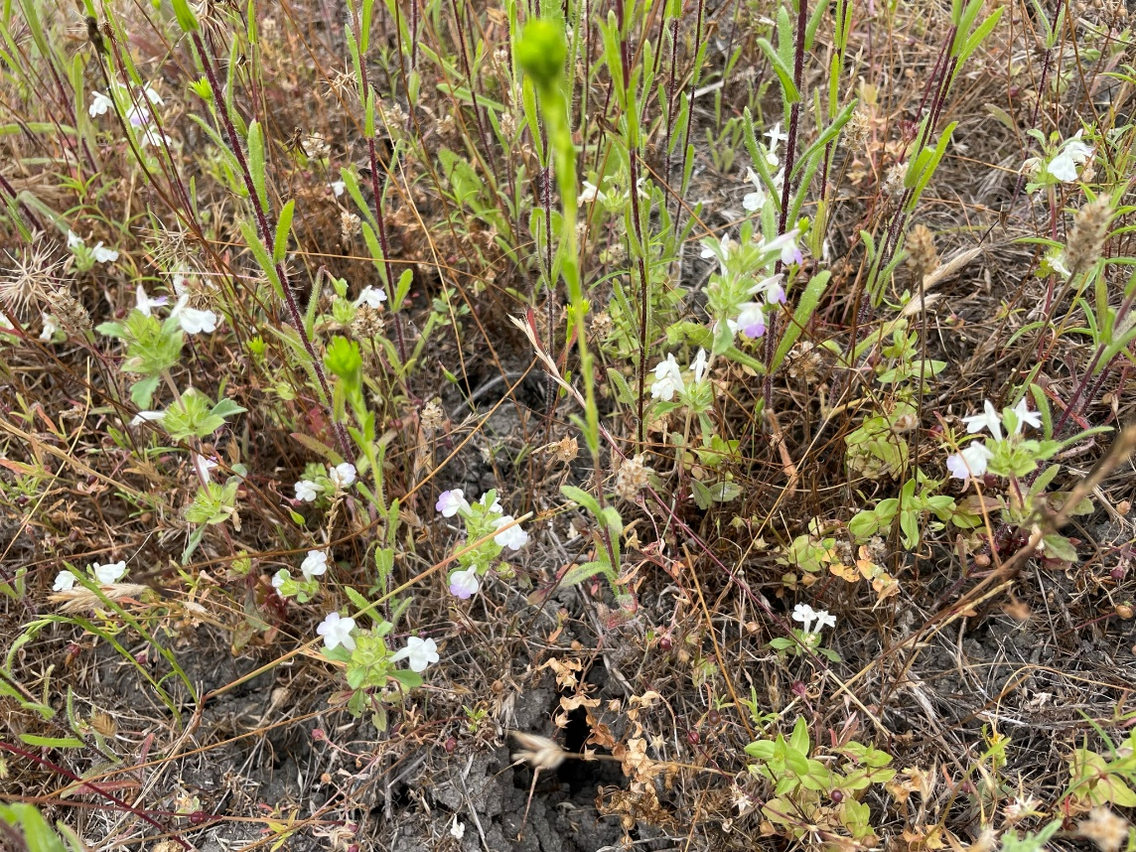
Photo 5. ACIL at Taylor Preserve, June 6, 2023
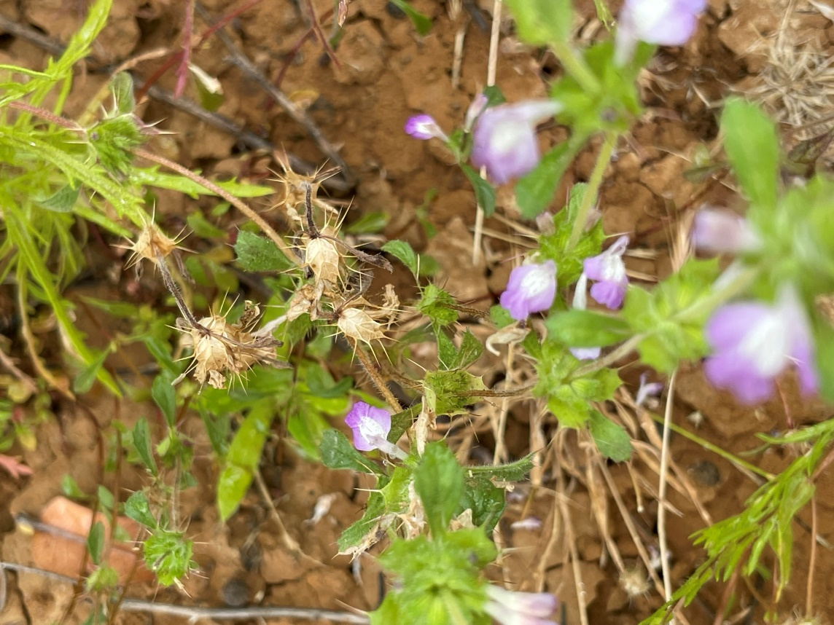
Figure 6. ACIL at Carlsbad Raceway Preserve going to seed, June 29, 2023

SDMMP Project Page
To receive reimbursement for work conducted within the quarter, submission of Quarterly Progress, Annual, and Final Reports must be added to your project’s Project Page on the SDMMP website. Add any necessary photographs to the photo carousal and fill out the photograph information. Please contact Sarah McCutcheon (smccutcheon@usgs.gov) or Emily Perkins (eperkins@usgs.gov) if you are having trouble accessing or editing your project page.

Project Performance Measures Instructions
SANDAG will utilize the SANDAG Performance Measures to document compliance with the Project. Grantee’s performance will be measured against the Performance Measures (Exhibit D) during the term of the project. More details on Performance Measures and Grant Recovery Plans are outlined in the Grant Agreements.

Performance Measures
Please include the Project’s Performance Measures for each Quarterly Invoice and Progress Report in order to receive reimbursement.

