San Diego Association of Governments
San Diego Thornmint Enhancement Project
San Diego Habitat Conservancy
Quarterly Progress Report
Reporting Period: October 1 – December 31, 2023
Submission Date: January 22, 2024
SANDAG Contract Number: S1125501

Quarterly Status Report Overview
PLEASE DO NOT CHANGE OR ALTER THE FORMATTING OF THIS DOCUMENT! SANDAG has developed a standardized grant monitoring and tracking program for the Environmental Mitigation Program (EMP) Land Management Grant Program. The purpose is to collect information on individual projects and the grant program as a whole for reporting to the Regional Habitat Conservation Taskforce, SANDAG Policy Advisory Committees, and the SANDAG Board of Directors. SANDAG monitors grantees through invoices, progress reports, performance measures, and designated photograph points. These standardized reporting templates and instructions for submittal are included below.

Work Performed this Period:

Task 1- ACIL Monitoring
During this reporting period, the Native Plant Seed Bank at San Diego Zoo Wildlife Alliance (NSB) cleaned and processed the San Diego Thornmint seed SDHC collected in July and August 2023. SDHC and a contracted botanist distributed approximately one-third of the total seed at Emerald Pointe and Carlsbad Raceway Preserves on December 18, 2023. SDHC anticipates using the remaining seed in the fall of 2024.
To prepare for seeding, SDHC constructed a two-foot galvanized mesh wire fence around the restoration areas to prevent herbivory from rabbits and other animals. (Note: SANDAG funds were not used to cover labor expenses for constructing the fence). SDHC then broadcasted the San Diego Thornmint seed within the fenced areas. At Emerald Pointe, some seed was distributed in unfenced areas where existing San Diego Thornmint resides. The total area seeded was approximately 1,303 square feet (632 square feet at Carlsbad Raceway and 671 square feet at Emerald Pointe). This task is 15% complete.

Task 2- Invasive Control in surrounding ACIL areas
No work was conducted for Task 2 during this reporting period. This task is 30% complete.

Task 3- Reporting and Invoicing
A quarterly progress report and invoice for the July 1-September 30, 2023 reporting period was prepared and submitted on October 20, 2023. On December 1, 2023, SDHC conducted a site visit with SANDAG staff to Carlsbad Raceway Preserve to observe the project progress. The SDMMP website project page was also updated. This task is 30% complete.

Task 4- Administrative
Administrative tasks were performed throughout this reporting period and included internal meetings and coordination with contractors. This task is 98% complete.

Work Anticipated Next Period

For the next reporting period, from January 1 to March 31, 2023, SDHC anticipates the following tasks will occur:

- An approximately 2,000 square foot area at Carlsbad Raceway will be dethatched and treated with fusillade to kill existing invasive grasses. This area will be seeded with San Diego Thornmint in the fall of 2024.
- Monitoring and watering of the San Diego Thornmint will begin in February 2024.
- Hand removal of weeds within three feet of the San Diego Thornmint will be conducted.

Issues to Note
SDHC anticipates needing a no-cost extension for this project due to the delay in the notice-to-proceed from November 2022 to April 2023. The project called for dethatching and treating invasive grasses in the winter at Carlsbad Raceway Preserve prior to seeding the San Diego Thornmint. SDHC missed the window to conduct this work in the winter of 2023 since the NTP was not received until April 2023. SDHC seeded a an approximately 632 square foot area in December 2023 that had less invasive grasses and will dethatch and treat invasive grasses in an additional 2,000 square feet area in February 2024 and seed the area in the fall of 2024. SDHC does not anticipate needing a no-cost extension for more than 12 months.

Photographs & Figures

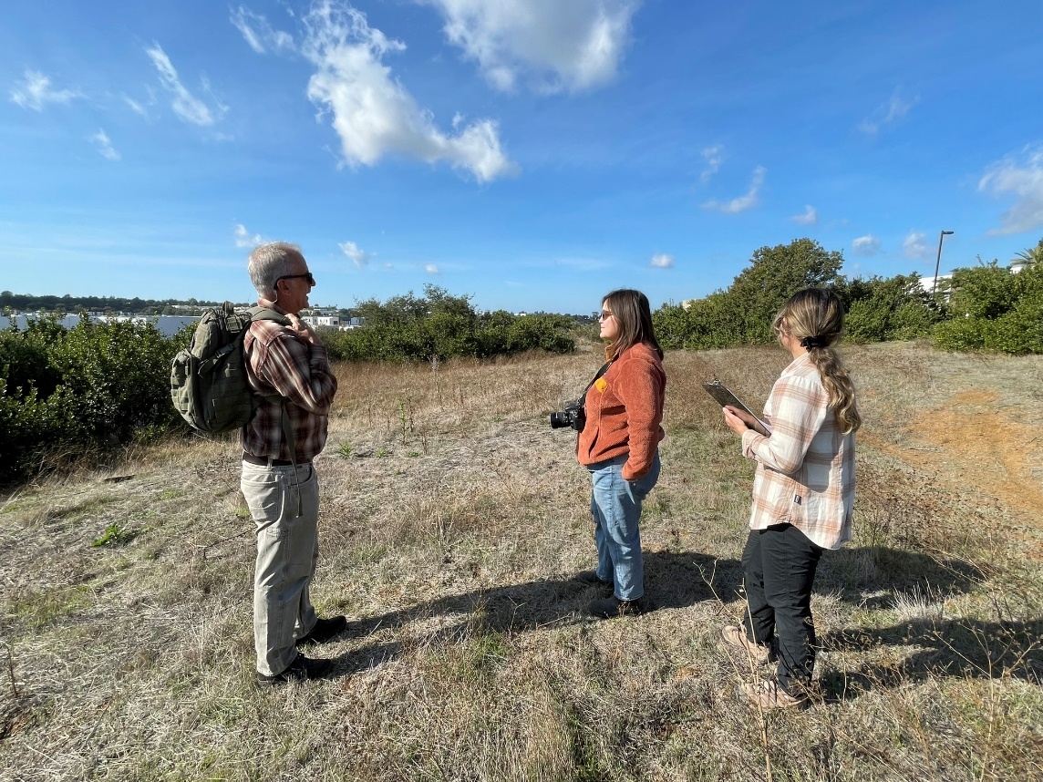
Photo 1. Site Visit with SDHC Executive Director, Don Scoles, and SANDAG Staff, Carlsbad Raceway Preserve (December 1, 2023)
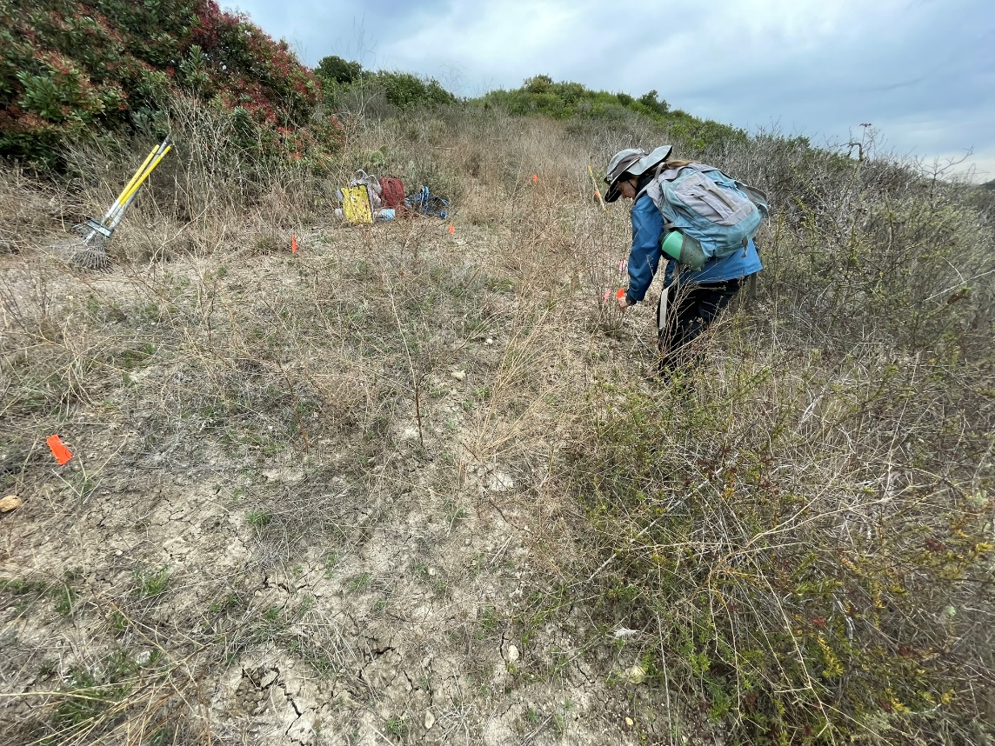
Photo 2. Flagging the San Diego Thornmint Enhancement Area, Emerald Pointe (December 18, 2023)
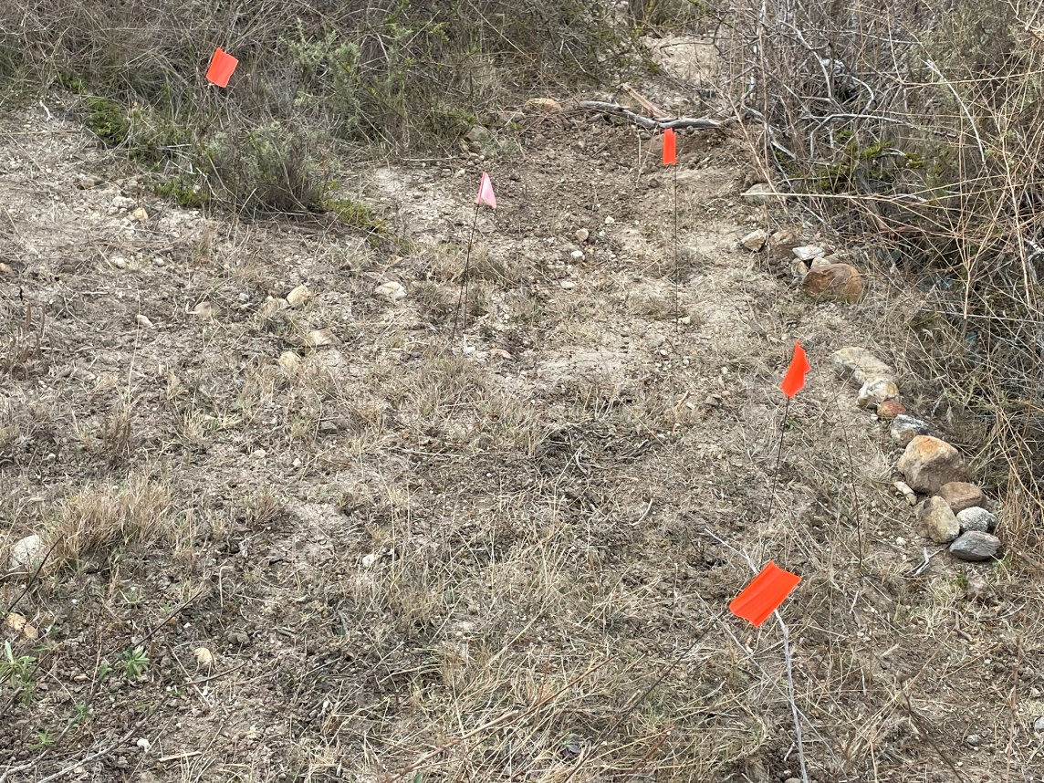
Photo 3. San Diego Thornmint Enhancement Area Before Seeding, Emerald Pointe (December 18, 2023)
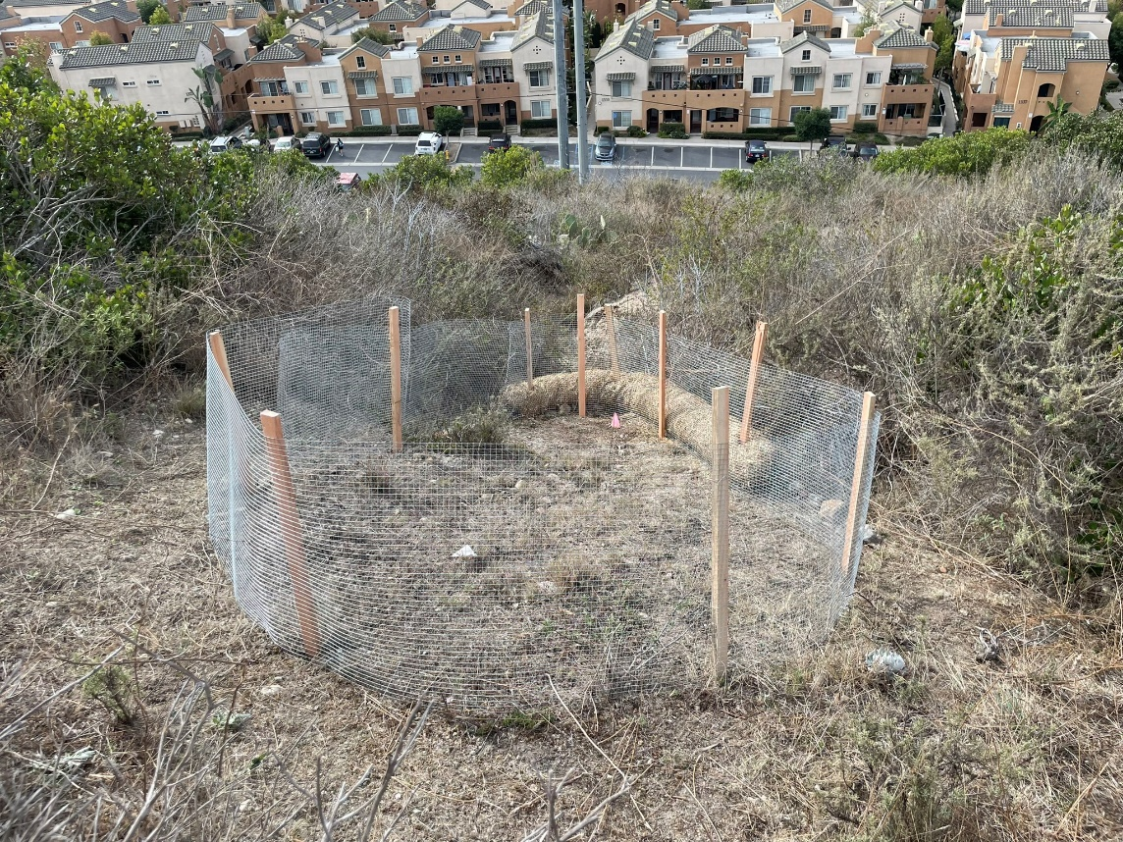
Photo 4. Fenced Enhancement Area, Emerald Pointe (December 18, 2023)
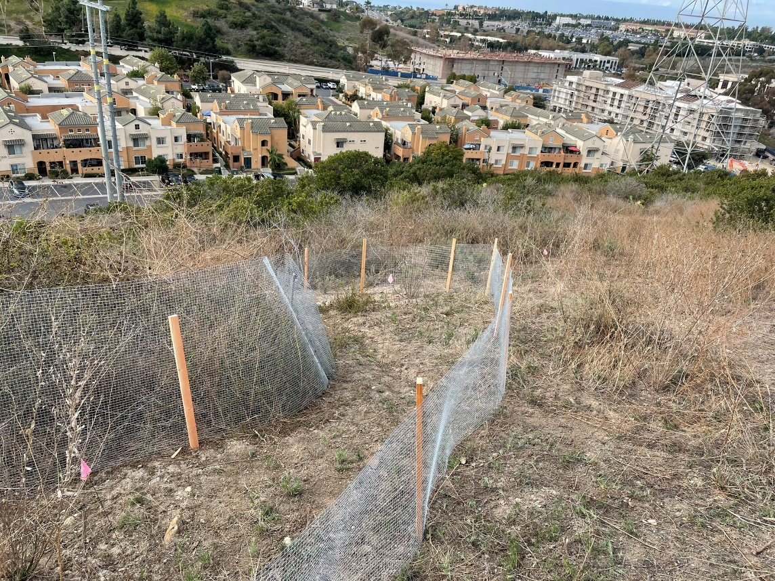
Photo 5. Fenced Enhancement Area further up slope, Emerald Pointe (December 18, 2023)

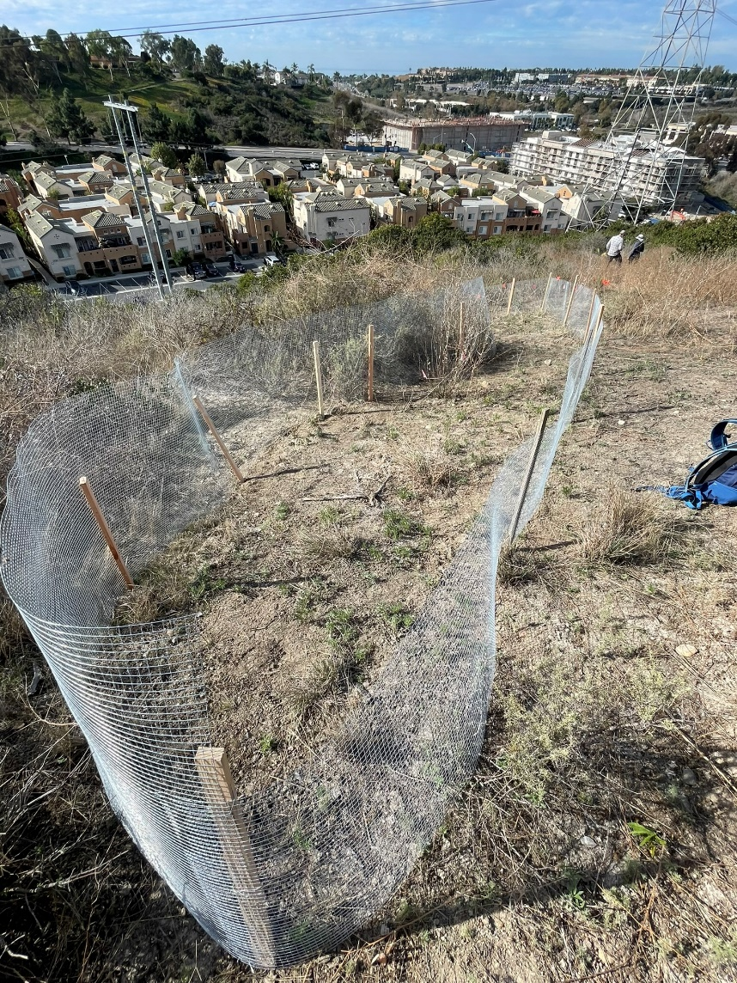
Photo 6. Fenced Enhancement Area further up slope, Emerald Pointe (December 18, 2023)

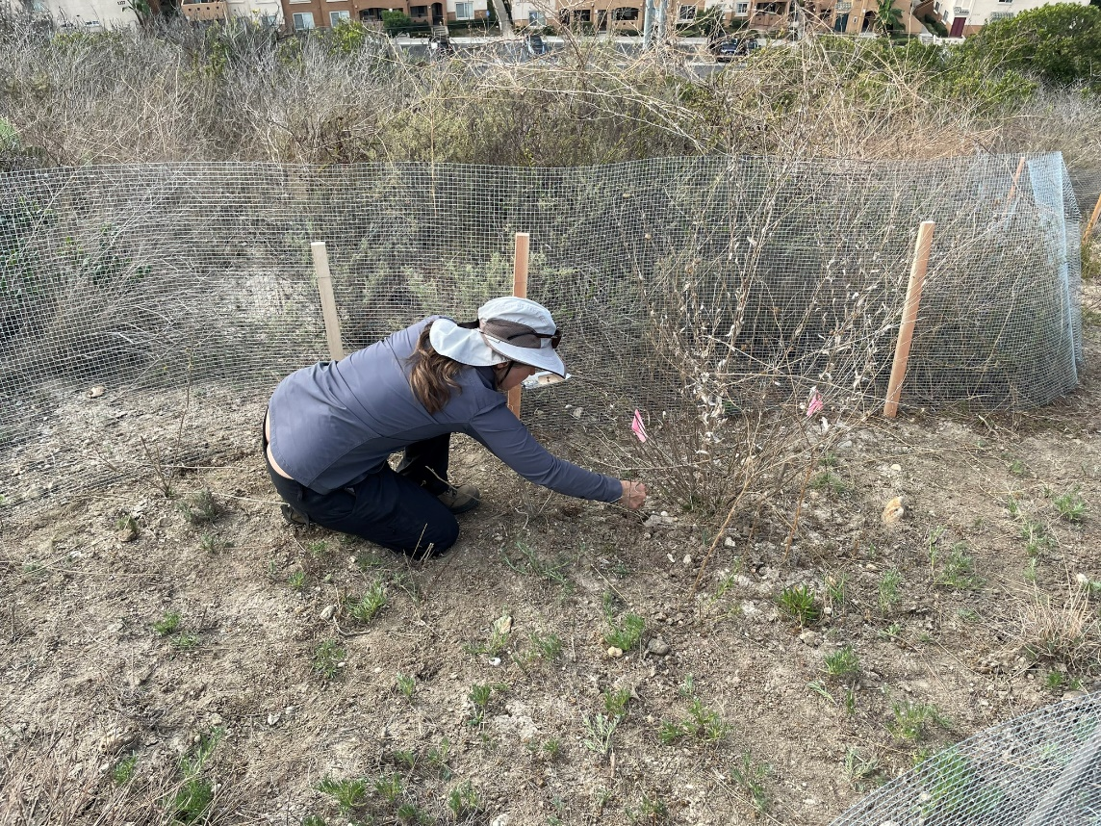
Photo 7. Distributing San Diego Thornmint Seed, Emerald Pointe (December 18, 2023)
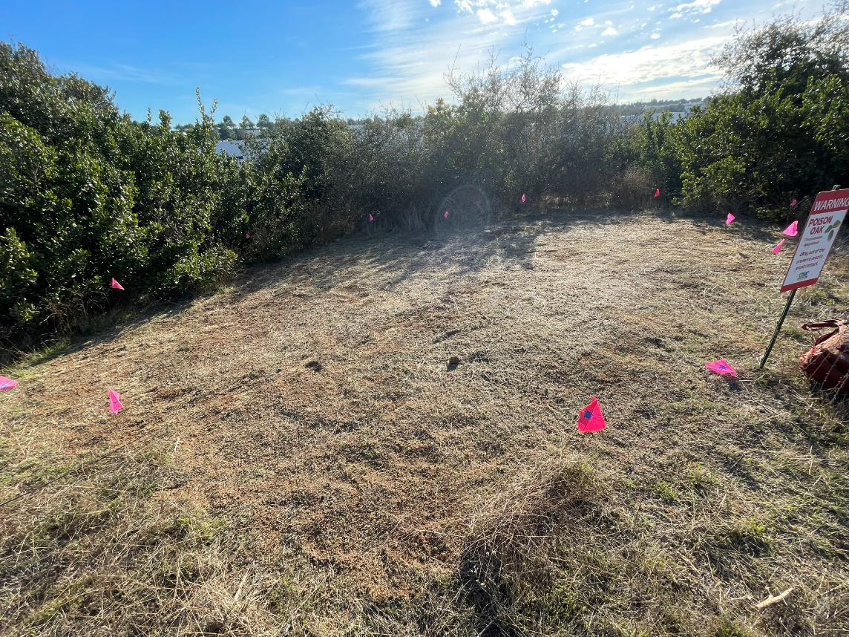
Photo 8. Flagged San Diego Thornmint Enhancement Area, Carlsbad Raceway Preserve (December 18, 2023)

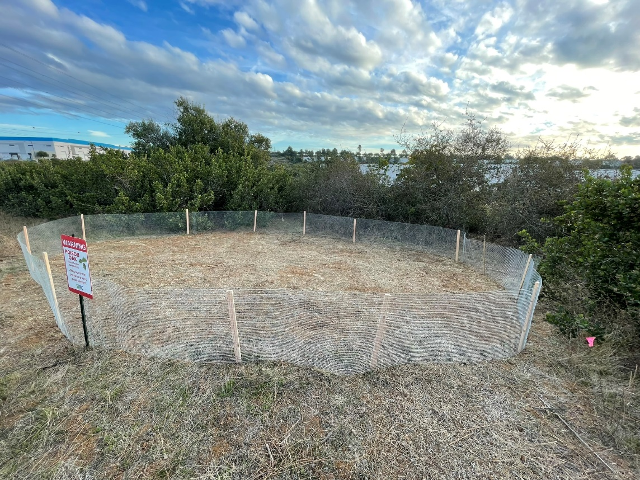
Photo 9. Fenced Area for San Diego Thornmint Enhancement, Before Seeding, Carlsbad Raceway (December 18, 2023)

SDMMP Project Page
To receive reimbursement for work conducted within the quarter, submission of Quarterly Progress, Annual, and Final Reports must be added to your project’s Project Page on the SDMMP website. Add any necessary photographs to the photo carousal and fill out the photograph information. Please contact Sarah McCutcheon (smccutcheon@usgs.gov) or Emily Perkins (eperkins@usgs.gov) if you are having trouble accessing or editing your project page.

Performance Measures
Please include the Project’s Performance Measures for each Quarterly Invoice and Progress Report in order to receive reimbursement.

