San Diego Association of Governments
San Diego Thornmint Enhancement Project
San Diego Habitat Conservancy
Quarterly Progress Report
Reporting Period: January 1 – March 31, 2024
Submission Date: April 22, 2024
SANDAG Contract Number: S1125501

Quarterly Status Report Overview
PLEASE DO NOT CHANGE OR ALTER THE FORMATTING OF THIS DOCUMENT! SANDAG has developed a standardized grant monitoring and tracking program for the Environmental Mitigation Program (EMP) Land Management Grant Program. The purpose is to collect information on individual projects and the grant program as a whole for reporting to the Regional Habitat Conservation Taskforce, SANDAG Policy Advisory Committees, and the SANDAG Board of Directors. SANDAG monitors grantees through invoices, progress reports, performance measures, and designated photograph points. These standardized reporting templates and instructions for submittal are included below.

Work Performed this Period:

Task 1- ACIL Monitoring
During this reporting period, SDHC’s contract botanist, Jessie Vinje, and biologists from HELIX Environmental Planning Inc., performed biological monitoring visits at the two San Diego Thornmint Enhancement Areas to inspect the overall status and health of seed germinants and to assess the need for and perform as needed watering and removal of nonnative plant competitors.
Ms. Vinje first detected signs of the seedling germination on February 2nd, in which a meeting with SDHC and HELIX followed to strategize an appropriate schedule for ongoing monitoring and maintenance throughout the growing season. HELIX biologists conducted weekly site visits as weather permitted on February 29th, March 7th, March 14th, and March 25th. During these monitoring patrols, the approximate quantity of San Diego Thornmint seedlings was recorded at each site, flowering status of indiviuals, nonnative plant species within a three-foot radius, maintenance activities performed, and noted site issues.
During this period, a high of 74 individuals and 100 individuals were noted at Emerald Pointe and Carlsbad Raceway, respectively. No flowering plants have been observed. Supplemental watering only occurred on two of these visits, as natural rainfall events provided sufficient water. Hand clipping of nonnative plants within the Enhancement Areas was only necessary during the last visit of March, focusing on Sonchus asper, Festuca myourus, and Brachypodium distachyum at Emerald Pointe, and Bachypodium distachyum at Carlsbad Raceway.
Other notes included the presence of Harpagonella palmeri, another California Rare Plant Rank listed species, within the Emerald Pointe Enhancement area. This task is 35% complete.

Task 2- Invasive Control in surrounding ACIL areas
Two maintenance events were conducted by HELIX maintenance crews during this reporting period. Maintenance was performed in the areas surrounding the Enhancement Areas at both preserve sites on February 29th and March 25th. Efforts included line trimming and selective herbicide application to vegetative invasive plant species. Dethatching was not needed as previously anticipated. Species targeted during maintenance included those noted above in the Monitoring section, as well as minor patches of Brassica nigra and Centaurea melitensis. This task is 47% complete.

Task 3- Reporting and Invoicing
A quarterly progress report and invoice for the October 1-December 31, 2023 reporting period was prepared and submitted on January 22, 2024. The SDMMP website project page was also updated. This task is 39% complete.

Task 4- Administrative
Administrative tasks included internal meetings and coordination with contractors. This task is 96% complete.

Work Anticipated Next Period

For the next reporting period, from April 1 to June 30, 2024, SDHC anticipates the following tasks will occur:

- Monitoring of the San Diego Thornmint will continue with as needed watering.
- Hand removal of weeds within three feet of the San Diego Thornmint and maintenance within a buffer around the Enhancement Areas will continue as funds allow.
- Additional seeding of San Diego Thornmint will occur in the fall of 2024.

Issues to Note
There are no issues to note during this reporting period.

Photographs & Figures

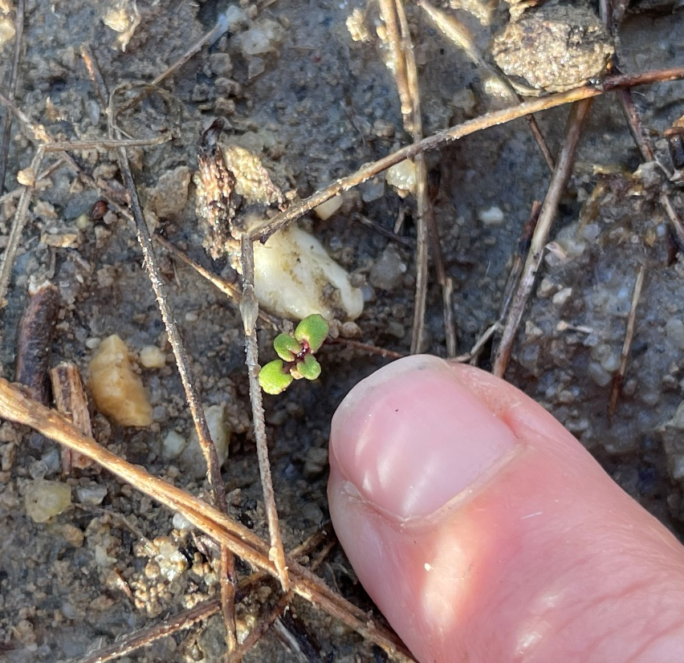
Photo 1. Initial San Diego Thornmint germinant observed by Jessie Vinje (February 2, 2024)
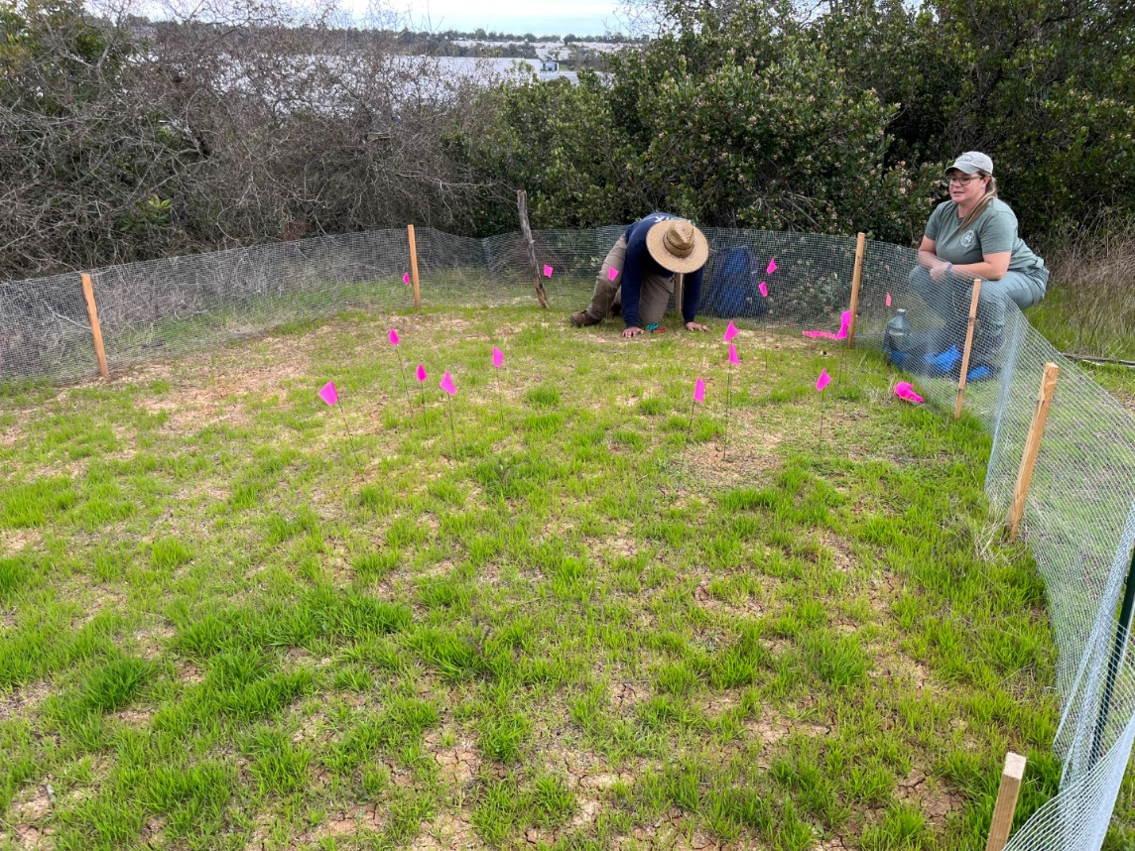
Photo 2. HELIX biologists flagging the San Diego Thornmint Enhancement Area, Carlsbad Raceway (February 29, 2024)

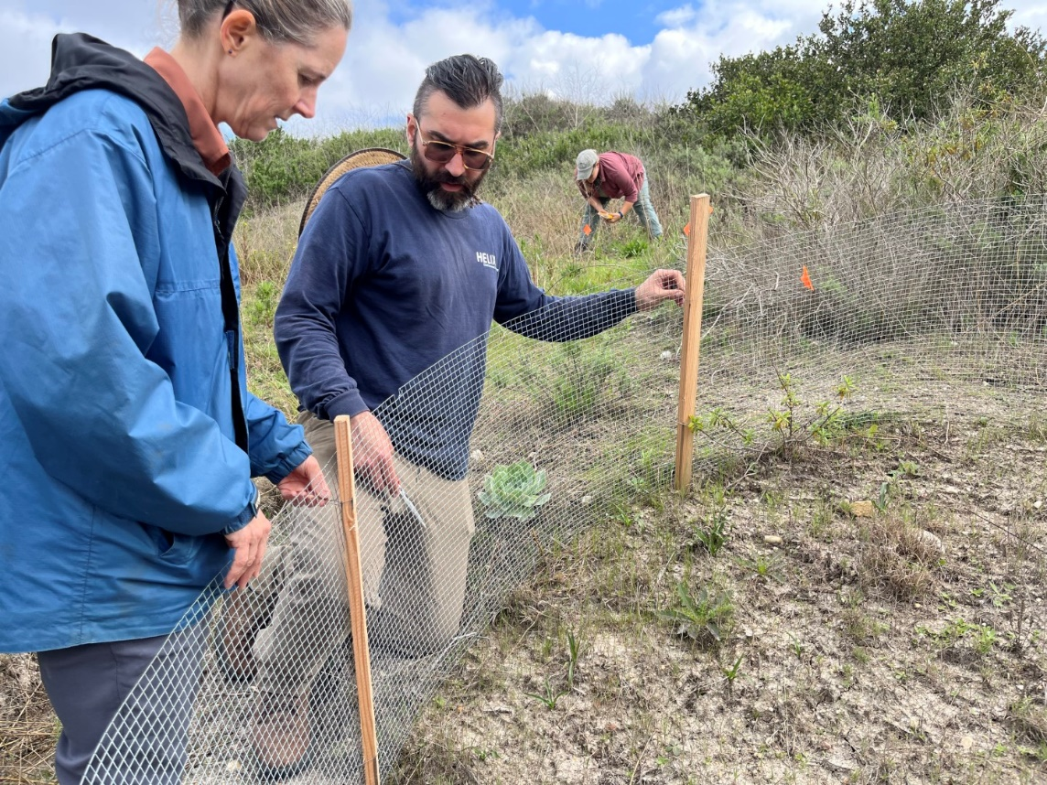
Photo 3. Site Visit with contract botanist and HELIX staff, Emerald Pointe (February 29, 2024)
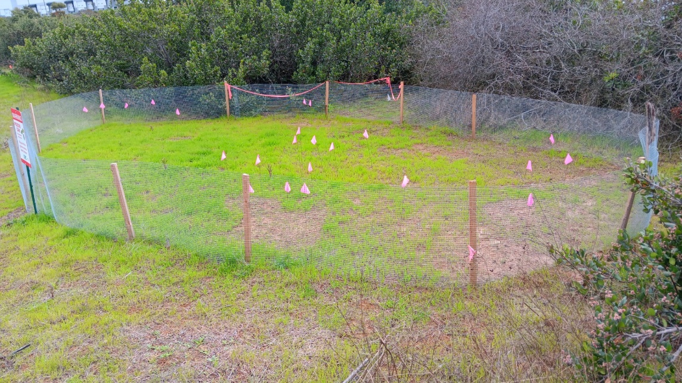
Photo 4. Flagged individuals in Enhancement Area, Carlsbad Raceway (March 7, 2024)
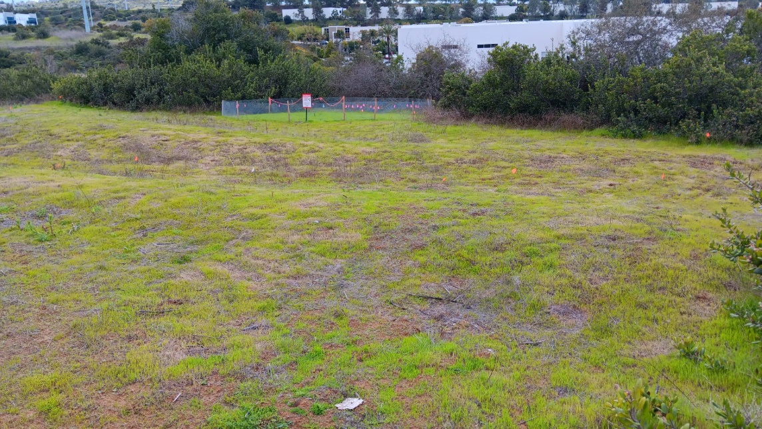
Photo 5. Area surrounding Enhancement Area, Carlsbad Raceway (March 7, 2024)

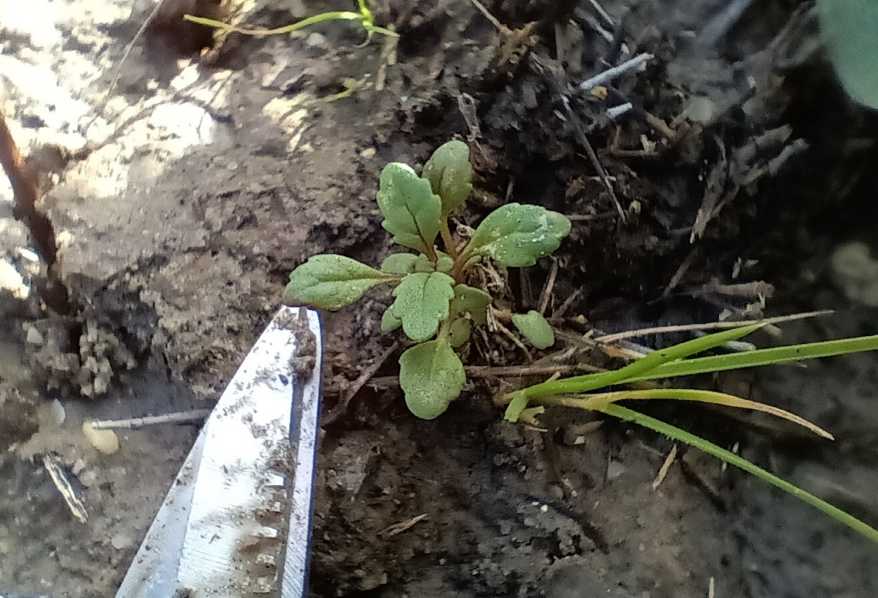
Photo 6. San Diego Thornmint individual, Emerald Pointe (March 7, 2024)
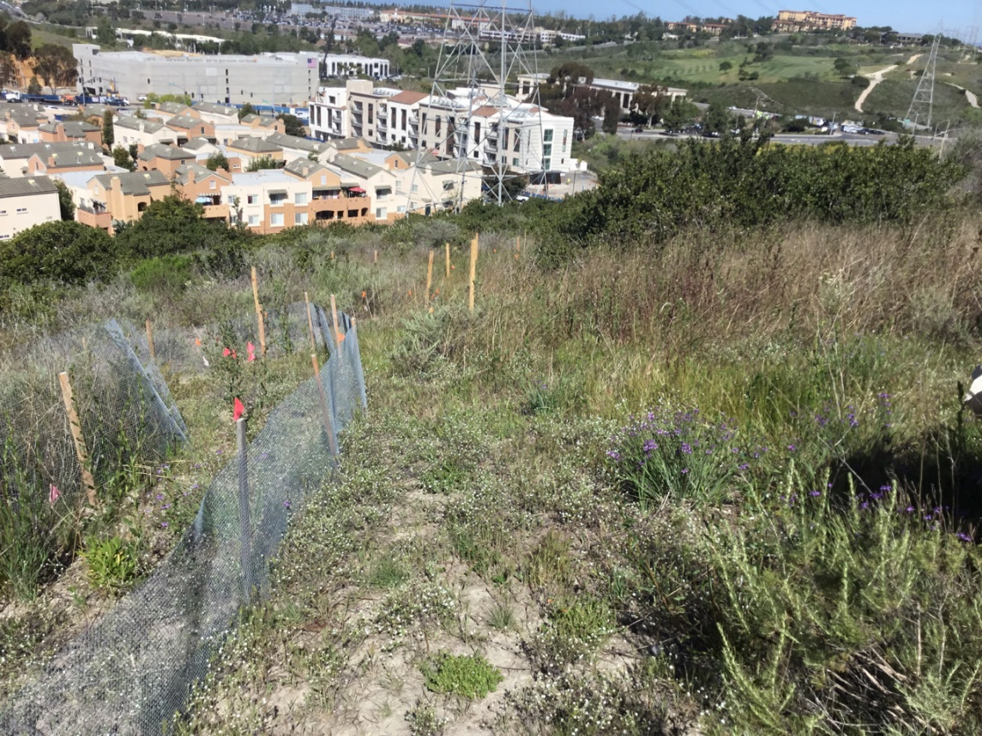
Photo 7. Area outside Enhancement Area following maintenance, Emerald Point (March 31, 2024)

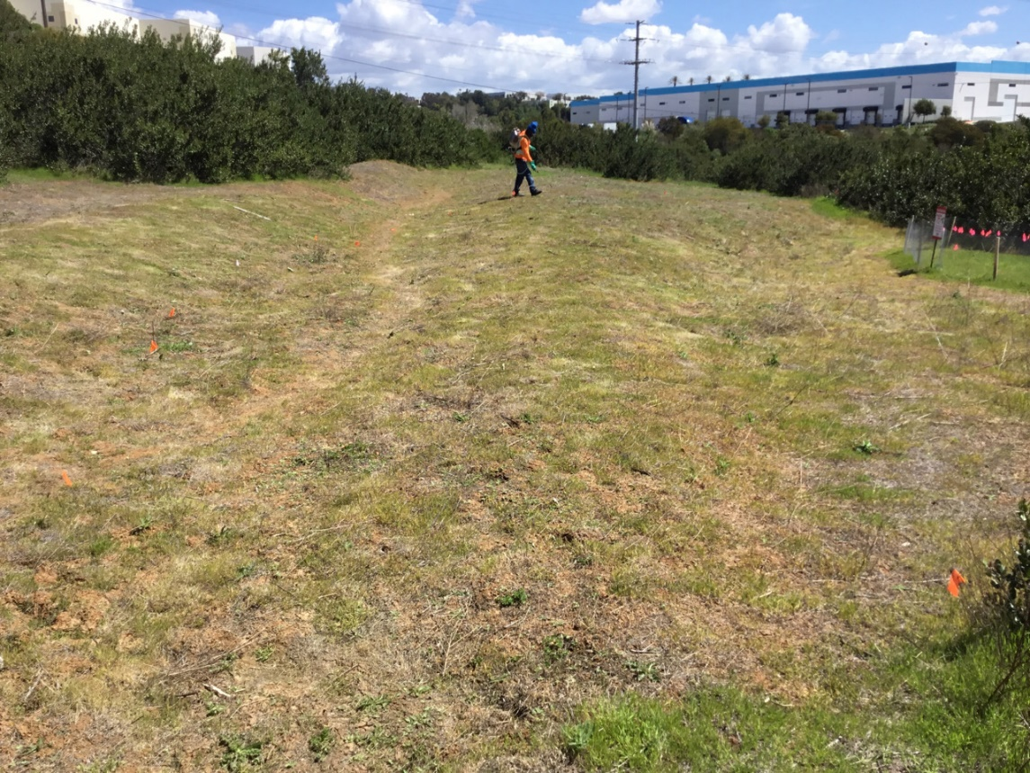
Photo 8. Crew performing maintenance outside Enhancement Area, Carlsbad Raceway (March 31, 2024)
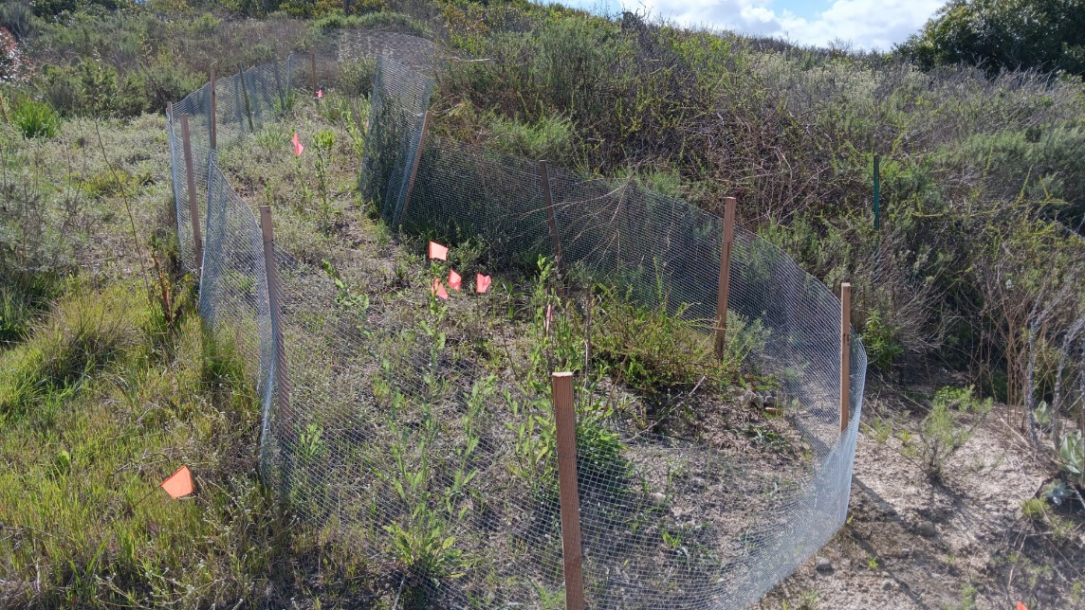
Photo 9. Flagged individuals in Enhancement Area, Emerald Pointe (March 22, 2024)

SDMMP Project Page
To receive reimbursement for work conducted within the quarter, submission of Quarterly Progress, Annual, and Final Reports must be added to your project’s Project Page on the SDMMP website. Add any necessary photographs to the photo carousal and fill out the photograph information. Please contact Sarah McCutcheon (smccutcheon@usgs.gov) or Emily Perkins (eperkins@usgs.gov) if you are having trouble accessing or editing your project page.

Performance Measures
Please include the Project’s Performance Measures for each Quarterly Invoice and Progress Report in order to receive reimbursement.

