San Diego Association of Governments
San Diego Thornmint Enhancement Project
San Diego Habitat Conservancy
Quarterly Progress Report
Reporting Period: April 1 – June 30, 2024
Submission Date: July 15, 2024
SANDAG Contract Number: S1125501

Quarterly Status Report Overview
PLEASE DO NOT CHANGE OR ALTER THE FORMATTING OF THIS DOCUMENT! SANDAG has developed a standardized grant monitoring and tracking program for the Environmental Mitigation Program (EMP) Land Management Grant Program. The purpose is to collect information on individual projects and the grant program as a whole for reporting to the Regional Habitat Conservation Taskforce, SANDAG Policy Advisory Committees, and the SANDAG Board of Directors. SANDAG monitors grantees through invoices, progress reports, performance measures, and designated photograph points. These standardized reporting templates and instructions for submittal are included below.

Work Performed this Period:

Task 1- ACIL Monitoring
During this reporting period, biologists from HELIX Environmental Planning Inc., performed biological monitoring visits at the two San Diego Thornmint Enhancement Areas to inspect the overall status and health of the individual plants and to continue to assess the need for and perform as needed watering and removal of nonnative plant competitors.
HELIX biologists conducted weekly site visits as weather permitted on April 2nd, April 11th, April 19th, April 25th, May 2nd, May 7th, May 13th, May 22nd, June 4th, June 14th, and June 24th. During these monitoring patrols, the approximate quantity of San Diego Thornmint seedlings was recorded at each site, flowering status of individuals, nonnative plant species within a three-foot radius, maintenance activities performed, and noted site issues.
During this period, a high of 185 individuals and 146 individuals were noted at Emerald Pointe and Carlsbad Raceway, respectively. The majority of individuals were observed flowering, with approximately 93% of individuals flowering at each site. Supplemental watering occurred on nine of these visits to help promote seed production. Hand clipping of nonnative plants within the Enhancement Areas was performed during nearly every visit with the most abundant weed cover occurring between late April and mid-May. Removal efforts focused on Bromus madritensis, Festuca myuros, Helmithotheca echioides, Centarea melitensis, Sonchus asper, Sonchus asper, and Brachypodium distachyon at Emerald Pointe, and Bachypodium distachyon, Sonchus asper, and Centaurea melitensis at Carlsbad Raceway.
It should be noted that neither of the existing populations of San Diego Thornmint germinated at Emerald Pointe or Carlsbad Raceway this year. This task is 63% complete.

Task 2- Invasive Control in surrounding ACIL areas
Six maintenance events were conducted by HELIX maintenance crews during this reporting period. Maintenance was performed in the areas surrounding the Enhancement Areas at both preserve sites on April 10th, April 24th, May 8th, May 22nd, June 7^{t}, and June 21st. Efforts included line trimming and selective herbicide application to vegetative invasive plant species. Dethatching was not needed as previously anticipated. Species targeted during maintenance included those noted above in the Monitoring section, as well as minor patches of Lysimachia arvensis. Minor fence repair and trash removal was also performed at Carlsbad Raceway. This task is 76% complete.

Task 3- Reporting and Invoicing
A quarterly progress report and invoice for the January 1-March 31, 2024 reporting period was prepared and submitted on April 22, 2024. The SDMMP website project page was also updated. This task is 49% complete.

Task 4- Administrative
Administrative tasks included internal meetings and coordination with contractors. This task is 96% complete.

Work Anticipated Next Period

For the next reporting period, from July 1 to September 30, 2024, SDHC anticipates the following tasks will occur:

- Monitoring of the San Diego Thornmint and removal of weeds will continue as needed.
- Additional seeding of San Diego Thornmint will occur in the fall of 2024.

Issues to Note
There are no issues to note during this reporting period.

Photographs & Figures

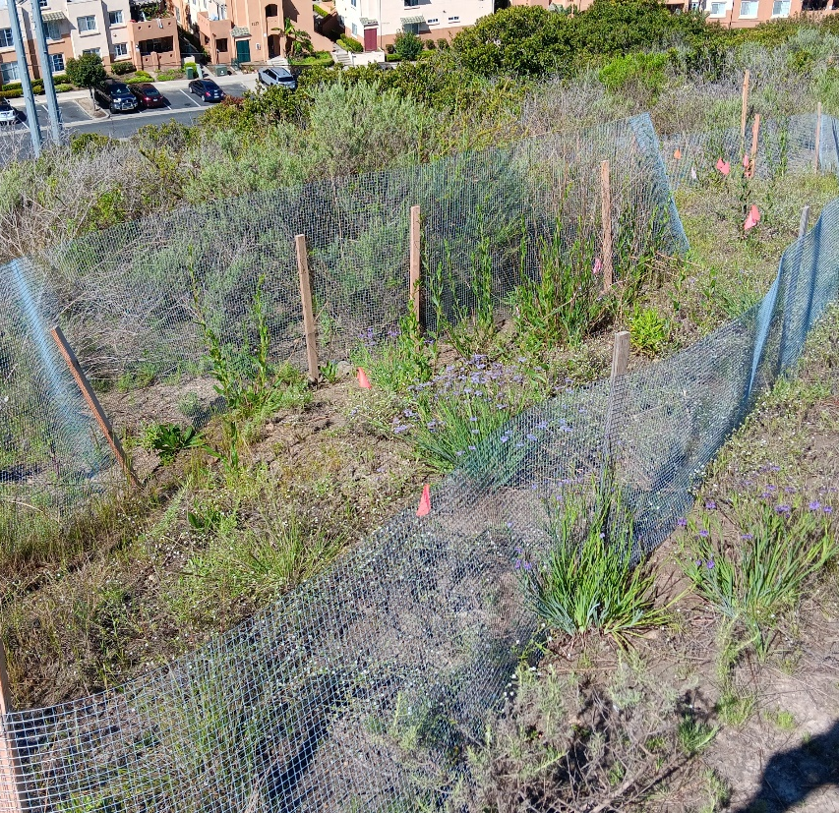
Photo 1. Overview of Emerald Pointe Enhancement Area (April 2, 2024)
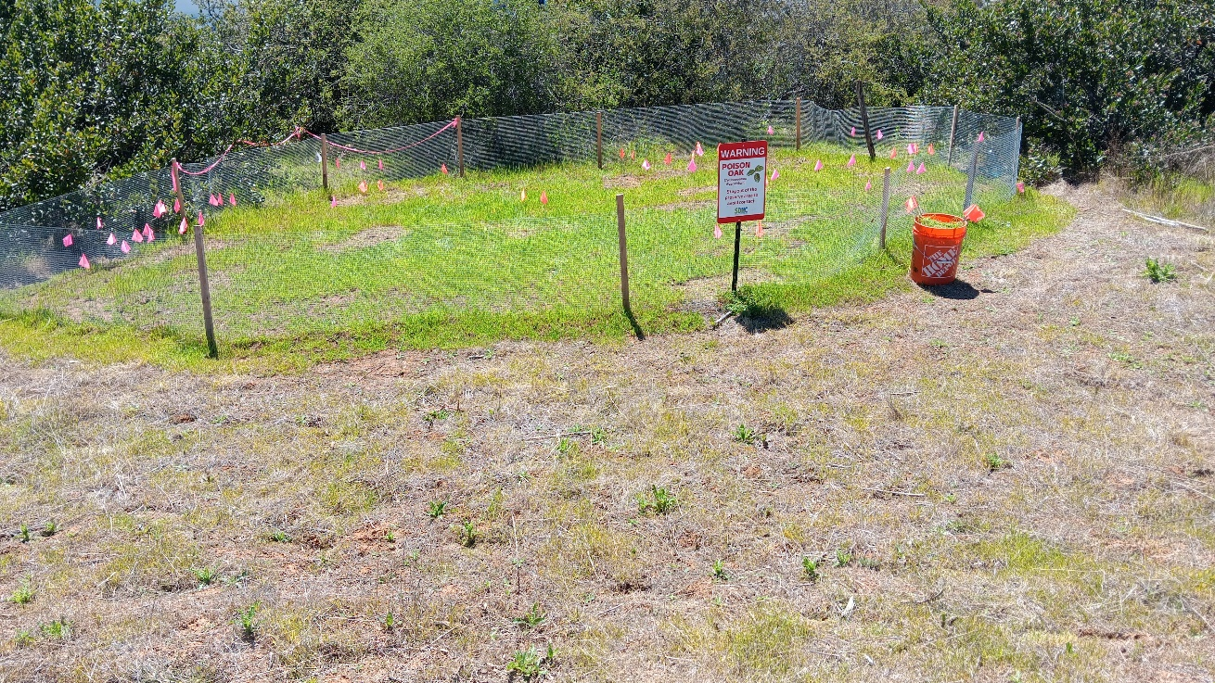
Photo 2. Overview of Carlsbad Raceway Enhancement Area and buffer (April 2, 2024)

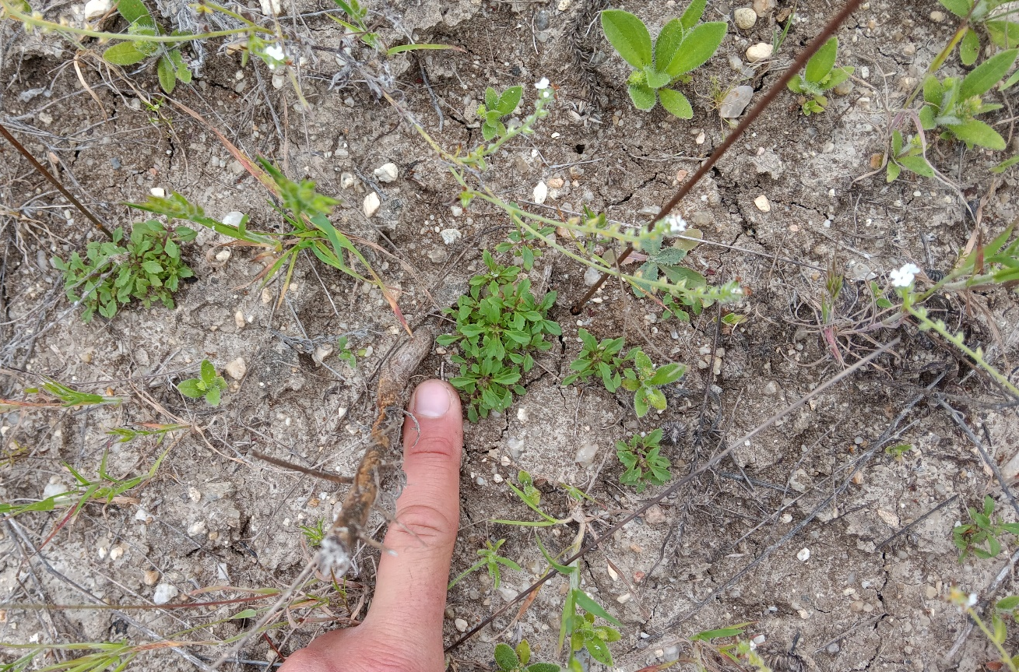
Photo 3San Diego Thornmint individuals, Emerald Pointe (April 19, 2024)

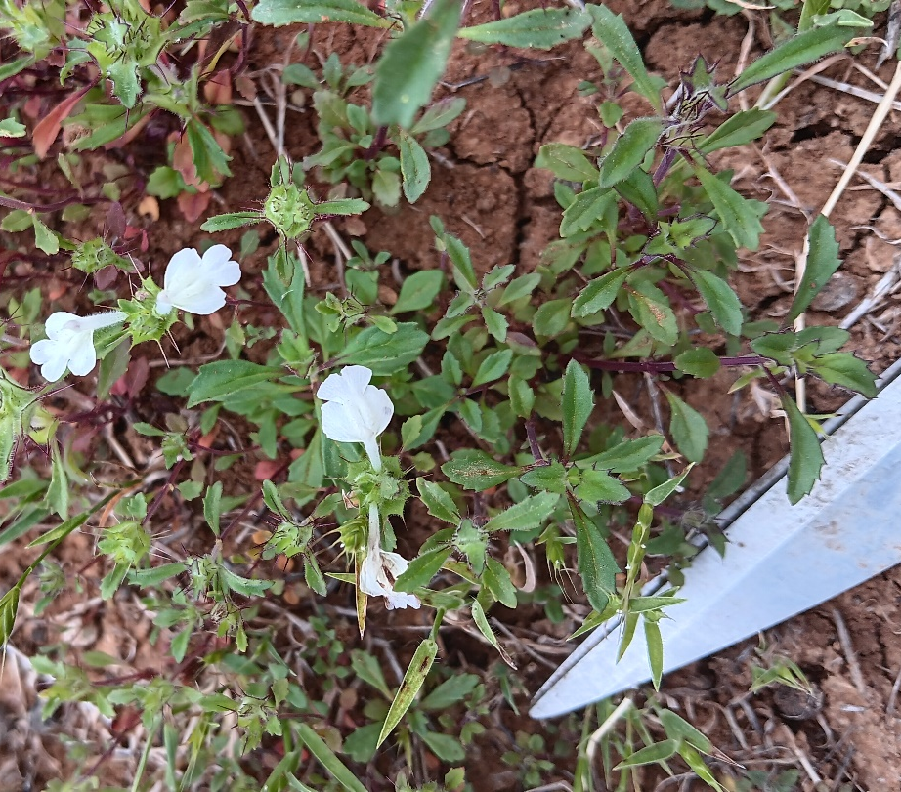

Photo 4. Flowering individuals in Enhancement Area, Carlsbad Raceway (May 2, 2024)
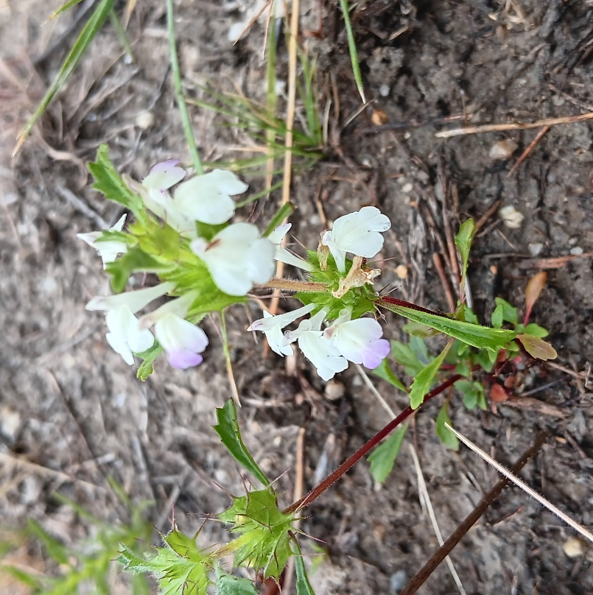
Photo 5. Flowering individual in Enhancement Area, Emerald Pointe (May 13, 2024)

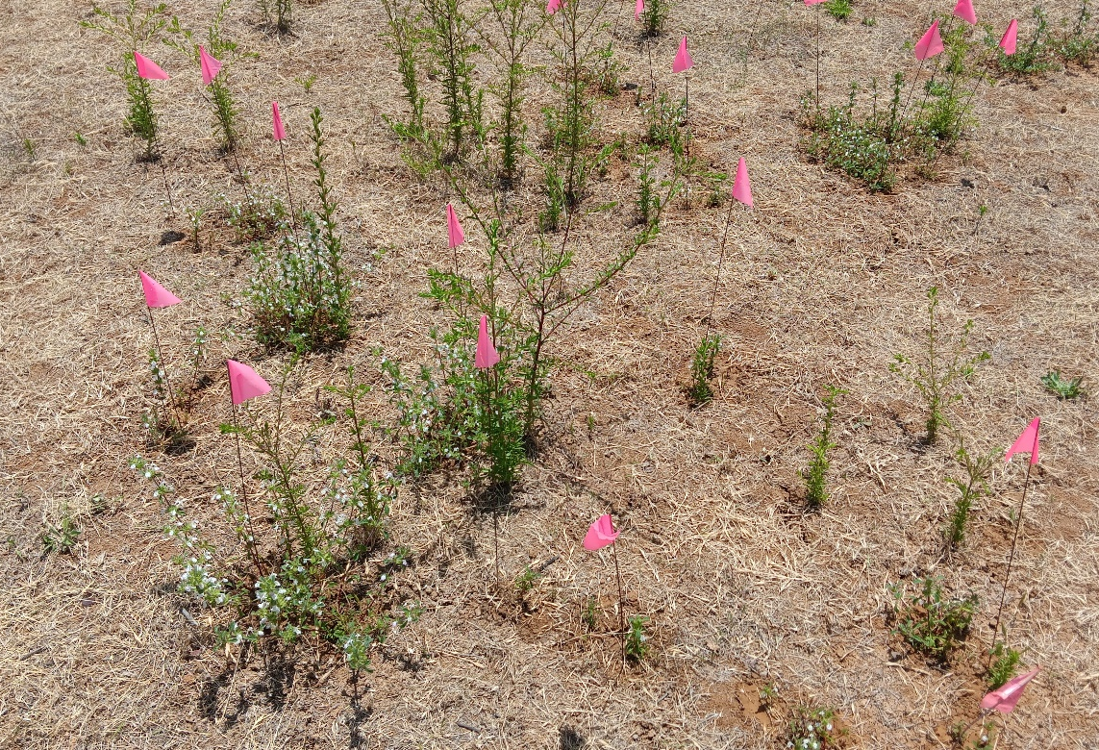
Photo 6. Flagged San Diego Thornmint individuals in Enhancement Area, Carlsbad Raceway (June 4, 2024)
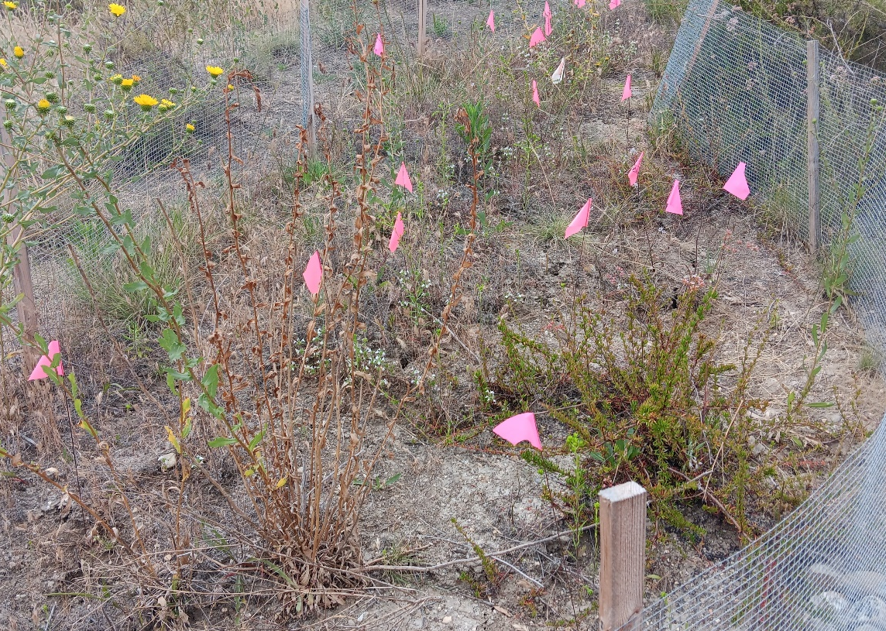
Photo 7. Flagged San Diego Thornmint individuals in Enhancement Area, Emerald Point (June 4, 2024)

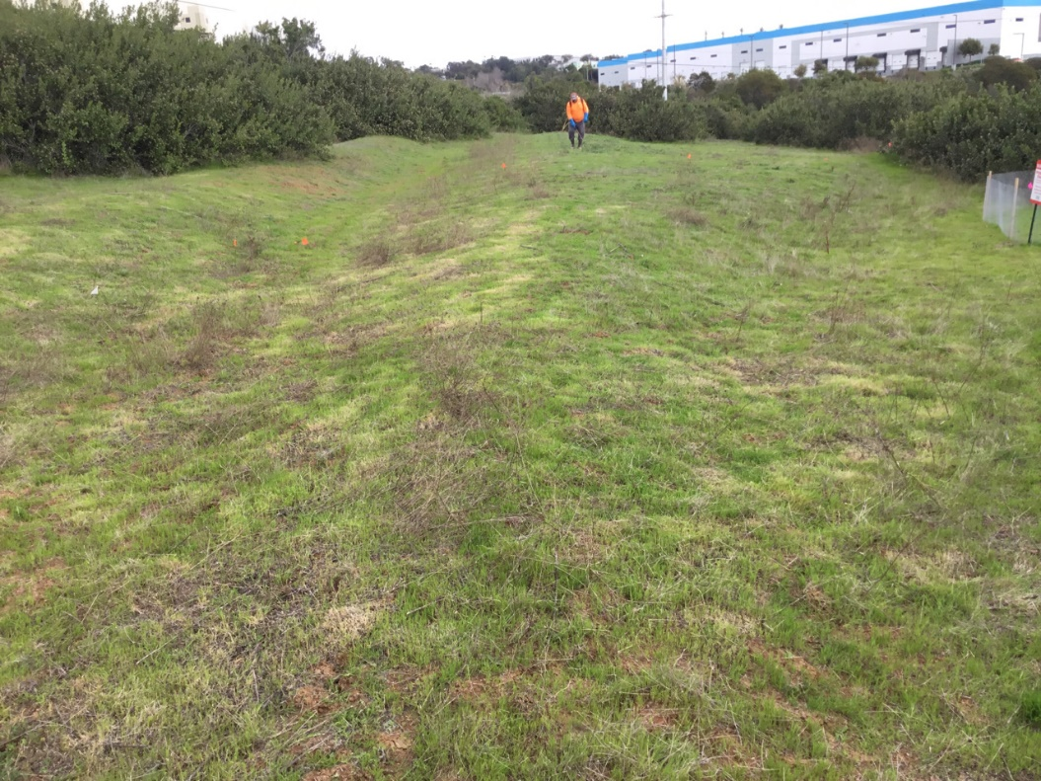
Photo 8. Crew performing maintenance outside Enhancement Area, Carlsbad Raceway (April 24, 2024)
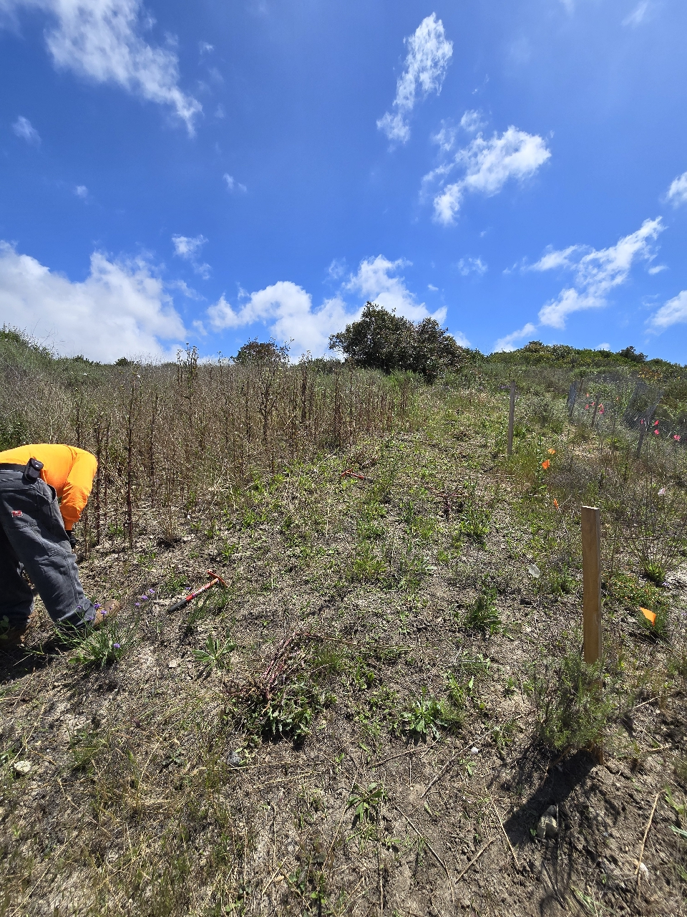
Photo 9. Crew performing weed control within buffer outside Enhancement Area, Emerald Pointe (May 8, 2024)
SDMMP Project Page
To receive reimbursement for work conducted within the quarter, submission of Quarterly Progress, Annual, and Final Reports must be added to your project’s Project Page on the SDMMP website. Add any necessary photographs to the photo carousal and fill out the photograph information. Please contact Sarah McCutcheon (smccutcheon@usgs.gov) or Emily Perkins (eperkins@usgs.gov) if you are having trouble accessing or editing your project page.

Performance Measures
Please include the Project’s Performance Measures for each Quarterly Invoice and Progress Report in order to receive reimbursement.

