San Diego Association of Governments
San Diego Thornmint Enhancement Project
San Diego Habitat Conservancy
Quarterly Progress Report
Reporting Period: July 1 – September 30, 2024
Submission Date: October 11, 2024
SANDAG Contract Number: S1125501

Quarterly Status Report Overview
PLEASE DO NOT CHANGE OR ALTER THE FORMATTING OF THIS DOCUMENT! SANDAG has developed a standardized grant monitoring and tracking program for the Environmental Mitigation Program (EMP) Land Management Grant Program. The purpose is to collect information on individual projects and the grant program as a whole for reporting to the Regional Habitat Conservation Taskforce, SANDAG Policy Advisory Committees, and the SANDAG Board of Directors. SANDAG monitors grantees through invoices, progress reports, performance measures, and designated photograph points. These standardized reporting templates and instructions for submittal are included below.

Work Performed this Period:

Task 1- ACIL Monitoring
During this reporting period, SDHC determined that monitoring efforts can be delayed over summer due to the lack of vegetative activity and increased temperatures. Biologists from HELIX Environmental Planning Inc., performed one biological monitoring visits at the two San Diego Thornmint Enhancement Areas to inspect the overall status and health of the individual plants and to continue to assess the need for and perform as needed watering and removal of nonnative plant competitors.
HELIX biologists conducted site visits at both preserves on July 2nd and just Carlsbad Raceway on July 11th before monitoring was paused. During these monitoring patrols, the approximate quantity of San Diego Thornmint individuals was recorded at each site, flowering status of individuals, nonnative plant species within a three-foot radius, maintenance activities performed, and noted site issues.
During this period, the populations of San Diego Thornmint were passed their peak germination periods, as populations stopped growing at Emerald Pointe and decreased at Carlsbad Raceway. 180 and 98 total individuals were observed at each site, respectively. The percentage of flowering individuals significantly dropped, with approximately 8% and 72% of individuals flowering at each site, respectively.
Supplemental watering occurred just once at Carlsbad Raceway but was determined no longer necessary. Hand clipping of nonnative plants within the Enhancement Areas was not needed during this period due to the lack of weed cover. This task is 70% complete.

Task 2- Invasive Control in surrounding ACIL areas
No maintenance events were conducted during this reporting period due to the lack of weed species present. This task is 77% complete.

Task 3- Reporting and Invoicing
A quarterly progress report and invoice for the April 1-June 31, 2024 reporting period was prepared and submitted on July 15, 2024. The SDMMP website project page was also updated. This task is 57% complete.

Task 4- Administrative
Administrative tasks included internal meetings and coordination with contractors. This task is 96% complete.

Work Anticipated Next Period

For the next reporting period, from October 1 to December 31, 2024, SDHC anticipates the following tasks will occur:

- Monitoring of the San Diego Thornmint and removal of weeds will continue as needed.
- Additional seeding of San Diego Thornmint will occur with the start of the wet season this fall.

Issues to Note
There are no issues to note during this reporting period.

Photographs & Figures

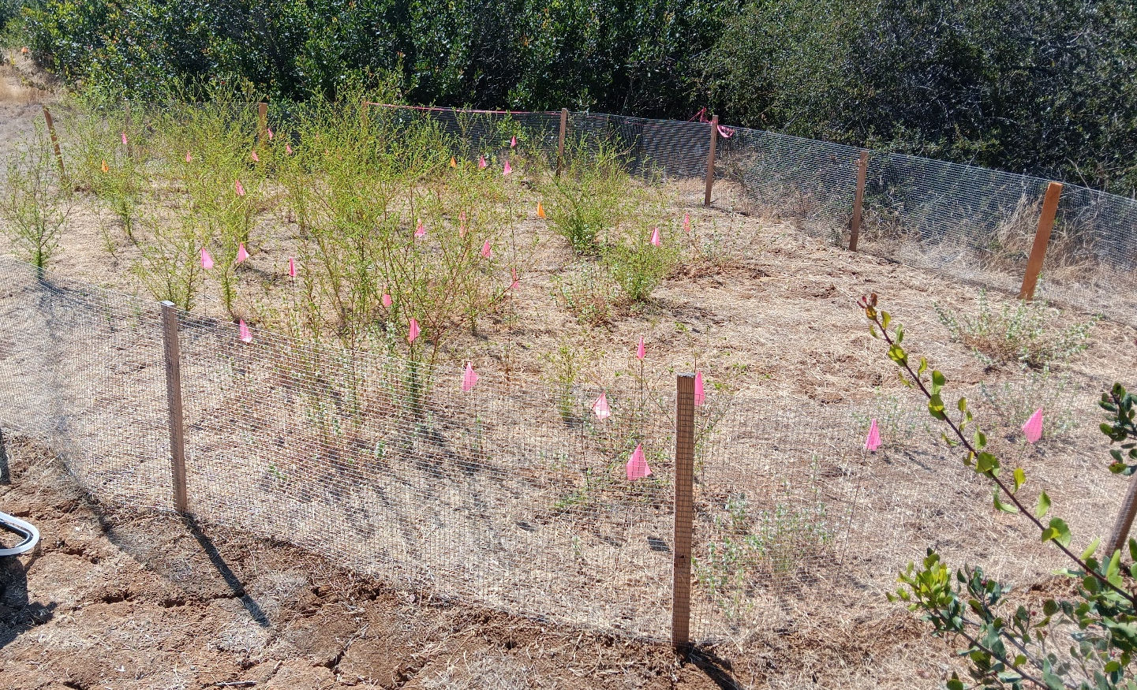
Photo 1. Overview of Carlsbad Raceway Enhancement Area (July 2, 2024)
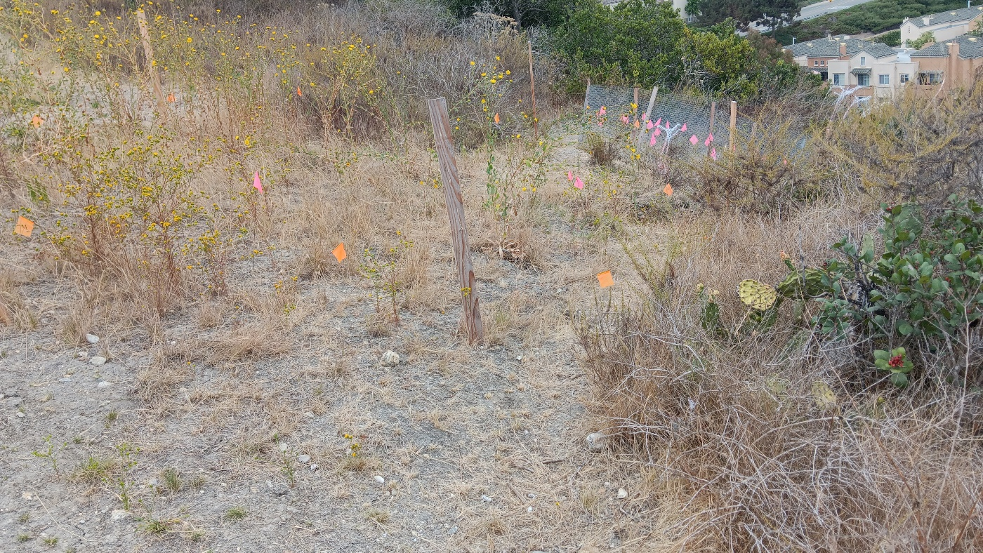
Photo 2. Overview of Emerald Pointe Enhancement Area (July 2, 2024)

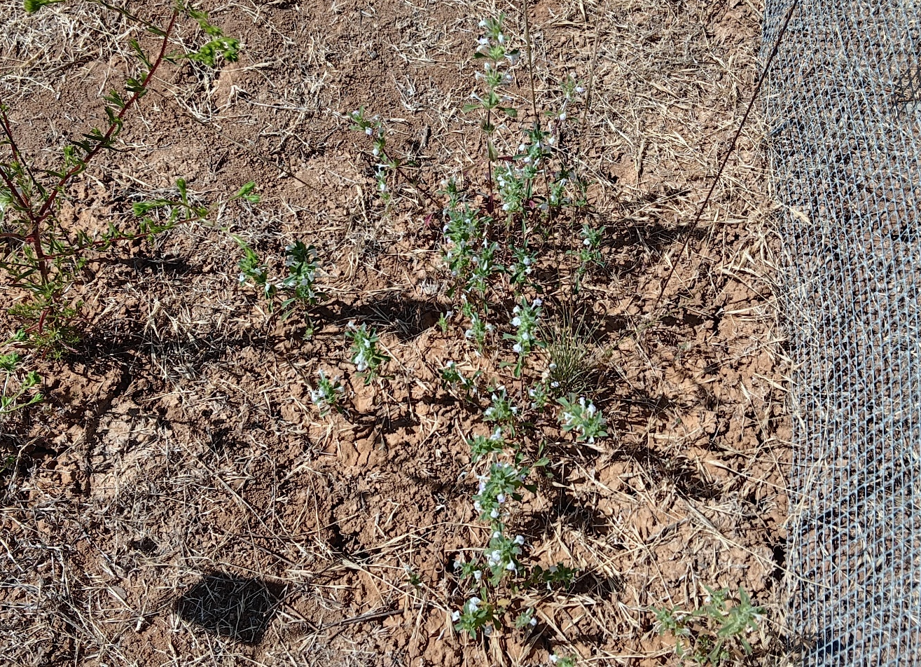
Photo 3. San Diego Thornmint individuals, Carlsbad Raceway (July 2, 2024)
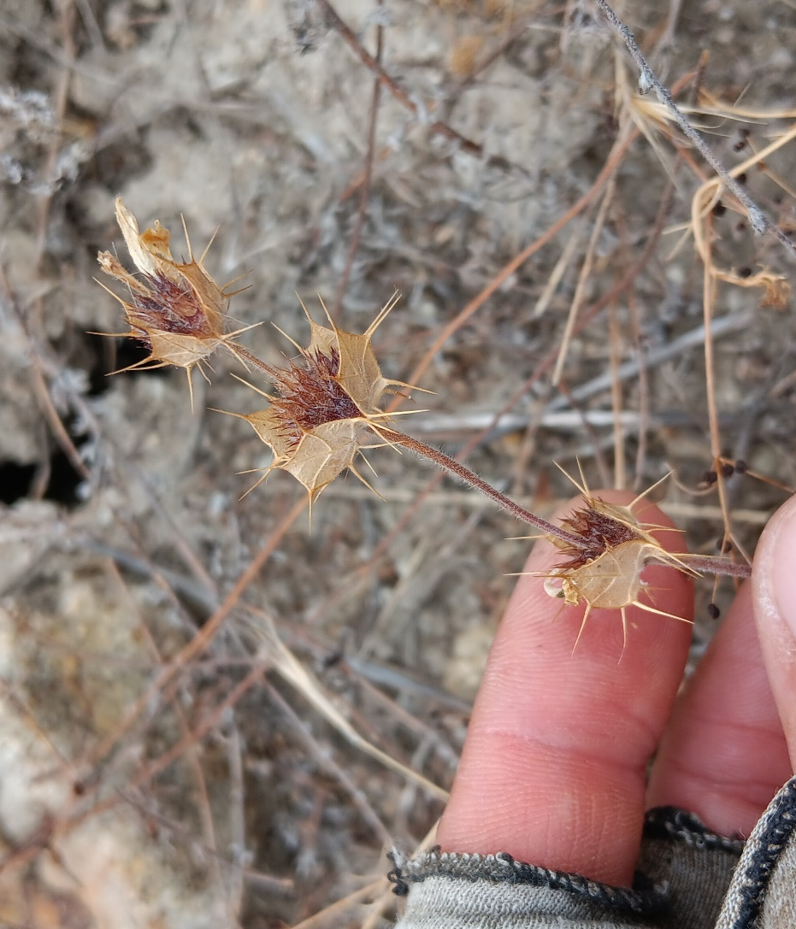

Photo 4. Dried flowers at Emerald Pointe (July 2, 2024)
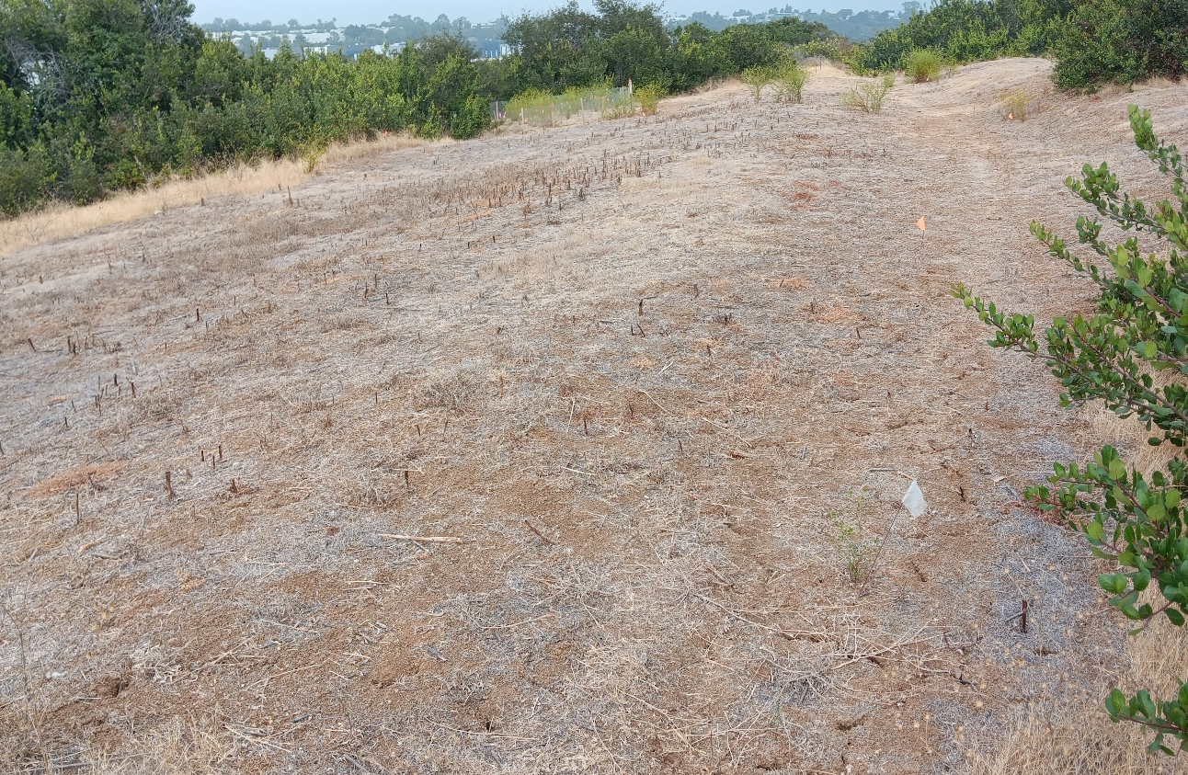
Photo 5. Overview of buffer area, Carlsbad Raceway (July 11, 2024)
SDMMP Project Page
To receive reimbursement for work conducted within the quarter, submission of Quarterly Progress, Annual, and Final Reports must be added to your project’s Project Page on the SDMMP website. Add any necessary photographs to the photo carousal and fill out the photograph information. Please contact Sarah McCutcheon (smccutcheon@usgs.gov) or Emily Perkins (eperkins@usgs.gov) if you are having trouble accessing or editing your project page.

Performance Measures
Please include the Project’s Performance Measures for each Quarterly Invoice and Progress Report in order to receive reimbursement.

