San Diego Association of Governments
San Diego Thornmint Enhancement Project
San Diego Habitat Conservancy
Quarterly Progress Report
Reporting Period: April 1 – June 30, 2025
Submission Date: July 17, 2025
SANDAG Contract Number: S1125501

Quarterly Status Report Overview
PLEASE DO NOT CHANGE OR ALTER THE FORMATTING OF THIS DOCUMENT! SANDAG has developed a standardized grant monitoring and tracking program for the Environmental Mitigation Program (EMP) Land Management Grant Program. The purpose is to collect information on individual projects and the grant program as a whole for reporting to the Regional Habitat Conservation Taskforce, SANDAG Policy Advisory Committees, and the SANDAG Board of Directors. SANDAG monitors grantees through invoices, progress reports, performance measures, and designated photograph points. These standardized reporting templates and instructions for submittal are included below.

Work Performed this Period:

Task 1- ACIL Monitoring
During this reporting period, SDHC Habitat Managers Vince Rivas and Dane van Tamelen performed biological monitoring at the three San Diego Thornmint Enhancement Areas to inspect the overall status and health of seed germinants and to assess needed watering and removal of nonnative plant competitors. Between May 3rd and June 29th, SDHC staff visited the sites weekly and applied water to promote seed production and hand pulled nonnative plant species as needed.
Hand weeding at the three sites was conducted on seven days and included removal of the following nonnative species: Brachipodium distachyon, Sonchus asper, Erodium sp., Lysimachia arvensis, Centaurea melitensis, and Brassica nigra. Brachipodium remains to be the most persistent issue at Carlsbad Raceway, particularly in the areas surrounding the Enhancement Area, but does not occur at the other two sites. Natural rainfall was lower than previous years, so between one and three gallons of water was applied to the Carlsbad Raceway and Emerald Pointe populations. The Taylor population did not persist for long, so additional enhancement efforts will be targeted at this site. During this monitoring period, the maximum number of individuals recorded at each site were as follows: 612 at Carlsbad Raceway, 116 at Emerald Pointe, and 13 at Taylor.
Other notes included the presence of Harpagonella palmeri, another California Rare Plant Rank listed species, immediately outside of the Carlsbad Raceway Enhancement Area. This task is 78% complete.

Task 2- Invasive Control in surrounding ACIL areas
One maintenance event was conducted by East County Transitional Living Center maintenance crews during this reporting period. Maintenance was performed in the 0.4-acre area surrounding the Enhancement Areas at Carlsbad Raceway on April 28th. Efforts included line trimming of Brachipodium distachyon and removal of Brassica nigra, but no dethatching was needed. This maintenance event was paid for with funds from the Carlsbad Raceway Preserve endowment to save for use of HELIX Environmental Planning maintenance crew that is permitted to use chemical herbicide if needed. No maintenance efforts were necessary at Emerald Pointe or Taylor. This task is 77% complete.

Task 3- Reporting and Invoicing
A quarterly progress report and invoice for the January 1-March 31, 2025 reporting period was prepared and submitted on April 19, 2025. The SDMMP website project page was also updated. This task is 77% complete.

Task 4- Administrative
Administrative tasks included internal meetings and coordination with contractors, as well as coordinating with the SANDAG board for a contract extraction to utilize the remaining funds through June 27, 2026. This task is 96% complete.

Work Anticipated Next Period

For the next reporting period, from July 1 to September 30, 2025, SDHC anticipates the following tasks will occur:

- Monitoring of the San Diego Thornmint and removal of weeds will continue as needed.

Issues to Note
There are no issues to note during this reporting period.

Photographs & Figures

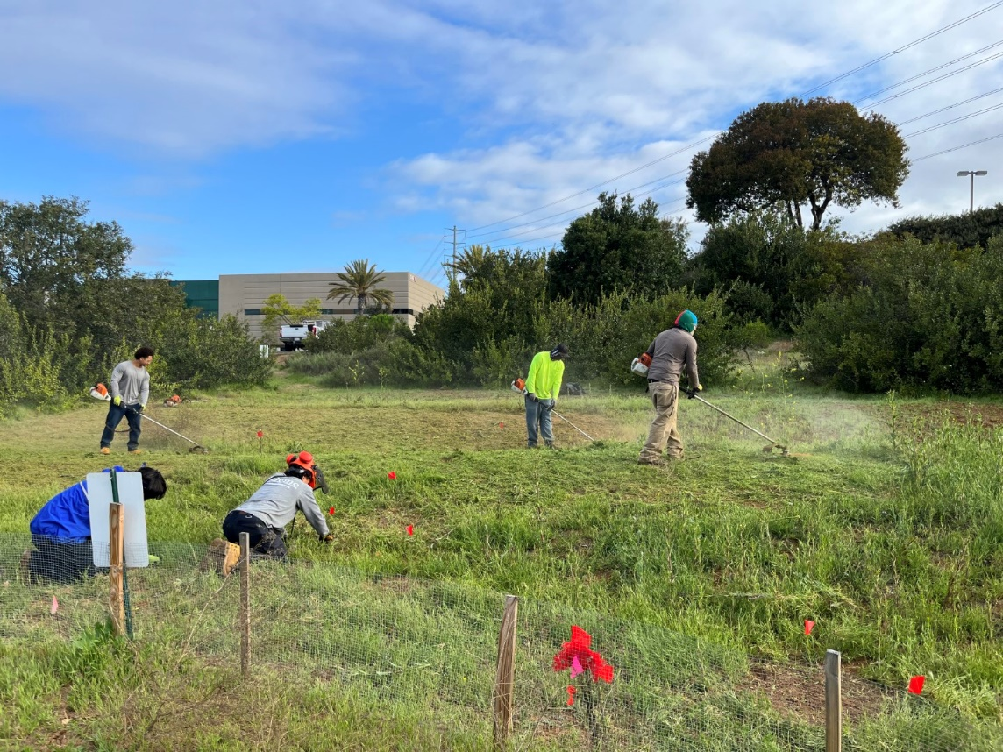
Photo 1. Maintenance crew line trimming around the Carlsbad Raceway Enhancement Area (April 28, 2025)
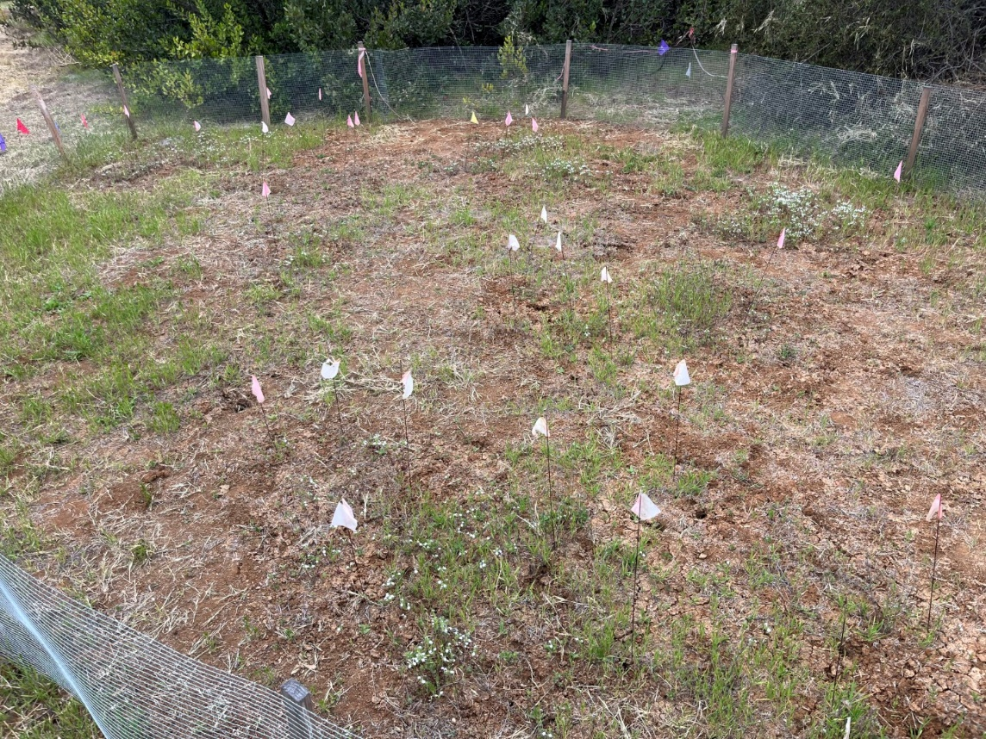
Photo 3. Overview of the Carlsbad Raceway Enhancement Area (May 3, 2025)

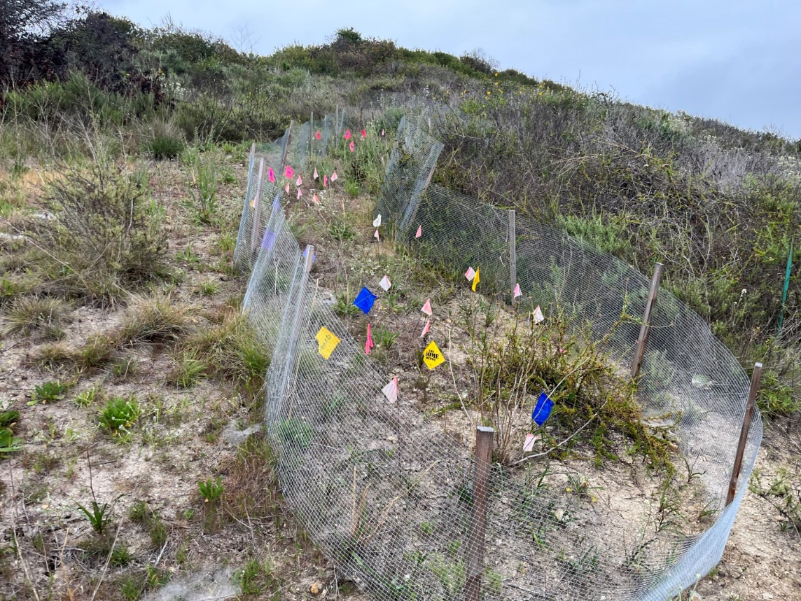
Photo 3. Overview of the Emerald Pointe Enhancement Area (May 3, 2025)
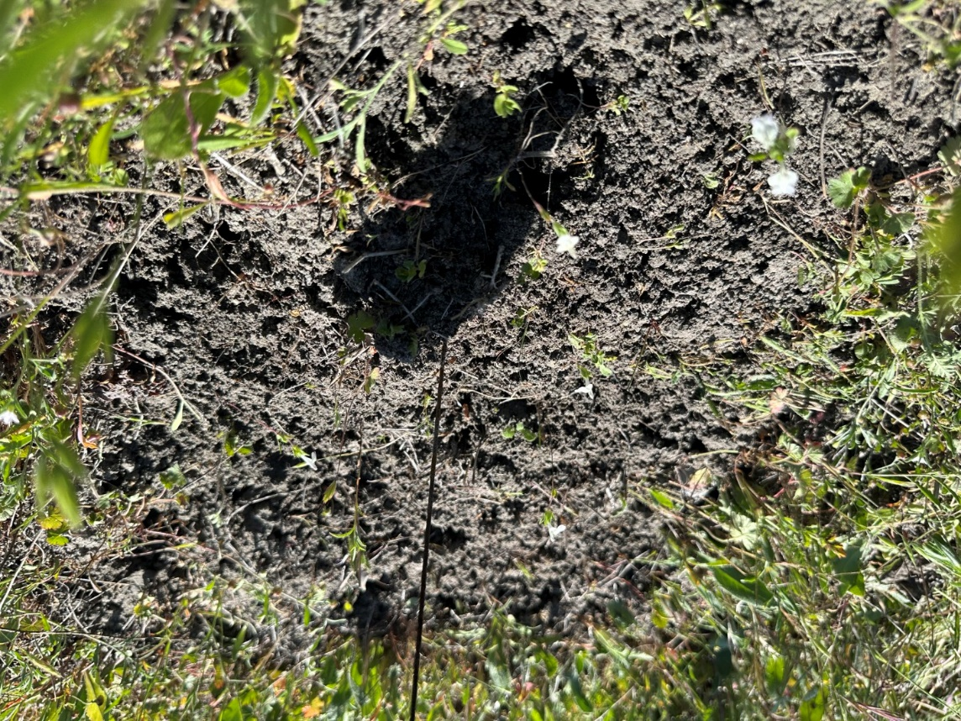
Photo 4. San Diego Thornmint individuals at the Taylor Enhancement Area (May 9, 2025)

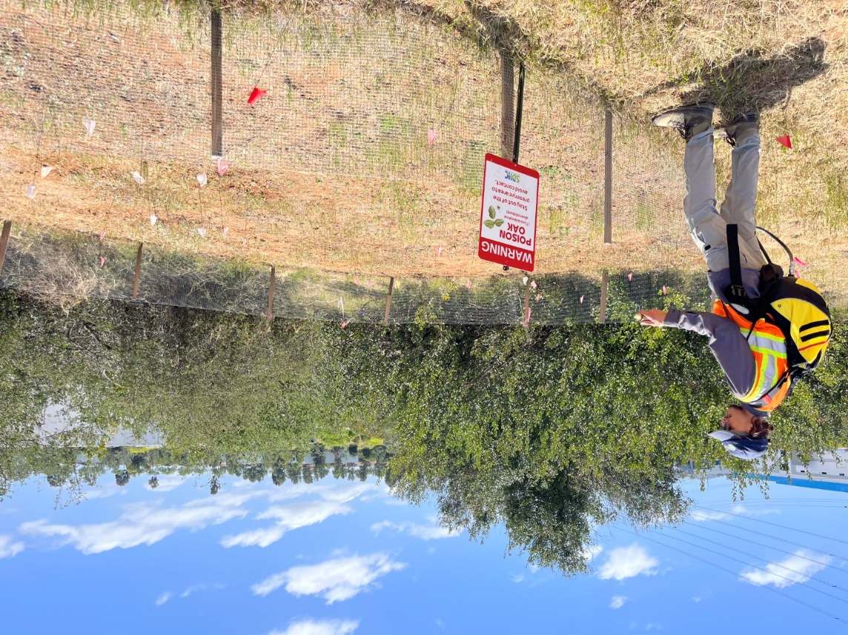
Photo 5. Watering the Carlsbad Raceway Enhancement Area (May 14, 2025)
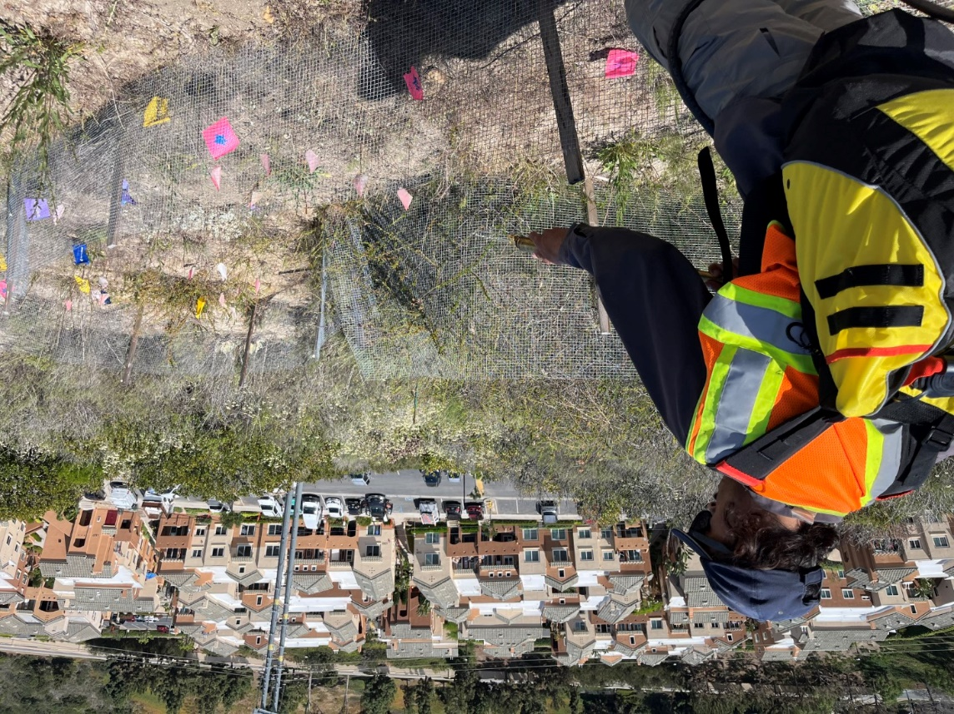
Photo 6. Watering the Emerald Pointe Enhancement Area (May 14, 2025)

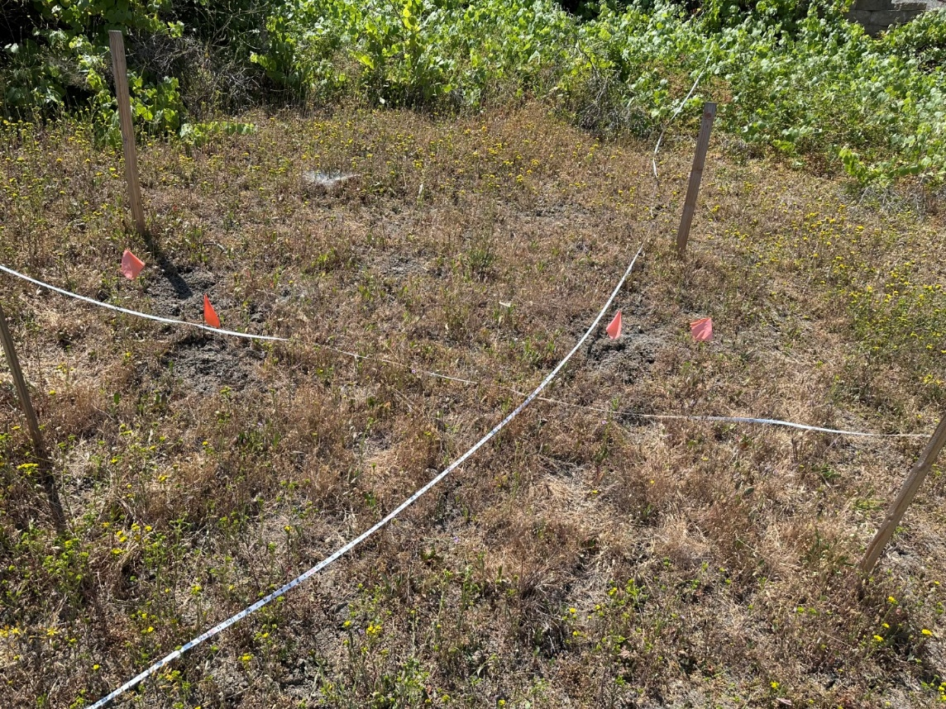
Photo 7. Overview of the Taylor Enhancement Area (May 27, 2025)

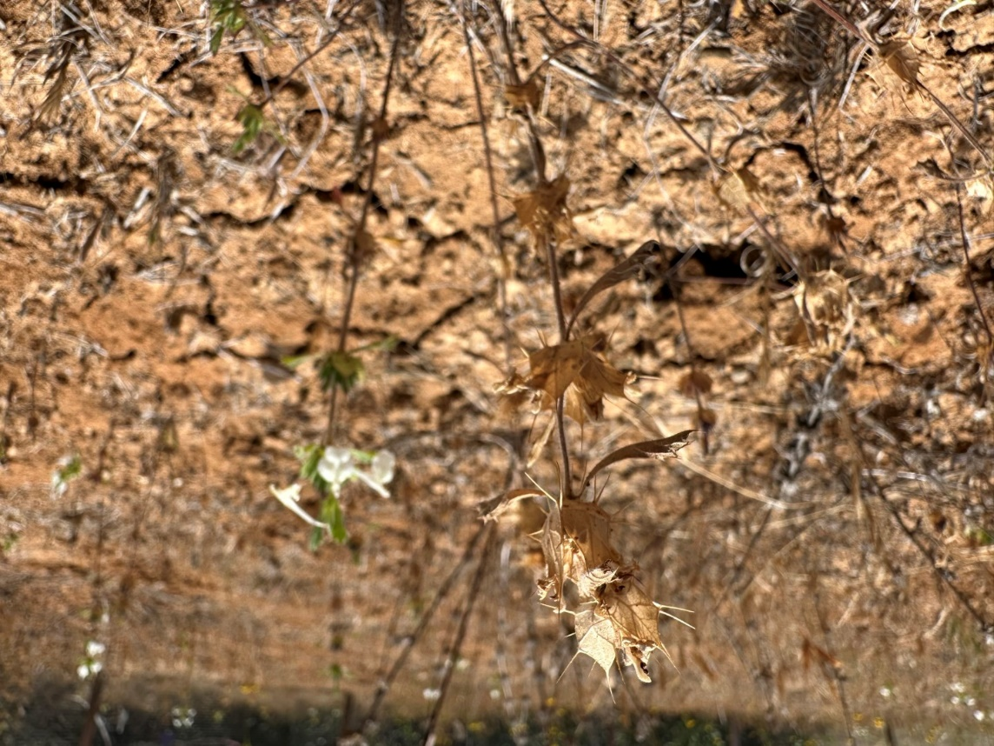
Photo 8. Fruiting and flowering individuals at the Carlsbad Raceway Enhancement Area (June 14, 2025)

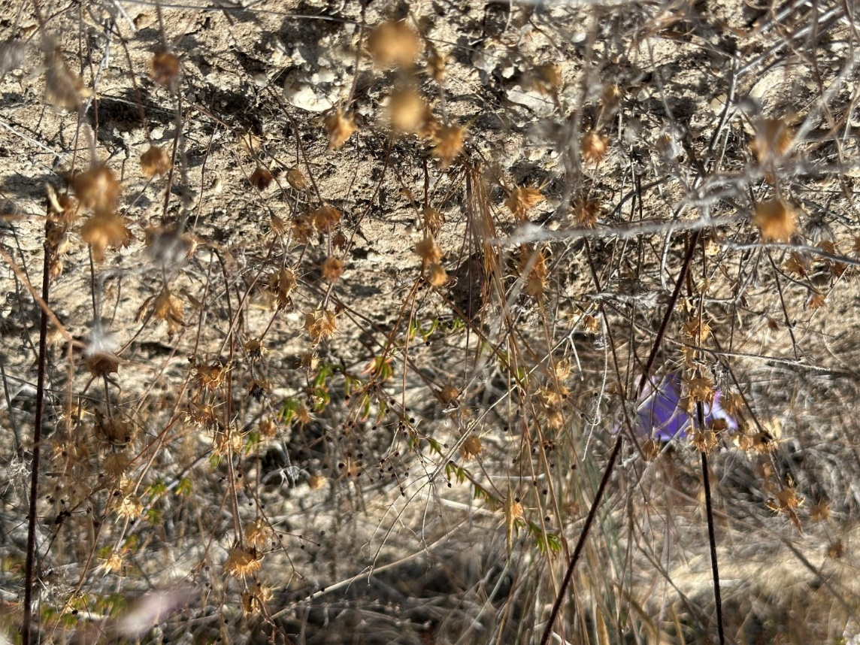
Photo 9. Fruiting individuals at the Emerald Pointe Enhancement Area (June 14, 2025)

SDMMP Project Page
To receive reimbursement for work conducted within the quarter, submission of Quarterly Progress, Annual, and Final Reports must be added to your project’s Project Page on the SDMMP website. Add any necessary photographs to the photo carousal and fill out the photograph information. Please contact Sarah McCutcheon (smccutcheon@usgs.gov) or Emily Perkins (eperkins@usgs.gov) if you are having trouble accessing or editing your project page.

Performance Measures
Please include the Project’s Performance Measures for each Quarterly Invoice and Progress Report in order to receive reimbursement.
Performance Measures-San Diego Thornmint Enhancement Project SDHC_2025

