San Diego Association of Governments
San Diego Thornmint Enhancement Project
San Diego Habitat Conservancy
Quarterly Progress Report
Reporting Period: July 1 – September 30, 2025
Submission Date: October 17, 2025
SANDAG Contract Number: S1125501

Quarterly Status Report Overview
PLEASE DO NOT CHANGE OR ALTER THE FORMATTING OF THIS DOCUMENT! SANDAG has developed a standardized grant monitoring and tracking program for the Environmental Mitigation Program (EMP) Land Management Grant Program. The purpose is to collect information on individual projects and the grant program as a whole for reporting to the Regional Habitat Conservation Taskforce, SANDAG Policy Advisory Committees, and the SANDAG Board of Directors. SANDAG monitors grantees through invoices, progress reports, performance measures, and designated photograph points. These standardized reporting templates and instructions for submittal are included below.

Work Performed this Period:

Task 1- ACIL Monitoring
No monitoring activities were performed during this period, due to the populations of ACIL reaching going to seed in June. This task is 78% complete.

Task 2- Invasive Control in surrounding ACIL areas
No maintenance events were conducted during this reporting period due to the lack of weed species present. This task is 77% complete.

Task 3- Reporting and Invoicing
A quarterly progress report and invoice for the April 1-June 30, 2025 reporting period was prepared and submitted on July 17, 2025. The SDMMP website project page was also updated. This task is 85% complete.

Task 4- Administrative
Administrative tasks included internal coordination. This task is 96% complete.

Work Anticipated Next Period

For the next reporting period, from October 1 to December 31, 2025, SDHC anticipates the following tasks will occur:

- Additional seeding of the San Diego Thornmint at the three enhancement sites and removal of weeds will be performed as needed.

Issues to Note
There are no issues to note during this reporting period.

Photographs & Figures

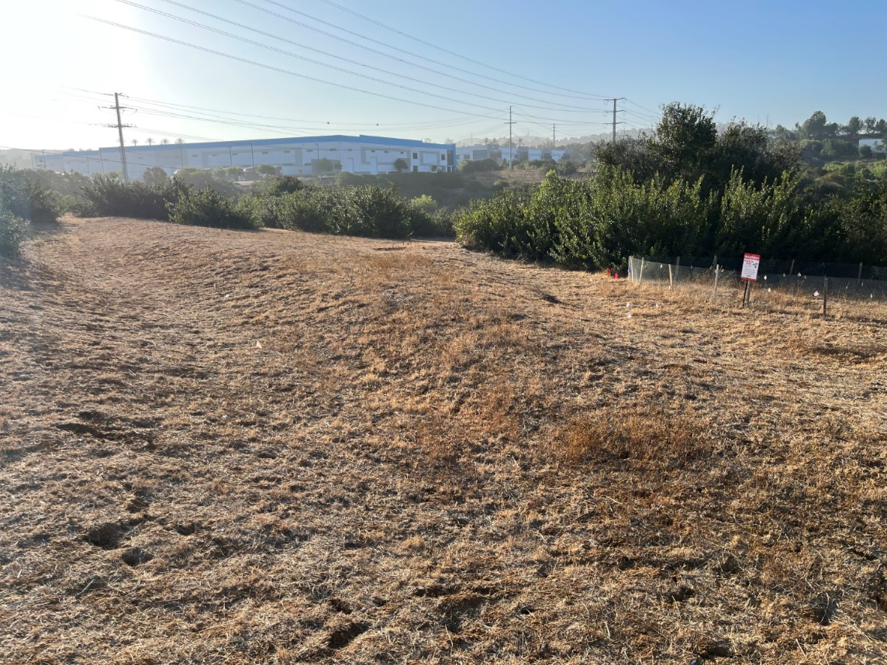
Photo 1. View of the area surrounding the Carlsbad Raceway Enhancement Area (September 3, 2025)
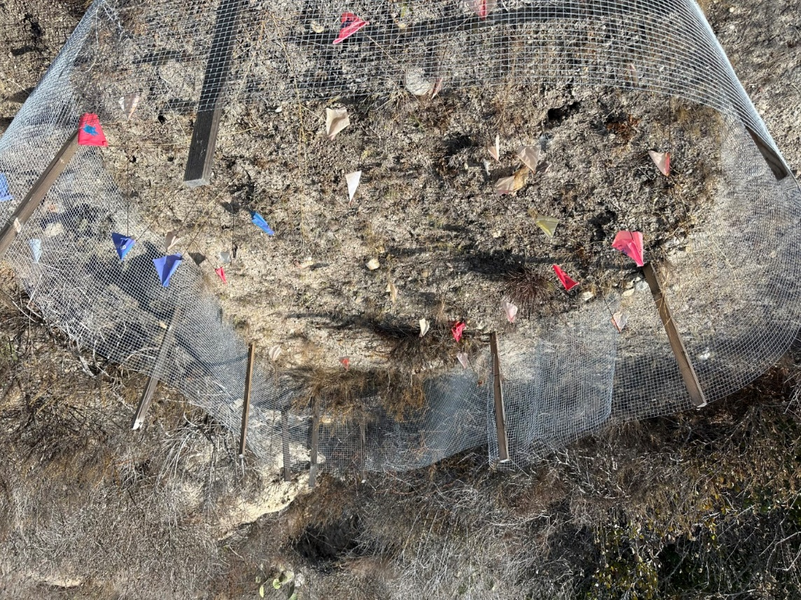
Photo 2. View of the southern fenced area at the Emerald Pointe Enhancement Area (September 19, 2025)

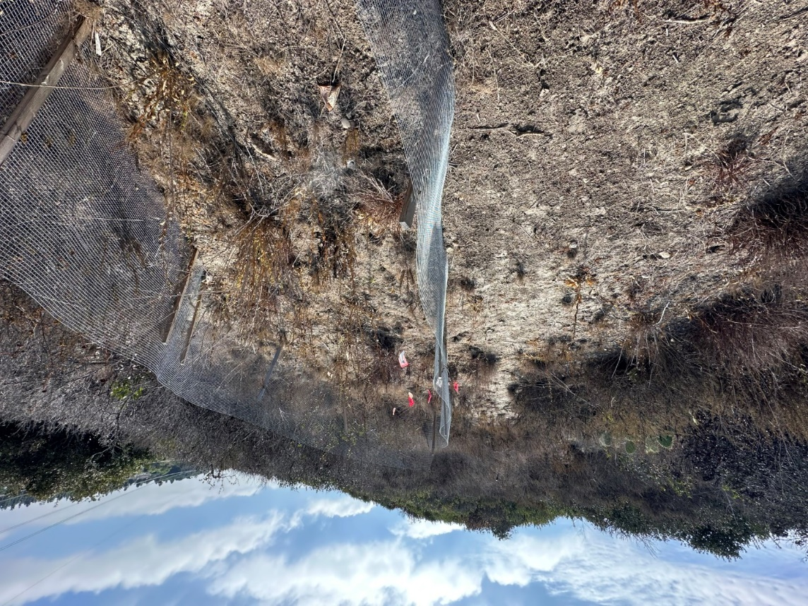
Photo 3. View of the northern fenced area at the Emerald Pointe Enhancement Area (September 19, 2025)
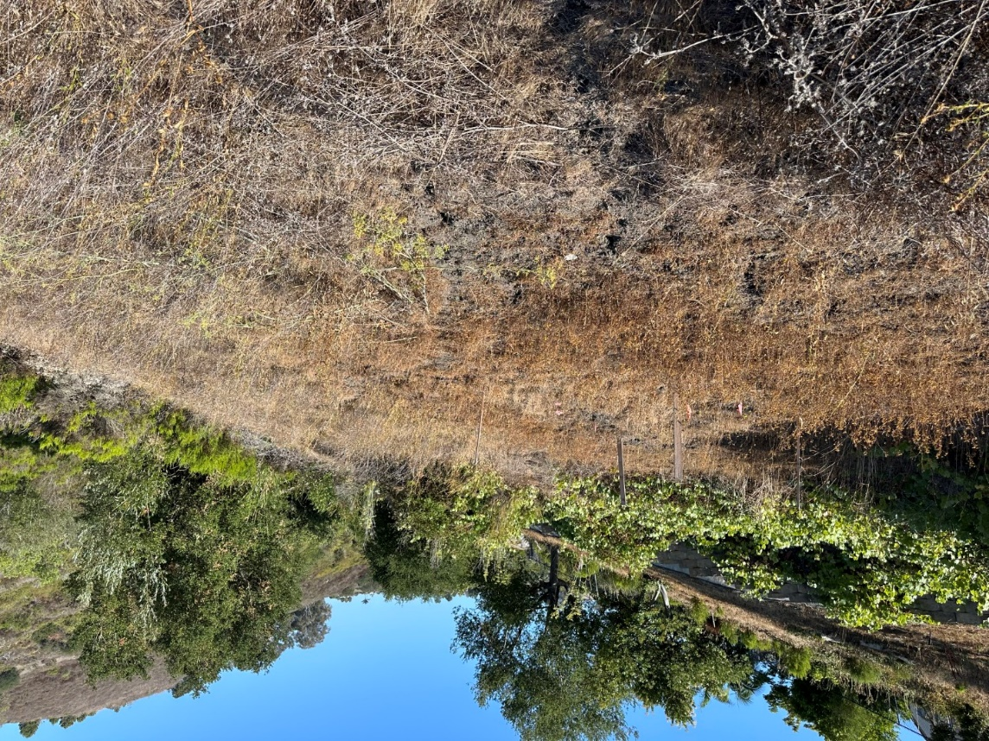
Photo 4. View of the Taylor Enhancement Area (August 5, 2025)

SDMMP Project Page
To receive reimbursement for work conducted within the quarter, submission of Quarterly Progress, Annual, and Final Reports must be added to your project’s Project Page on the SDMMP website. Add any necessary photographs to the photo carousal and fill out the photograph information. Please contact Sarah McCutcheon (smccutcheon@usgs.gov) or Emily Perkins (eperkins@usgs.gov) if you are having trouble accessing or editing your project page.

Performance Measures
Please include the Project’s Performance Measures for each Quarterly Invoice and Progress Report in order to receive reimbursement.
Performance Measures-San Diego Thornmint Enhancement Project SDHC_2025

