San Diego Association of Governments
San Diego Thornmint Enhancement Project
San Diego Habitat Conservancy
Quarterly Progress Report
Reporting Period: October 1 – December 31, 2025
Submission Date: January 15, 2025
SANDAG Contract Number: S1125501

Quarterly Status Report Overview
PLEASE DO NOT CHANGE OR ALTER THE FORMATTING OF THIS DOCUMENT! SANDAG has developed a standardized grant monitoring and tracking program for the Environmental Mitigation Program (EMP) Land Management Grant Program. The purpose is to collect information on individual projects and the grant program as a whole for reporting to the Regional Habitat Conservation Taskforce, SANDAG Policy Advisory Committees, and the SANDAG Board of Directors. SANDAG monitors grantees through invoices, progress reports, performance measures, and designated photograph points. These standardized reporting templates and instructions for submittal are included below.

Work Performed this Period:

Task 1- ACIL Monitoring
On November 14th, 2025, SDHC added more San Diego Thornmint seed (collected in 2023) within the Enhancement Areas on the three preserves: Carlsbad Raceway, Emerald Pointe, and Taylor. The approximate amounts were applied to each preserve, respectively: 3/8 teaspoon, 3/8 teaspoon, and 1/8 teaspoon. The seed was scattered in areas with divots and near native vegetation that could shelter thornmint germinants. The seeding event was timed to occur following a minor rain event and just before another significant rain event (greater than 1/2 inch). Prior to seeding, there were roughly 15.3 grams of seed (roughly 4 teaspoons of seed). Note that the remaining thornmint seed (roughly 3-1/8 teaspoons) is being stored at SDHC’s office freezer for future seed installments.
Per recommendations from botanical consultant, Jessie Vinje of Sage Vinje Biological, SDHC will water the seedlings until the majority of the populations are fruiting. SDHC began watering in December, following the precipitation received in November. The three sites were watered on December 5th, Carlsbad Raceway and Emerald Pointe on 15th, and Taylor on the 17th with roughly 1.5 to 2 gallons of water applied to each Enhancement Area. Watering was not performed for the remainder of the 2025 year due to significant rainfall. This task is 81% complete.

Task 2- Invasive Control in surrounding ACIL areas
No maintenance events were conducted during this reporting period due to the lack of weed species present. However, nonnative grass, specifically Brachypodium distachyon, is germinating at Carlsbad Raceway, so treatment will be performed soon. This task is 77% complete.

Task 3- Reporting and Invoicing
A quarterly progress report and invoice for the July 1-September 30, 2025 reporting period was prepared and submitted on October 17, 2025. The SDMMP website project page was not able to be updated during that time due to the federal government shutdown, but will be updated with this report. This task is 88% complete.

Task 4- Administrative
Administrative tasks included internal coordination. This task is 96% complete.

Work Anticipated Next Period

For the next reporting period, from January 1 to March 31, 2026, SDHC anticipates the following tasks will occur:

- Continued watering of the three Enhancement Areas, as needed (to maintain moisture between rain events) until the majority of thornmint individuals fruit in each population.

- Removal of Brachypodium distachyon within and near the Carlsbad Raceway Enhancement Area and removal of weeds at the other two preserves as needed.

Issues to Note
At Carlsbad Raceway, signs of trespasser use were noted nearby but within the Enhancement Area. Additional security measures will be considered if issues persist.

Photographs & Figures

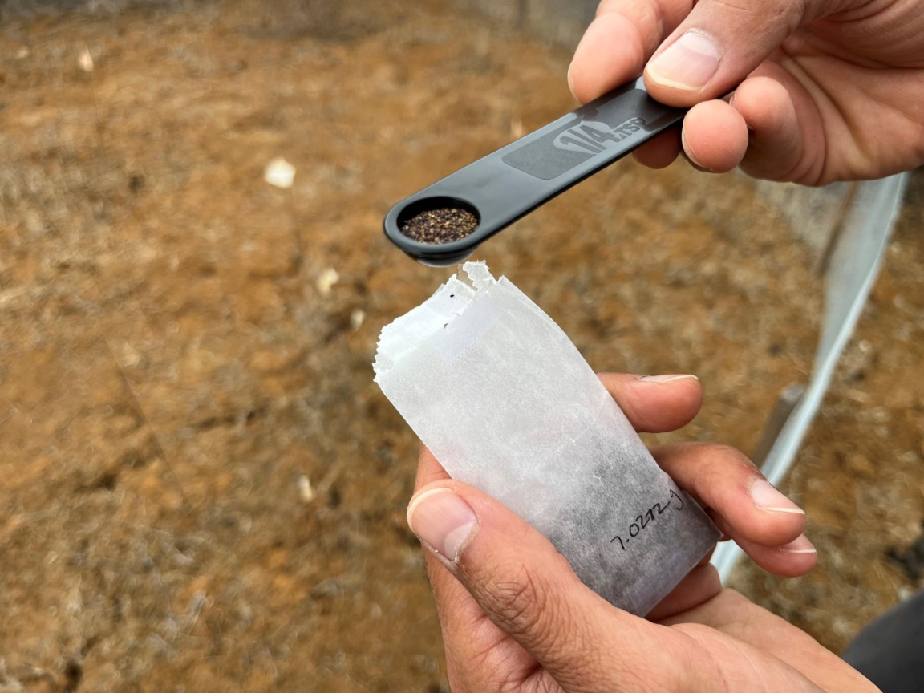
Photo 1. Scooping seed to spread at the Carlsbad Raceway Enhancement Area (November 14, 2025)

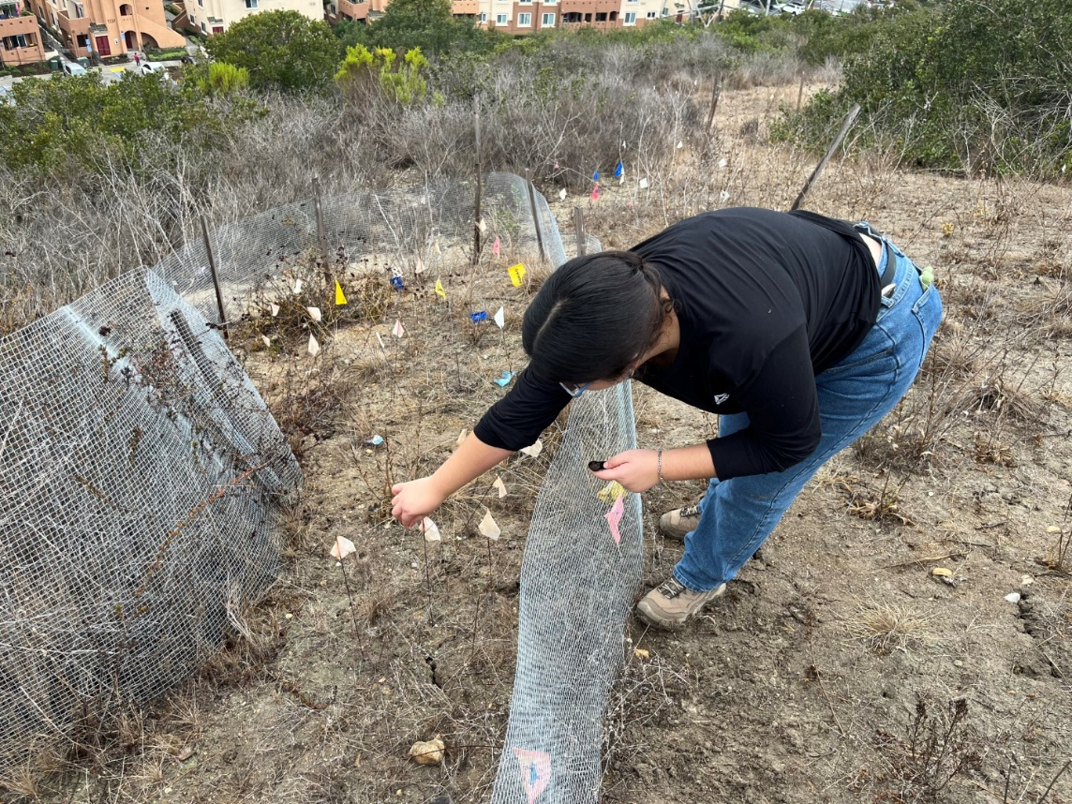
Photo 2. Spreading seed in the Emerald Pointe Enhancement Area (November 14, 2025)
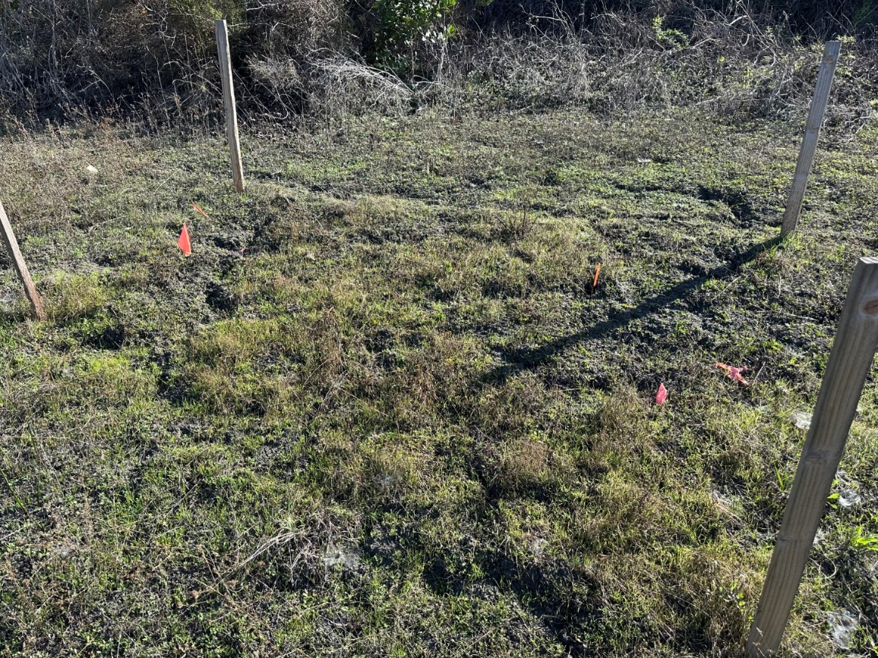
Photo 3. Overview of the Taylor Enhancement Area (December 17, 2025)
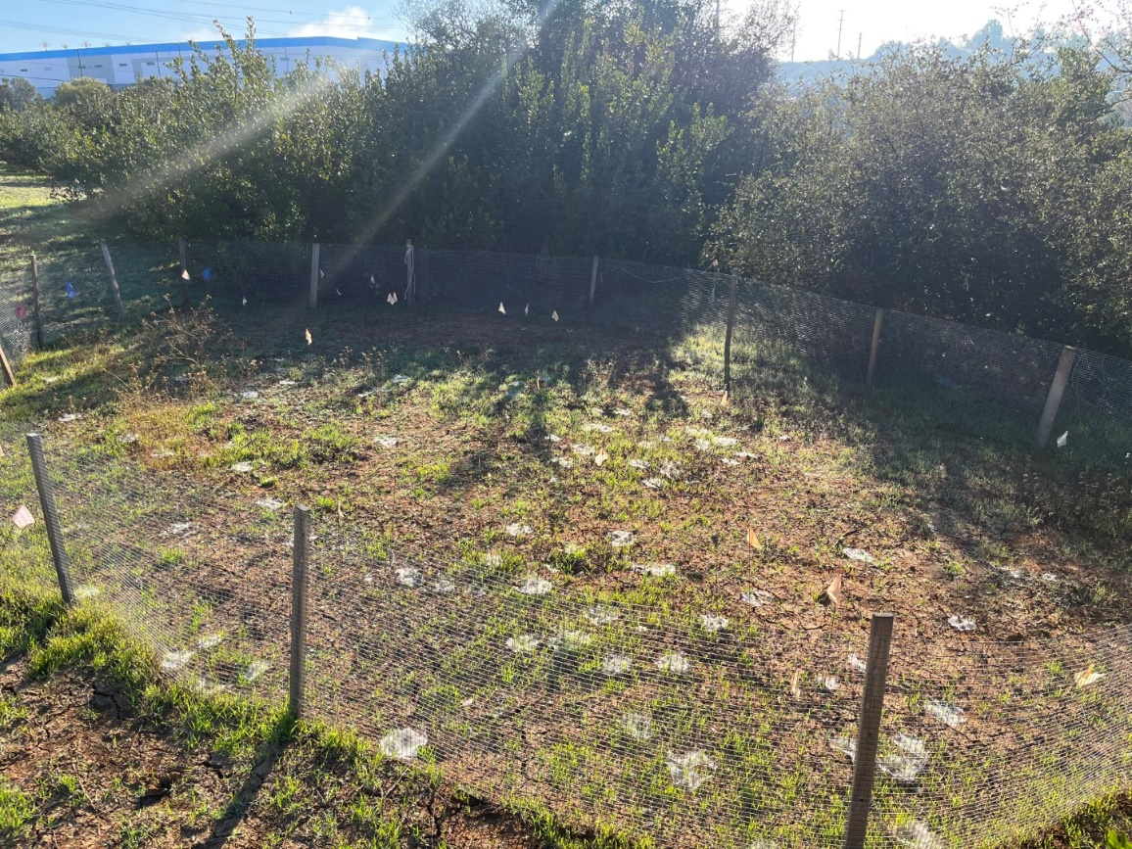
Photo 4. Overview of the Carlsbad Raceway Enhancement Area (December 15, 2025)
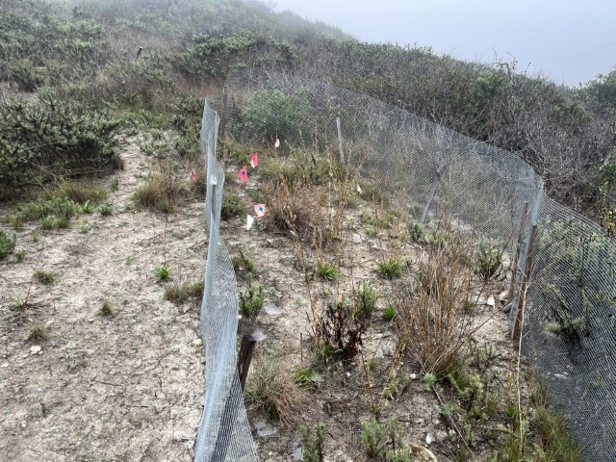
Photo 5. Overview of the Emerald Pointe Enhancement Area (December 15, 2025)

SDMMP Project Page
To receive reimbursement for work conducted within the quarter, submission of Quarterly Progress, Annual, and Final Reports must be added to your project’s Project Page on the SDMMP website. Add any necessary photographs to the photo carousal and fill out the photograph information. Please contact Sarah McCutcheon (smccutcheon@usgs.gov) or Emily Perkins (eperkins@usgs.gov) if you are having trouble accessing or editing your project page.

Performance Measures
Please include the Project’s Performance Measures for each Quarterly Invoice and Progress Report in order to receive reimbursement.
Performance Measures-San Diego Thornmint Enhancement Project SDHC_2025

