San Diego Association of Governments
San Diego Thornmint Enhancement Project
San Diego Habitat Conservancy
Quarterly Progress Report
Reporting Period: January 1 – March 31, 2026
Submission Date: April 21, 2026
SANDAG Contract Number: S1125501

Quarterly Status Report Overview
PLEASE DO NOT CHANGE OR ALTER THE FORMATTING OF THIS DOCUMENT! SANDAG has developed a standardized grant monitoring and tracking program for the Environmental Mitigation Program (EMP) Land Management Grant Program. The purpose is to collect information on individual projects and the grant program as a whole for reporting to the Regional Habitat Conservation Taskforce, SANDAG Policy Advisory Committees, and the SANDAG Board of Directors. SANDAG monitors grantees through invoices, progress reports, performance measures, and designated photograph points. These standardized reporting templates and instructions for submittal are included below.

Work Performed this Period:

Task 1- ACIL Monitoring
During this quarter, SDHC staff and HELIX biologist, Jonathon Mercado, visited the three San Diego Thornmint Enhancement Areas weekly to monitor for germination of thornmint and nonnative plants, and to hand weed and apply supplemental watering, as needed. Monitoring visits were skipped during weeks of significant rainfall (over ½ inch) to avoid soil disturbance.
Per recommendations from botanical consultant, Jessie Vinje of Sage Vinje Biological, supplemental water was applied to sites between rain events to promote germination and fruit production. Water was applied to the Enhancement Areas through the use of a backpack water buffalo or other methods to avoid erosion and damage to individuals. SDHC began watering in mid-January following rainfall in early January. Watering continued through the end of March, skipping three weeks due to significant rain events. Watering amounts varied for each site and depended on temperatures, with Carlsbad Raceway and Emerald Pointe receiving 1 to 3 gallons, and Taylor receiving 0.5 to 2 gallons. During this period, 1,500 individuals were estimated to be growing at Carlsbad Raceway, over 100 at Emerald Pointe, and dozens at Taylor, with several dozen individuals flowering at Carlsbad Raceway and Emerald Pointe.
Nonnative plant presence was documented in each of the Enhancement Areas during this quarter, with the following species present in each preserve; Carlsbad Raceway: Brachypodium distachyon, Brassica nigra, Erodium cicutarium, and Lysimachia arvensis; Emerald Pointe: Lysimachia arvensis and Sonchus sp.; Taylor: Brassica nigra, centaurea melitensis , Erodium cicutarium, Foeniculum vulgare, Helminthotheca echioides, Medicago polymorpha, and Lysimachia arvensis. These species were targeted for removal within the Enhancement Areas during monitoring events. This task is 90% complete.

Task 2- Invasive Control in surrounding ACIL areas
In January, HELIX field staff were contracted to apply grass-specific herbicide to a 0.4-acre area of Brachypodium distachyon immediately outside of the Carlsbad Raceway Enhancement Area (with a 20-foot buffer). This task is 97% complete.

Task 3- Reporting and Invoicing
A quarterly progress report and invoice for the October 1-December 31, 2025 reporting period was prepared and submitted on January 15, 2026. The SDMMP website project page was also updated with this report. This task is 95% complete.

Task 4- Administrative
Administrative tasks included internal coordination. This task is 96% complete.

Work Anticipated Next Period

For the next reporting period, from April 1 to June 30, 2026, SDHC anticipates the following tasks will occur:

- Continued watering of the three Enhancement Areas, as needed (to maintain moisture between rain events) until the majority of thornmint individuals fruit in each population.

- Removal of Brachypodium distachyon within and near the Carlsbad Raceway Enhancement Area and removal of weeds at the other two preserves as needed.

Issues to Note
Invasive plant growth has been observed in areas adjacent to the enhancement areas at Carlsbad Raceway and Taylor, particularly from Brassica nigra.

Photographs & Figures

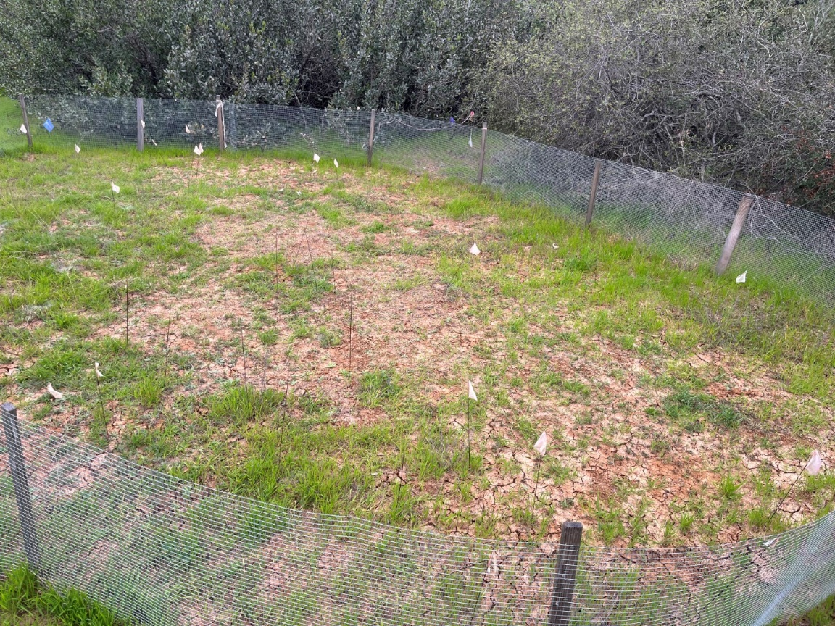
Photo 1. Overview of Carlsbad Raceway Enhancement Area (February 5, 2026)

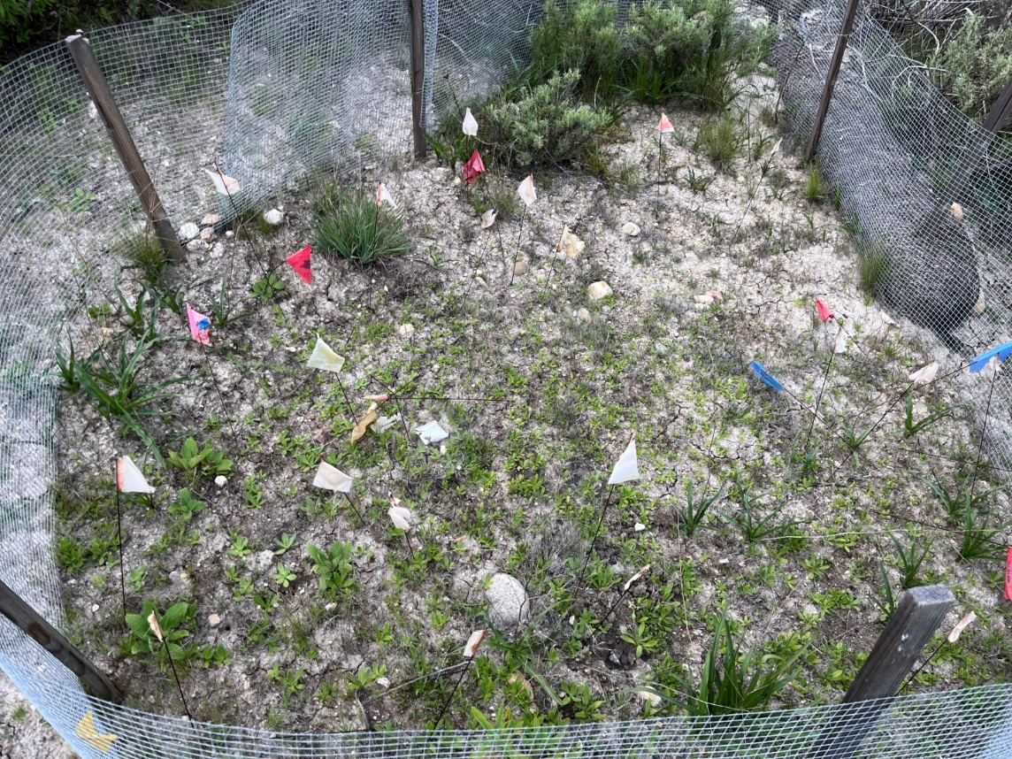
Photo 2. Overview of Emerald Pointe Enhancement Area (February 5, 2026)
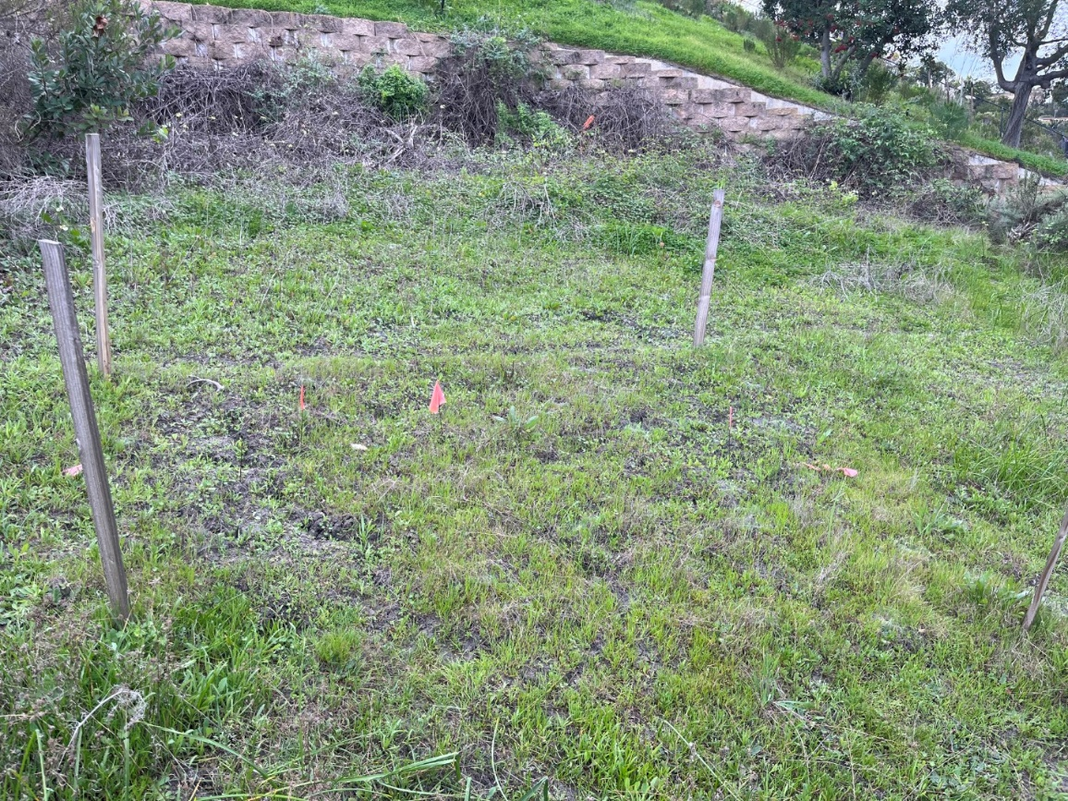
Photo 3. Overview of the Taylor Enhancement Area (February 5, 2026)
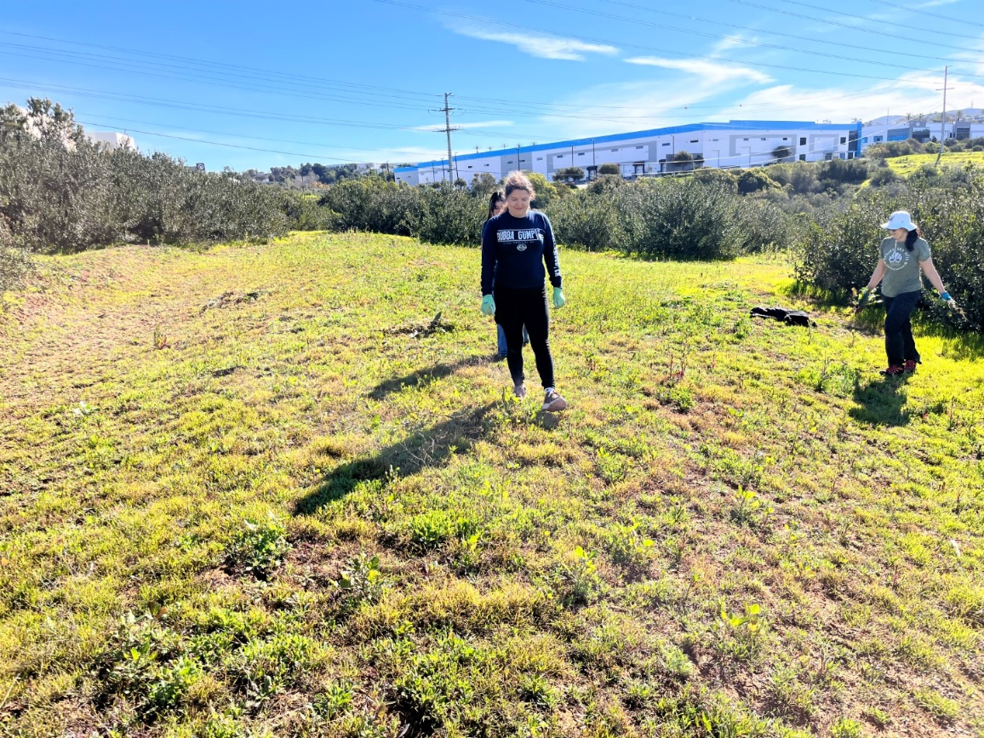
Photo 4. Volunteers hand weeding mustard outside the Carlsbad Raceway Enhancement Area (February 24, 2026)
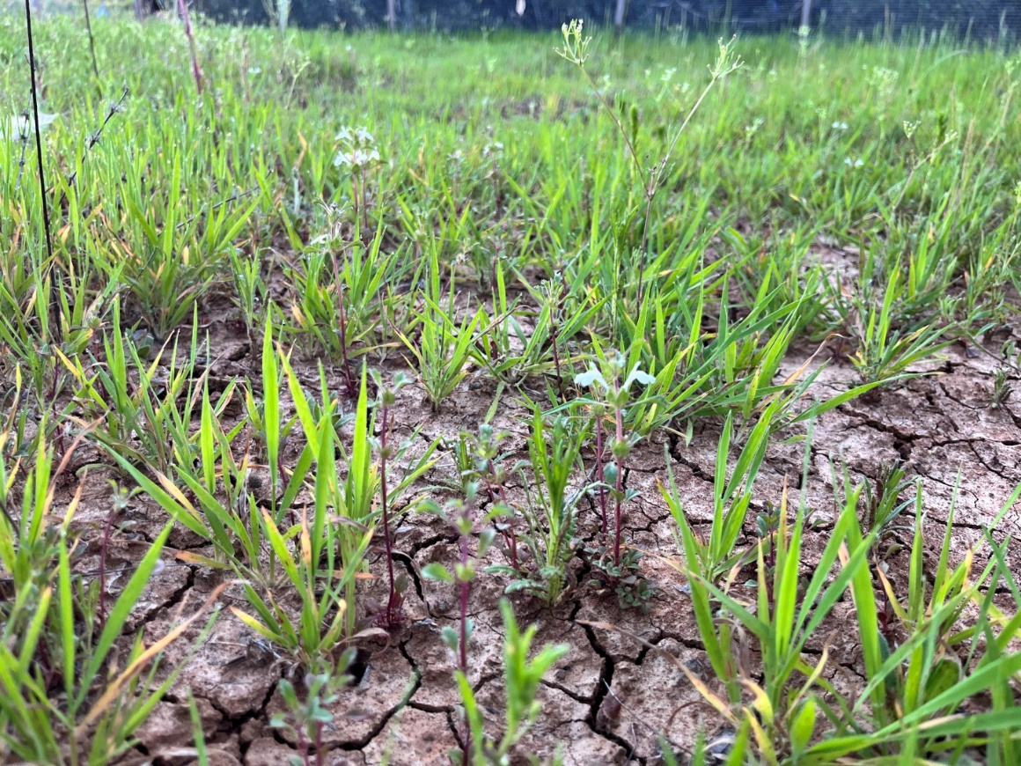
Photo 5. Flowering thornmint at Carlsbad Raceway Enhancement Area (March 13, 2026)

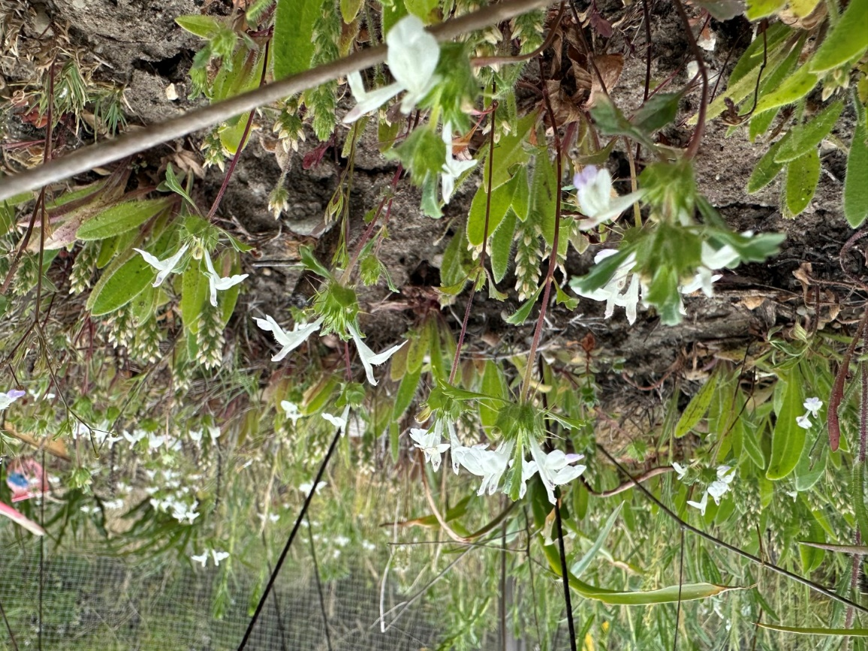
Photo 6. Flowering thornmint at Emerald Pointe Enhancement Area (March 31, 2026)
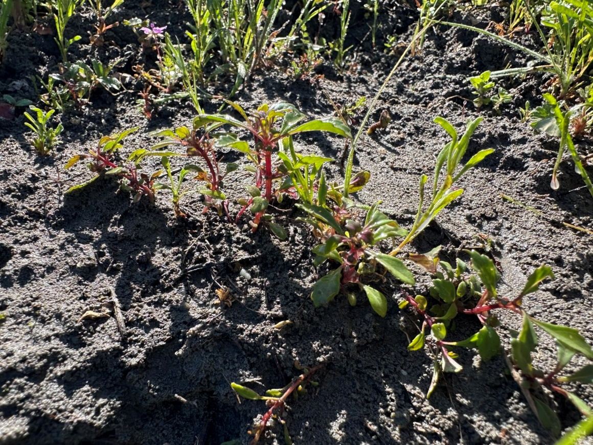
Photo 7. Thornmint individuals at Taylor Enhancement Area (March 11, 2026)

SDMMP Project Page
To receive reimbursement for work conducted within the quarter, submission of Quarterly Progress, Annual, and Final Reports must be added to your project’s Project Page on the SDMMP website. Add any necessary photographs to the photo carousal and fill out the photograph information. Please contact Sarah McCutcheon (smccutcheon@usgs.gov) or Emily Perkins (eperkins@usgs.gov) if you are having trouble accessing or editing your project page.

Performance Measures
Please include the Project’s Performance Measures for each Quarterly Invoice and Progress Report in order to receive reimbursement.
Performance Measures-San Diego Thornmint Enhancement Project SDHC_2026

