San Diego Association of Governments
Stinknet Removal II Project
San Diego Zoo Wildlife Alliance (SDZWA)
Quarterly Progress Report
Reporting Period: October 1 – December 31, 2023
Submission Date: January 22, 2024
SANDAG Contract Number: S1125508

Quarterly Status Report Overview
PLEASE DO NOT CHANGE OR ALTER THE FORMATTING OF THIS DOCUMENT! SANDAG has developed a standardized grant monitoring and tracking program for the Environmental Mitigation Program (EMP) Land Management Grant Program. The purpose is to collect information on individual projects and the grant program as a whole for reporting to the Regional Habitat Conservation Taskforce, SANDAG Policy Advisory Committees, and the SANDAG Board of Directors. SANDAG monitors grantees through invoices, progress reports, performance measures, and designated photograph points. These standardized reporting templates and instructions for submittal are included below.

Work Performed this Period:

Task 1- Stinknet removal
Work start: October 23, 2023
% complete: 16.7
- New Research Coordinator. Thanks to SANDAG EMP funding, we hired Research Coordinator Madison Wilson. Madison will manage aspects of the planning and implementation of both stinknet treatments, and the restoration project funded by this grant.
- Fall pre-emergent weed treatment. SDZWA staff with a crew of two weed management specialists from Black Sage Environmental conducted pre-emergent treatments in the Biodiversity Reserve. The crew treated 14 acres with Gallery SC, a pre-emergent annual broadleaf specific herbicide. Pre-emergent treatments focused on roadsides in the Biodiversity Reserve and other high-traffic areas in the Safari Park.
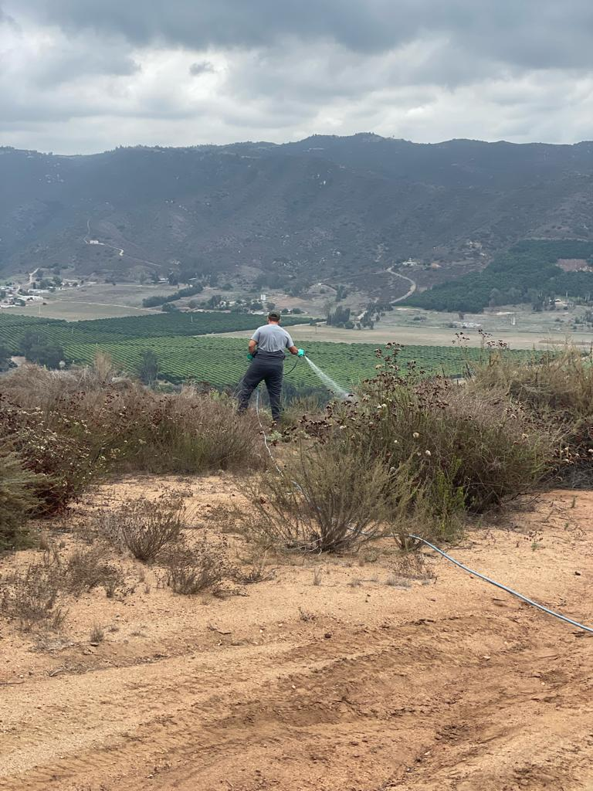
Figure 1: Black Sage Environmental (BSE) crew treating stinknet-infested roadsides in the Biodiversity Reserve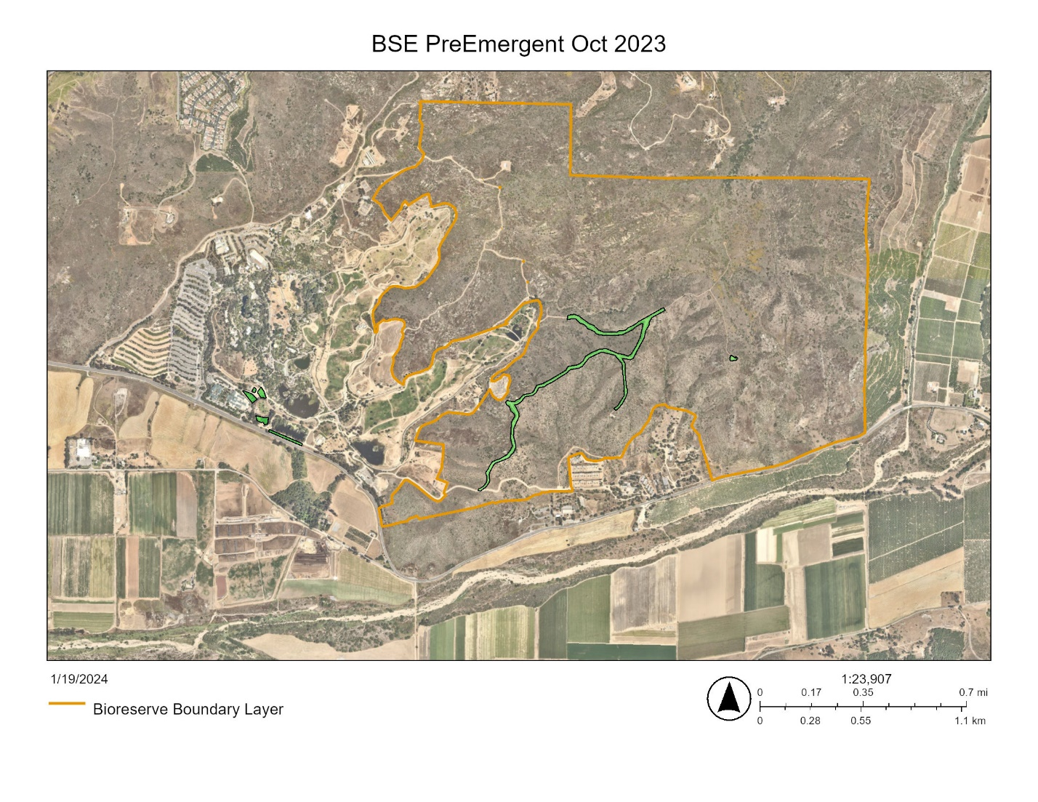Figure 2: Map showing Fall 2023 stinknet pre-emergent treatment areas (green).

Task 2- Restoration planning and implementation
Work start: October 1, 2023
% complete: 8.3
- Seed collection with San Pasqual Environmental Wellness Ambassadors (EWA) and seed processing. We held a native seed collection day with youth from the San Pasqual Band’s EWA, an environmental stewardship after-school program. With facilitators from the SDZWA Seed Bank, 16 participants (12 students and 4 chaperones) collected chia (Salvia columbariae), wild carrot (Daucus pusillus), and lance-leaf dudleya (Dudleya lanceolata) seeds in the Biodiversity Reserve. At the SDZWA Seed Bank, participants learned how to clean and store seed.

In Q2, Madison collected an additional 21,000 white sage (Salvia apiana) and 145,000 showy penstemon (Penstemon spectabilis), 40 hollyleaf cherry (Prunus ilicifolia) and 60,000 blue dicks (Dichelostemma capitatum) seeds. We will use the seeds to repopulate the native seed bank in the OBF.
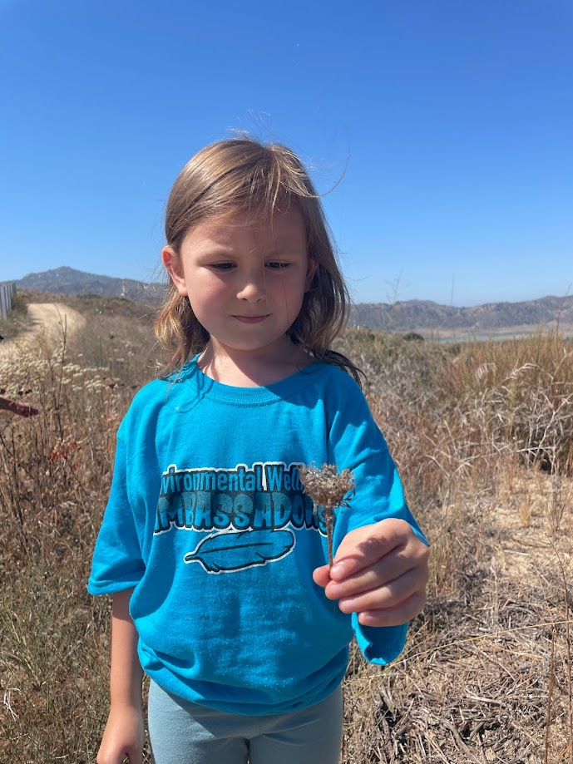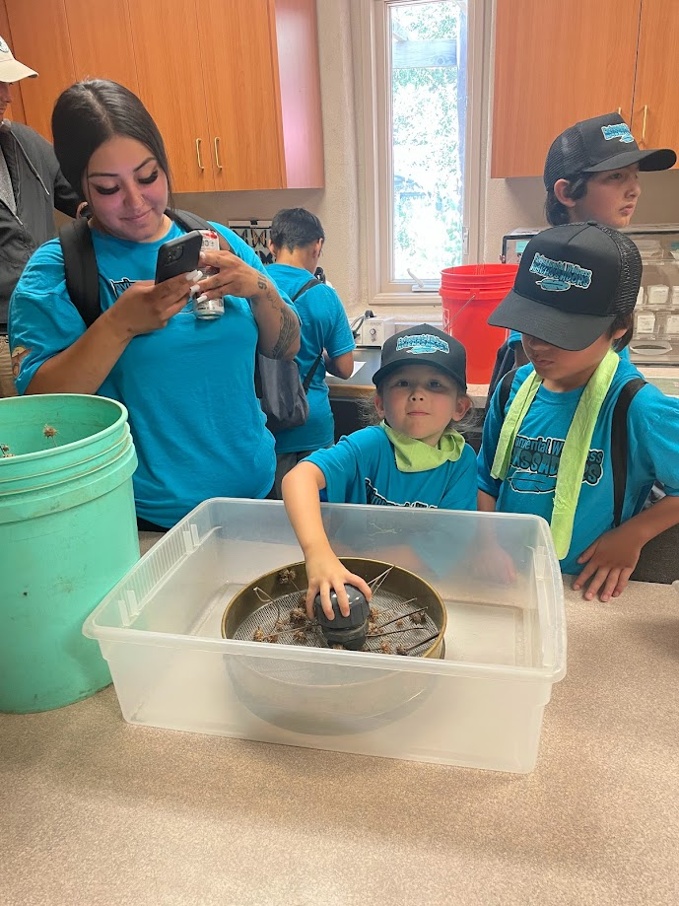
Figure 3: Seed collection participants from the San Pasqual Band of Mission Indian’s Environmental Wellness Ambassadors, a youth program of San Pasqual’s Environmental Department.
- Volunteer day. On December 8, we hosted 10 SDZWA volunteers for a day in the field collecting Russian thistle (Salsola tragus) biomass for composting in the Old Browse Farm (OBF) restoration area. The California Invasive Plant Council rates Russian thistle as Limited- invasive, but with minor ecological impacts. In 2023, however, Russian thistle emerged as a successional weed in the OBF, following removal of stinknet, with some plants reaching over a meter square. We removed dead Russian thistle plants with pitchforks, clearing space for other plants to grow and preparing the area for further restoration work.
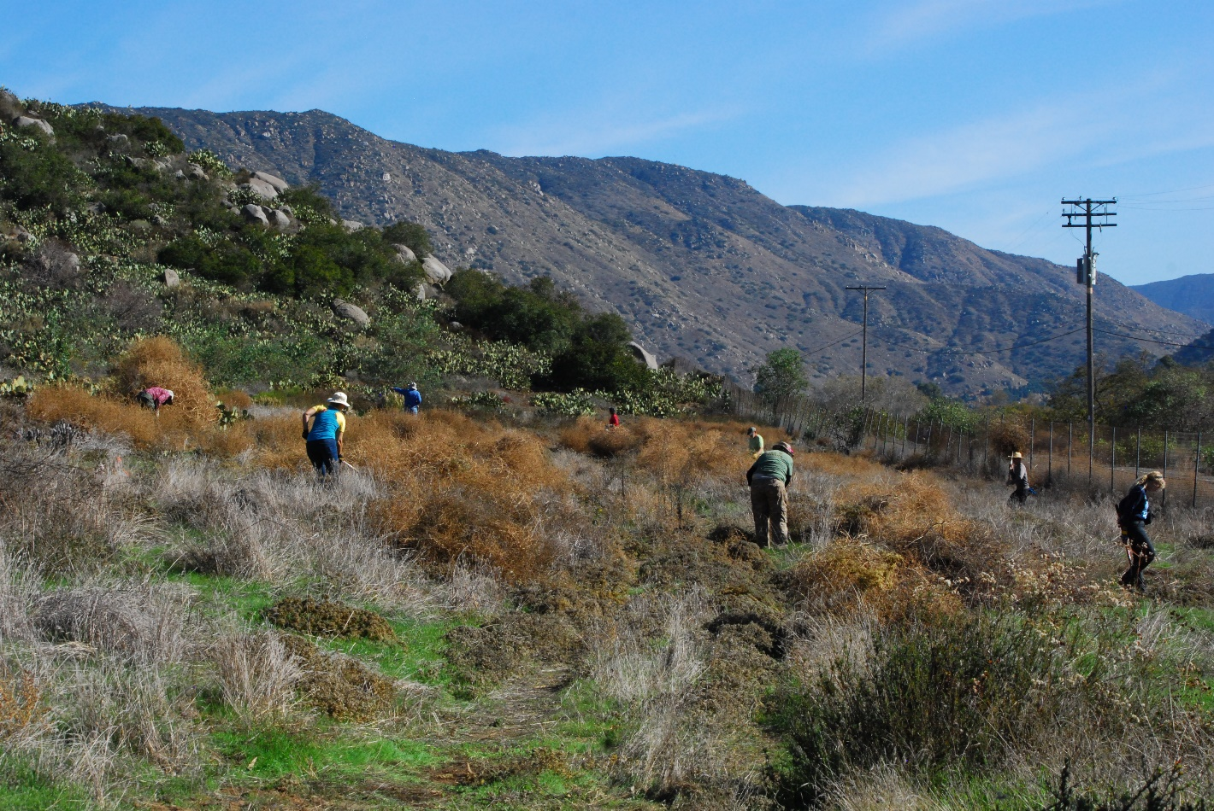Figure 4: Volunteers remove dead Russian thistle from the Old Browse Farm restoration area.
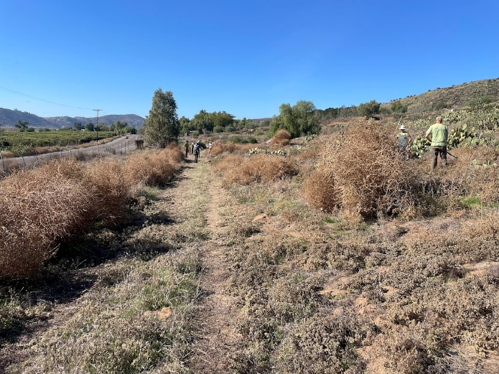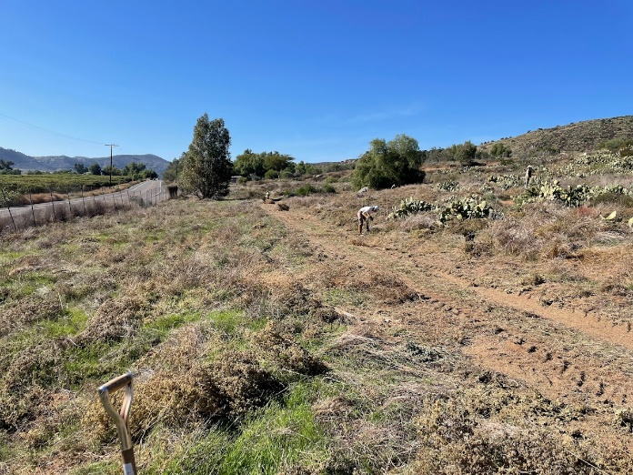
Figure 5: Before and after Russian thistle biomass removal.
- Photo points. We established additional locations for photo points to track restoration progress in the OBF. We also created a cellphone camera bracket system to standardize photos at each location. The brackets were designed by Madison in CAD and created on a 3D printer in SDZWA’s Conservation Technology Lab.
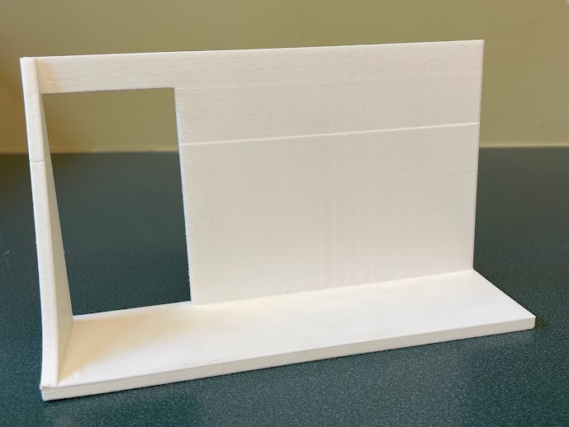
Figure 6: Photo point cell camera bracket, designed in CAD and created on a 3D printer.

Task 3- Administrative
- ArcGIS Story Maps. We created two story maps in ArcGIS. The first shows polygons of each stinknet treatment, starting in 2019, with acreages over time. The second story map takes the viewer to each photo point, with 4-5 photos per station showing seasonal changes and vegetation changes due to stinknet management.
  - Oncosiphon in the Biodiversity Reserve
  - San Diego Zoo Safari Park Biodiversity Reserve: A photo tour through the seasons
Work start: October 1, 2023
% complete: 8.3

Provide the exact work start date, a description of the work completed under each task, and percent complete. Add additional tasks as necessary.

Work Anticipated Next Period
This does not need to be task specific but should include a short paragraph or bullet point list of activities anticipated for next quarter.

In Q3 2024, we will:
- Spot treat stinknet in management area
- Begin plant propagation with seed collected in the Biodiversity Reserve
- Hold a collaborative planning meeting with tribal partners
- Hand pull weeds in the OBF
- Install photo point posts and brackets in the Biodiversity Reserve

Issues to Note
Please provide a brief description of any issue(s) encountered during the reporting period and any steps taken to address the issue(s).

We had no issues to note in Q2 2023.

Photographs & Figures
Photographs and figures are invaluable! Please include photos in the Quarterly Progress Reports and any figures (if applicable). Both photos and figures may be included throughout the document under corresponding tasks or at the end following the Issues to Note section. Photographs taken at the same place or photographic points (photo-points) can assist SANDAG staff in tracking the project’s progress over time.
It is required that Photographs include:
- A before and after comparison sequence from the start to the completion of the project for photo points.
- A brief description of the corresponding tasks, date, and activity in the photograph.
- A copy of each photograph included in the report submitted in a .jpeg or .png file format.
It is required that Figures include:
- A caption with a brief description.
SDMMP Project Page
To receive reimbursement for work conducted within the quarter, submission of Quarterly Progress, Annual, and Final Reports must be added to your project’s Project Page on the SDMMP website. Add any necessary photographs to the photo carousal and fill out the photograph information. Please contact Sarah McCutcheon (smccutcheon@usgs.gov) or Emily Perkins (eperkins@usgs.gov) if you are having trouble accessing or editing your project page.

Project Performance Measures Instructions
SANDAG will utilize the SANDAG Performance Measures to document compliance with the Project. Grantee’s performance will be measured against the Performance Measures (Exhibit D) during the term of the project. More details on Performance Measures and Grant Recovery Plans are outlined in the Grant Agreements.
To access the Project Performance Measures Excel Spreadsheet:
- Simply double-click on the Excel icon located under the Project Performance Measures section.
  - An excel sheet will open, please fill out and then click save.
- Once the Excel spreadsheet is saved, please exit Excel and the spreadsheet will automatically update the icon in the Quarterly Progress Report Word document.
When opening the document with the Project Performance Measures Excel Spreadsheet:
- When you first open the Quarterly Progress Report Template, a warning message will open (image of the warning message below)

  - Click Yes to update the links in the document.

Performance Measures
Please include the Project’s Performance Measures for each Quarterly Invoice and Progress Report in order to receive reimbursement.

