San Diego Association of Governments
Stinknet Removal II Project
San Diego Zoo Wildlife Alliance (SDZWA)
Quarterly Progress Report
Reporting Period: January 1 – March 31, 2024
Submission Date: April 21, 2024
SANDAG Contract Number:
S1125508

Quarterly Status Report Overview
PLEASE DO NOT CHANGE OR ALTER THE FORMATTING OF THIS DOCUMENT! SANDAG has developed a standardized grant monitoring and tracking program for the Environmental Mitigation Program (EMP) Land Management Grant Program. The purpose is to collect information on individual projects and the grant program as a whole for reporting to the Regional Habitat Conservation Taskforce, SANDAG Policy Advisory Committees, and the SANDAG Board of Directors. SANDAG monitors grantees through invoices, progress reports, performance measures, and designated photograph points. These standardized reporting templates and instructions for submittal are included below.

Work Performed this Period:

Task 1- Stinknet removal
Work start: January 1, 2024
% complete: 33.4
Activities with grant dollars: B (coordinator labor)
Activities with matching funds: A, B (volunteer labor)
- Spot treat stinknet in management areas. SDZWA Research Coordinator Madison Wilson with a crew of 2-4 weed management specialists from Black Sage Environmental conducted post-emergent spot treatments of stinknet in the Biodiversity Reserve. 10.4 acres were treated with Milestone (aminopyralid), a broadleaf specific herbicide using backpack sprayers. Treatments focused on precise application in established weed management areas in the Biodiversity Reserve, areas treated with pre-emergent in Fall 2023, and areas of the Safari Park with frequent vehicle traffic.
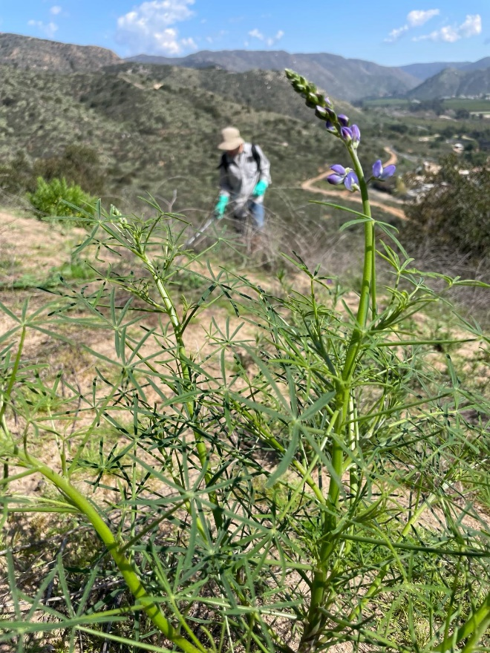
Figure 1. Black Sage Environmental crew applying post-emergent herbicide in the Biodiversity Reserve.
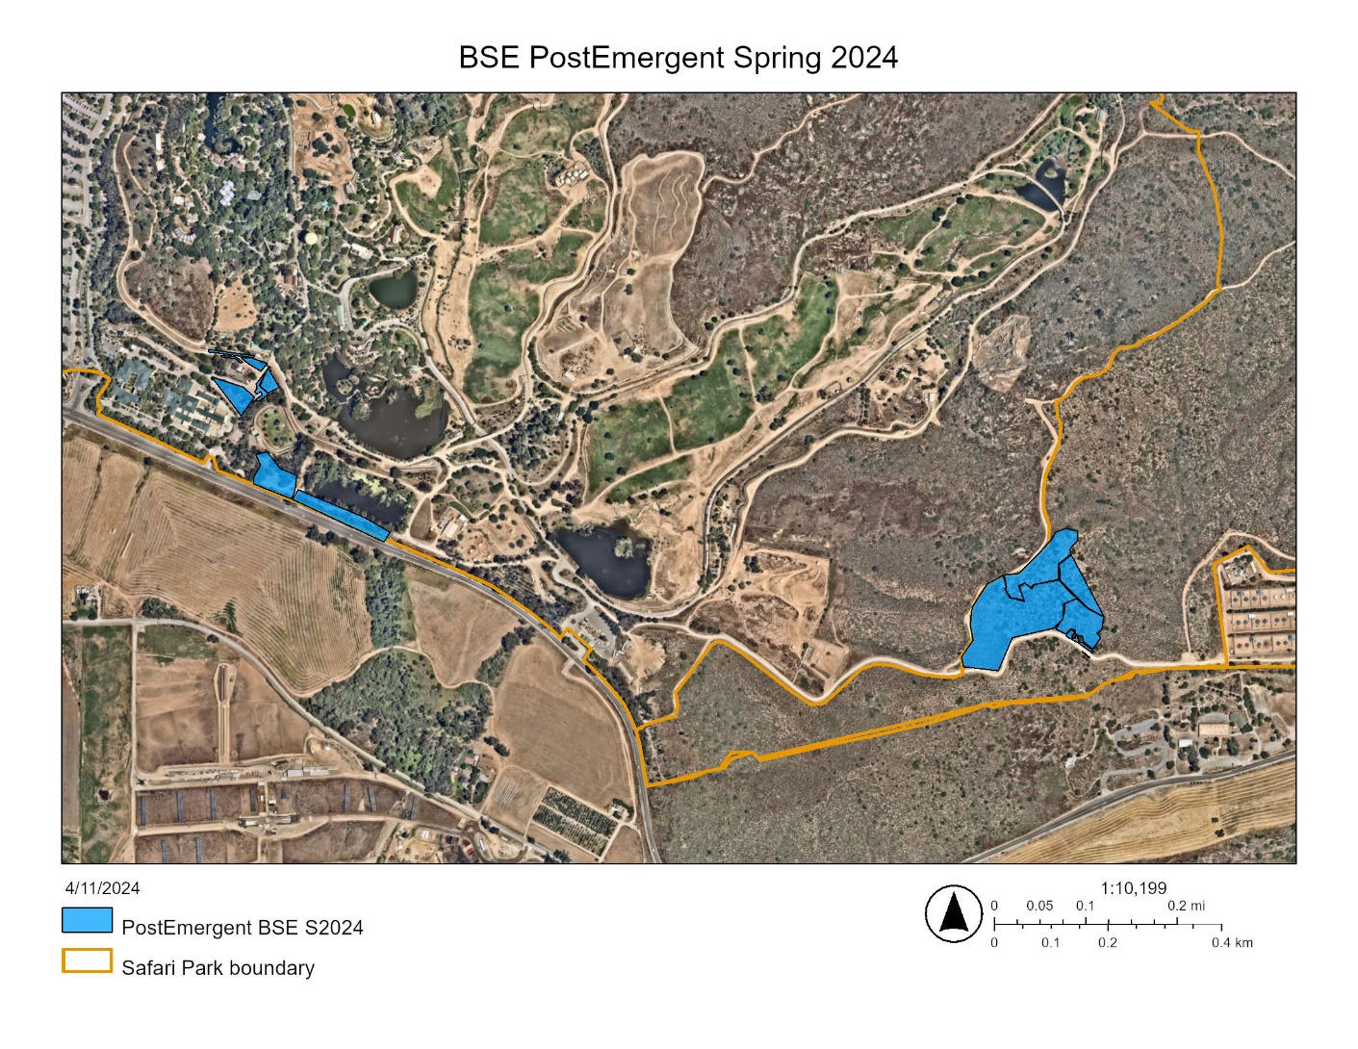
Figure 2. Map of post-emergent treatment areas in Spring 2024 (blue).

- Hand pull weeds in the Old Browse Farm (OBF). Led by SDZWA Research Coordinator Madison Wilson, a crew of volunteers from the American Conservation Experience hand pulled and used hand tools to remove stinknet in 5 acres at the OBF. Additionally, the crew removed Pennisetum setaceum and other invasive weeds from around the SDZWA Propagation Shade House to reduce the spread and introduction of invasive seed.
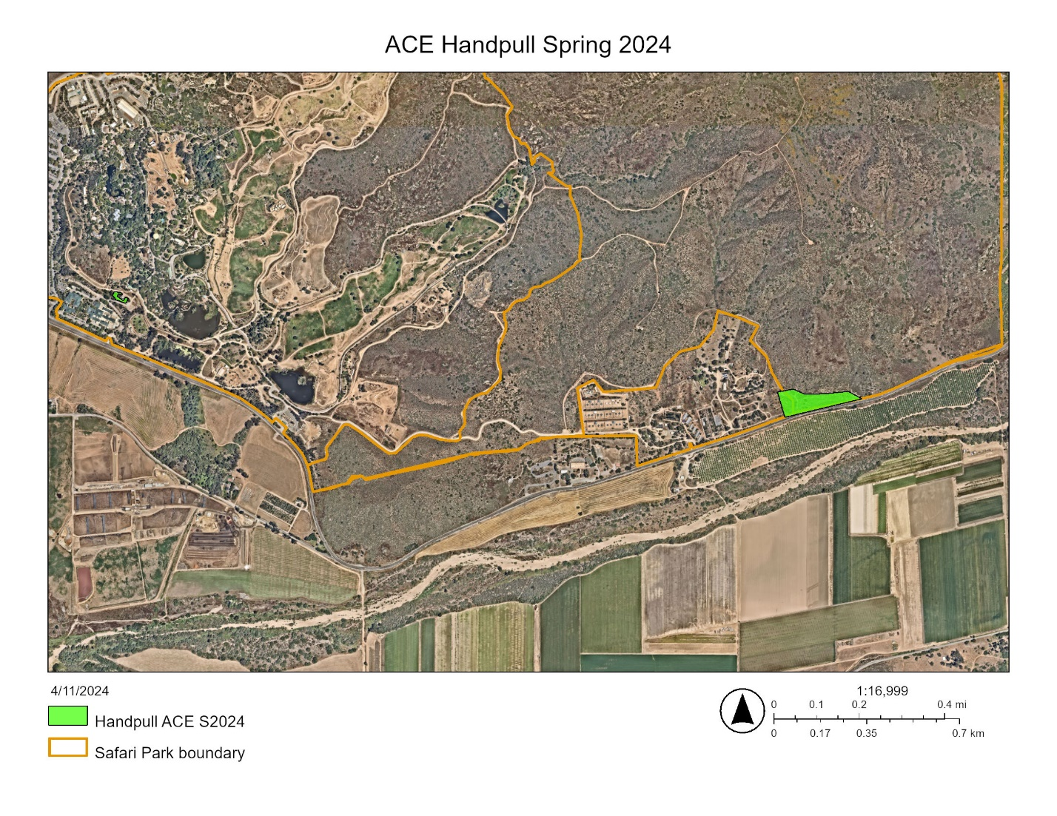
Figure 3. Map of hand removal areas performed by ACE volunteers in the OBF and near the SDZWA Propagation Shade House (green).
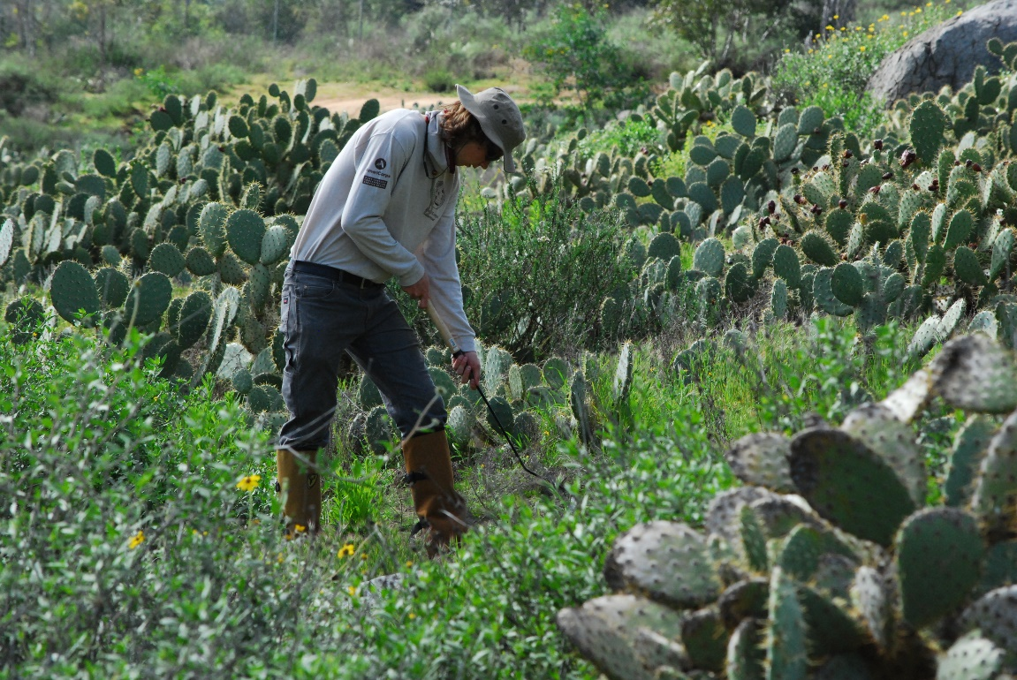
Figure 4. ACE crew member using a hand tool to remove small stinknet plants in the OBF.

Task 2- Restoration planning and implementation
Work start: January 1, 2024
% complete: 16.7
Activities with grant dollars: A, B, C
Activities with matching funds: NA
- Begin plant propagation with seed collected in the Biodiversity Reserve (BDR). Research Coordinator Madison Wilson processed seed from 4 species and propagated 2 species from seeds collected in the BDR and by the San Pasqual Environmental Wellness Ambassadors. Additionally, 8 species were donated by the Seed Bank to the project from germination trials, also collected in the BDR.
  - Species seed processed: Salvia apiana, Penstemon spectabilis, Daucus pusillus, Dudleya pulverulenta
  - Species propagated: Salvia apiana, Prunus illicifolia
  - Species from germination trials: Calochortus weedii var weedii, Calochortus splendens, Crocanthemum scoparium, Phacelia parryi, Lupinus truncatus, Lupinus hirsutissimus, Lupinus concinnus, Helianthus annus

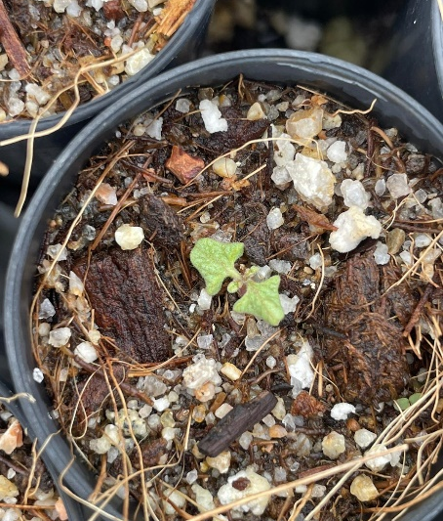
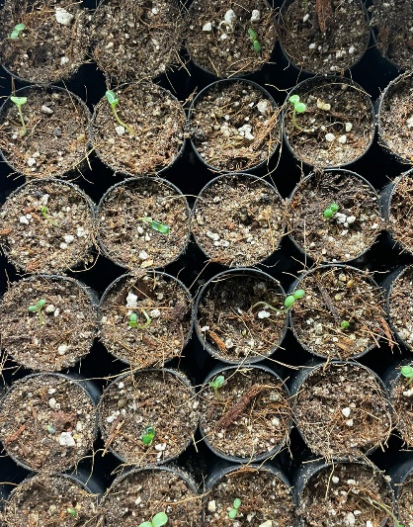
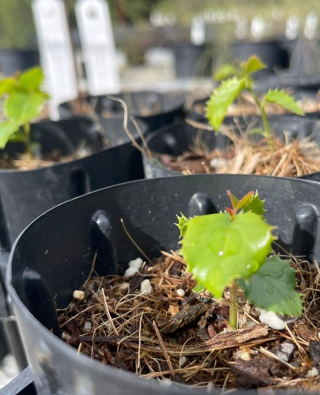
Figure 5. Lupinus spp. (Fig. 5a, left), Prunus illicifolia (Fig. 5b, center) and Salvia apiana (Fig. 5c, right) in propagation from seed collected in the BDR.
- Hold a collaborative planning meeting with tribal partners. The initial Restoration Planning Meeting was scheduled for March 28th and included RSVP’s from more than 12 participants from the San Pasqual Band of Mission Indians (SPBMI) including the Tribal Historic Preservation Office, Business and Environmental committees as well as Leadership team. Sadly, a member of the SPBMI community passed away shortly before and out of respect, the meeting has been rescheduled for May 2nd. During this time period, we attended other meetings which included tribal partners in this restoration project, including the Climate Science Alliance Tribal Working Group, La Jolla Intertribal Earth Day and the Southern California Regional Meeting of the California Wildfire and Forest Resilience Task Force.

- Install photo point posts and brackets in the Biodiversity Reserve. Installation and final design of photo point brackets was delayed due to a vacant position on the SDZWA C&M weld team. However, mounting posts were constructed by C&M in an all-metal design which will be longer-lasting and more fire resilient than planned wood posts. As a result, Research Coordinator Madison Wilson is redesigning the brackets to fit the new specs of the mounting platform on the posts.

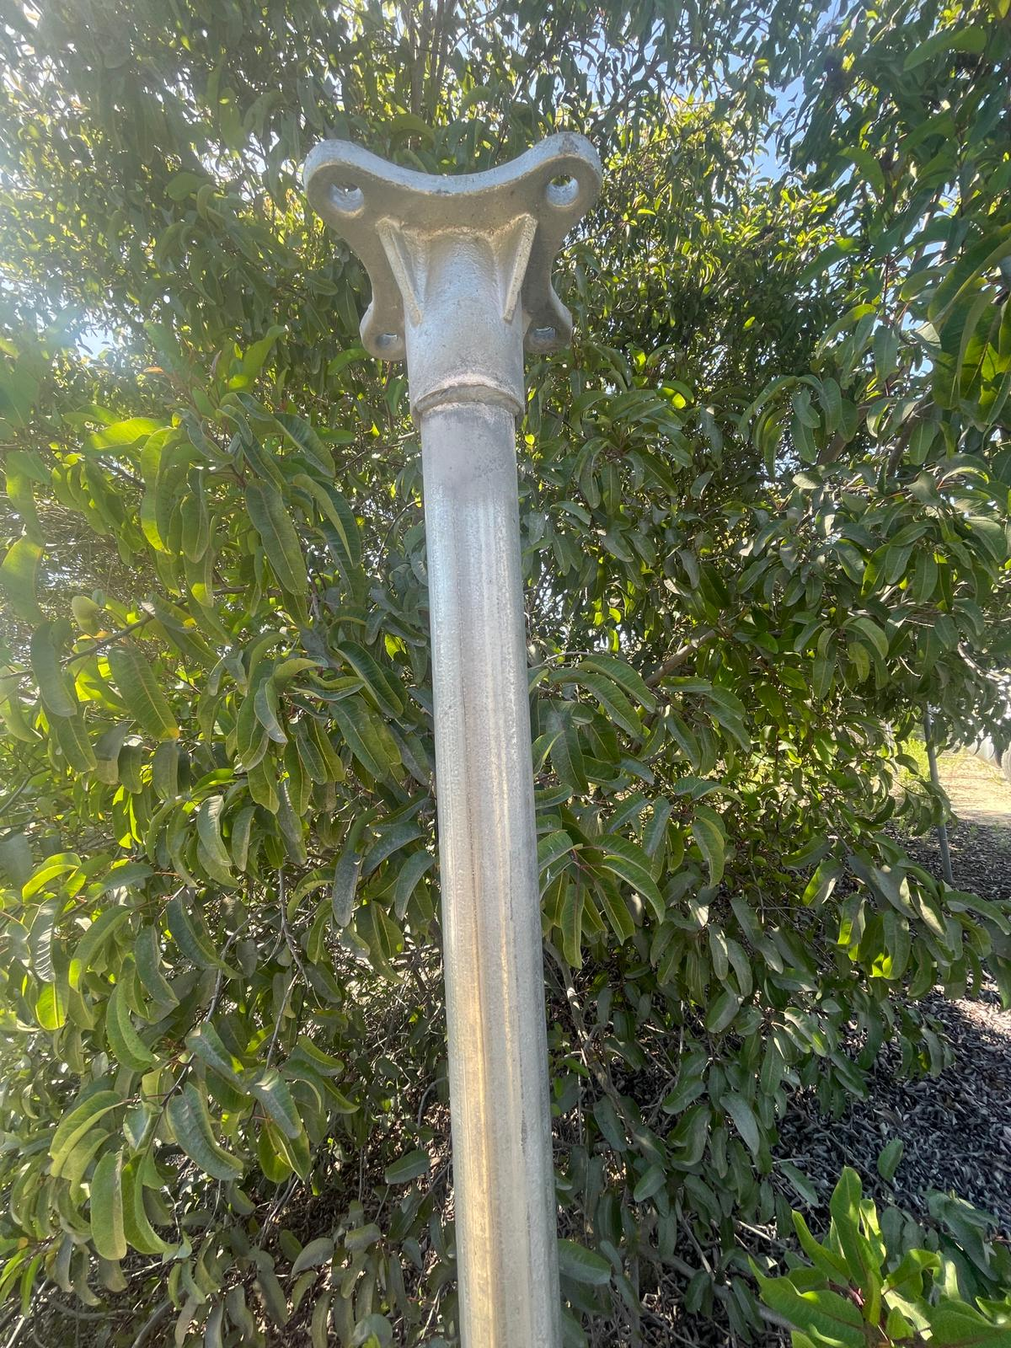
Figure 6. Newly fabricated photopoint posts, metal construction.

Task 3- Administrative
Work start: January 1, 2024
% complete: 16.7
Administrative work completed during the reporting period included project coordination.

Work Anticipated Next Period
- Hold a collaborative planning meeting with tribal partners. We will hold our rescheduled meeting with tribal and SDZWA partners.
- Seed collection, seed sorting, and seedling propagation. We will collect seed in the Biodiversity Reserve and continue sorting and propagation in the Seed Bank.
- Shade structure. We will research and begin preliminary work to install a plant propagation shade structure near the OBF restoration site.

Issues to Note
Please provide a brief description of any issue(s) encountered during the reporting period and any steps taken to address the issue(s).

Photographs & Figures
Photographs and figures are invaluable! Please include photos in the Quarterly Progress Reports and any figures (if applicable). Both photos and figures may be included throughout the document under corresponding tasks or at the end following the Issues to Note section. Photographs taken at the same place or photographic points (photo-points) can assist SANDAG staff in tracking the project’s progress over time.
It is required that Photographs include:
- A before and after comparison sequence from the start to the completion of the project for photo points.
- A brief description of the corresponding tasks, date, and activity in the photograph.
- A copy of each photograph included in the report submitted in a .jpeg or .png file format.
It is required that Figures include:
- A caption with a brief description.
SDMMP Project Page
To receive reimbursement for work conducted within the quarter, submission of Quarterly Progress, Annual, and Final Reports must be added to your project’s Project Page on the SDMMP website. Add any necessary photographs to the photo carousal and fill out the photograph information. Please contact Sarah McCutcheon (smccutcheon@usgs.gov) or Emily Perkins (eperkins@usgs.gov) if you are having trouble accessing or editing your project page.

Project Performance Measures Instructions
SANDAG will utilize the SANDAG Performance Measures to document compliance with the Project. Grantee’s performance will be measured against the Performance Measures (Exhibit D) during the term of the project. More details on Performance Measures and Grant Recovery Plans are outlined in the Grant Agreements.
To access the Project Performance Measures Excel Spreadsheet:
- Simply double-click on the Excel icon located under the Project Performance Measures section.
  - An excel sheet will open, please fill out and then click save.
- Once the Excel spreadsheet is saved, please exit Excel and the spreadsheet will automatically update the icon in the Quarterly Progress Report Word document.
When opening the document with the Project Performance Measures Excel Spreadsheet:
- When you first open the Quarterly Progress Report Template, a warning message will open (image of the warning message below)

  - Click Yes to update the links in the document.

Performance Measures
Please include the Project’s Performance Measures for each Quarterly Invoice and Progress Report in order to receive reimbursement.

