San Diego Association of Governments
Stinknet Removal II Project
San Diego Zoo Wildlife Alliance (SDZWA)
Quarterly Progress Report
Reporting Period: January 1 – March 31, 2024
Submission Date: January 21, 2025
SANDAG Contract Number:
S1125508

Quarterly Status Report Overview
PLEASE DO NOT CHANGE OR ALTER THE FORMATTING OF THIS DOCUMENT! SANDAG has developed a standardized grant monitoring and tracking program for the Environmental Mitigation Program (EMP) Land Management Grant Program. The purpose is to collect information on individual projects and the grant program as a whole for reporting to the Regional Habitat Conservation Taskforce, SANDAG Policy Advisory Committees, and the SANDAG Board of Directors. SANDAG monitors grantees through invoices, progress reports, performance measures, and designated photograph points. These standardized reporting templates and instructions for submittal are included below.

Work Performed this Period:

Task 1- Stinknet Removal
Work start: January 1, 2024
% complete: 50
Activities with grant dollars: A
Activities with matching funds: A, B, C

- Fall Pre-emergent treatments
Fall pre-emergent applications of Gallery SC in the Biodiversity Reserve were very effective. We were able to treat all planned areas and are seeing excellent control in our treatment areas.
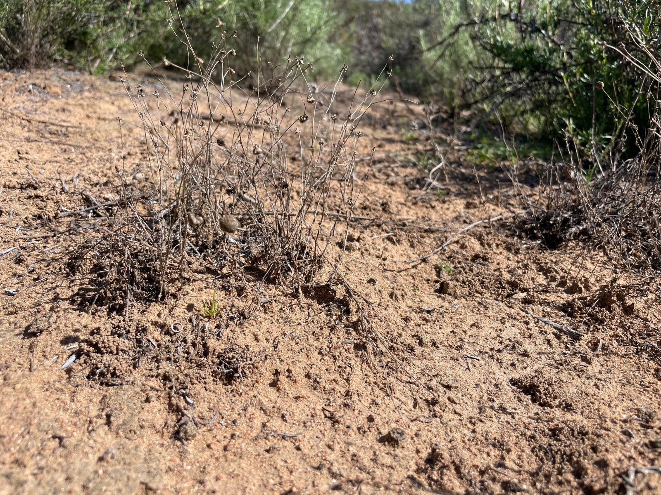
Figure 1. Stinknet litter from 2024 in an area treated with pre-emergent herbicide. No germination of stinknet is occurring despite seed presence and observed germination in non-treatment areas.

- Stinknet Management Plan and EDRR
We continued work on a joint-management plan with the Safari Park and created a task-force to align stinknet and fuels management plans between our two areas. Safari Park Habitats are directly adjacent to the project area, and seedfall from these areas can infiltrate into our stinknet management areas. By collaborating and aligning our management goals and treatments, we hope to create more resilience to stinknet in our management areas.
- Vegetation survey data analysis
Preliminary results from our vegetation analysis show an overall reduction of stinknet, with a greater magnitude of decline in our treatment plots. Cover of perennial species is generally increasing, with prickly pear cactus cover increasing everywhere. We suspect that increasing perennial cover may be contributing to overall stinknet decline. This is great evidence that our stinknet treatments are working in our management areas. We look forward to diving deeper into our analyses.
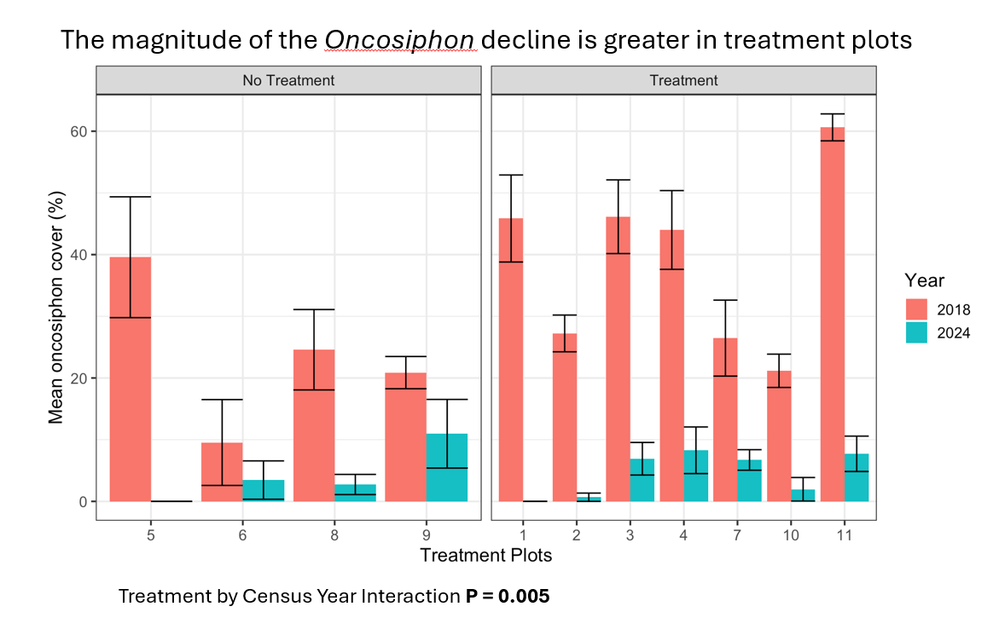Figure 2. Stinknet (Oncosiphon pilulifer) cover by plot (no treatment, treatment) between 2018 (red) and 2024 (blue). Stinknet is decreasing overall, but the magnitude of the decline is greater in our treatment plots (p=0.005).
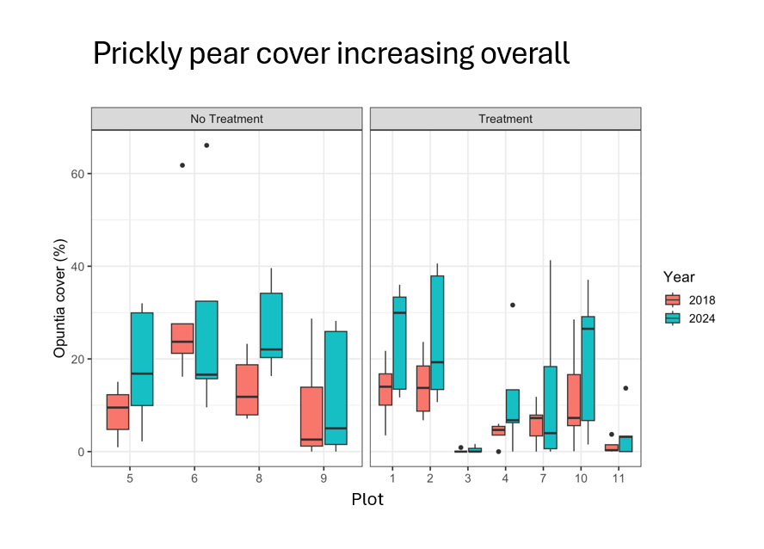
Figure 3. Prickly pear (Opuntia littoralis) cover by plot (no treatment, treatment), between 2018 (red) and 2024 (blue). Prickly pear cactus cover is increasing across the Biodiversity Reserve.

Task 2- Restoration Planning and Implementation
Work start: January 1, 2024
% complete: 33.3
Activities with grant dollars: A, B
Activities with matching funds: A, B, C, D

- Irrigation
Irrigation will be temporary dripline laid on the soil surface and will not disturb soil or require any digging in our project area. Providing supplemental water will increase the survivorship of propagules, as determined by a study done by SDZWA in a previous cactus outplanting project. We are waiting for approval of the San Pasqual tribe to do this work, which we hope will be completed before Fall 2025 to supplement water for the first year, after which it will be removed.
- Planting planning and problem solving
We ordered and received 500 burlap sacs that will be used to root cactus pads without disturbing soil while also reducing weed competition. These bags will be filled with soil and cactus propagules will be planted into them with drippers in each to supplement water for the first year. Roots and permeate the bags into the ground and will decompose after a few years.
- Delayed plantings due to low rainfall
This year was particularly dry and received little fall or winter. As a result, we chose to delay plantings of annual seed and perennials as it is difficult to get plants to establish successfully in dry years. Instead, we will be able to use this time to target annuals for seed collection (Lasthenia californica, Amsinckia menziesii, Lupinus spp. ) and grow on perennials already planted from collected seed (Penstemon spectablils, Dudleya edulis, others) to increase their survivorship.
- Volunteer hand removal in planned new project area
Due to site restrictions, we plan to relocate the cultural aspects of the project to a different site within our stinknet management area, and where we host our annual cactus fruit gathering. We rely on volunteer supported stewardship of this area, and hosted 2 days of hand-pulling stinknet. Plants were very small this year due to lack of rain, but this allowed volunteers to make great progress removing many small plants without much soil disturbance.
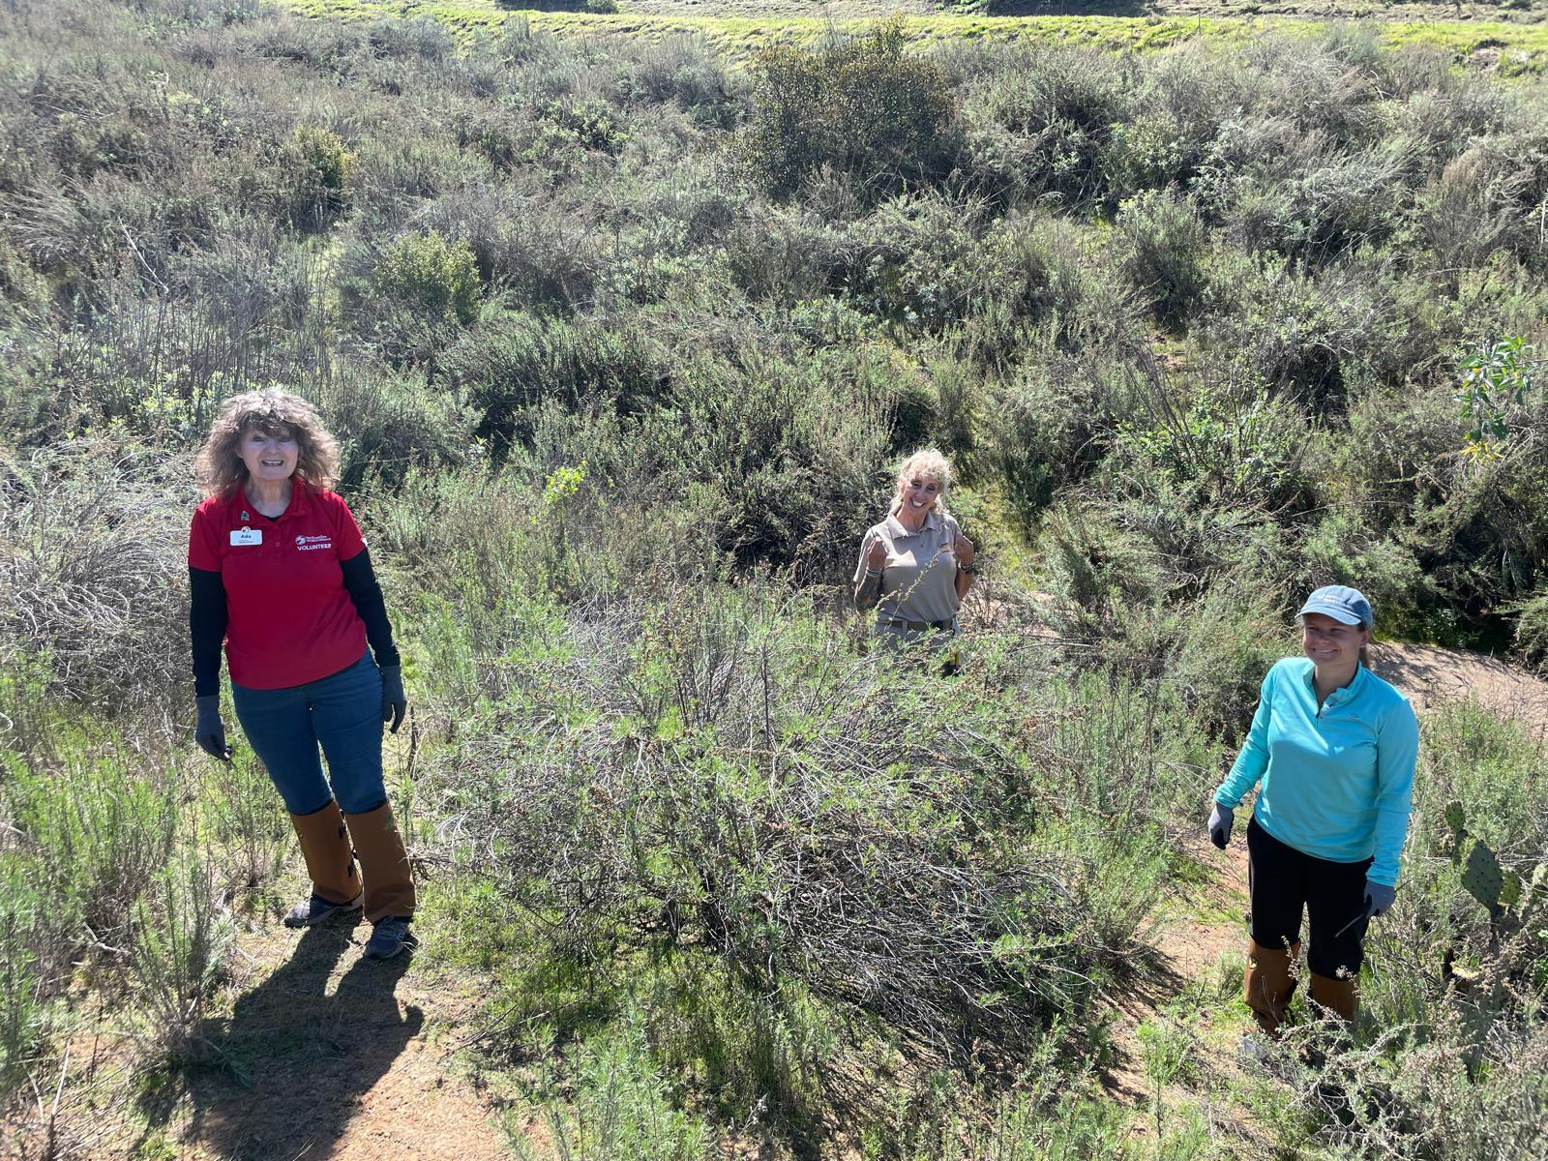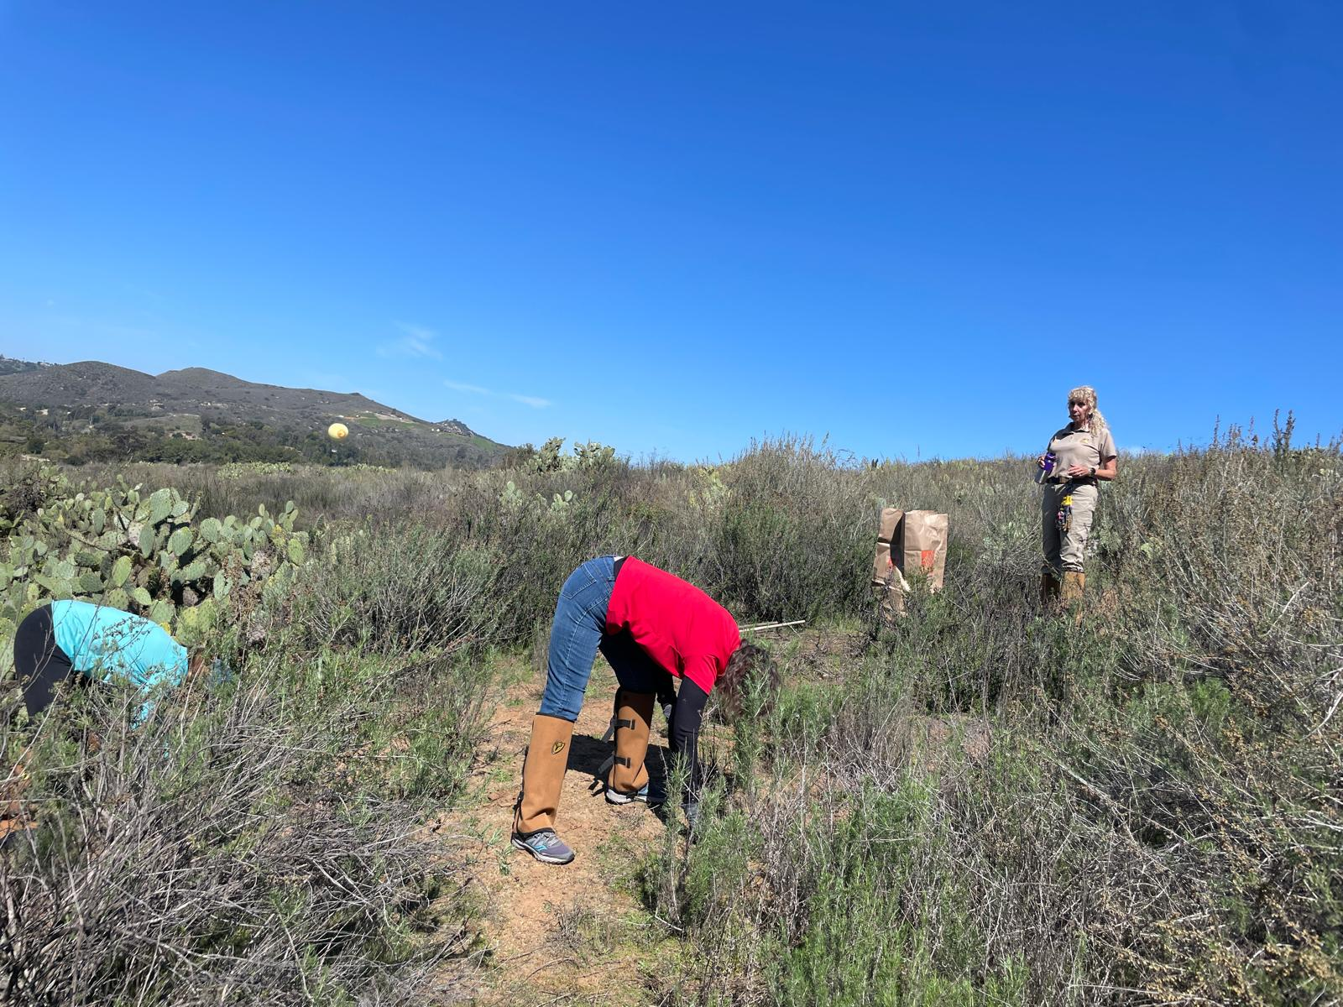
Figures 4 and 5. Volunteers hand-pulling stinknet.

Task 3- Administrative
Work start: January 1, 2024
% complete: 33.3
Activities with grant dollars: A
Activities with matching funds: A

- Project coordination
Project coordination includes weekly planning meetings with Natural Lands staff to discuss seasonal stinknet treatments, restoration logistics, volunteer coordination and planning monitoring efforts. Other administrative duties performed during the quarter included report preparation and maintenance of ArcGIS spatial data relevant to the project.

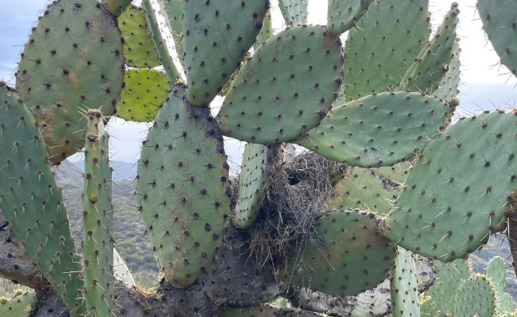

Figures 6 . A Coastal Cactus Wren nest in Prickly pear cactus.

Work Anticipated Next Period
Post-emergent stinknet treatments
Discussion with San Pasqual about work in the project area
Continued stinknet handpulling in new planned project area
Monitoring annual phenology for seed collection

Issues to Note
No issues to note are anticipated in this period.

Photographs & Figures
Photographs and figures are invaluable! Please include photos in the Quarterly Progress Reports and any figures (if applicable). Both photos and figures may be included throughout the document under corresponding tasks or at the end following the Issues to Note section. Photographs taken at the same place or photographic points (photo-points) can assist SANDAG staff in tracking the project’s progress over time.
It is required that Photographs include:
- A before and after comparison sequence from the start to the completion of the project for photo points.
- A brief description of the corresponding tasks, date, and activity in the photograph.
- A copy of each photograph included in the report submitted in a .jpeg or .png file format.
It is required that Figures include:
- A caption with a brief description.
SDMMP Project Page
To receive reimbursement for work conducted within the quarter, submission of Quarterly Progress, Annual, and Final Reports must be added to your project’s Project Page on the SDMMP website. Add any necessary photographs to the photo carousal and fill out the photograph information. Please contact Sarah McCutcheon (smccutcheon@usgs.gov) or Emily Perkins (eperkins@usgs.gov) if you are having trouble accessing or editing your project page.

Project Performance Measures Instructions
SANDAG will utilize the SANDAG Performance Measures to document compliance with the Project. Grantee’s performance will be measured against the Performance Measures (Exhibit D) during the term of the project. More details on Performance Measures and Grant Recovery Plans are outlined in the Grant Agreements.
To access the Project Performance Measures Excel Spreadsheet:
- Simply double-click on the Excel icon located under the Project Performance Measures section.
  - An excel sheet will open, please fill out and then click save.
- Once the Excel spreadsheet is saved, please exit Excel and the spreadsheet will automatically update the icon in the Quarterly Progress Report Word document.
When opening the document with the Project Performance Measures Excel Spreadsheet:
- When you first open the Quarterly Progress Report Template, a warning message will open (image of the warning message below)

  - Click Yes to update the links in the document.

Performance Measures
Please include the Project’s Performance Measures for each Quarterly Invoice and Progress Report in order to receive reimbursement.

