San Diego Association of Governments
Stinknet Removal II Project
San Diego Zoo Wildlife Alliance (SDZWA)
Quarterly Progress Report
Reporting Period: July 1 – September 30, 2024
Submission Date: October 21, 2024
SANDAG Contract Number:
S1125508

Quarterly Status Report Overview
PLEASE DO NOT CHANGE OR ALTER THE FORMATTING OF THIS DOCUMENT! SANDAG has developed a standardized grant monitoring and tracking program for the Environmental Mitigation Program (EMP) Land Management Grant Program. The purpose is to collect information on individual projects and the grant program as a whole for reporting to the Regional Habitat Conservation Taskforce, SANDAG Policy Advisory Committees, and the SANDAG Board of Directors. SANDAG monitors grantees through invoices, progress reports, performance measures, and designated photograph points. These standardized reporting templates and instructions for submittal are included below.

Work Performed this Period:

Task 1- Stinknet removal
Work start: January 1, 2024
% complete: 33.4
Activities with grant dollars: A, B, C
Activities with matching funds: A

- Completion of vegetation survey and data entry
We completed the 2018 Stinknet Resurvey on July 17th. This large effort brought together SDZWA scientists, horticulturists, educators, volunteers and summer fellows. In total, 120 volunteer hours were logged for this effort. Volunteers have also assisted with the data entry phase of this survey, many of whom also helped with field work. We have seen that this survey had an impact on many of the individuals who worked on it and are able to share with SDZWA guests more in-depth knowledge of the Biodiversity Reserve and the importance of coastal sage scrub conservation.

- Planning of fall pre-emergent treatments
The Natural Lands team was able to map priority areas for applying pre-emergent herbicide treatments to stinknet management areas in the Biodiversity Reserve. We will be contracting Black Sage Environmental to do this work in November of 2024.

- Safari Park/ BioReserve EDRR & Stinknet Management Plan
We have been collaborating with Dr. Chris McDonald from UCANR to develop an interdepartmental EDRR strategy and Stinknet Management Plan. We met during this period to discuss our goals and priorities. We began by presenting to horticulture department meetings about the context and importance of invasive species response.

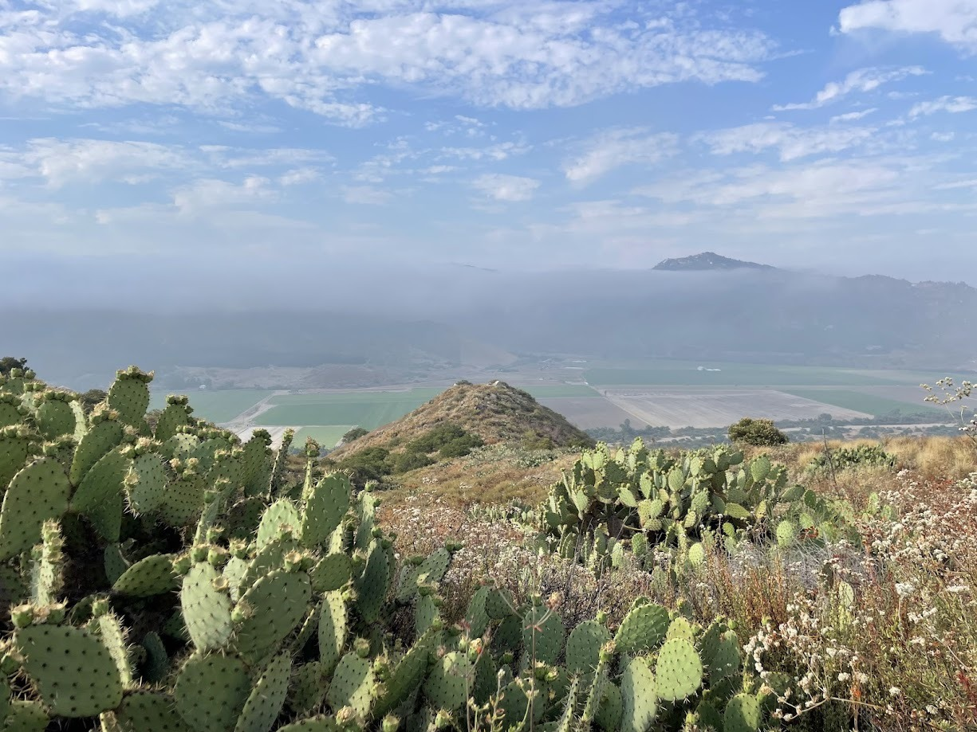

Figure 1. Cactus and buckwheat in the Biodiversity Reserve with summer fog in the San Pasqual Valley in the background.

Task 2- Restoration planning and implementation

Work start: January 1, 2024
% complete: 25
Activities with grant dollars: A
Activities with matching funds: NA

- Follow-up Restoration Meeting
We continued our discussion from May about the planned restoration of the Old Browse Farm area. The cultural resources survey preformed by Dudek in December 2023 concluded that our restoration efforts (as little as 1 in sq of soil disturbance) would cause significant impact to the site and require mitigation by artifact recovery, site capping or avoidance. Both Natural Lands and the San Pasqual THPO feel that recovery and capping would cause significant disturbance ecological damage to the site which we are seeking to restore. Therefore, we are currently discussing 2 options: restoring the site without disturbing soil and while avoiding the culturally sensitive area outlined by Dudek, or seeking a different site within the MSCP and Safari Park properties that would less limiting in restoration activities.

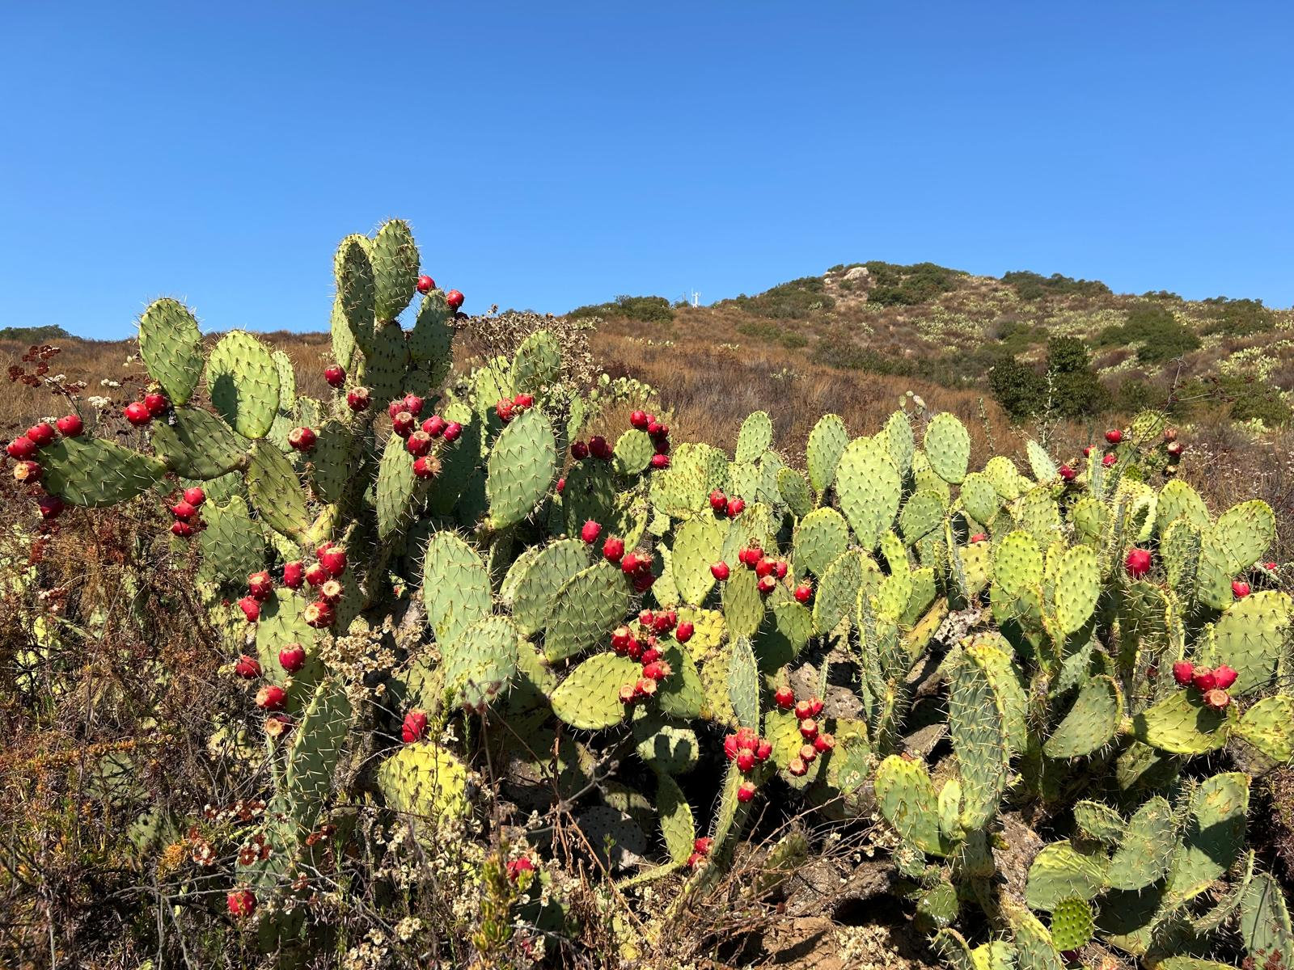
Figure 2. Ripening prickly pear cactus (Opuntia littoralis) in the Biodiversity Reserve.

Task 3- Administrative
Work start: January 1, 2024
% complete: 16.7

Administrative work completed during the reporting period included project coordination.

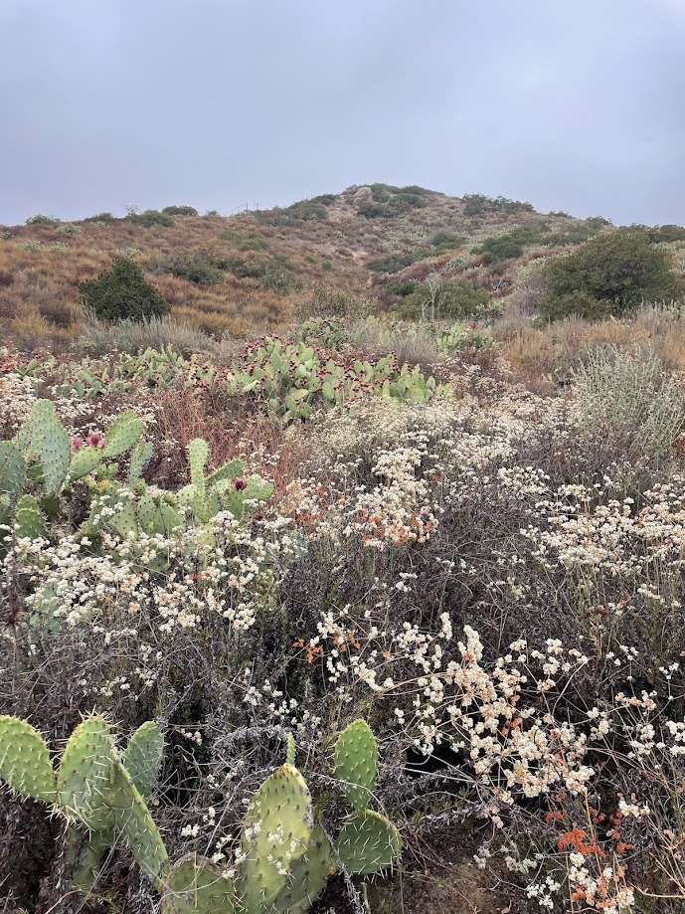
Figure 3. Ripening prickly pear fruit and flowering buckwheat late summer in the Biodiversity Reserve.

Work Anticipated Next Period

Next quarter, we will:
- Conduct stinknet pre-emergent treatments in the Biodiversity Reserve
- Continue our discussions with San Pasqual and the Safari Park on the best way to proceed with restoration work

Issues to Note
As of now, we are on schedule for the project. However, if San Pasqual and SDZWA decide that restoration work is not feasible in the Old Browse Farm area, and an alternative site is needed, then a no-cost extension will be needed.

Photographs & Figures
Photographs and figures are invaluable! Please include photos in the Quarterly Progress Reports and any figures (if applicable). Both photos and figures may be included throughout the document under corresponding tasks or at the end following the Issues to Note section. Photographs taken at the same place or photographic points (photo-points) can assist SANDAG staff in tracking the project’s progress over time.
It is required that Photographs include:
- A before and after comparison sequence from the start to the completion of the project for photo points.
- A brief description of the corresponding tasks, date, and activity in the photograph.
- A copy of each photograph included in the report submitted in a .jpeg or .png file format.
It is required that Figures include:
- A caption with a brief description.
SDMMP Project Page
To receive reimbursement for work conducted within the quarter, submission of Quarterly Progress, Annual, and Final Reports must be added to your project’s Project Page on the SDMMP website. Add any necessary photographs to the photo carousal and fill out the photograph information. Please contact Sarah McCutcheon (smccutcheon@usgs.gov) or Emily Perkins (eperkins@usgs.gov) if you are having trouble accessing or editing your project page.

Project Performance Measures Instructions
SANDAG will utilize the SANDAG Performance Measures to document compliance with the Project. Grantee’s performance will be measured against the Performance Measures (Exhibit D) during the term of the project. More details on Performance Measures and Grant Recovery Plans are outlined in the Grant Agreements.
To access the Project Performance Measures Excel Spreadsheet:
- Simply double-click on the Excel icon located under the Project Performance Measures section.
  - An excel sheet will open, please fill out and then click save.
- Once the Excel spreadsheet is saved, please exit Excel and the spreadsheet will automatically update the icon in the Quarterly Progress Report Word document.
When opening the document with the Project Performance Measures Excel Spreadsheet:
- When you first open the Quarterly Progress Report Template, a warning message will open (image of the warning message below)
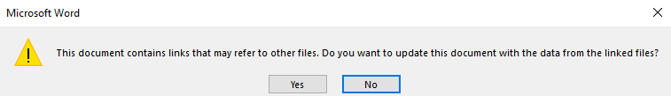
  - Click Yes to update the links in the document.

Performance Measures
Please include the Project’s Performance Measures for each Quarterly Invoice and Progress Report in order to receive reimbursement.

