San Diego Association of Governments
Stinknet Removal II Project
San Diego Zoo Wildlife Alliance (SDZWA)
Quarterly Progress Report
Reporting Period: April 1 – June 30, 2024
Submission Date: July 21, 2024
SANDAG Contract Number:
S1125508

Quarterly Status Report Overview
PLEASE DO NOT CHANGE OR ALTER THE FORMATTING OF THIS DOCUMENT! SANDAG has developed a standardized grant monitoring and tracking program for the Environmental Mitigation Program (EMP) Land Management Grant Program. The purpose is to collect information on individual projects and the grant program as a whole for reporting to the Regional Habitat Conservation Taskforce, SANDAG Policy Advisory Committees, and the SANDAG Board of Directors. SANDAG monitors grantees through invoices, progress reports, performance measures, and designated photograph points. These standardized reporting templates and instructions for submittal are included below.

Work Performed this Period:

Task 1- Stinknet removal

Work start: January 1, 2024
% complete: 25
Activities with grant dollars: B (coordinator labor)
Activities with matching funds: A, B (volunteer labor)

Hand removal with volunteers
Four SDZWA volunteers participated in a spring hand-removal of stinknet in the Biodiversity Reserve. The 2.5 acre area addressed has a relatively low stinknet density and is located in an area where cactus fruits are harvested and consumed annually, making it a good candidate for this type of management. We pulled plants at the base and placed in bags ensuring little to no disturbance of the flower heads to reduce chance of seed spread. Observationally, a lot of potential seed was removed with no impact on erosion and little soil disturbance.

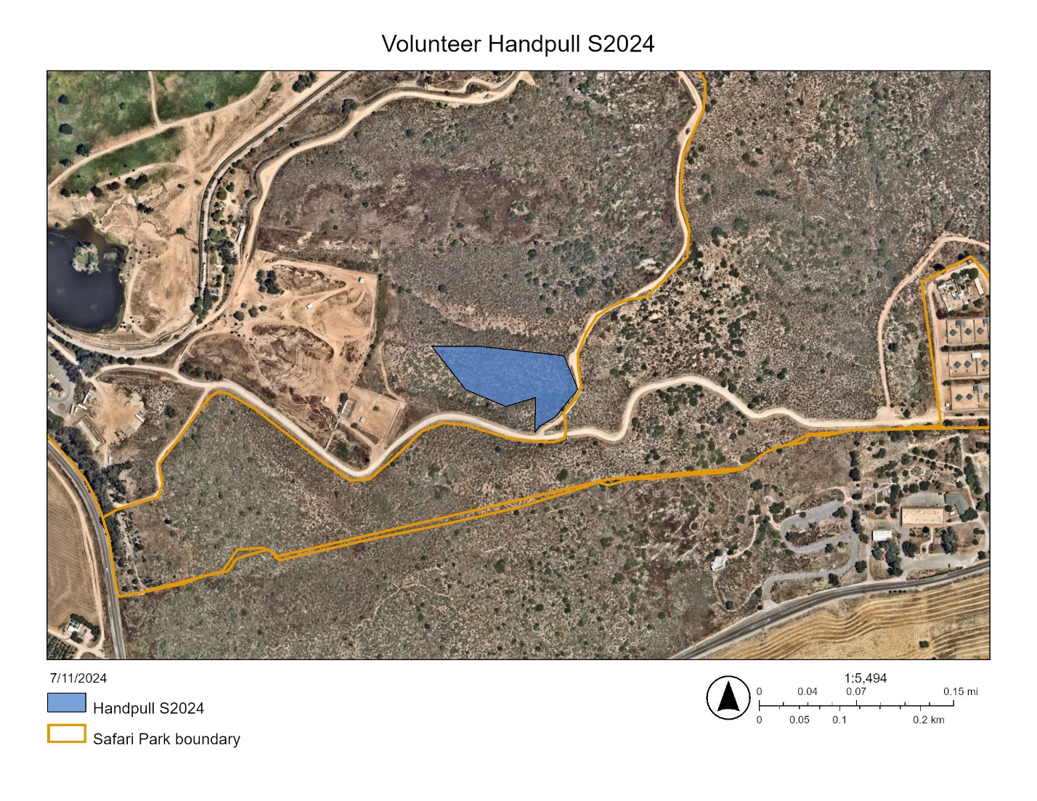
Figure 1. Map of 2.5 acre area of stinknet hand-pulled by volunteers in May 2024.

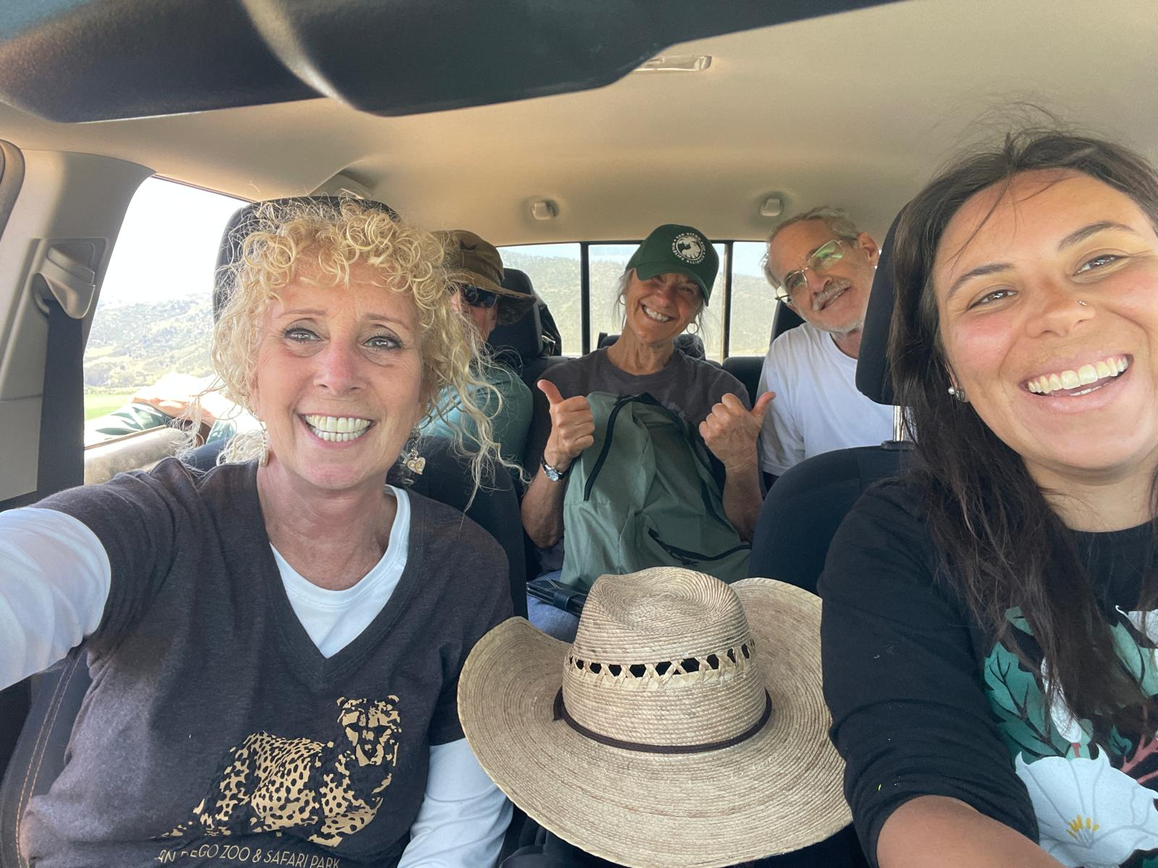
Figure 2. SDZWA Volunteers and Research Coordinator Madison Wilson (right) after hand-pulling 2.5 acres of stinknet.

2018 Stinknet Resurvey
The Natural Lands Research Coordinator and Program Manager collaborated with SDZWA Plant Conservation, Horticulture and Community Engagement teams along with volunteers, graduate students and student fellows to repeat a large scale stinknet survey across the Biodiversity Reserve. This survey was conducted by the Plant Conservation team in 2018 before the founding of the Natural Lands program to serve as a baseline for future stinknet management. This survey consists of 11 plots each with five 50-meter transect lines. Along each transect, we quantified shrub cover using the line-intercept method and annual cover in five 1-meter squared subquadrats using the percent-cover method. This large, collaborative effort provided dozens of SDZWA students, staff and volunteers to engage in hands-on learning of vegetation survey methods and time interacting with and learning about native and invasive vascular plants present in the Biodiversity Reserve. In total, 14 volunteers spent 120 hours* from May through June to complete this survey. The Natural Lands team looks forward to comparing these data and sharing results about vegetation composition and stinknet management in the Biodiversity Reserve.

*These volunteer hours will be counted as match during the next quarterly invoice.
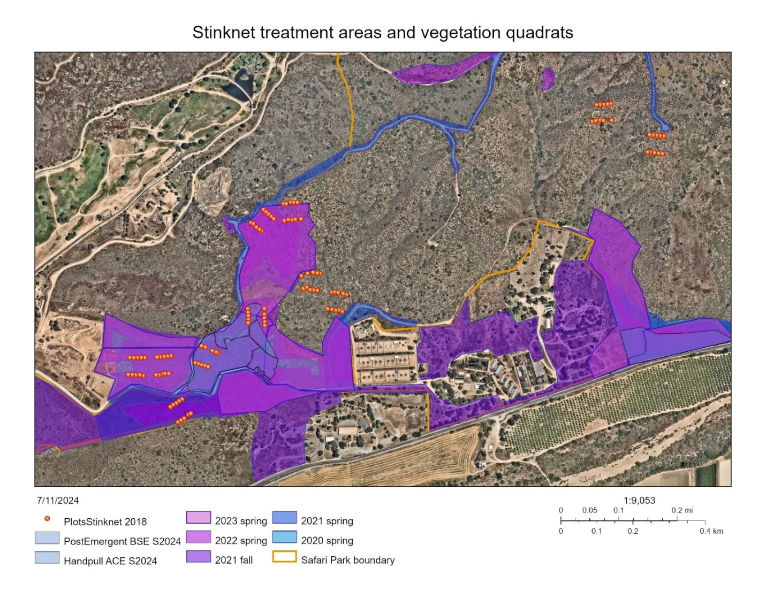
Figure 3. Map of vegetation survey transects in the Biodiversity Reserve (red points, 11 total plots) shown with stinknet treatments by season since 2020 (blue and purple polygons).

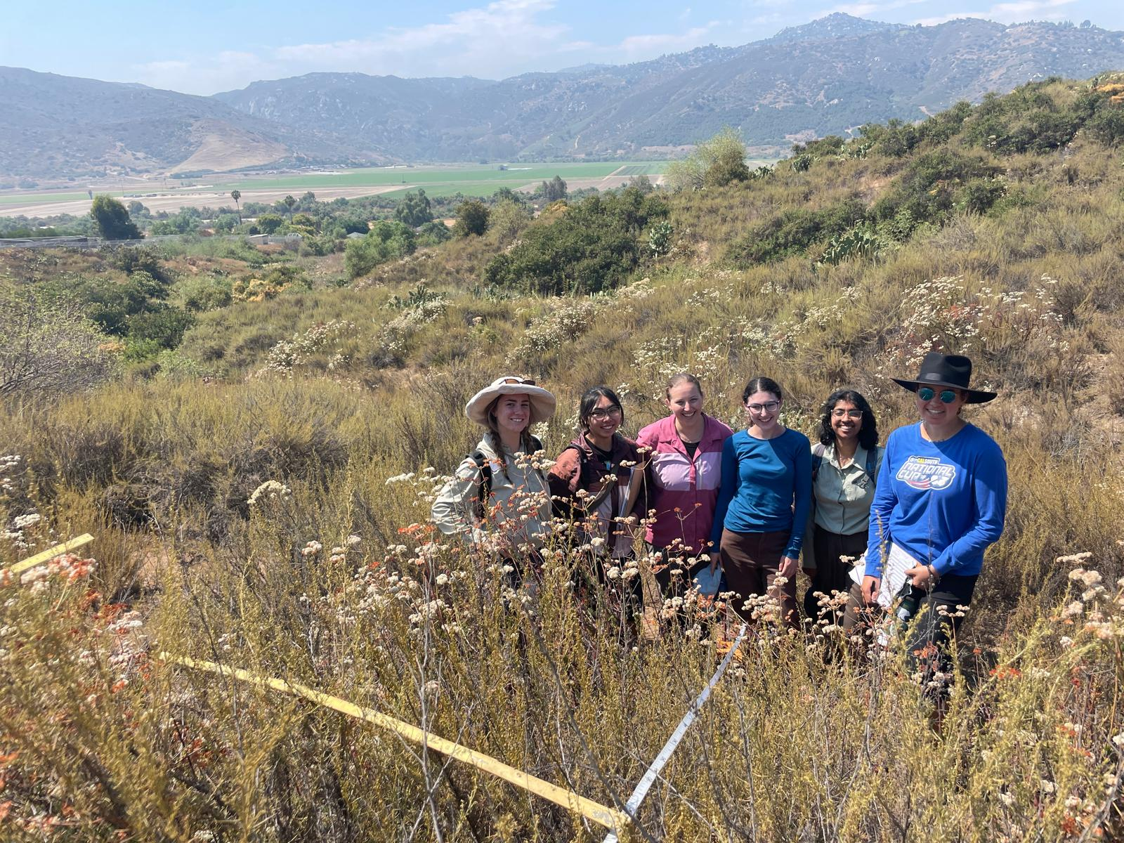
Figure 4. SDZWA Summer Student Fellows participating in the vegetation survey in the Biodiversity Reserve.

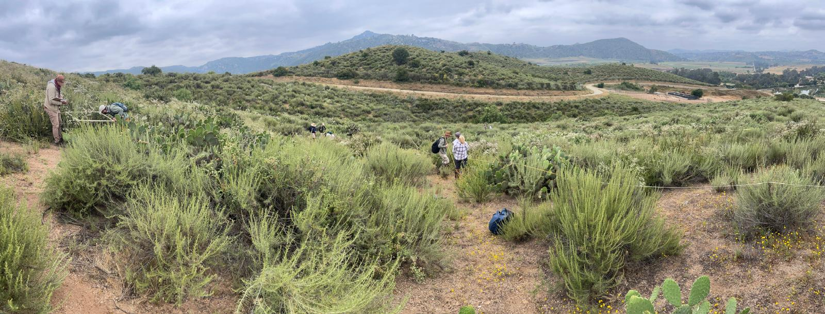
Figure 5. Panoramic image of Plant Conservation, Horticulture, Volunteer and Natural Lands teams collecting vegetation survey data in the Biodiversity Reserve.

EDRR & Park-wide management plan
On Friday, June 7th Natural Lands Research Coordinator attended the 2024 San Diego Weed Management Areas Summer Symposium. At this meeting, we were able to connect with University of California Cooperative Extension Natural Resource Advisor Chris McDonald Ph.D to collaborate on a comprehensive EDRR and Stinknet Management Plan for both the Safari Park and the Biodiversity Reserve to address the emergence and spread of weeds across the developed and protected areas of the San Diego Zoo Safari Park. We intend to complete and share this plan with relevant departments by the end of the year.

Task 2- Restoration planning and implementation

Work start: January 1, 2024
% complete: 16.7
Activities with grant dollars: A, B, C
Activities with matching funds: NA

Hold a collaborative planning meeting with tribal partners
Our first meeting with partners from the San Pasqual Band of Mission Indians was hosted on Thursday, May 2nd at the San Diego Zoo Safari Park. In attendance were representatives from the Tribal Historic Preservation Office, the Business Committee, the Environmental Department as well as San Pasqual’s Chairman. During the meeting we discussed the results of the Cultural Resources Survey performed in December, 2023 by Dudek. The results yielded that the site was eligible for the California Register of Historic Places, and that the planned activities (hand-pulling weeds) would cause significant soil disturbance to the site, and mitigation would be required to do habitat restoration work in the area. This requirement poses a challenge in balancing both the protection of tribal cultural resources, as well as the protection and stewardship of ecological resources at the site. After visiting the area, we decided that more discussion was needed to find a path forward that balances the delicate nature of both cultural and ecological resources while meeting all our shared goals. A new meeting date is currently under discussion.

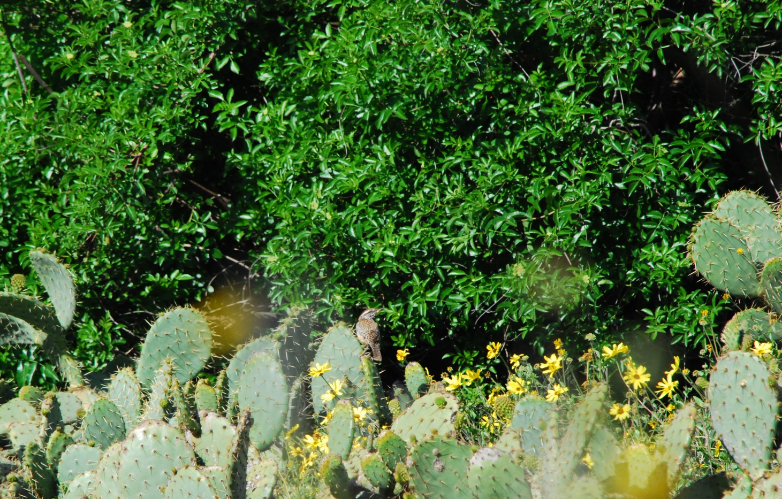
Figure 6. Coastal Cactus Wren (Campylorhynchus brunneicapillus sandiegensis) perched on top coastal prickly pear cactus (Opuntia littoralis) with bush sunflower (Encelia californica) and a backdrop of blue elderberry (Sambucus mexicana) at the Old Browse Farm.

Seed collection, seed sorting, and seedling propagation
Research Coordinator Madison Wilson processed seed from 1 species and propagated 2 species from seeds collected in the BDR and by the San Pasqual Environmental Wellness Ambassadors.
  - Species seed processed: Stipa pulchra
  - Species propagated: Salvia apiana, Penstemon spectabilis
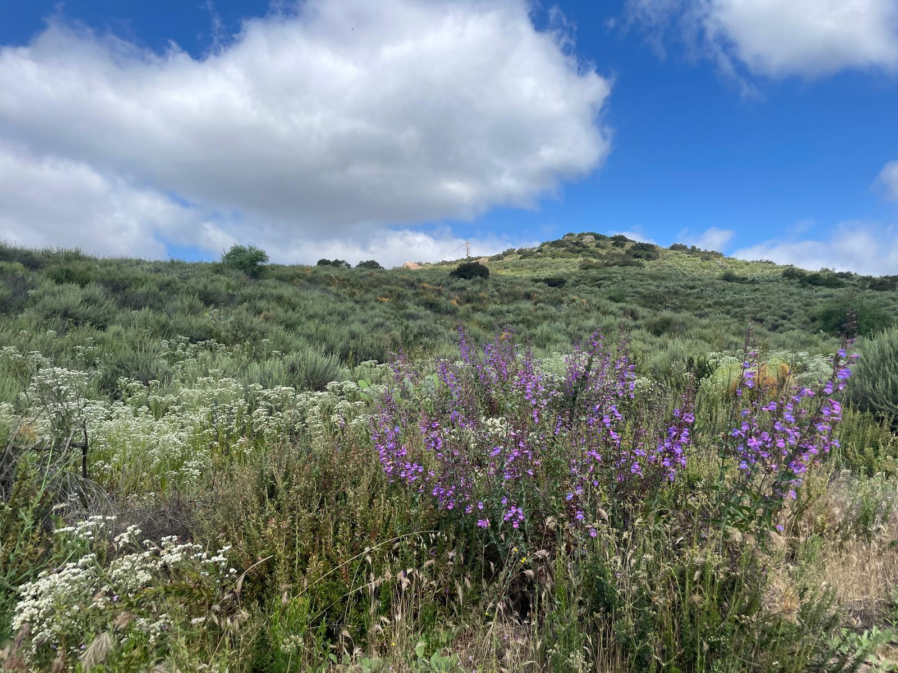Figure 7. Penstemon spectabilis and Pseudognaphalium california blooming on a hillside in the Biodiversity Reserve.

Photopoint Stations
We continued taking quarterly photo points at key locations in the Biodiversity Reserve. Installation of photopoint stations (see Jan – Mar 2024 report) is underway.

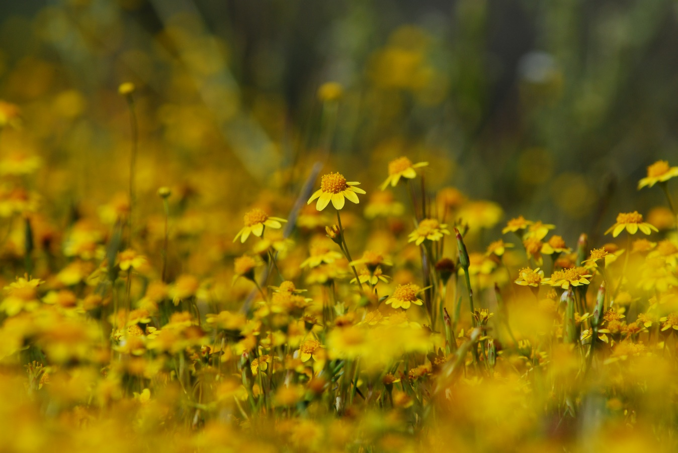
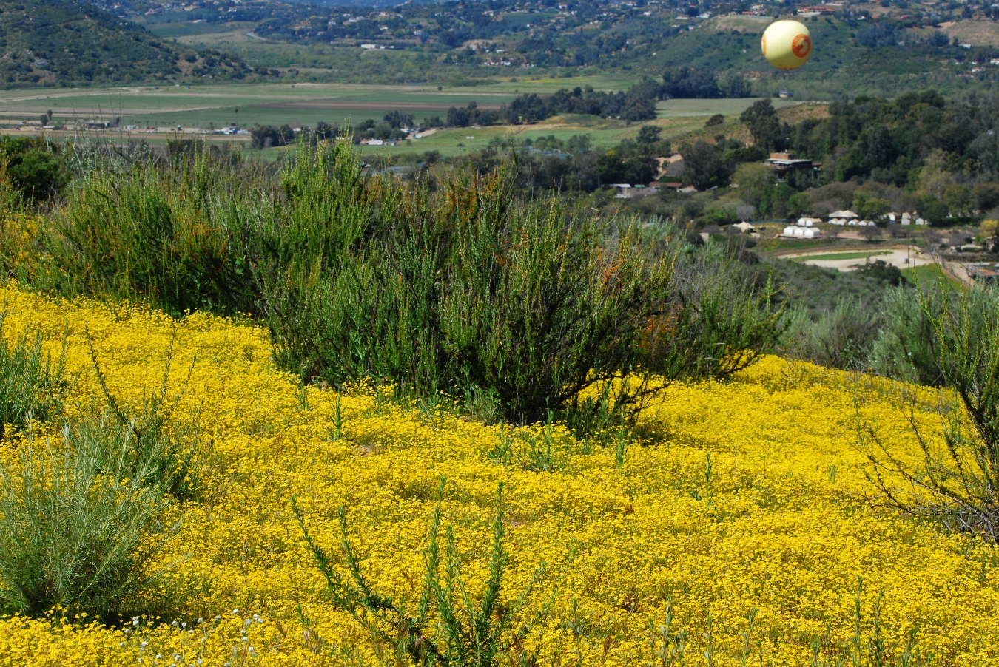
Figure 8. California goldfields (Lasthenia californica) blooming in the Biodiversity Reserve, up-close (Figure 8a, top) and with the Safari Park in the background (Figure 8b, bottom).

Shade structure
We received approval for a new Native Plant Shade Structure and will purchase the equipment pending discussions on location.

Task 3- Administrative
Work start: January 1, 2024
% complete: 16.7

Administrative work completed during the reporting period included project coordination.

Provide the exact work start date, a description of the work completed under each task, and percent complete. Add additional tasks as necessary

Work Anticipated Next Period
- Additional meeting with partners at the San Pasqual Band of Mission Indians
- Installation of photo point stations
- Planning of fall pre-emergent stinknet treatments
- Development of Safari Park / BioReserve EDRR & Stinknet Management Plan
- Data input and analysis for vegetation survey
- Continued seed collection, seed processing and plant propagation

Issues to Note
No issues to note this quarter.

Photographs & Figures
Photographs and figures are invaluable! Please include photos in the Quarterly Progress Reports and any figures (if applicable). Both photos and figures may be included throughout the document under corresponding tasks or at the end following the Issues to Note section. Photographs taken at the same place or photographic points (photo-points) can assist SANDAG staff in tracking the project’s progress over time.
It is required that Photographs include:
- A before and after comparison sequence from the start to the completion of the project for photo points.
- A brief description of the corresponding tasks, date, and activity in the photograph.
- A copy of each photograph included in the report submitted in a .jpeg or .png file format.
It is required that Figures include:
- A caption with a brief description.
SDMMP Project Page
To receive reimbursement for work conducted within the quarter, submission of Quarterly Progress, Annual, and Final Reports must be added to your project’s Project Page on the SDMMP website. Add any necessary photographs to the photo carousal and fill out the photograph information. Please contact Sarah McCutcheon (smccutcheon@usgs.gov) or Emily Perkins (eperkins@usgs.gov) if you are having trouble accessing or editing your project page.

Project Performance Measures Instructions
SANDAG will utilize the SANDAG Performance Measures to document compliance with the Project. Grantee’s performance will be measured against the Performance Measures (Exhibit D) during the term of the project. More details on Performance Measures and Grant Recovery Plans are outlined in the Grant Agreements.
To access the Project Performance Measures Excel Spreadsheet:
- Simply double-click on the Excel icon located under the Project Performance Measures section.
  - An excel sheet will open, please fill out and then click save.
- Once the Excel spreadsheet is saved, please exit Excel and the spreadsheet will automatically update the icon in the Quarterly Progress Report Word document.
When opening the document with the Project Performance Measures Excel Spreadsheet:
- When you first open the Quarterly Progress Report Template, a warning message will open (image of the warning message below)

  - Click Yes to update the links in the document.

Performance Measures
Please include the Project’s Performance Measures for each Quarterly Invoice and Progress Report in order to receive reimbursement.

