San Diego Association of Governments
Stinknet Removal II Project
San Diego Zoo Wildlife Alliance (SDZWA)
Quarterly Progress Report
Reporting Period: October 1 – December 30, 2024
Submission Date: January 21, 2025
SANDAG Contract Number:
S1125508

Quarterly Status Report Overview
PLEASE DO NOT CHANGE OR ALTER THE FORMATTING OF THIS DOCUMENT! SANDAG has developed a standardized grant monitoring and tracking program for the Environmental Mitigation Program (EMP) Land Management Grant Program. The purpose is to collect information on individual projects and the grant program as a whole for reporting to the Regional Habitat Conservation Taskforce, SANDAG Policy Advisory Committees, and the SANDAG Board of Directors. SANDAG monitors grantees through invoices, progress reports, performance measures, and designated photograph points. These standardized reporting templates and instructions for submittal are included below.

Work Performed this Period:

Task 1- Stinknet Removal
Work start: January 1, 2024
% complete: 50
Activities with grant dollars: A
Activities with matching funds: A, B, C

- Fall Pre-emergent treatments
We contracted Black Sage Environmental to apply pre-emergent herbicides (Gallery SC) to prevent stinknet germination in the Biodiversity Reserve. We treated a total of 12.9 acres, with 10.2 acres in re-treatment of current management acres (East polygons) and 2.7 acres treated for the first time (West polygon), adding to our overall management acreage.
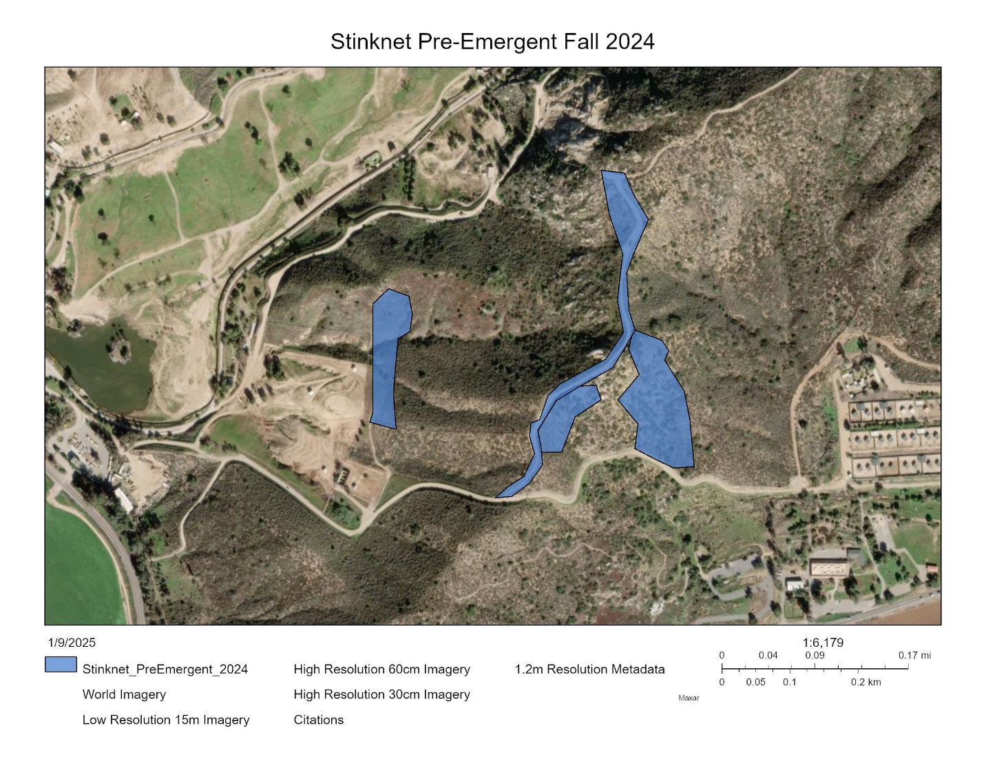Figure 1. Areas where pre-emergent herbicides were applied (13 acres)

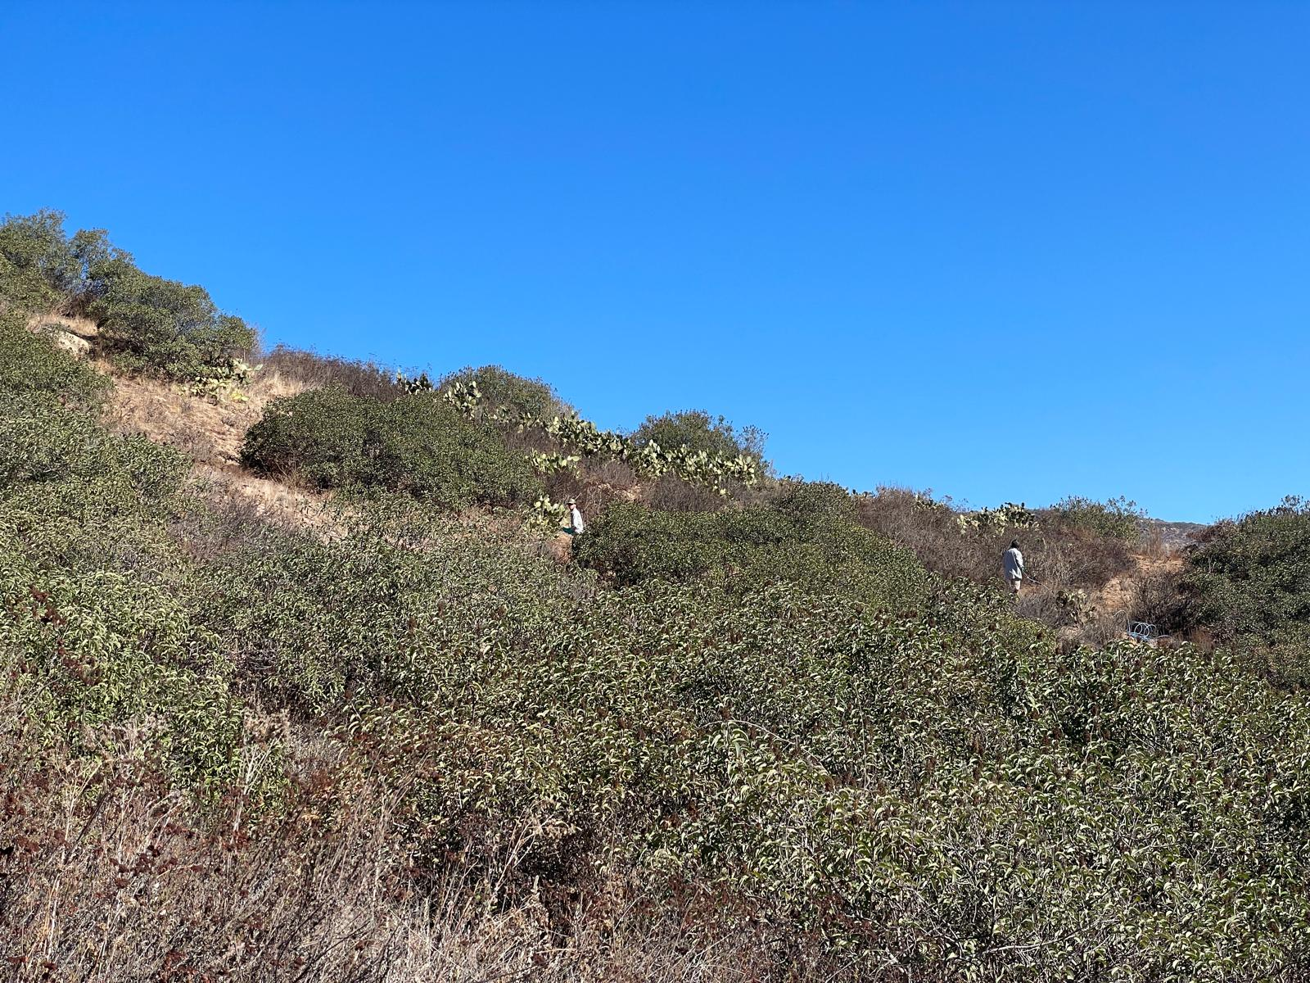
Figure 2. Black Sage Environmental Crew applying pre-emergent herbicides in the Biodiversity Reserve.

- Stinknet Management Plan and EDRR
We continued conversations with SD WMA and Park Horticulture to further develop a plan to control stinknet spread throughout the Safari Park and Biodiversity Reserve, including the project area.
- Vegetation survey data analysis
Data entry for 2018-2024 vegetation survey is completed and data analysis is underway. The results of this survey will give us a deeper understanding of the efficacy of our treatments and vegetation composition in treated vs control areas.

Task 2- Restoration Planning and Implementation
Work start: January 1, 2024
% complete: 33.3
Activities with grant dollars: A, B
Activities with matching funds: A, B

- Irrigation
We met with an irrigation specialist to plan installation of temporary drip irrigation for the cactus plantings along the fence line.
- Planting planning and problem solving
We developed a solution that will allow us to plant the cactus in soil without digging or soil disturbance activities which have been deemed impactful to the site. While cactus has some success rooting by being dry-laid on the ground, previous plantings and research from SDZWA have shown that plants are more successful when larger propagules are head-started in soil. We plan to use layered burlap bags which will provide a wide and shallow container to keep in soil and moisture as the plants establish, but will allow roots to penetrate into the soil and will eventually decompose into organic matter.

Task 3- Administrative
Work start: January 1, 2024
% complete: 33.3
Activities with grant dollars: A
Activities with matching funds: A

- Project coordination
Project coordination includes weekly planning meetings with Natural Lands staff to discuss seasonal stinknet treatments, restoration logistics, volunteer coordination and planning monitoring efforts. Other administrative duties performed during the quarter included report preparation and maintenance of ArcGIS spatial data relevant to the project.

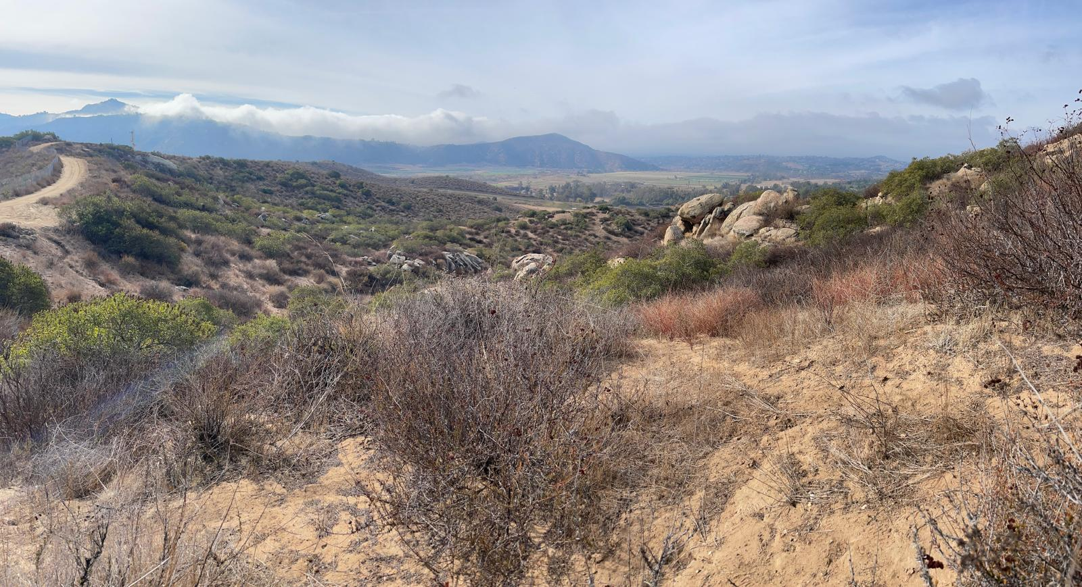
Figure 3. The Biodiversity Reserve in December, waiting for rain.

Work Anticipated Next Period
Work anticipated next period includes seeding of collected annual species in the project area, experimental cactus plantings (dry lay on the ground without irrigation), and planning of the irrigation install. We will monitor stinknet germination and begin manual removal or post-emergent treatment of germinated plants where appropriate, pending rain. We will also attend the 2025 Arizona-California Stinknet Symposium.

Issues to Note
No issues to note are anticipated in this period.

Photographs & Figures
Photographs and figures are invaluable! Please include photos in the Quarterly Progress Reports and any figures (if applicable). Both photos and figures may be included throughout the document under corresponding tasks or at the end following the Issues to Note section. Photographs taken at the same place or photographic points (photo-points) can assist SANDAG staff in tracking the project’s progress over time.
It is required that Photographs include:
- A before and after comparison sequence from the start to the completion of the project for photo points.
- A brief description of the corresponding tasks, date, and activity in the photograph.
- A copy of each photograph included in the report submitted in a .jpeg or .png file format.
It is required that Figures include:
- A caption with a brief description.
SDMMP Project Page
To receive reimbursement for work conducted within the quarter, submission of Quarterly Progress, Annual, and Final Reports must be added to your project’s Project Page on the SDMMP website. Add any necessary photographs to the photo carousal and fill out the photograph information. Please contact Sarah McCutcheon (smccutcheon@usgs.gov) or Emily Perkins (eperkins@usgs.gov) if you are having trouble accessing or editing your project page.

Project Performance Measures Instructions
SANDAG will utilize the SANDAG Performance Measures to document compliance with the Project. Grantee’s performance will be measured against the Performance Measures (Exhibit D) during the term of the project. More details on Performance Measures and Grant Recovery Plans are outlined in the Grant Agreements.
To access the Project Performance Measures Excel Spreadsheet:
- Simply double-click on the Excel icon located under the Project Performance Measures section.
  - An excel sheet will open, please fill out and then click save.
- Once the Excel spreadsheet is saved, please exit Excel and the spreadsheet will automatically update the icon in the Quarterly Progress Report Word document.
When opening the document with the Project Performance Measures Excel Spreadsheet:
- When you first open the Quarterly Progress Report Template, a warning message will open (image of the warning message below)
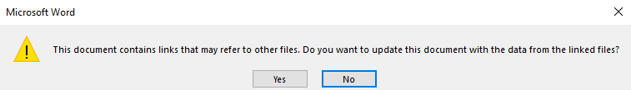
  - Click Yes to update the links in the document.

Performance Measures
Please include the Project’s Performance Measures for each Quarterly Invoice and Progress Report in order to receive reimbursement.

