San Diego Association of Governments
Rare Dune Species Restoration Project
Nature Collective
Quarterly Progress Report
Reporting Period: March 08, 2023 –June 30, 2023
Submission Date: July 20, 2023
SANDAG Contract Number: S1125507

Quarterly Status Report Overview
During this reporting period Nature Collective staff began project planning, baseline mapping, and installed photo points and monitoring transects. We took baseline vegetation transect data and completed rare plant surveys using SDMMP IMG protocol for Nuttall’s acmispon (Acmispon prostratus) (ACMPRO) and Orcutt’s yellow pincushion (Chaenactis glabriuscula var. orcuttiana). During this quarter we began weed control efforts and debris removal. We also began seed collection and propagation at our nursery and in coordination with San Diego Botanic Garden (SDBG).

Work Performed this Period:

Task 1- Seed Collection & Propagation
We started collecting seeds for propagation and spreading on 05/18/2023. We collected on three dates including one volunteer event on 06/07/2023. We collected seed from nine species totaling 3.6 lbs. Details on species and weight per species are included in Table 1. We are approximately 70% complete with seed collection efforts for Year 1.
Species | Common Name | 5/18/23 | 6/7/23 | 6/14/23 | Total (g) | Total (lbs.)
Abronia maritima | sticky sand verbena | 98 | 465 | - | 563 | 1.2
Abronia umbellata var. umbellata | pink sand verbena | 178 | 328 | - | 506 | 1.1
Acmispon prostratus | Nuttall’s acmispon | 6 | 221 | - | 227 | 0.5
Ambrosia chamissonis | beach bur | 23 | 208 | - | 231 | 0.5
Camissoniopsis cheiranthifolia ssp. suffruticosa | beach primrose | 33 | 26 | - | 59 | 0.1
Chaenactis glabriuscula var. orcuttiana | Orcutt’s yellow pincushion | - | 5 | - | 5 | 0.01
Croton californicus | California croton | - | 3 | 40 | 43 | 0.1
Lupinus concinnus | Bajada lupine | 3 | - | - | 3 | 0.007
Nicotiana clevelandii | Cleveland’s tobacco | 4 | - | - | 4 | 0.009
Total |  | 345 | 1256 | 40 | 1641 | 3.6
Table 1. Seed Collected for Propagation and Spreading
We have begun propagation and seed treatments of sticky sand verbena (Abronia maritima) , pink sand verbena (Abronia umbellata var. umbellata), sea cliff buckwheat (Eriogonum parviflorum), beach bur (Ambrosia chamissonis), beach primrose (Camissoniopsis cheiranthifolia ssp. suffruticosa), and California croton (Croton californicus). We have initiated a growing agreement with San Diego Botanic Garden (SDBG) wherein they will grow the species and quantities listed in Table 2 for planting in winter 2024. We are approximately 30% complete with seed collection and propagation efforts for Year 1.

Species | Common Name | Quantity
Abronia maritima | sticky sand verbena | 150
Abronia umbellata var. umbellata | pink sand verbena | 270
Ambrosia chamissonis | beach bur | 150
Camissoniopsis cheiranthifolia ssp. suffruticosa | beach primrose | 250
Croton californicus | California croton | 230
Eriogonum parviflorum | sea cliff buckwheat | 180
Total |  | 1230
Table 2. Container Plant (1-gallon) Expectations for Year 1

Task 2- Work & Monitoring Plan
During this quarter we have completed planning and researching for seed collection, propagation, seeding, planting, maintenance, and monitoring. Planning has involved creating timelines and expectations for each task throughout the course of the project. We are 100% complete with the work and monitoring plan.

Task 3- Seeding & Planting
Seeding and planting efforts have not yet commenced. Seeding efforts will begin in Fall 2023 and planting will begin in Winter 2024 or once the plants we have grown from seed are ready for outplanting. We are 0% complete with this task.

Task 4- Maintenance
We began maintenance activities shortly following the Notice to Proceed on 03/08/2023. We have hosted four volunteer events for weed control and debris removal- these events took place on 03/08, 04/05, 04/26, and 05/03/2023. Volunteer events consisted of hand pulling non-native and invasive species including European sea rocket (Cakile maritima), yellow sweet clover (Melilotus indicus), crystal iceplant (Mesembryanthemum crystallinum), etc. We used 12 gallons of Round up Pro Concentrate mixed at 2.5% to foliar spray large patches of iceplant species, sea lavender (Limonium sinuatum), European sea rocket, and other target non-native species within the West Basin Dune project area. We did not foliar spray areas with dense cover of rare plants, we carefully spot sprayed in any areas where rare species were observed. We removed debris from sand verbena that had accumulated at Cardiff Living Shorelines after the strong winter storms. We removed patches of beach primrose debris at West Basin Dunes. These dead shrubs are being removed to create open sand areas for seeding of rare species in the fall. Maintenance for Year 1 is approximately 60% complete.

Task 5- Monitoring
We established photo monitoring points on 03/16/2023 throughout the project area and we documented site conditions at the beginning and end of this reporting period. Photo-point locations are shown in Appendix A: Map B. Baseline photos are included in Appendix B, Appendix C includes photo points that were taken on 06/12/2023.
We began botanical monitoring efforts on 04/12/2023. For monitoring we mapped the occurrence extent of rare species including Nuttall’s Acmispon, Orcutt’s yellow pincushion, and coast woolly heads (Nemacaulis denudata var. denudata). The mapping results can be view in Appendix A: Map E, F, G, H, I. We used SDMMP (San Diego Management and Monitoring Plan) MSP (Management Strategic Plan) IMG (Inspect and Manage) protocol to conduct surveys for Nuttall’s acmispon and Orcutt’s yellow pincushion. We used the three established sample plots for Nuttall’s acmispon as well as a ten additional 2.5 m radius plots at Cardiff Living Shoreline to assess percent cover within the species occurrence. We completed an exact count of all Nuttall’s acmispon individuals within the occurrence extent, the total individuals counted was 10,836. Table 3 shows a breakdown of the population count between sites: West Basin Dunes (WBD), Seaside Terrace Dunes, and (Cardiff Living Shorelines). The increase in individuals at West Basin Dunes is likely due to favorable climactic factors such as above average precipitation and cool temperatures during the active growing season. WBD is also blocked from harsh environmental conditions such as wind and high tides putting less stress on the individuals at this site than at CLS and STD. Winter storms washed away much of the sand that made up the foredune of Cardiff Living Shorelines and Seaside Terrace Dune, therefore, inferences can be made that sand movement had an impact on the population density of Nuttall’s acmispon. Additionally, mounds of sand were observed along the fence line of CLS and Highway 101 following clean-up efforts after strong winter storms. These mounds were located in areas that ACMPRO was mapped in 2022, however, we did not observe the species in these same areas in 2023.
 | Individual Count |  | Individual Count  Difference | Area Mapped 2022 |  | Area Mapped 2023 |  | Area Mapped  Difference
Area | 2022 | 2023 | 2022 to 2023 | Sq. M | Acres | Sq. M | Acres | 2022 to 2023 (Sq. M.)
1 (WBD) | 7,273 | 8,743 | 1,470 | 4,559.2 | 1.1 | 6,089.0 | 1.5 | 1,529.8
2 (STD) | 2,126 | 1,920 | -206 | 2,035.3 | 0.50 | 1,193.8 | 0.29 | -841.5
3 (CLS) | 247 | 63 | -184 | 371.6 | 0.10 | 111.4 | 0.03 | -260.3
4 (CLS) | 37 | 11 | -26 | 66.5 | 0.02 | 19.8 | 0.01 | -46.7
5 (CLS) | 34 | 28 | -6 | 109.2 | 0.03 | 90.4 | 0.02 | -18.8
6 (CLS) | 21 | 13 | -8 | 55.2 | 0.01 | 72.8 | 0.02 | 17.6
7 (CLS) | 54 | 41 | -13 | 170.7 | 0.04 | 131.8 | 0.03 | -39.0
8 (CLS) | 16 | 1 | -15 | 6.0 | 0.00 | 0.1 | 0.00 | -6.0
9 (CLS) | 4 | 7 | 3 | 0.8 | 0.00 | 10.5 | 0.00 | 9.7
10 (CLS) | 75 | 9 | -66 | 63.2 | 0.02 | 12.3 | 0.00 | -50.9
Total | 9,887 | 10,836 | 949 | 7,437.7 | 1.9 | 7,731.7 | 1.9 | 294.0
Table 3. Population Count and Mapped Extent of Nuttall’s acmispon 2022-2023
Figure 1 shows the plants per mapped extent of Nuttall’s acmispon compared to the accumulated rainfall. The number of plants recorded within the extent has risen overall since 2016, however, different surveyors year to year and user bias should be taken into consideration when reviewing the data.
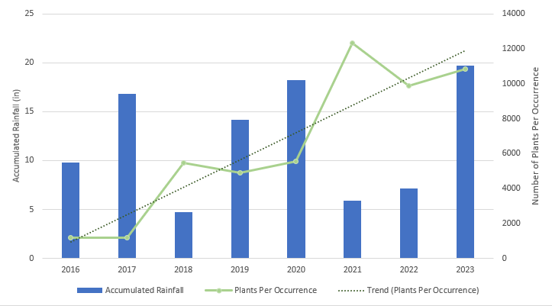
Figure 1. Number of Plants Per Occurrence of Nuttall’s acmispon and Accumulated Rainfall per Rain Year (October to September)

Figures 2-5 show the species composition of all sample plots using IMG protocol. Percent cover of ACMPRO ranges from 0-3%, the highest percent cover was recorded at Cardiff State Beach. It should be noted that when doing percent cover surveys most plants were small and leaves were curled up -likely in response to the intense sunlight or drought stress-both of which conditions may have resulted in a lower percent cover being recorded
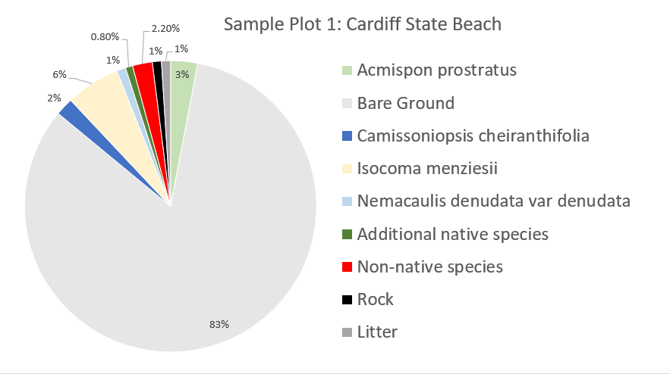
Figure 2. Species Composition for Nuttall’s acmispon Sample Plot 1 at Cardiff State Beach
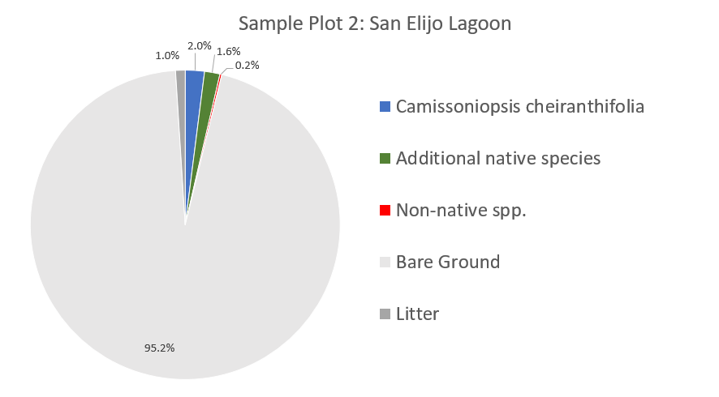
Figure 3. Species Composition for Nuttall’s acmispon Sample Plot 2 at San Elijo Lagoon

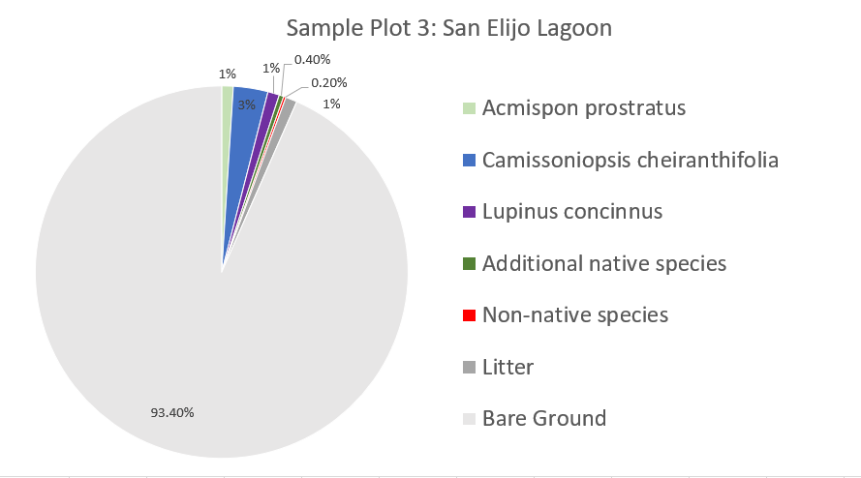
Figure 4. Species Composition for Nuttall’s acmispon Sample Plot 3 at San Elijo Lagoon

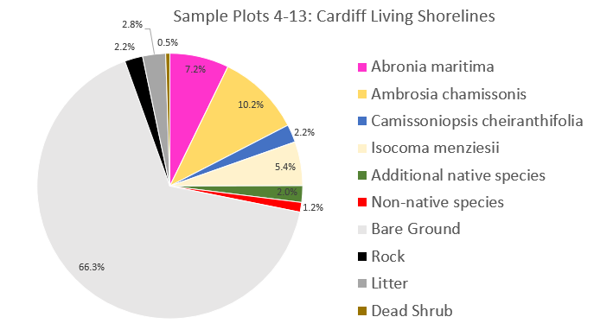
Figure 5. Species Composition for Nuttall’s acmispon Sample Plots 4-13 at Cardiff Living Shorelines

Orcutt’s yellow pincushion is not included on the list of species monitored under the MSP IMG protocol, however we wanted to establish a monitoring plot and keep the protocol consistent with our monitoring for Nuttall’s acmispon. We established a sample plot in WBD (Appendix A: Map D) and counted all individuals or clusters of individuals within the occurrence extent which includes Seaside Terrace Dune, West Basin Dunes, and Harbaugh Seaside Trails- we counted 27,228 individuals. Table 4 shows a breakdown of recorded individuals per site and the mapped area size. Figure 6 shows the percent cover data recorded at the IMG sample plot for Orcutt’s yellow pincushion.
Site | Count | Mapped Area (sq m) | Mapped Area (acres)
Seaside Terrace Dunes | 534 | 31.8 | 0.09
West Basin Dunes | 24,752 | 765.7 | 0.19
Harbaugh Seaside Trails | 1942 | 1,099.8 | 0.27
Total | 27,228 | 1,897.3 | 0.55
Table 4. 2023 Population Count and Mapped Extent of Orcutt’s yellow pincushion

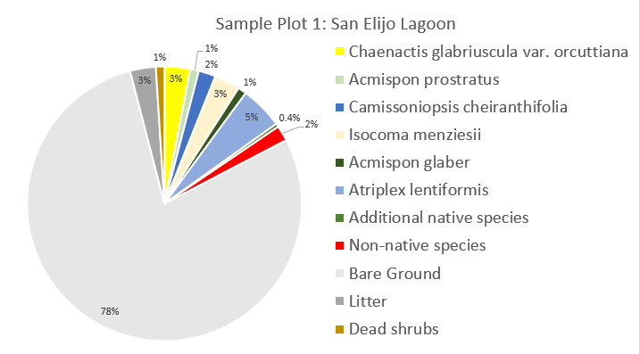
Figure 6. Species Composition for Orcutt’s yellow pincushion Sample Plot 1 at San Elijo Lagoon

We installed 16 vegetation monitoring transects (Appendix A: Map C) throughout the project site on 04/18/2023. We decided to use the same protocol that San Diego Audubon Society used for monitoring on their Coastal Dune Vegetation Enhancement Project- SANDAG contract number: 5004729. This protocol was used so that we will comparable data to a successful project. The vegetation transects involves a combination of point intercept and quadrats. The point intercept data is taken at every 0.25 m along a meter tape that runs for 10 meters. All vegetation is recorded at every 0.25 m, as well as ground cover and a height category. A 1 m sq quadrat is placed at the origin of 1 m, on the left side of the tape, within each quadrat vegetation; sand; bare ground; litter; and rock are designated a percent cover class. Any new species found in the quadrat that were not recorded for point intercept are recorded, we also recorded any additional species found along a 2-meter belt on the transect tape. Photos were taken at the start and end of each transect and are included in Appendix D. Figures 7-9 show the average native vs. non-native cover of the three sites and Figure 10-12 show the average species composition and ground cover of each site.

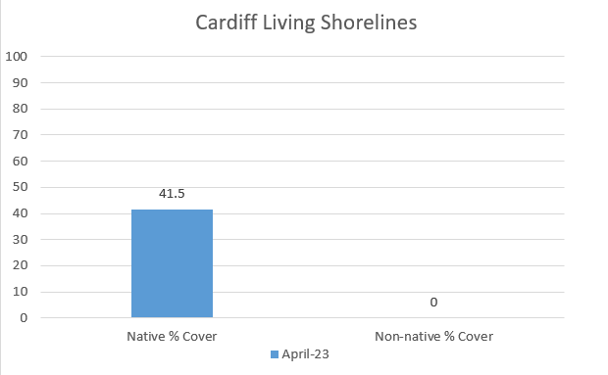
Figure 7. Native vs. Non-native Cover at Cardiff Living Shorelines

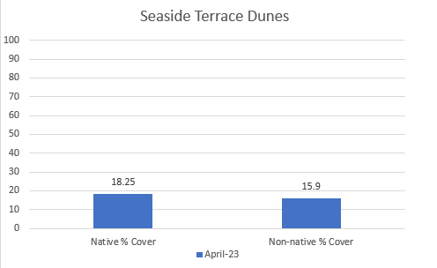
Figure 8. Native vs. Non-native Cover at Seaside Terrace Dunes

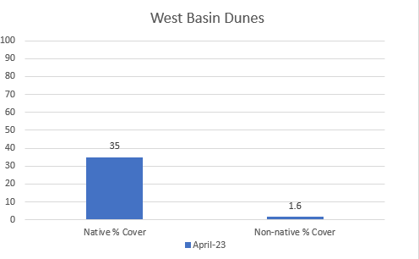
Figure 9. Native vs. Non-native Cover at West Basin Dunes
.
Seaside Terrace Dunes (STD) has the highest non-native cover and the lowest native cover. This can likely be attributed to winter storms impacting much of the dunes and heavy foot traffic bringing in an influx of non-native species. Sweet clover (Melilotus indicus) and burclover (Medicago polymorpha) were the prominent non-native species at STD, primarily in areas with high foot traffic. Many of our volunteer events in this reporting period were focused on hand removal of non-native species at STD.

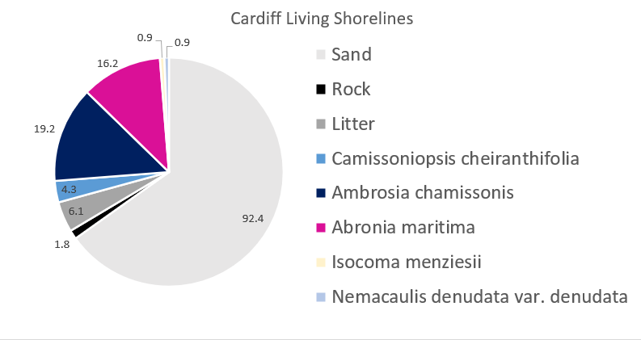
Figure 10. Species Diversity and Ground Cover at Cardiff Living Shorelines

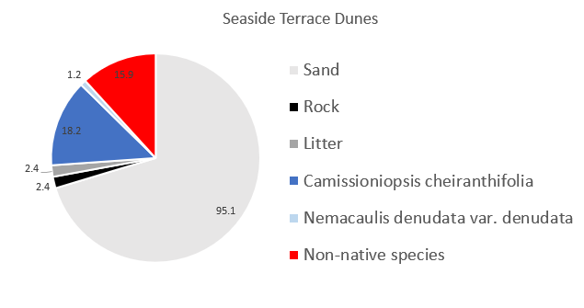
Figure 11. Species Diversity and Ground Cover at Seaside Terrace Dunes

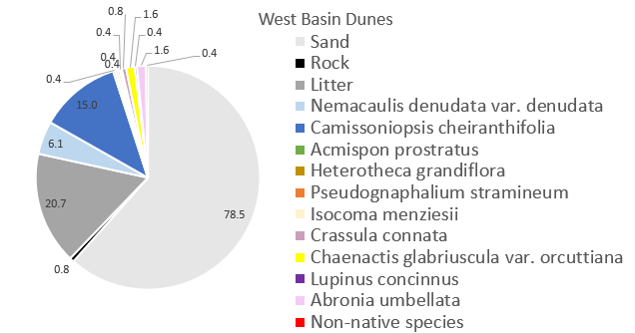Figure 12. Species Diversity and Ground Cover at West Basin Dunes

Low species richness at CLS and STD is the result of limited species being planted during the implementation of these restoration sites. We expect species richness and diversity to increase after future planting and seeding efforts. West Basin Dunes has the highest species richness, however large patches of debris or “litter” – as recorded on the transect – are found throughout the site which inhibits the growth of other native species. We plan to remove patches of debris in the next quarter.
Since completing our quarterly vegetation transects, quarterly photo monitoring, annual IMG monitoring, and annual rare plant mapping we estimate we are 75% complete with monitoring for Year 1.

Task 6- Reporting & Media
During this period, we have completed quarterly reporting and we created and updated our SDMMP Project Page. We are approximately 30% complete with reporting for Year 1.

Task 7- GOIN Program
We have not hosted a GOIN event this quarter. We are 0% complete with this task.

Task 8- Administrative
We began administrative tasks in March 2023 including project management, planning, and invoicing. We are approximately 15 % complete with this task.

Work Anticipated Next Period
We will continue with weed control using hand removal methods. We will remove large patches of debris to make open sand areas for seeding of rare plants species. We will continue to collect seed from target species and propagate them in our native plant nursery and in partnership with SDBG. Next quarter we anticipate sowing seeds of sensitive species including Nuttall’s acmispon, Orcutt’s pincushion, and coast woolly heads.

Issues to Note
After the project planning began, we determined that we will more than likely not be able to meet two of our performance measures including “Atriplex coulteri – 200 individuals restored” and “Phacelia stellaris” – 200 individuals restored”. However, we anticipate restoring 400+ individuals of Chaenactis orcuttiana ssp. glabriuscula (Orcutt’s yellow pincushion) to replace those performance measures. Orcutt’s yellow pincushion is listed at California Rare Plant Rank 1B.1 – “Plants rare, threatened, or endangered in California and elsewhere; seriously threatened in California” and has only 20 presumed extant occurrences in California. (CNPS, RPP 2023) We do not expect to meet the original performance measures due to the lack of seed available to ethically collect from these sensitive species as well as the difficult germination requirements.

Photographs & Figures
All project photo monitoring, transect photo monitoring, and project photos are included in the appendices following this report.
- Appendix B: Photo Monitoring – Baseline
- Appendix C: Photo Monitoring – 06/12/2023
- Appendix D: Transect Photo Monitoring – Baseline
- Appendix E: 2023 Q2 Project Photos

Performance Measures

References
California Native Plant Society (CNPS), Rare Plant Program (RPP). 2023. Rare Plant Inventory (online edition, v9.5). Website https://www.rareplants.cnps.org [accessed 20 July 2023].

