San Diego Association of Governments
Rare Dune Species Restoration Project
Nature Collective
Quarterly Progress Report
Reporting Period: January 1, 2025 – March 31, 2025
Submission Date: April 21, 2025
SANDAG Contract Number: S1125507

Quarterly Status Report Overview
During this reporting period Nature Collective staff installed and maintained container plants at Seaside Terrace Dune. Volunteers were used to help hand weed the entire project boundary.

Work Performed this Period:

Task 1- Seed Collection & Propagation
During this quarter we continued with propagation of seed in our nursery. We are 75% complete with seed collection and propagation efforts.

Task 2- Work & Monitoring Plan
This task has been completed.

Task 3- Seeding & Planting
During this quarter NC staff installed and watered a total of 30 container plants in the Seaside Terrace Dunes during our Get Out In Nature (GOIN) event (Table 1). A combination of dune and coastal sage scrub species were installed to replace mortality and fill in small trails from off path foot traffic.
Table 1. Containers Planted at Seaside Terrace Dune – Q1 2025
Species | Common name | Qty. (1gal)
Acmispon glabor | deerweed | 5
Ambrosia chamissonis | beach bur | 5
Camissoniopsis cheiranthifolia ssp. suffruticosa | beach primrose | 7
Eriogonum parvifolium | sea cliff buckwheat | 6
Lycium californicum | California boxthorn | 2
Peritoma arborea | bladderpod | 5
Total |  | 30

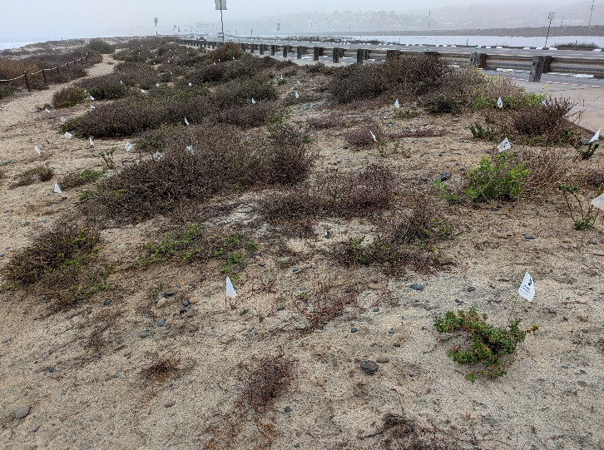
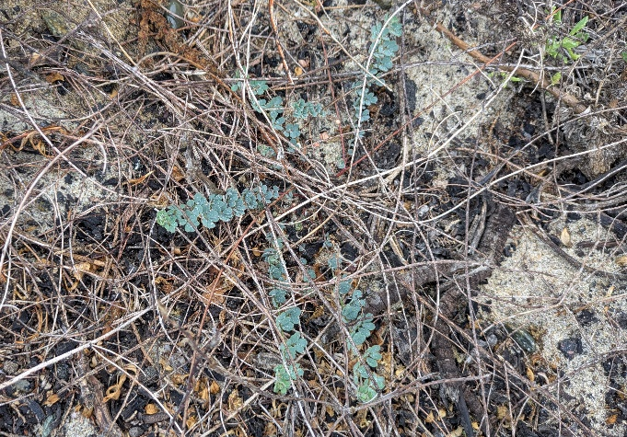
After receiving about 3-inches of rain in March, germination of Nuttal’s acmispon (Acmispon prostratus) was seen predominately in the West Basin and Seaside Terrace Dunes where debris removal, weed control, and seed distribution has been occurring throughout the life of the project. SDMMP Inspect and Manage (IMG) surveys are planned for late April/ early May to assess the species distribution in the project areas.
Photo 1. Nuttal’s acmispon germinating Photo 2. Seaside Terrace Dune planting site

Task 4- Maintenance
During this quarter we continued with irrigation of new and old container plants. During two events, volunteers helped to hand weed around native species in the Seaside Terrace Dune as well as the entire stretch of the Cardiff Living Shoreline. The main target species continues to be annual yellow sweetclover (Melilotus indicus) and European searocket (Cakile maritima). We are 60% complete with the maintenance task.

Task 5- Monitoring
Monitoring did not take place during this quarter but is planned for the next reporting period. We are approximately 35% complete with the monitoring task.

Task 7- GOIN Program
We held our GOIN event at the Seaside Terrace Dune on February 22, 2025. 34 3rd-5th grade students and their families participated in planting and watering 1-gallon containers, as well as learning about the ecological importance of sensitive dune species. We are 100% complete with the GOIN task.

Task 8- Administrative
Yassin Wahhab, Habitat Restoration Manager, oversaw and participated in daily planning, project management, invoicing, monitoring and restoration tasks during this period. We are approximately 60% complete with this task.

Work Anticipated Next Period
We will continue with irrigation of new plantings and weed control using hand and chemical removal methods. Monitoring will occur next report period along the 16 transect/quadrat locations.

Issues to Note
As stated in previous quarterly reports- after project planning began, we determined that we will more than likely not be able to meet two of our performance measures including “Atriplex coulteri – 200 individuals restored” and “Phacelia stellaris” – 200 individuals restored”. However, we anticipate restoring 400+ individuals of Chaenactis orcuttiana ssp. glabriuscula (Orcutt’s yellow pincushion) to replace those performance measures. Orcutt’s yellow pincushion is listed at California Rare Plant Rank 1B.1 – “Plants rare, threatened, or endangered in California and elsewhere; seriously threatened in California” and has only 20 presumed extant occurrences in California (CNPS, RPP 2023). We do not expect to meet the original performance measures due to the lack of seed available to ethically collect as well as the difficult germination requirements.

Photographs & Figures
All maps are included in Appendix A following this report.

Performance Measures

