San Diego Association of Governments
Ocean Beach Estuary Enhancement Project
The San Diego River Park Foundation (SDRPF)
Quarterly Progress Report
Reporting Period: 05/18/23 – 06/30/23
Submission Date: 07/21/23
SANDAG Contract Number: S1125510

Quarterly Status Report Overview
PLEASE DO NOT CHANGE OR ALTER THE FORMATTING OF THIS DOCUMENT! SANDAG has developed a standardized grant monitoring and tracking program for the Environmental Mitigation Program (EMP) Land Management Grant Program. The purpose is to collect information on individual projects and the grant program as a whole for reporting to the Regional Habitat Conservation Taskforce, SANDAG Policy Advisory Committees, and the SANDAG Board of Directors. SANDAG monitors grantees through invoices, progress reports, performance measures, and designated photograph points. These standardized reporting templates and instructions for submittal are included below.

Work Performed this Period:

Task 1 - Invasive Removal and Habitat Restoration
With the Notice to Proceed, staff participated in an initial planning meeting on June 12, 2023 to receive updates on the status of the Site Development Permit (submitted, pending) from the City of San Diego Planning Department and the Coastal Development Permit submittal to the California Coastal Commission (will be submitted pending award of City Site Development Permit, as directed by Coastal Commission staff). No field work has begun on this task at this time.
0% complete.

Task 2 - Access Control
As reported in Task 1, staff participated in a planning meeting on June 12 to discuss status of project permitting and next steps. No field work has begun at this time.
0% complete.

Task 3 - Community Engagement, Education and Outreach
Chief Operating Officer met with engagement staff to outline scope of work for project, collateral needs, partner roles, and outreach strategy. No field work has begun at this time.
0% complete.

Task 4 – Monitoring
Staff coordinated in late May with the City of San Diego Biologist to allow SDRPF staff and San Diego Audubon Society (SDAS) staff to participate in the City’s annual Rare Plant Monitoring for the salt marsh bird’s beak (Chloropyron maritimum ssp. maritimum) in the project area on June 8, 2023. This survey provided training for project partners to inform future expansion of the rare plant monitoring enabled by this grant. This was conducted later in the season than is typical, likely as a result of the wet winter and delayed bloom. Data will be shared after it is processed with the next quarterly report. Photos included.
1.5% complete

Task 5 - Administration
SDRPF staff initiated project administration on May 18, 2023 with the Notice to Proceed. Staff coordinated with project partners to schedule a kickoff meeting to include SDRPF, SDAS, and City staff from the Natural Resources team, Shoreline Rangers and Mission Bay Park Rangers. Staff worked with SDAS to advance developing an MOU for the project partnership, and scheduled and attended a Labor Compliance meeting with GAFCON on June 27, 2023. SDRPF developed internal budget tracking documents and planning to begin project.
3.5% complete.
Provide the exact work start date, a description of the work completed under each task, and percent complete. Add additional tasks as necessary

Work Anticipated Next Period
This does not need to be task specific but should include a short paragraph or bullet point list of activities anticipated for next quarter.

In Q3 of 2023, SDRPF and project partners expect to launch coordinated outreach and engagement efforts in advance of fall field work. We will finalize and execute the MOU with the San Diego Audubon Society. We expect to support the City’s submittal of the Coastal Development Permit package for this project. We will host volunteer trainings for invasive removal leaders, volunteer botanists and docents.

Issues to Note
Please provide a brief description of any issue(s) encountered during the reporting period and any steps taken to address the issue(s).

No significant issues to note, but a few minor notes:
Due to the later than expected Notice to Proceed and slow permit timelines, some field work (invasive removal in sensitive areas and access control) will not begin until at least fall after bird nesting season ends and the appropriate permits are secured. Finally, we have not submitted match with this first invoice for several reasons: first, the City of San Diego and San Diego Audubon Society have not completed setting up and reporting on their match tracking system, which will be resolved and reported on in the coming quarter; second, a significant portion of the match is anticipated to be met through in-kind service by community volunteers, but because of the NTP in the spring instead of the fall/winter (as was initially anticipated), volunteer work will begin in earnest in a future quarter after nesting season. We do not expect this to affect our ability to meet the match commitments in the grant agreement.

Photographs & Figures
Photographs and figures are invaluable! Please include photos in the Quarterly Progress Reports and any figures (if applicable). Both photos and figures may be included throughout the document under corresponding tasks or at the end following the Issues to Note section. Photographs taken at the same place or photographic points (photo-points) can assist SANDAG staff in tracking the project’s progress over time.
It is required that Photographs include:
- A before and after comparison sequence from the start to the completion of the project for photo points.
- A brief description of the corresponding tasks, date, and activity in the photograph.
- A copy of each photograph included in the report submitted in a .jpeg or .png file format.
It is required that Figures include:
- A caption with a brief description.

Photos from Task 4 Monitoring:
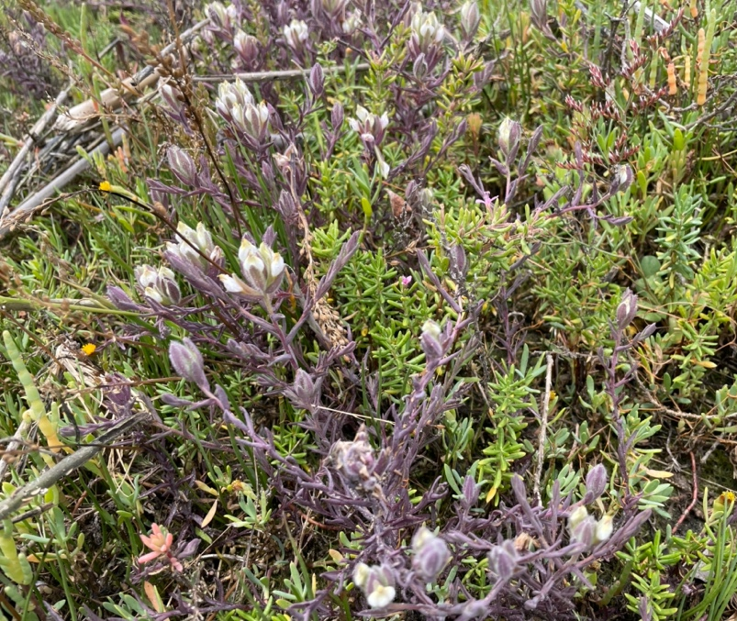
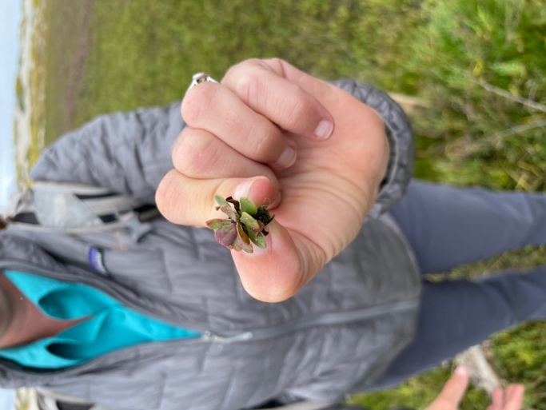
Photo 1 and 2: Salt marsh bird’s beak in bloom (left) and invasive sea lavender that crowds the salt marsh bird’s beak (right)

Photos 3 and 4: Project partners survey for salt marsh bird’s beak

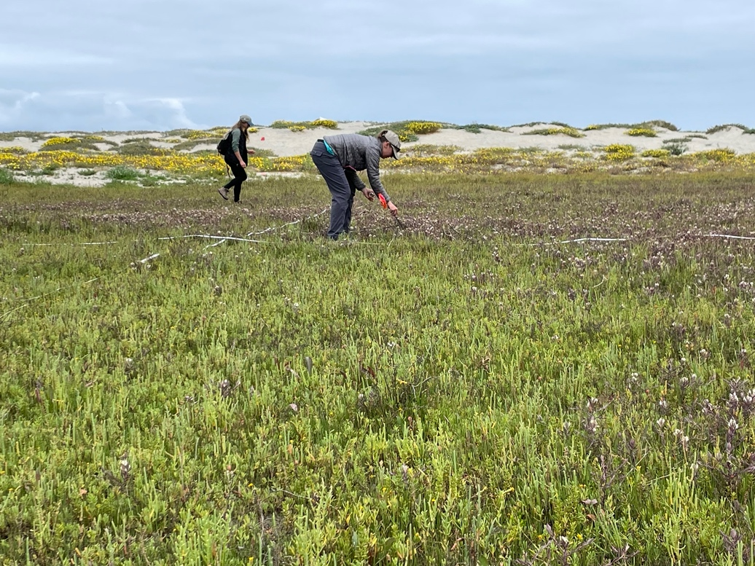

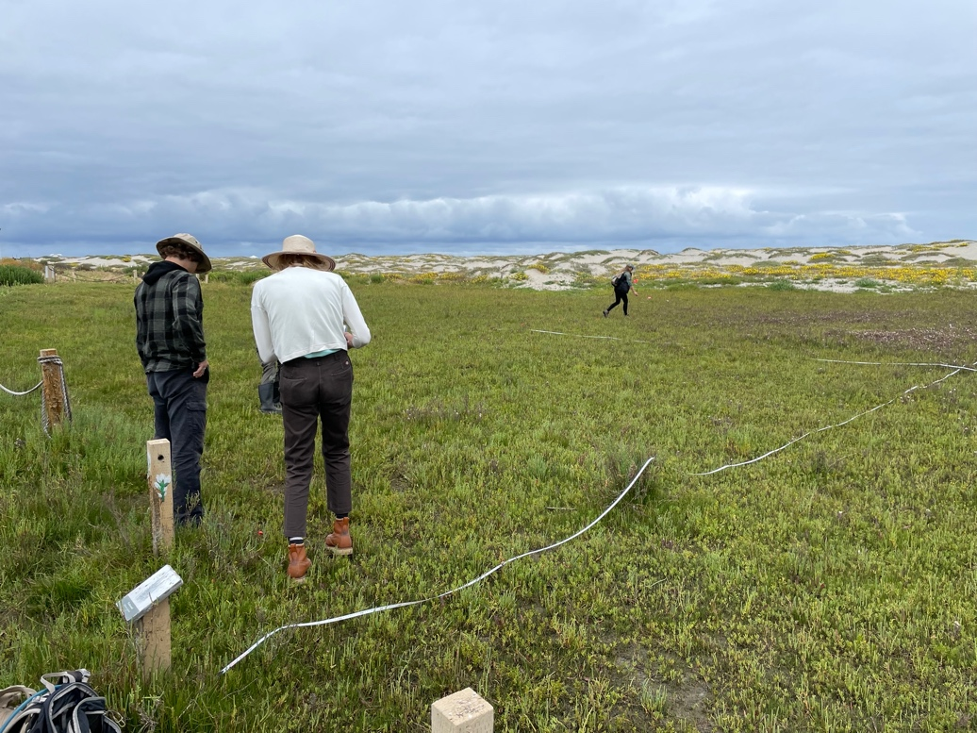
Photo 5: Group photo from rare plant survey, June 8, 2023
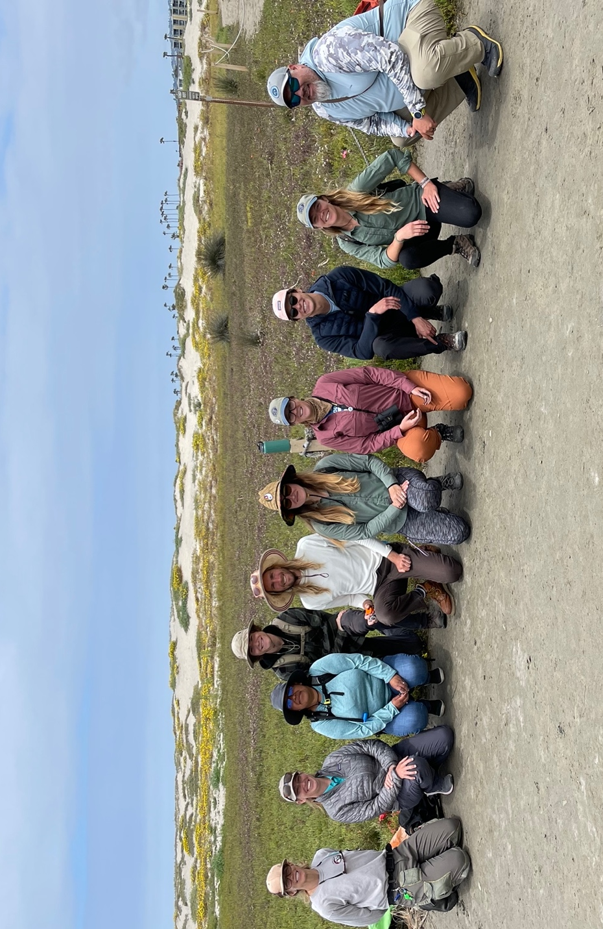

SDMMP Project Page
To receive reimbursement for work conducted within the quarter, submission of Quarterly Progress, Annual, and Final Reports must be added to your project’s Project Page on the SDMMP website. Add any necessary photographs to the photo carousal and fill out the photograph information. Please contact Sarah McCutcheon (smccutcheon@usgs.gov) or Emily Perkins (eperkins@usgs.gov) if you are having trouble accessing or editing your project page.

Project Performance Measures Instructions
SANDAG will utilize the SANDAG Performance Measures to document compliance with the Project. Grantee’s performance will be measured against the Performance Measures (Exhibit D) during the term of the project. More details on Performance Measures and Grant Recovery Plans are outlined in the Grant Agreements.
To access the Project Performance Measures Excel Spreadsheet:
- Simply double-click on the Excel icon located under the Project Performance Measures section.
  - An excel sheet will open, please fill out and then click save.
- Once the Excel spreadsheet is saved, please exit Excel and the spreadsheet will automatically update the icon in the Quarterly Progress Report Word document.
When opening the document with the Project Performance Measures Excel Spreadsheet:
- When you first open the Quarterly Progress Report Template, a warning message will open (image of the warning message below)
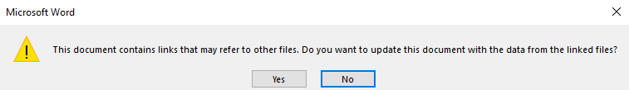
  - Click Yes to update the links in the document.

Performance Measures
Please include the Project’s Performance Measures for each Quarterly Invoice and Progress Report in order to receive reimbursement.

