San Diego Association of Governments
Ocean Beach Estuary Enhancement Project
The San Diego River Park Foundation (SDRPF)
Quarterly Progress Report
Reporting Period: 07/01/23 – 09/30/23
Submission Date: 10/23/23
SANDAG Contract Number: S1125510

Quarterly Status Report Overview
PLEASE DO NOT CHANGE OR ALTER THE FORMATTING OF THIS DOCUMENT! SANDAG has developed a standardized grant monitoring and tracking program for the Environmental Mitigation Program (EMP) Land Management Grant Program. The purpose is to collect information on individual projects and the grant program as a whole for reporting to the Regional Habitat Conservation Taskforce, SANDAG Policy Advisory Committees, and the SANDAG Board of Directors. SANDAG monitors grantees through invoices, progress reports, performance measures, and designated photograph points. These standardized reporting templates and instructions for submittal are included below.

Work Performed this Period:

Task 1 - Invasive Removal and Habitat Restoration
Because most of the invasive removal portion of our restoration project requires a Coastal Development Permit that has not yet been awarded, we continue to focus on planning and securing the permit (see Task 5 discussion of permit status). SDRPF staff met internally and with project partners to advance permit progress, to plan for work until permit is secured, and to be ready to begin work immediately after permits are secured. This included an on-site kick-off meeting on July 21.

In order to gain momentum in advance of permit award, we did engage volunteers in invasive removal alongside existing trails as part of the maintenance of the project site, and to limit growth of invasive species that germinated after the August storms. This work was limited to the existing trail corridors, while we await permit award. As part of an outreach and education event on September 24 hosted by SDRPF, San Diego Audubon Society (SDAS), and the City Park Ranger, we coordinated 22 volunteers to remove 10 cubic yards of invasive plants from the existing trail corridors. Photos from this event are included with this report as Photos 1-3.

In preparation for future work, staff also aggregated existing geospatial observations in and around the project area from iNaturalist. This community science data is a helpful baseline as we start restoration. A map showing the density of these observations is included with the figures section of this report as Figures 1, 2, and 3.

In addition, SDRPF interns, in coordination with staff, developed a handout on invasive and native plants and species of special concern (see figure 3). This handout will be utilized in future invasive removal events to educate the community and first-time volunteers about the distinctions between look-alike native and invasive plants in the project area. The handout also specifies species of concern, including coast woolly heads, salt marsh bird's beak, Nuttall's lotus, snowy plover, least tern, Ridgway's rail, and the Belding's savannah sparrow. We will continue to update this document as questions from the community are fielded through volunteer events and outreach. The handout is included with the figures section of this report as Figure 4.

2.0% complete.

Task 2 - Access Control
No field work has been completed for this task while project partners await permits to begin installing the access control fencing.

Complementary to this task, but not funded by this project, the San Diego Audubon Society and City Ranger worked with volunteers at the September 24th volunteer event to add some temporary signs designed by local kids encouraging trail users to stay on marked trails. This is part of a soft rollout of improvements to access control, timed to coincide with outreach and public education. Future more permanent signage funded by this project will include SANDAG logos and will be submitted in advance for approval. Photos of these signs are included with this report as Photos 4-5.

0% complete.

Task 3 - Community Engagement, Education and Outreach
The community engagement, education and outreach effort for this project has been designed to increase community awareness of the value of these rare habitats to help gain voluntary compliance with and community support of future access control.

For the third quarter of 2023, the San Diego River Park Foundation staff focused on outreach and education in the adjacent Point Loma and Ocean Beach neighborhoods by attending and hosting a total of 4 community events. Three of the outreach efforts were in conjunction with a volunteer event:
- 9/7/23: outreach presence set up at project site during Bioblitz event described in Task 4
- 9/9/23: outreach presence set up at project site during a trash clean-up (clean-up was not part of this project, but brought interested community members to the project site and presented an outreach opportunity)
- 9/24/23: outreach presence set up during habitat restoration event

In addition to these events, in order to reach additional community members who live and visit the area, staff and outreach volunteers attended the Point Loma Farmers’ Market on 9/3/23, where we were able to connect with 60 community members about the value of the habitat, the future access control project, and ways to get involved.

In addition, the San Diego Audubon Society hosted weekly docent programs in September to connect with community members. These were run by staff this month, but they are recruiting volunteer docents for future events. In addition, they have begun planning for additional outreach in the coming quarters, including a Bark Ranger program.
3.7% complete.

Task 4 – Monitoring
This quarter, both SDRPF and SDAS staff coordinated and planned for monitoring activities that can engage community members.

On September 7, the San Diego River Park Foundation conducted a volunteer Bioblitz in partnership with the San Diego Audubon Society. This event coincided with California's Biodiversity Week for 2023. 3 volunteers recorded 163 observations, accounting for 92 different species during the monitoring event. The iNaturalist project encompassing the observations recorded can be found here: https://tinyurl.com/OBestuary.

SDAS initiated discussions with Ridgway’s rail surveyors to identify the monitoring that they can do for rails and other species along the San Diego River at the River Mouth and Southern Wildlife Preserve. SDAS coordinated California Least Tern monitoring over the summer, and began exploring the methods for future King Tide and call-response surveys for Ridgway’s rail.

We are still awaiting the data report from the salt marsh bird’s-beak survey conducted last quarter, and will include in a future report once received.

2.2% complete

Task 5 - Administration
Project administration this quarter included submitting our first invoice and progress report, setting up the CIS and project page. In addition, staff submitted a Sole Source Contractor proposal, which was approved by SANDAG. Then, staff worked with SDAS to draft and execute Subcontractor Agreement, which enabled them to submit their own first invoice and progress report to SDRPF. Other project admin included correspondence with partners and SANDAG, updating budgets and coordinating timesheets and reports both internally and from partner organizations.

In addition, staff continued to meet with the City of San Diego and SDAS about the permits to enable this project. As previously reported, the invasive removal, fencing and some signage will require a Coastal Development Permit from the California Coastal Commission. The City of San Diego (as the landowner) is the lead for this application, and SDAS and SDRPF named partners in completing the work.

The permit packet was submitted to the Coastal Commission on July 1, 2022. The Coastal Commission has reviewed the permit packet and environmental compliance that the City staff prepared for this project and determined that this project first needs a Site Development Permit from the City of San Diego. The City submitted the Site Development Permit packet on August 2, 2022, all prior to NTP in order to be ready for this project.

This permit has been moving through the review process for more than a year. This quarter, we received direction from the City of San Diego Stormwater Dept. reviewers that the project will require an Army Corps of Engineers review for a Section 408 certification. This was unexpected, and will cause some delay while the Army Corps reviews our project. The Army Corps of Engineers have requested additional documents, which City staff are working to prepare promptly. With a possible federal government shutdown in November, we hope to complete this review quickly so as not to extend any review.

10% complete.

Provide the exact work start date, a description of the work completed under each task, and percent complete. Add additional tasks as necessary

Work Anticipated Next Period
This does not need to be task specific but should include a short paragraph or bullet point list of activities anticipated for next quarter.

In Q4 of 2023, SDRPF and project partners will continue coordinated outreach and engagement effort in advance of field work. We expect to support the City’s submittal of the Coastal Development Permit package for this project. We will host volunteer trainings for invasive removal leaders, volunteer botanists and docents.

Issues to Note
Please provide a brief description of any issue(s) encountered during the reporting period and any steps taken to address the issue(s).

As discussed in the Task 5 report above, the permitting for the project is taking longer than anticipated. We are working with the City of San Diego (the permit applicant) to resolve the remaining questions to submit the final permit package for review and award.

Photographs & Figures
Photographs and figures are invaluable! Please include photos in the Quarterly Progress Reports and any figures (if applicable). Both photos and figures may be included throughout the document under corresponding tasks or at the end following the Issues to Note section. Photographs taken at the same place or photographic points (photo-points) can assist SANDAG staff in tracking the project’s progress over time.
It is required that Photographs include:
- A before and after comparison sequence from the start to the completion of the project for photo points.
- A brief description of the corresponding tasks, date, and activity in the photograph.
- A copy of each photograph included in the report submitted in a .jpeg or .png file format.
It is required that Figures include:
- A caption with a brief description.

Task 1: Invasive Removal and Habitat Restoration
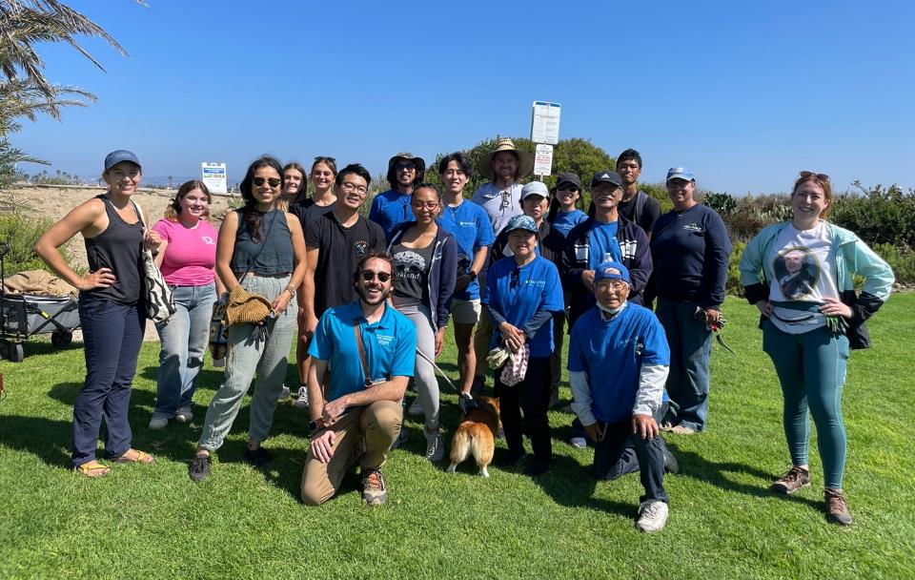
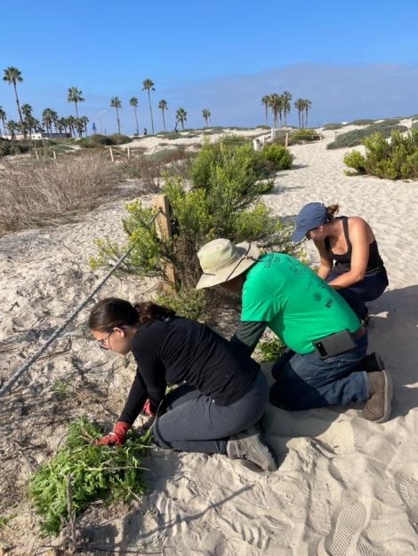
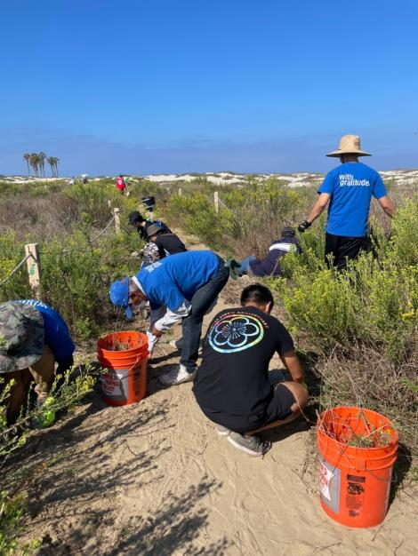
Photos 1-3: Volunteers remove invasive plants from within the existing trail corridor as part of the site maintenance during 9/24/23 work party and outreach event.
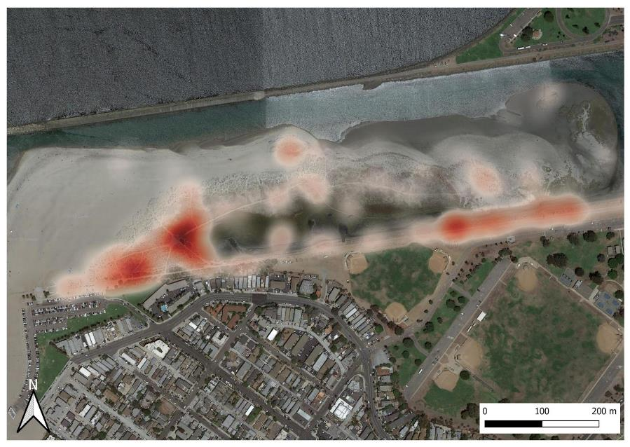
Figures 1-2: Map documenting invasive (top, red) and native (bottom, green) plant species observations from iNaturalist 2012-present.

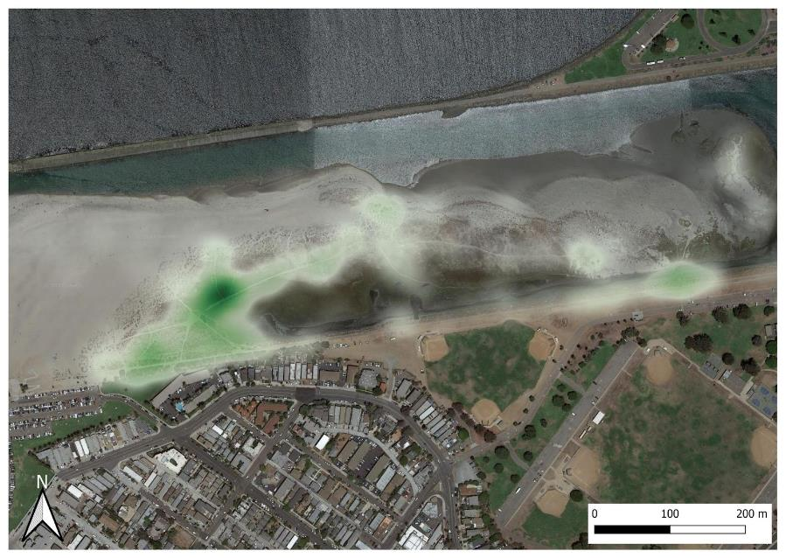
Figure 3: Map documenting salt marsh bird's beak (purple) and Ridgway's rail (pink) observations from iNaturalist 2012-present.
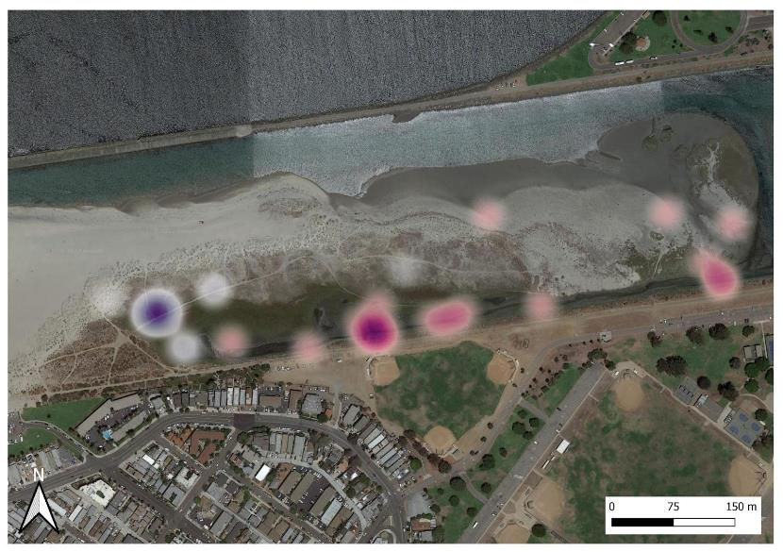

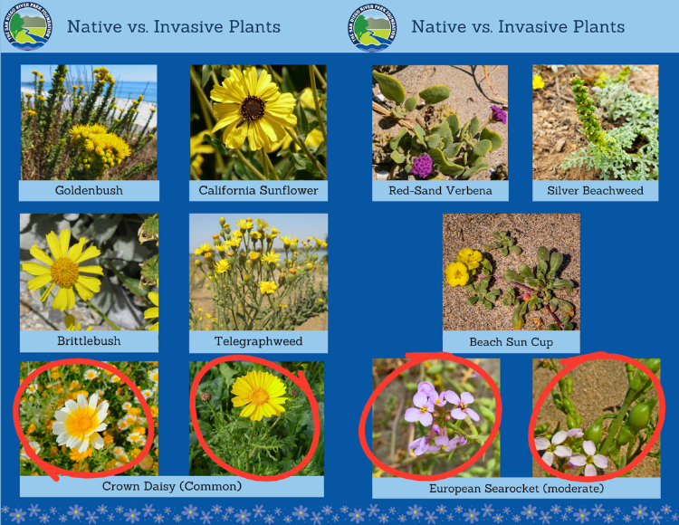
Figure 4: Hand out documenting invasive and native plants and species of special concern (6 pages).
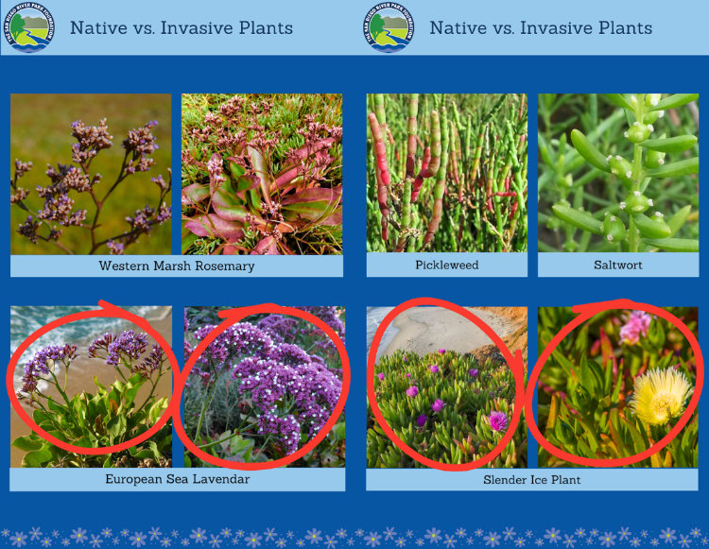
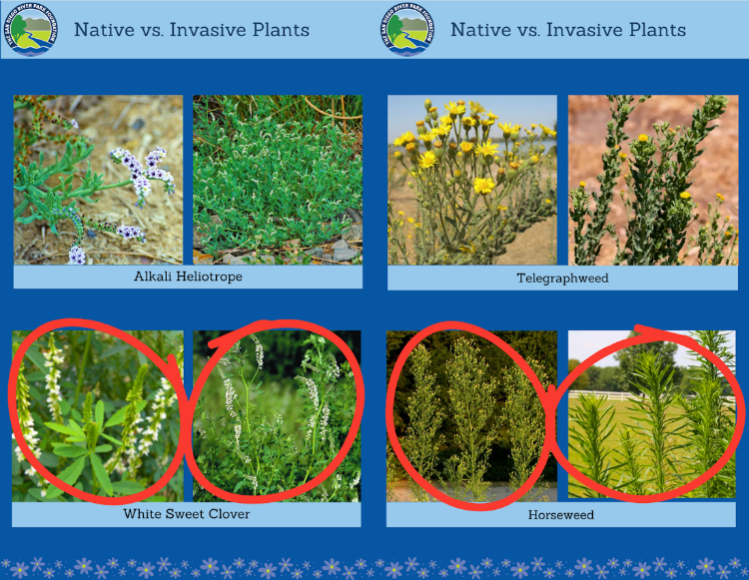

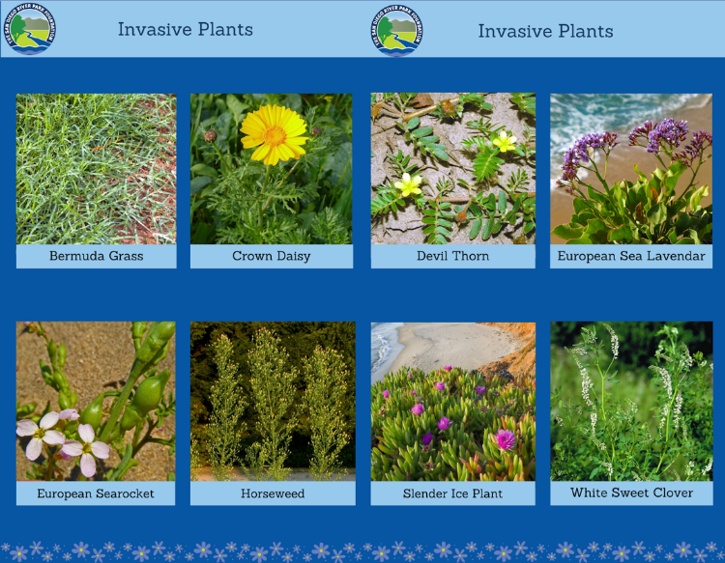
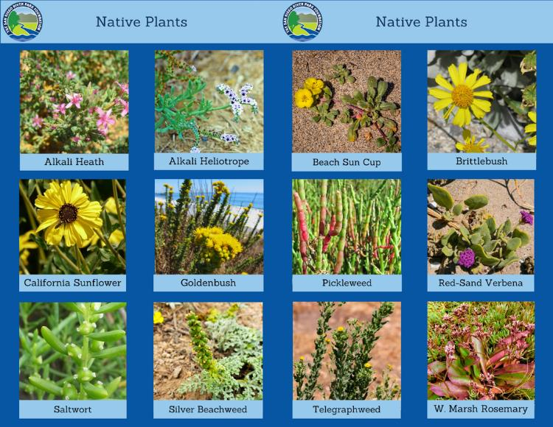

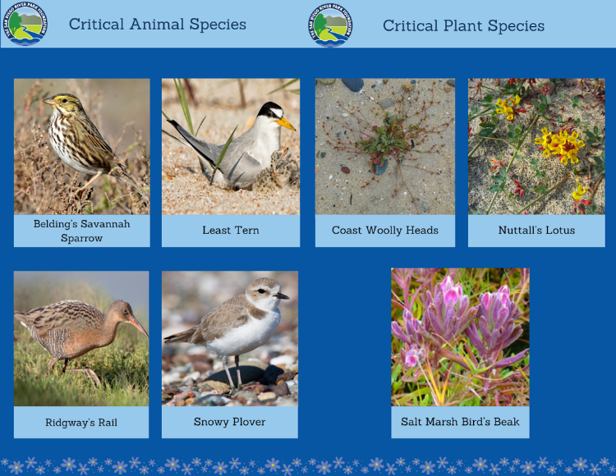
Task 2: Access Control
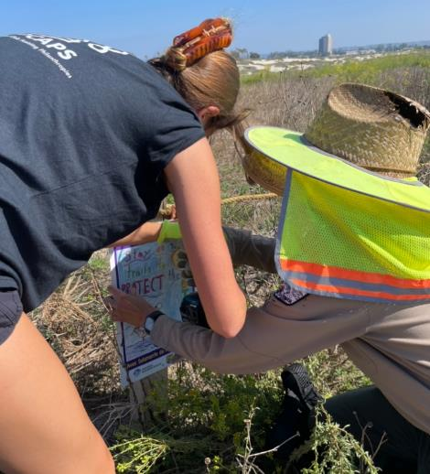
Photos 4 and 5: These signs were installed on 9/24/23. They were not billed to this project, but complement the project goals while we await permits to install new access control, and begin to introduce the upcoming access control improvements to trail users.
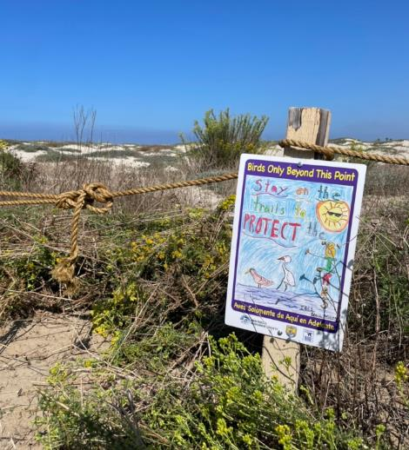

Task 3: Community Engagement, Education, and Outreach
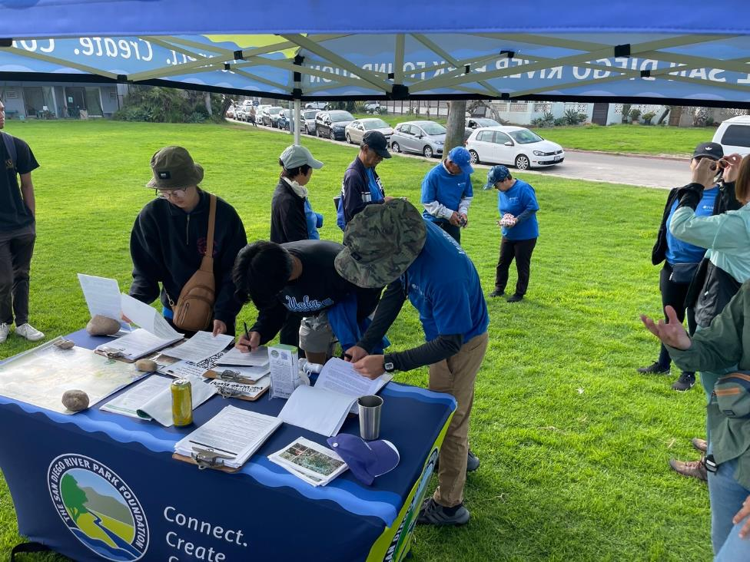
Photo 6: Outreach booth set-up at project site.

SDMMP Project Page
To receive reimbursement for work conducted within the quarter, submission of Quarterly Progress, Annual, and Final Reports must be added to your project’s Project Page on the SDMMP website. Add any necessary photographs to the photo carousal and fill out the photograph information. Please contact Sarah McCutcheon (smccutcheon@usgs.gov) or Emily Perkins (eperkins@usgs.gov) if you are having trouble accessing or editing your project page.

Project Performance Measures Instructions
SANDAG will utilize the SANDAG Performance Measures to document compliance with the Project. Grantee’s performance will be measured against the Performance Measures (Exhibit D) during the term of the project. More details on Performance Measures and Grant Recovery Plans are outlined in the Grant Agreements.
To access the Project Performance Measures Excel Spreadsheet:
- Simply double-click on the Excel icon located under the Project Performance Measures section.
  - An excel sheet will open, please fill out and then click save.
- Once the Excel spreadsheet is saved, please exit Excel and the spreadsheet will automatically update the icon in the Quarterly Progress Report Word document.
When opening the document with the Project Performance Measures Excel Spreadsheet:
- When you first open the Quarterly Progress Report Template, a warning message will open (image of the warning message below)
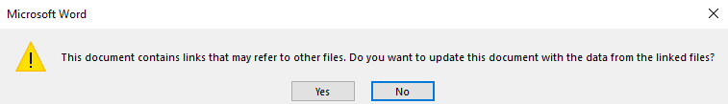
  - Click Yes to update the links in the document.

Performance Measures
Please include the Project’s Performance Measures for each Quarterly Invoice and Progress Report in order to receive reimbursement.

