San Diego Association of Governments
Ocean Beach Estuary Enhancement Project
The San Diego River Park Foundation (SDRPF)
Quarterly Progress Report
Reporting Period: 1/01/25 – 3/31/25
Submission Date: 4/21/24
SANDAG Contract Number: S1125510

Quarterly Status Report Overview
PLEASE DO NOT CHANGE OR ALTER THE FORMATTING OF THIS DOCUMENT! SANDAG has developed a standardized grant monitoring and tracking program for the Environmental Mitigation Program (EMP) Land Management Grant Program. The purpose is to collect information on individual projects and the grant program as a whole for reporting to the Regional Habitat Conservation Taskforce, SANDAG Policy Advisory Committees, and the SANDAG Board of Directors. SANDAG monitors grantees through invoices, progress reports, performance measures, and designated photograph points. These standardized reporting templates and instructions for submittal are included below.

Work Performed this Period:

Task 1 - Invasive Removal and Habitat Restoration
This quarter, staff advanced key habitat restoration efforts by intensifying invasive plant removal across the project area. Staff and volunteers were addressed last season’s annual weed biomass (see photos 1 and 2). Work was strategically focused on plots where sensitive native species — such as Nuttall’s acmispon (Acmispon prostratus) — occur at higher densities. The goal was to reduce competition from invasive species and support the successful establishment of this rare native plant during its critical early-season growth period.

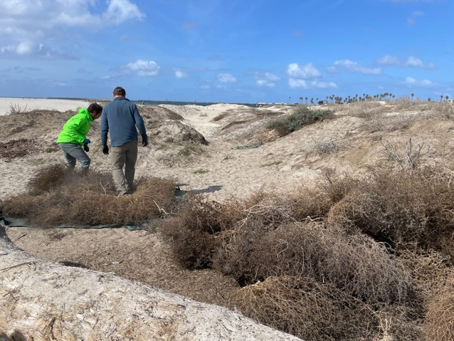
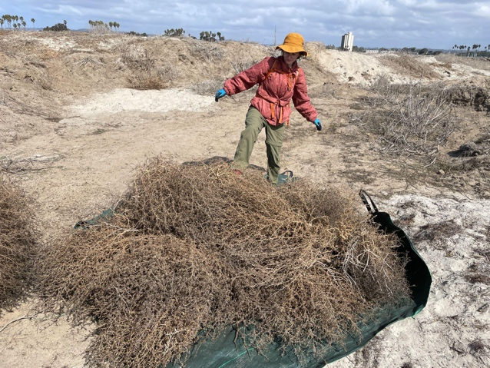
Photos 1 and 2: Volunteers hand-pulling in the project area to remove last season’s annual weeds, predominantly crown daisy (Chrysanthemum coronarium) and Russian thistle (Salsola tragus)

Primary non-native annual weeds targeted for removal included crown daisy (Chrysanthemum coronarium), white sweet clover (Melilotus albus), Russian thistle (Salsola tragus), devil’s thorn (Tribulus terrestris), small melilot (Melilotus indicus), sickle grass (Parapholis incurva), and European sea lavender (Limonium duriusculum). Because many of these species had not yet gone to seed, conditions were optimal for effective removal (see photos 3, 4 and 5).

Photos 3, 4 and 5: Volunteers hand-pulling in the project area to remove European sea lavender (Limonium duriusculum)
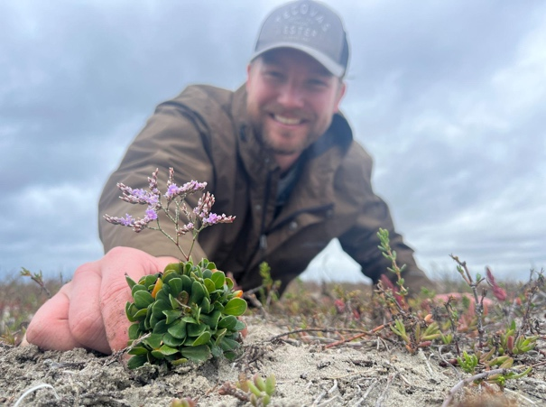
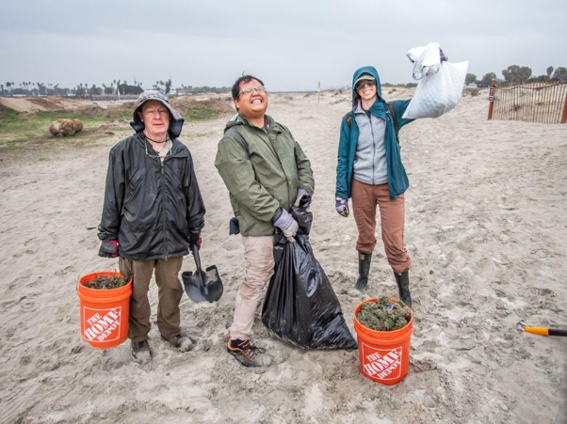
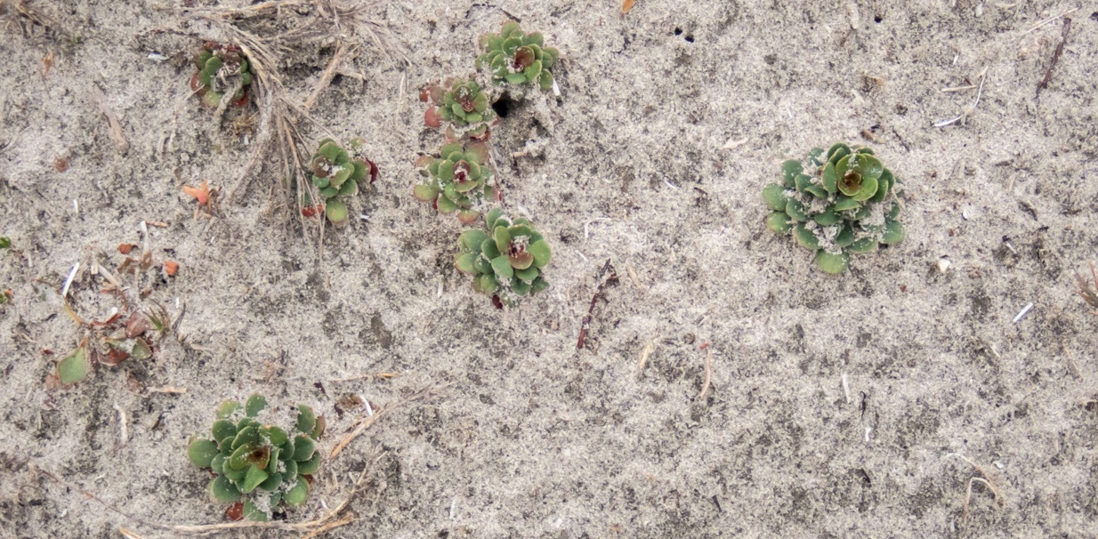

Following rains at the beginning of the quarter that triggered a flush of germination, trained volunteers joined staff to hand-pull emerging invasive plants across the restoration site. The biomass was later hauled and disposed of in a dumpster to prevent further spread (see photo 6).

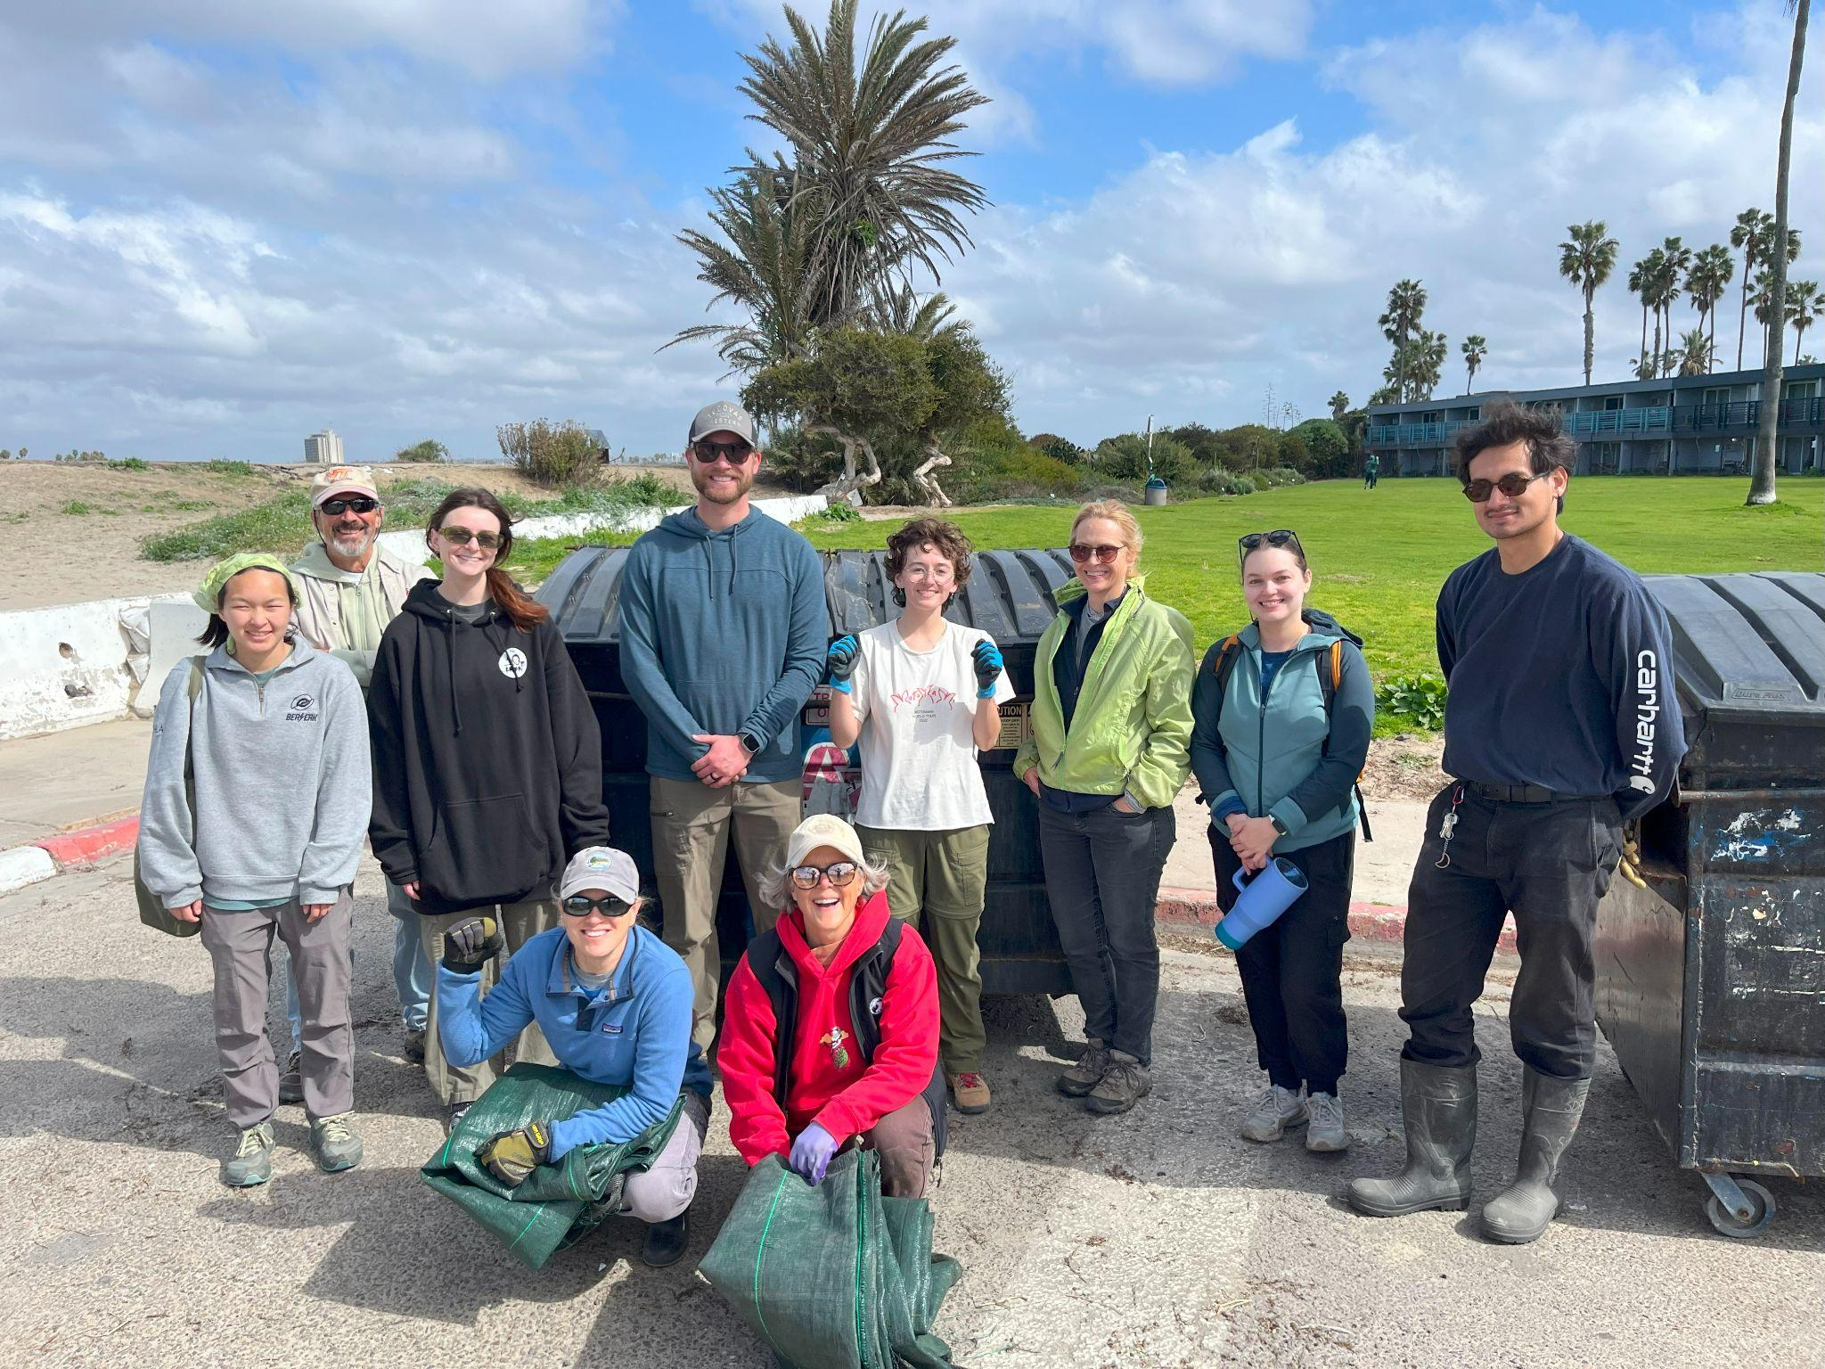
Photo 6: Volunteers after hauling annual weeds to the dumpster for disposal.

In total, The San Diego River Park Foundation (SDRPF) hosted six restoration events this quarter, engaging 89 community volunteers who contributed a combined 237 service hours. In addition to making substantial progress toward restoration goals, these events served as an educational opportunity—raising awareness about the ecological value of native species and the threats posed by invasive plants (see photo 7 and 8).

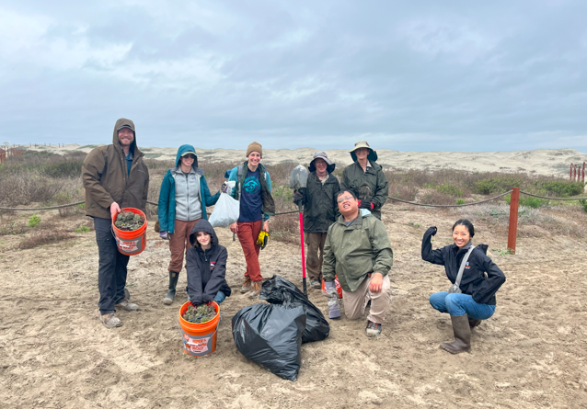
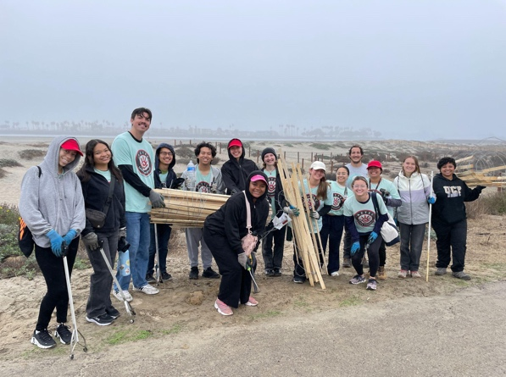
Photo 7 and 8: Group photos of the volunteers after some of the events.

In addition, partners from the San Diego Birding Alliance hosted a habitat restoration event for local kids and families on February 23, engaging 37 additional volunteers in 111 hours of service. They organized planting over 100 coastal salt marsh plants to discourage use of and hide unauthorized social trails. 10-15 coastal sage scrub plants were installed in ex-trail zones to fill in more social trails.

The removal work completed this quarter is especially impactful in priority areas where Acmispon prostratus is present, helping to ensure that native species have space and resources to grow in the coming season. These efforts are essential to promoting a more resilient, biodiverse, and functional ecosystem.

31% completed.

Task 2 - Access Control
Additional access control signage was installed along the sand dunes to help redirect visitors to the newly established trail system. Signs included those with a regulatory feel as well as signs featuring art by local youth, in order to convey the requirements as well as to encourage voluntary compliance (see photos 9 and 10).
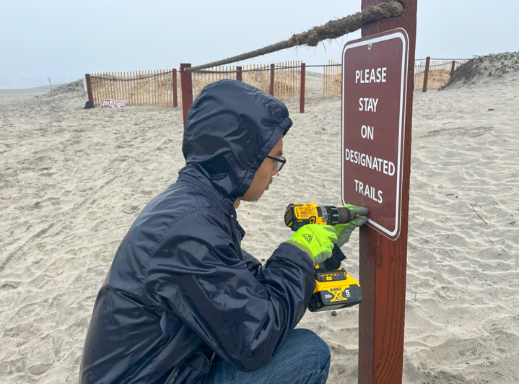
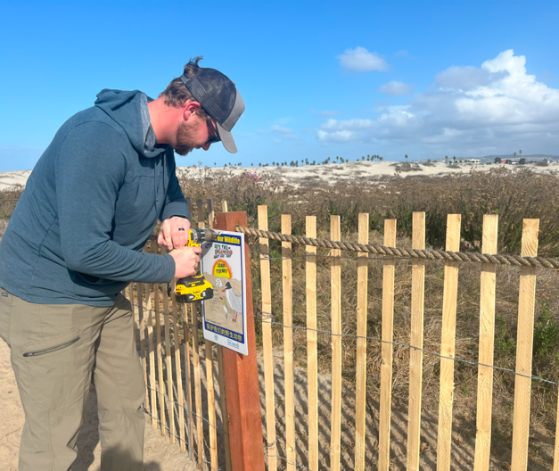
Photos 9 and 10: New sign installation

As part of these improvements, damaged wooden slats along the fence were repaired to reinforce boundaries and protect sensitive habitat areas. Additionally, the metal posts installed on the riprap adjacent to the bike path were reset more securely and straightened to improve stability, following instances of vandalism (see photos 11, 12 and 13).

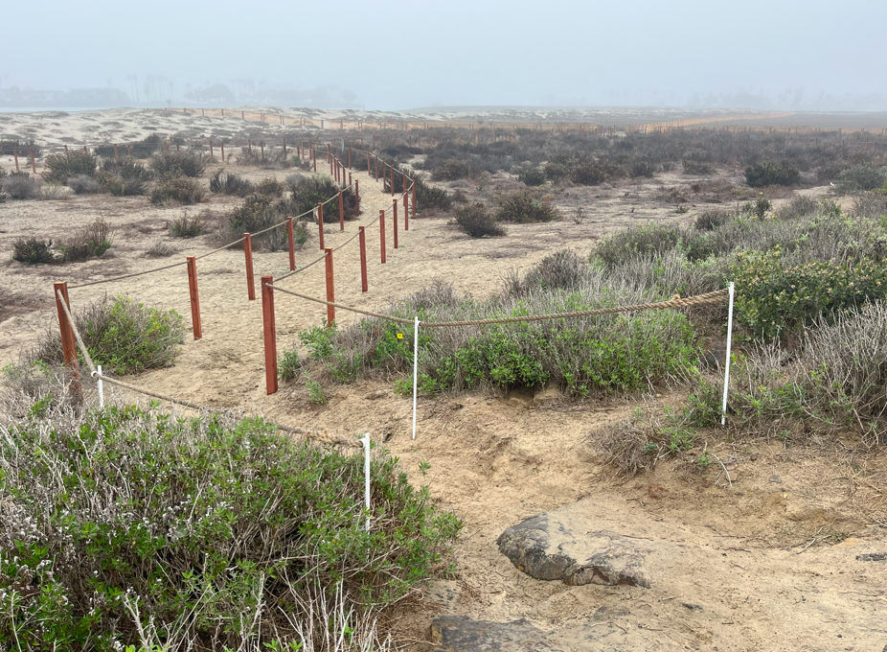
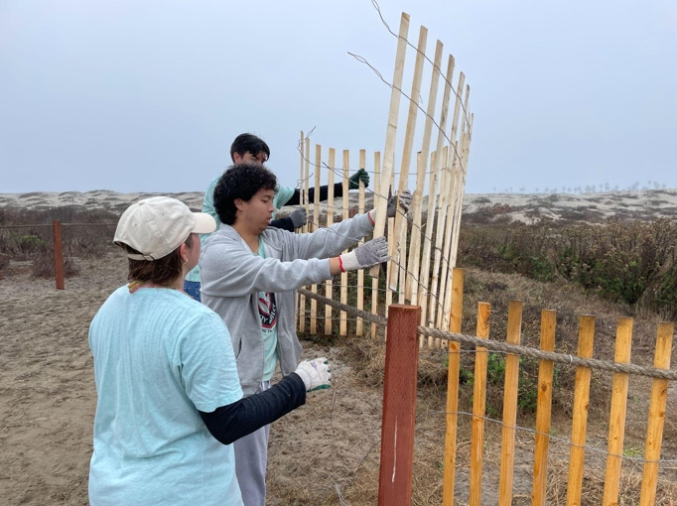
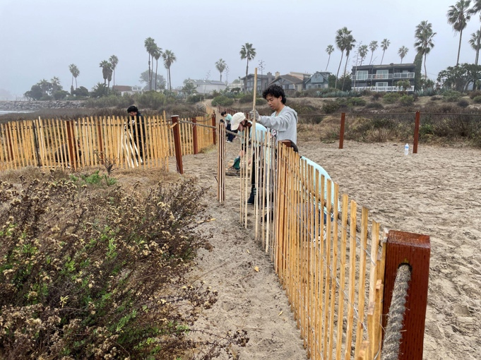
Photos 11, 12, and 13: Fence was repaired by volunteers.

Finally, outdated access control signs associated with the former trail layout were removed, as they were no longer relevant and had deteriorated over time (see photo 14).

Photo 14: Former trail signs were removed from the area.
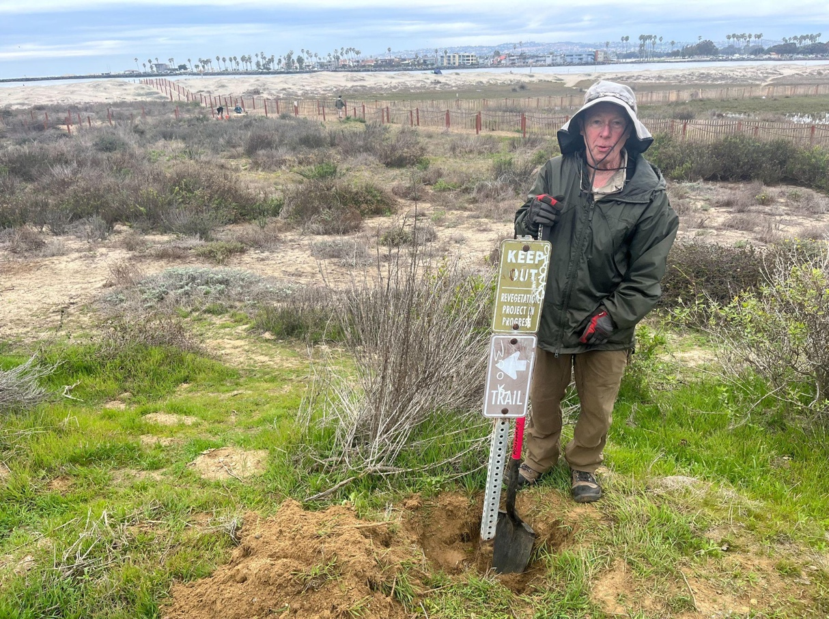

76% complete.

Task 3 - Community Engagement, Education and Outreach

During Q1, community outreach focused on volunteer recruitment, including outreach to community groups, posting of flyers in community gathering areas, preparation of social media and other communications, as well as tabling at volunteer events to connect with both volunteers and community members passing by. The SDRPF Education team continued to develop a bird guide and accompanying curricula to highlight the rare and endangered birds and overall biodiversity of the project area.

Project partners at the San Diego Birding Alliance held one San Diego River Mouth docent program per week at the River Mouth between January and March, engaging 11 individual volunteers in 34 volunteer hours total. SDBA staff kept in contact with the community by attending an OB Community Foundation meeting and an OB Planning Group meeting to give updates on the status of our work, especially the fencing project.

60% complete.

Task 4 – Monitoring
This quarter, SDRPF staff participated in the 2025 Rare Plant Inspect and Manage Training, conducted by the San Diego Management and Monitoring Program (SDMMP). This training will help staff to participate in rare plant monitoring scheduled for Q2 on the project site’s three rare plants: Nuttall's acmispon (Acmispon prostratus), salt marsh bird's beak (Chloropyron maritimum), coast wooly heads (Nemaculis denudata) (see photo 15).

In addition, staff planned for a larger BioBlitz event to be held in Q2 in partnership with the San Diego Natural History Museum for the City Nature Challenge.

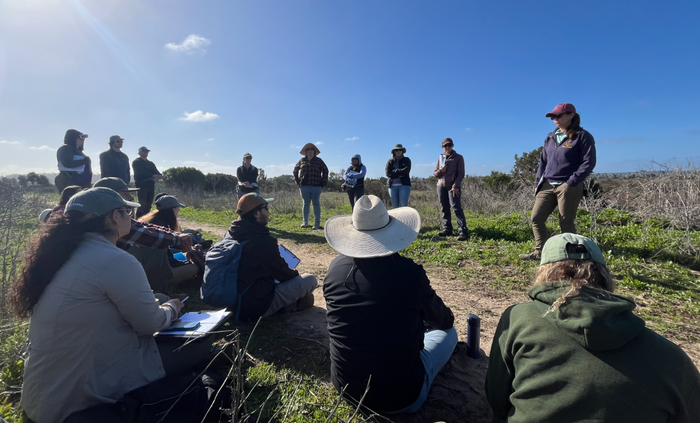
Photo 15: Rare Plant Inspect and Manage Training 2025

Project partners at San Diego Birding Alliance also organized one railwatching/docent program per week this quarter. The rail survey results from the Southern California Light-Footed Ridgway’s Rail Survey for 2025 will be included in the next quarterly report.

54% complete.

Task 5 - Administration

Project administration this quarter included submitting our seventh invoice and progress report, and working with SANDAG and the San Diego Bird Alliance to ensure compliance with various project requirements. Staff coordinated with the City of San Diego to document and report on their in-kind matching funds. Staff also met with City Rangers and Parks and Rec staff to stay on top of vandalism and unauthorized use of project area.

Project admin also included other correspondence with partners and SANDAG, updating budgets and coordinating timesheets and reports both internally and from partner organizations.

In addition, staff continued to meet with the City of San Diego and San Diego
Birding Alliance at least monthly about the permits, collaboration on events, and coordination on dealing with maintenance issues.

51% complete.

Provide the exact work start date, a description of the work completed under each task, and percent complete. Add additional tasks as necessary

Work Anticipated Next Period
This does not need to be task specific but should include a short paragraph or bullet point list of activities anticipated for next quarter.

Next quarter, all project partners (including City of San Diego and SDRPF) plan to join for the next round of community meetings, sharing with the local community that the fence is up and now being maintained.

Many events are planned for next quarter, including outreach events, restoration events, youth education events and monitoring. For example, SDRPF and SDBA are developing an event for May 13 during River Days which will feature a a variety of activities, including restoration, and educational activities to help participants understand the impact of canines on biodiversity and sensitive ecosystems, particularly concerning vulnerable bird species. This education day will be in partnership with the San Diego Bird Alliance.

SDRPF will also be partnering with the San Diego Natural History Museum (SDNHM) for the City Nature Challenge, a science bioblitz to document the flora and fauna present across the different habitat types in the project area using iNaturalist. The event will be Saturday, April 26.

Issues to Note
Please provide a brief description of any issue(s) encountered during the reporting period and any steps taken to address the issue(s).

Nothing of note.

Photographs & Figures
Photographs and figures are invaluable! Please include photos in the Quarterly Progress Reports and any figures (if applicable). Both photos and figures may be included throughout the document under corresponding tasks or at the end following the Issues to Note section. Photographs taken at the same place or photographic points (photo-points) can assist SANDAG staff in tracking the project’s progress over time.
It is required that Photographs include:
- A before and after comparison sequence from the start to the completion of the project for photo points.
- A brief description of the corresponding tasks, date, and activity in the photograph.
- A copy of each photograph included in the report submitted in a .jpeg or .png file format.
It is required that Figures include:
- A caption with a brief description.

Photos are in document above and also submitted as separate files.
SDMMP Project Page
To receive reimbursement for work conducted within the quarter, submission of Quarterly Progress, Annual, and Final Reports must be added to your project’s Project Page on the SDMMP website. Add any necessary photographs to the photo carousal and fill out the photograph information. Please contact Sarah McCutcheon (smccutcheon@usgs.gov) or Emily Perkins (eperkins@usgs.gov) if you are having trouble accessing or editing your project page.

Project Performance Measures Instructions
SANDAG will utilize the SANDAG Performance Measures to document compliance with the Project. Grantee’s performance will be measured against the Performance Measures (Exhibit D) during the term of the project. More details on Performance Measures and Grant Recovery Plans are outlined in the Grant Agreements.
To access the Project Performance Measures Excel Spreadsheet:
- Simply double-click on the Excel icon located under the Project Performance Measures section.
  - An excel sheet will open, please fill out and then click save.
- Once the Excel spreadsheet is saved, please exit Excel and the spreadsheet will automatically update the icon in the Quarterly Progress Report Word document.
When opening the document with the Project Performance Measures Excel Spreadsheet:
- When you first open the Quarterly Progress Report Template, a warning message will open (image of the warning message below)

  - Click Yes to update the links in the document.
Performance Measures
Please include the Project’s Performance Measures for each Quarterly Invoice and Progress Report in order to receive reimbursement.

