San Diego Association of Governments
Ocean Beach Estuary Enhancement Project
The San Diego River Park Foundation (SDRPF)
Quarterly Progress Report
Reporting Period: 4/01/25 – 6/30/25
Submission Date: 7/18/25
SANDAG Contract Number: S1125510

Quarterly Status Report Overview
PLEASE DO NOT CHANGE OR ALTER THE FORMATTING OF THIS DOCUMENT! SANDAG has developed a standardized grant monitoring and tracking program for the Environmental Mitigation Program (EMP) Land Management Grant Program. The purpose is to collect information on individual projects and the grant program as a whole for reporting to the Regional Habitat Conservation Taskforce, SANDAG Policy Advisory Committees, and the SANDAG Board of Directors. SANDAG monitors grantees through invoices, progress reports, performance measures, and designated photograph points. These standardized reporting templates and instructions for submittal are included below.

Work Performed this Period:

Task 1 - Invasive Removal and Habitat Restoration
This quarter, staff advanced key habitat restoration efforts by intensifying invasive plant removal across the project area. Staff and volunteers addressed the annual weeds. Work was strategically focused on plots where sensitive native species — such as Nuttall’s acmispon, salt marsh bird’s-beak and coast wooly heads — occur at higher densities. The goal was to reduce competition from invasive species and support the successful establishment of this rare native plant during its critical season growth period (see photos 1, 2, 3 and 4).

Photos 1 – 4: Volunteers hand-pulling annual weeds in the project area
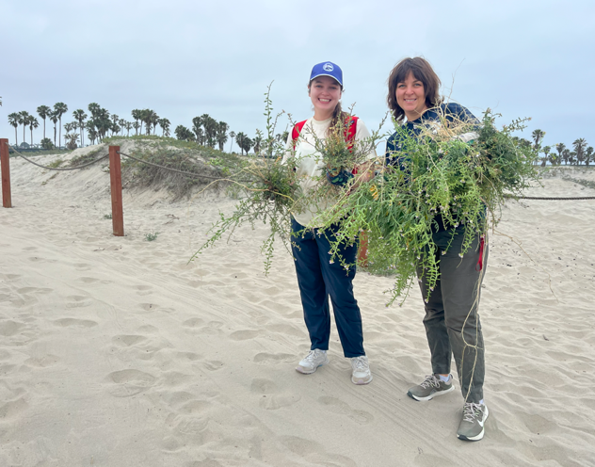
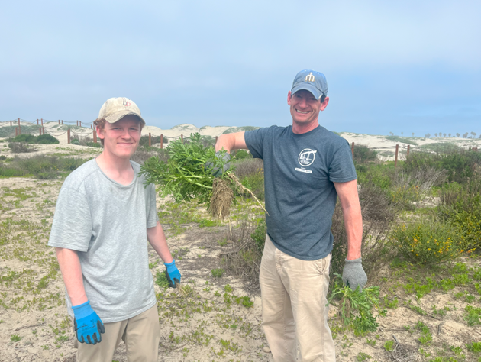
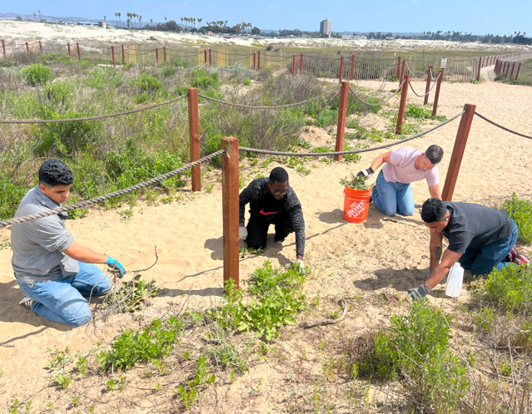
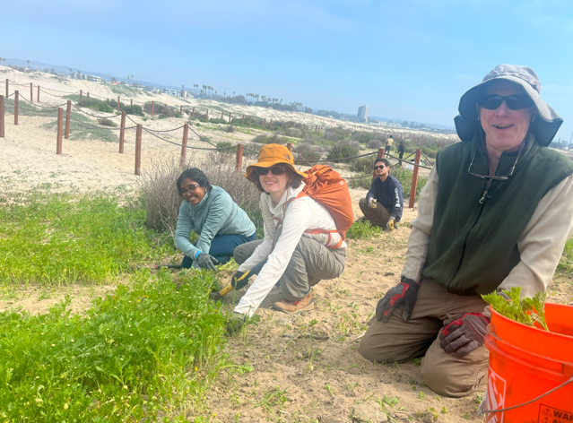
Primary non-native annual weeds targeted for removal included crown daisy (Chrysanthemum coronarium), white sweet clover (Melilotus albus), European sea rocket (Cakile maritima), Russian thistle (Salsola tragus), devil’s thorn (Tribulus terrestris), small melilot (Melilotus indicus), sickle grass (Parapholis incurva), and European sea lavender (Limonium duriusculum). Because many of these species had not yet gone to seed, conditions were optimal for effective removal (see photo 5).

Photo 5: Volunteers hand-pulling in the project area to remove weeds.
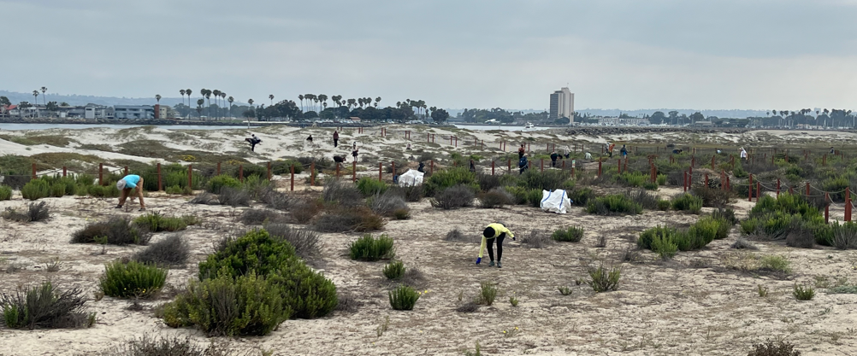

The San Diego River Park Foundation (SDRPF) hosted seven restoration events this quarter, engaging 196 community volunteers who contributed a combined 497 service hours toward this task. In addition to making substantial progress toward restoration goals, these events served as a hands-on educational opportunity—raising awareness about the ecological value of native species and the threats posed by invasive plants (see photos 6, 7, 8 and 9).

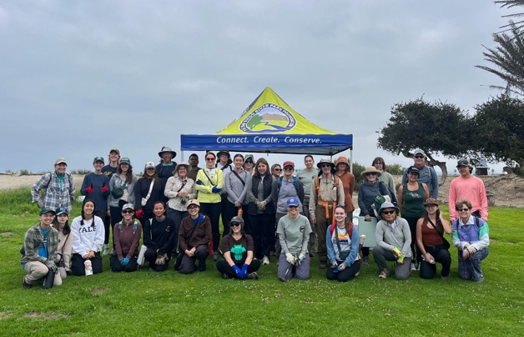
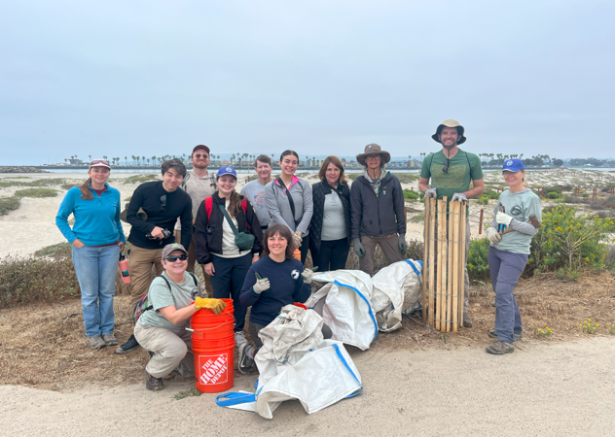
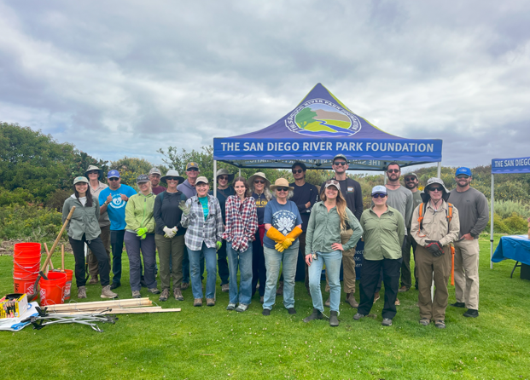
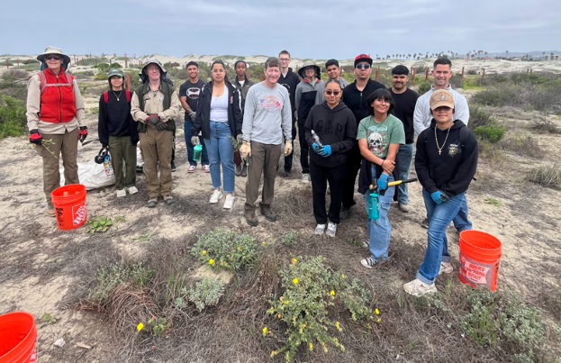
Photos 6 – 9: Group photos of the volunteers after some of the events.

In addition, project partners with the San Diego Bird Alliance hosted a restoration event with staff and 3 volunteers, targeting devil’s thorn (Tribulus terrestris) from the western portion of the project area where it overlaps with the rare native coast wooly heads. Volunteers also removed approximately 1.5 buckets (~7 gallons) of dog poop from the site during this event.

41% completed.

Task 2 - Access Control
As part of these improvements, damaged wooden slats along the fence were repaired to reinforce boundaries and protect sensitive habitat areas. Additionally, the metal posts installed on the riprap adjacent to the bike path were reset more securely and straightened to improve stability, following instances of vandalism (see photo 10).

San Diego Bird Alliance project partners also installed 10 additional trail signs in June, to encourage team to stay on trails.
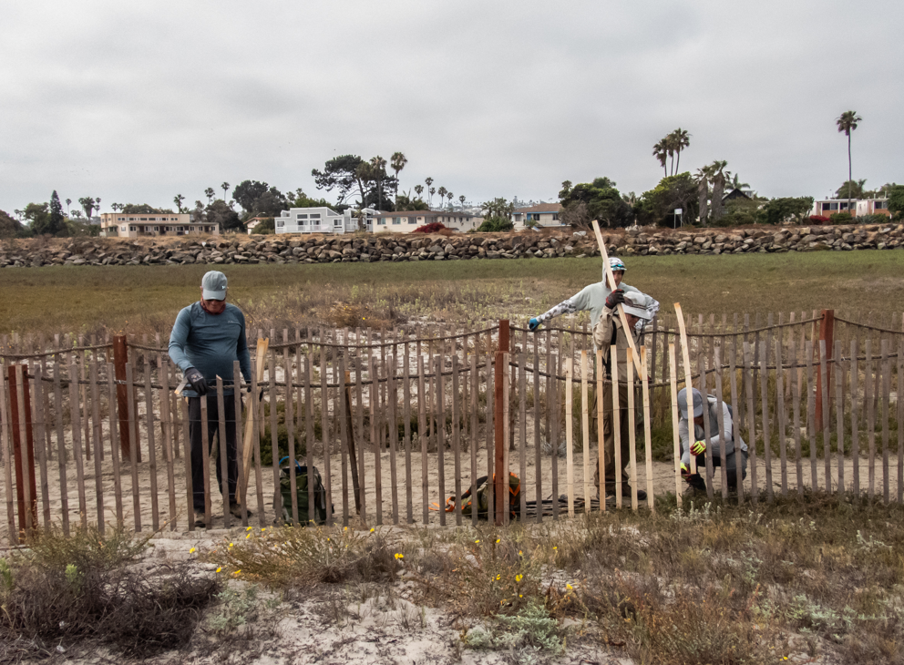
Photo 10: Fencing being repaired by volunteers.

Photo 11: San Diego Bird Alliance installing trail signs
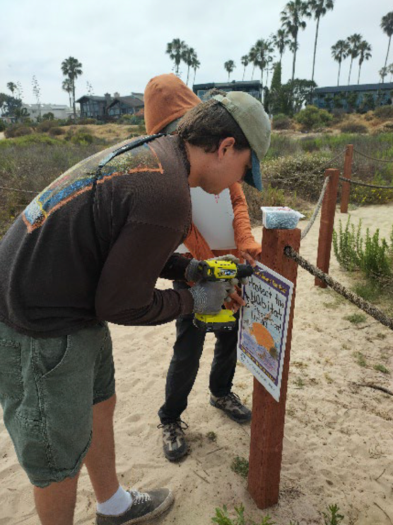

78% complete.

Task 3 - Community Engagement, Education and Outreach

This quarter, SDRPF staff met with community group leaders to recruit for volunteer events, and assisted in hosting events for the public, including education and interpretive tours.

SDRPF education staff conducted outreach and public education aimed at kids and families during events, and on May 13th, organized an Ocean Beach Estuary event to celebrate River Days. This event aimed to help participants understand the impact of dogs on biodiversity and sensitive ecosystems, particularly on vulnerable bird species. The education day was developed in partnership with the San Diego Bird Alliance.

The SDRPF education team is continuing to develop a bird guide to use at future events that highlights various species inhabiting our project area, including the at-risk Ridgway's rail, snowy plover, and the least tern. By involving our community in identifying these remarkable birds, we aim to inspire a more profound commitment to their conservation and the protection of their habitats.

In addition, San Diego Bird Alliance partners held one San Diego River Mouth docent program per week at the project site between April and June, though two shifts were cancelled because a staff member cancelled and because of weather. This engaged 12 individual volunteers in 38 volunteer hours total.

66% complete.

Task 4 – Monitoring
SDRPF staff, San Diego Bird Alliance staff, and project volunteers participated in Rare Plant Surveys on two of the project site’s rare plants: Nuttall's acmispon (Acmispon prostratus) (see photo 12) and salt marsh bird's beak (Chloropyron maritimum) (see photo 13). SDRPF also hosted an event as part of the City Nature Challenge that combined documenting species on site, as well as habitat restoration, teaching volunteers to use the iNaturalist app to record and identify species.

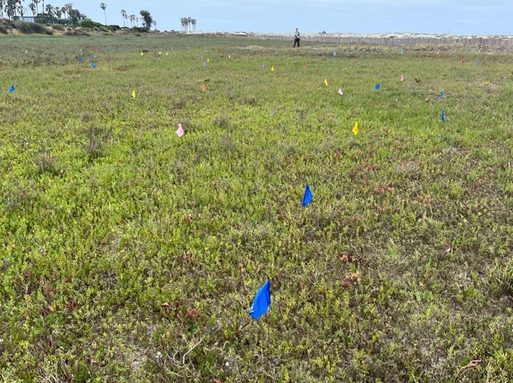
Photos 12 and 13: Photos during the Rare Plant Survey.
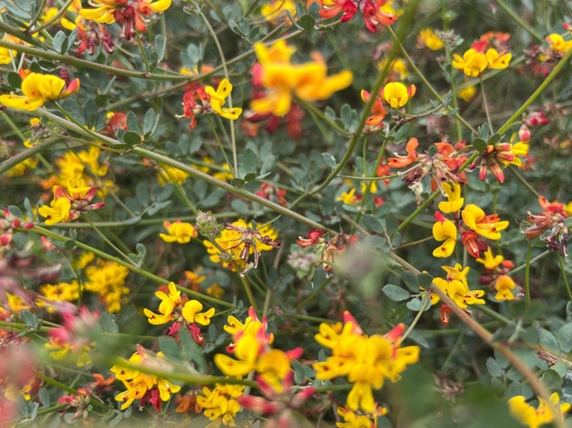

Project partners at San Diego Bird Alliance organized one railwatching/docent program per week this quarter. They increased the amount of education and outreach during these events, and accordingly, are reporting these volunteers under Task 3.

San Diego Bird Alliance also partnered with Dick Zembal and Susan Hoffman to do a Light-footed Ridgway’s Rail survey along the San Diego River Mouth habitat. The results of the survey from the March 1, 2025 playback survey showed nine pairs and five singles. Their surveyors saw two rails (unusual to see the birds) and heard two keks.

68% complete.

Task 5 - Administration
Project administration this quarter included submitting our eighth invoice and progress report, and working with SANDAG and the San Diego Bird Alliance to ensure compliance with various project requirements. Staff coordinated with the City of San Diego to document and report on their in-kind matching funds. Staff also met with City Rangers and Parks and Rec staff to stay on top of vandalism and unauthorized use of project area.

Project admin also included other correspondence with partners and SANDAG, updating budgets and coordinating timesheets and reports both internally and from partner organizations.

In addition, staff continued to meet with the City of San Diego and San Diego
Birding Alliance at least monthly about the permits, collaboration on events, and coordination on dealing with maintenance issues.

61% complete.

Provide the exact work start date, a description of the work completed under each task, and percent complete. Add additional tasks as necessary

Work Anticipated Next Period
This does not need to be task specific but should include a short paragraph or bullet point list of activities anticipated for next quarter.

Community meetings were postponed to a future quarter, and we will notify SANDAG as these get scheduled, and coordinate in advance of including any logos, consistent with the grant guidelines.

Monitoring, outreach, and habitat restoration events will continue next quarter.

Issues to Note
Please provide a brief description of any issue(s) encountered during the reporting period and any steps taken to address the issue(s).

Nothing of note.

Photographs & Figures
Photographs and figures are invaluable! Please include photos in the Quarterly Progress Reports and any figures (if applicable). Both photos and figures may be included throughout the document under corresponding tasks or at the end following the Issues to Note section. Photographs taken at the same place or photographic points (photo-points) can assist SANDAG staff in tracking the project’s progress over time.
It is required that Photographs include:
- A before and after comparison sequence from the start to the completion of the project for photo points.
- A brief description of the corresponding tasks, date, and activity in the photograph.
- A copy of each photograph included in the report submitted in a .jpeg or .png file format.
It is required that Figures include:
- A caption with a brief description.

Photos are in document above and also submitted as separate files.
SDMMP Project Page
To receive reimbursement for work conducted within the quarter, submission of Quarterly Progress, Annual, and Final Reports must be added to your project’s Project Page on the SDMMP website. Add any necessary photographs to the photo carousal and fill out the photograph information. Please contact Sarah McCutcheon (smccutcheon@usgs.gov) or Emily Perkins (eperkins@usgs.gov) if you are having trouble accessing or editing your project page.

Project Performance Measures Instructions
SANDAG will utilize the SANDAG Performance Measures to document compliance with the Project. Grantee’s performance will be measured against the Performance Measures (Exhibit D) during the term of the project. More details on Performance Measures and Grant Recovery Plans are outlined in the Grant Agreements.
To access the Project Performance Measures Excel Spreadsheet:
- Simply double-click on the Excel icon located under the Project Performance Measures section.
  - An excel sheet will open, please fill out and then click save.
- Once the Excel spreadsheet is saved, please exit Excel and the spreadsheet will automatically update the icon in the Quarterly Progress Report Word document.
When opening the document with the Project Performance Measures Excel Spreadsheet:
- When you first open the Quarterly Progress Report Template, a warning message will open (image of the warning message below)
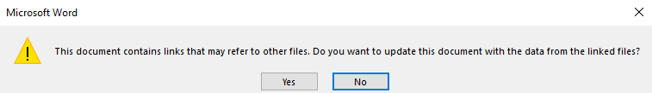
  - Click Yes to update the links in the document.
Performance Measures
Please include the Project’s Performance Measures for each Quarterly Invoice and Progress Report in order to receive reimbursement.

