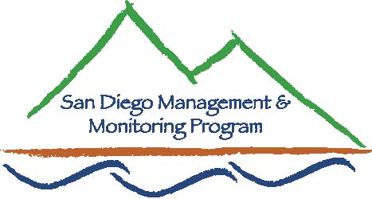

SDMMP Monitoring & Management Coordination Meeting
April 27, 2011, 9:30 am – 11:30 am
USGS Conference Room, 4165 Spruance Rd, San Diego, CA 92101

Contact Info:
Yvonne C. Moore, Management & Monitoring Coordinator (evemoore99@yahoo.com)
Ron Rempel, Program Director (rrempel2@msn.com)

Agenda

- Introductions (9:30-9:35am)

- SDMMP Program Updates (9:35 – 10:00am)
- SDMMP website – Y.Moore
- Status of projects – R.Rempel

- Topic Du Jour (10:00 - 10:25am)
  - Steps to Developing the Management Strategic Plan – R.Rempel

- Western Riverside Co. Burrowing Owl Recovery Project (10:25 - 11:25am)
  - Jared Bond (Riv Co. EPD) and Jeff Kidd (Kidd and Jimerson Consulting)
  - Link to 2008 Press-Enterprise article on BUOW project: http://www.rctlma.org/epd/documents/news/burrowing_owl_rescue_working_pe06132008.pdf

- Closing comments (11:25 - 11:30am)
- Future Meeting Topics:

    - May: Connectivity solutions in Europe - Cheryl Brehme (USGS)
    - June: Tracking in San Diego Co. - Barry Martin (WTI)
    - July: ARTO study, Camp Pendleton - C.Brehme (USGS)
    - Aug: Management of SD County lands - Jake Enriquez (County SD)
    - Sep: Tentative: Burrowing Owl Management Study (IEMM/ICR)
    - Oct: Tentative: End of Year Monitoring/Mgmt Results - Everyone
    - Nov/Dec: Tentative: End of Year Monitoring/Mgmt Results - Everyone

Our next monthly monitoring meeting will be held 9:30 a.m. – 11:30 a.m. on Wednesday,
May 25, 2011 at USGS

