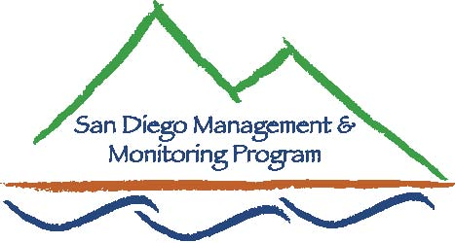

SDMMP Monitoring & Management Coordination Meeting
September 27, 2017, 9:30 am – 11:30 am
We will be in the Conference Room 103 at the USGS offices 4165 Spruance Rd, San Diego, CA 92101
Contact Info: Yvonne C. Moore, Administrator (evemoore99@gmail.com); Kris Preston, Ecologist (kpreston@usgs.gov); Emily Perkins, GIS Manager (eperkins@usgs.gov);, Sarah McCutcheon, Projects Manager (Sarah.McCutcheon@aecom.com), Brenda McMillan, Outreach Coordinator (Brenda.McMillan@aecom.com), Annabelle Bernabe, Data Entry/GIS Assistant (aebernabe@gmail.com), Frank Winter, Data Entry Assistant (fwinter@usgs.gov)

Agenda

- Introductions (9:30 - 9:35am)

- Announcements (9:35 – 9:50am)

- Speaker (9:50 – 11:00am)
- Barbara Kus – USGS Regional and Post-fire Occupancy of California Gnatcatchers in Southern California: Results of 2016 Surveys

- Roundtable Discussion (11:00 – 11:25am)

- Closing Remarks and Future Meeting Topics (11:25-11:30am)

October – SDMMP Oncosipon piluflierum Stinknet discussion
November - ******NO MEETING******
December – various speakers and annual Luncheon

Possible future topics:
- Coastal Cactus Wren habitat restoration
- San Diego’s Golden Eagle project
- Burrowing Owl burrow design

Our next monthly monitoring meeting will be held 9:30 a.m. – 11:30 a.m. on Wednesday,
October 25, 2017 at USGS

