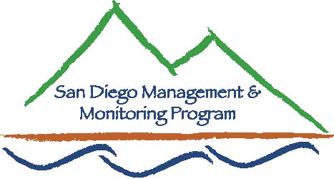

SDMMP Monitoring & Management Coordination Meeting
December 8th, 2010, 9:30 am – 11:30 am
USGS Conference Room, 4165 Spruance Rd, San Diego, CA 92101

Contact Info:
Yvonne C. Moore, Management & Monitoring Coordinator (evemoore99@yahoo.com)
Ron Rempel, Program Director (rrempel2@msn.com)
Clark Winchell, USFWS (clark_winchell@fws.gov)

Agenda

- Introductions (5 minutes)

- Program Updates (30 minutes)
- sdmmp.com website - Y. Moore
- SD thornmint working group update - Jessie Vinje (CNLM)
- Mountain Lion GPS Telemetry (60 minutes)
- Winston Vickers, DVM, UC Davis Wildlife Health Center

- Overview of the CA Landscape Conservation Cooperative (CA LCC) (15 min)
- Rebecca Fris, Science Coordinator, USFWS

- Future Meeting Topics (5 minutes)
- Jan: Local Jurisdiction Monitoring Priority Considerations - Betsy Miller (City
SD), Mark Dodero (City Chula Vista)
2011 IEMM Priorities: Doug Deutschman
- Feb: Tentative - Bobcat movement study: Seth Riley
- Mar: O.C. Cactus Wren study - Kris Preston (NROC)
- Apr: Tentative - Impacts of roads on connectivity - What Europe has done -
Cheryl Brehme (USGS)

- Closing comments (5 minutes)

Our next monthly monitoring meeting will be held 9:30 a.m. – 11:30 a.m. on Wednesday, January 26th at USGS.

