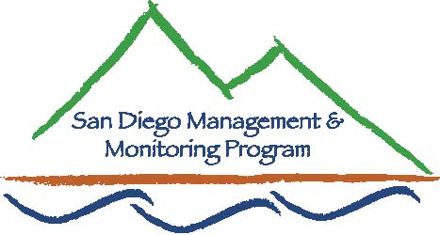

SDMMP Monitoring & Management Coordination Meeting
March 23, 2011, 9:30 am – 11:30 am
USGS Conference Room, 4165 Spruance Rd, San Diego, CA 92101

Contact Info:
Yvonne C. Moore, Management & Monitoring Coordinator (evemoore99@yahoo.com)
Ron Rempel, Program Director (rrempel2@msn.com)

Agenda

- Introductions (9:30-9:35am)

- SDMMP Program Updates (9:35–9:50am)
- Transnet land management grants
- SD Centralized Database
- BUOW management project

- Other Program Updates - Monitoring/Management Projects (10:00am - 10:20am)
  - County of San Diego – Jennifer Price
  - Anyone else?

- Orange County Cactus Wren study (10:25-11:25am)
  - Kris Preston (NROC)

- Closing comments (11:25-11:30am)
- Future Meeting Topics
    - Apr: Tentative: TBD
    - May: Connectivity solutions in Europe - Cheryl Brehme (USGS)
    - June: Tracking in San Diego Co. - Barry Martin (WTI)
    - July: ARTO study, Camp Pendleton - C.Brehme (USGS)
    - Aug: Tentative: Management topic TBD
    - Sep: Tentative: Monitoring topic TBD
    - Oct: Tentative: End of Year Monitoring/Mgmt Results - Everyone
    - Nov/Dec: Tentative: End of Year Monitoring/Mgmt Results - Everyone

Our next monthly monitoring meeting will be held 9:30 a.m. – 11:30 a.m. on Wednesday,
April 27, 2011 at USGS.

