San Diego Association of Governments
Endangered Avian Nesting Site Stewardship at D-Street Fill
San Diego Unified Port District
Quarterly Progress Report
Reporting Period: April 1 through June 30, 2023
Submission Date: July 21, 2023
SANDAG Contract Number: S1125502

Quarterly Status Report Overview
PLEASE DO NOT CHANGE OR ALTER THE FORMATTING OF THIS DOCUMENT! SANDAG has developed a standardized grant monitoring and tracking program for the Environmental Mitigation Program (EMP) Land Management Grant Program. The purpose is to collect information on individual projects and the grant program as a whole for reporting to the Regional Habitat Conservation Taskforce, SANDAG Policy Advisory Committees, and the SANDAG Board of Directors. SANDAG monitors grantees through invoices, progress reports, performance measures, and designated photograph points. These standardized reporting templates and instructions for submittal are included below.

Work Performed this Period:

Task 1 – Site Preparation
100% complete.
Due to excessive rains this winter, site preparation was planned for mid-March to allow the site time to drain and better accommodate the use of heavy equipment to mechanically scrape invasive vegetation from the site. On April 7, Urban Corps of Engineers began herbicide application to some areas of Bermuda grass, which is highly invasive and has taken over much of the site. However, the impending arrival of the California least terns, which generally arrive in mid-April, warranted a change in the site preparation schedule and herbicide could not be applied across the entire site. Herbicide application will resume after the nesting season is completed in September.

On April 14, removal of the vegetation began to in order to enhance the site for use by California least terns and Western snowy plovers immediately prior to the 2023 nesting season. Vegetation removal was primarily performed using had tools to trim and rake vegetation and was completed by April 25, when the least terns began arriving and utilizing the site.

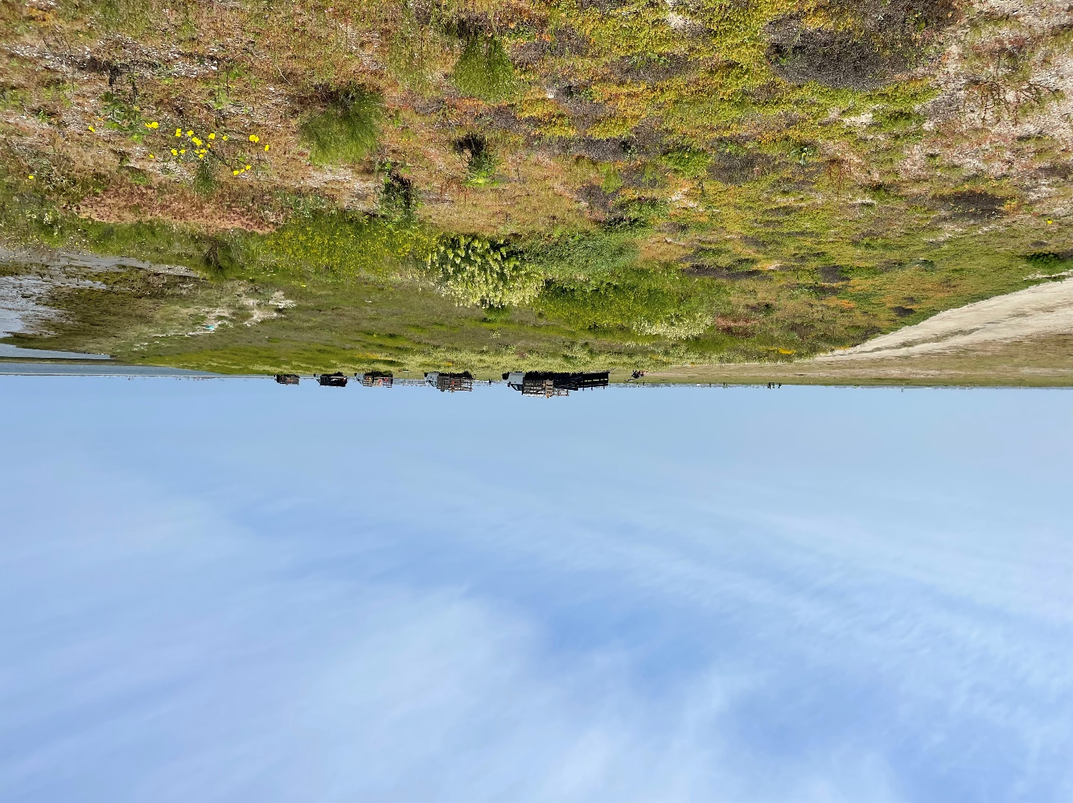
Figure 1. Urban Corps of Engineers mobilized to apply herbicide and remove invasive vegetation at the D Street Fill. April 18, 2023.

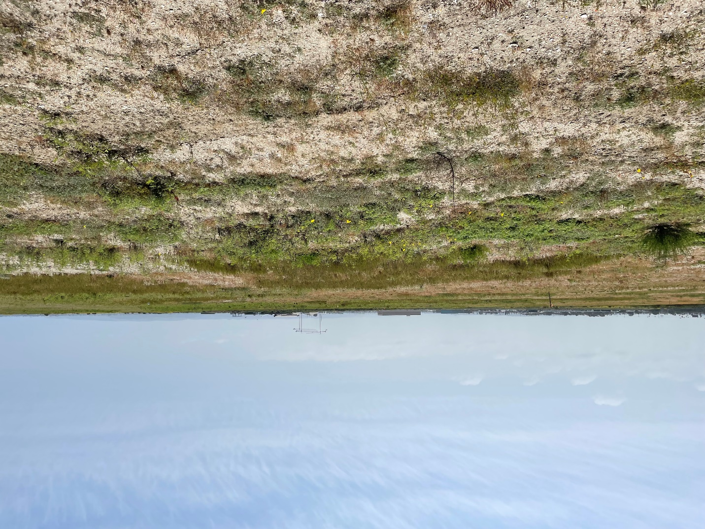
Figure 2. The D Street Fill prior to vegetation removal. The dominant invasive species is Bermuda grass. April 18, 2023.

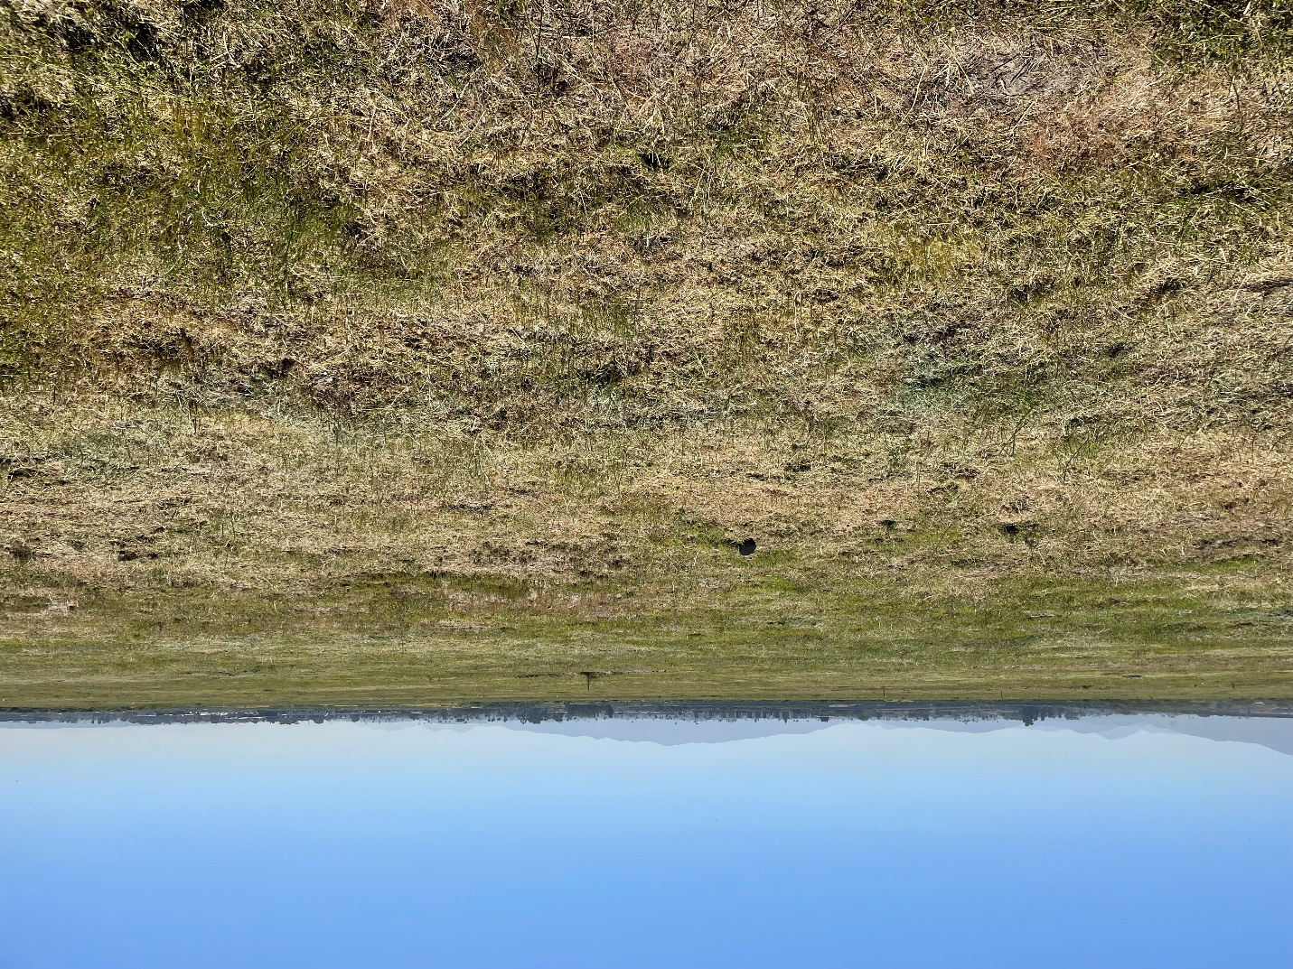
Figure 3. Vegetation has had herbicide applied and has been trimmed. April 21, 2023.

Task 2 – Management & Monitoring
45% complete.

Prior to herbicide application and vegetation removal, the Port’s consulting bird biologist (Robert Patton) surveyed the site for ground nesting birds and sensitive plants to avoid during ground disturbance. Populations of Nuttall’s lotus (Acmispon prostratus) and active bird nests, two killdeer and two horned lark nests, were demarcated for avoidance. In addition to the killdeer and horned lark nests, two Western snowy plover nests were also identified and marked for avoidance and active monitoring. These nests, along with one nest observed during the 2022 nesting season, are an excellent sign that snowy plovers may be returning to the D Street Fill to forage and nest. Prior to 2022, no snowy plovers had nested at the D street Fill since 2000.

Biological monitors also set out markers in a grid pattern across the site to assist with locating and counting nests throughout the season. The markers used are clay roofing tiles, which are easy to spot and also provide a place for chicks to shelter from predators or heat on hot summer days.

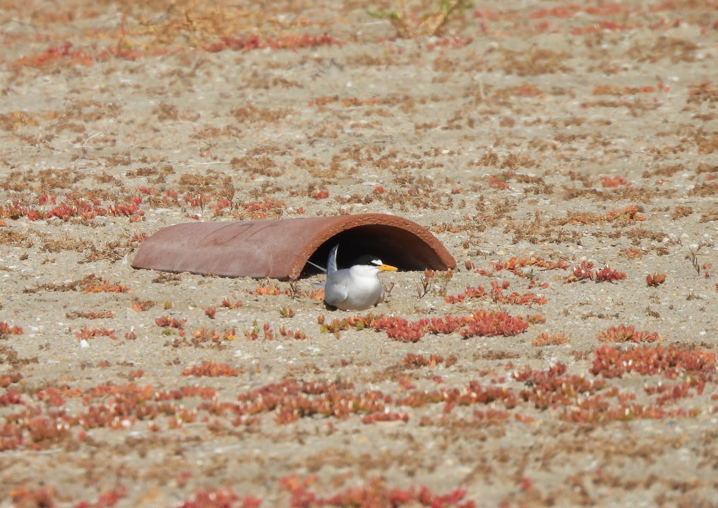
Figure 4. A California least tern has arrived at the D Street Fill and rests near a clay roofing tile. The birds will rest and forage offshore prior to beginning courtship and nesting activities. The roofing tile assist biologists with monitoring the site and re-locating nests. May 9, 2023.

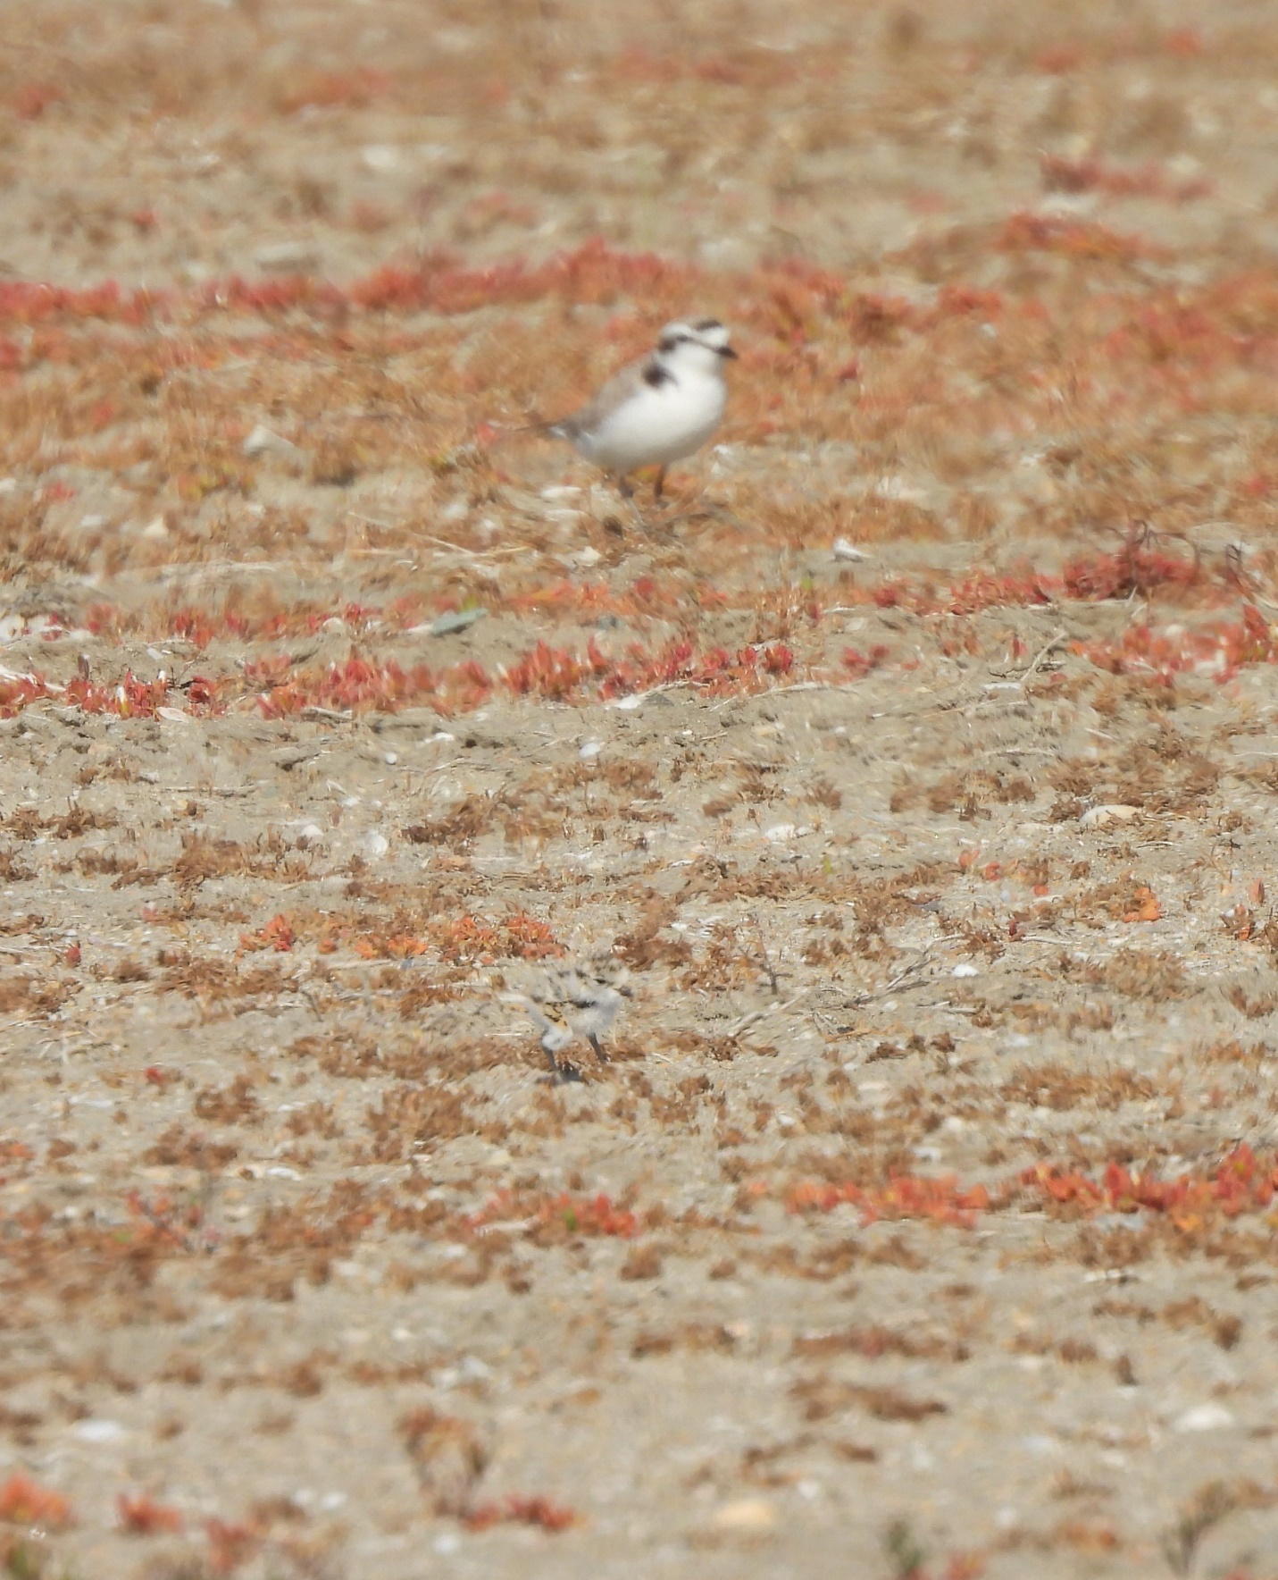
Figure 5. An adult Western snowy Plover and chick observed at the D Street Fill. The adult (out of focus at the top of the image) watches over a chick (center of photo) that is expertly camouflaged to blend in with its surroundings to avoid predators. May 9, 2023.

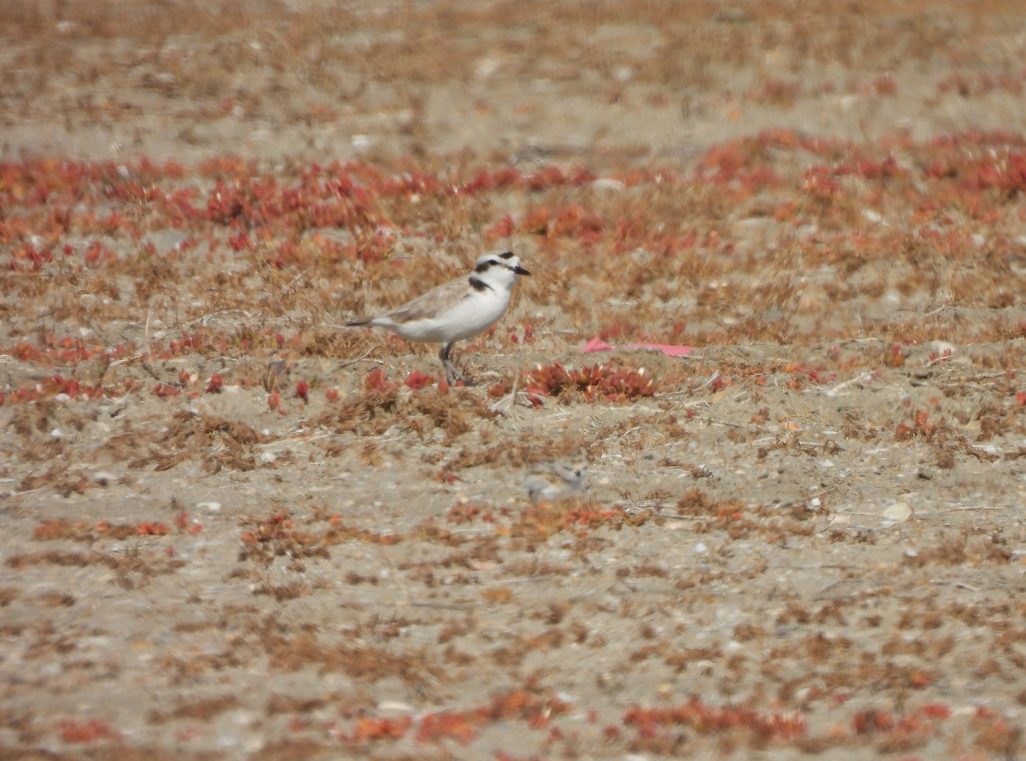
Figure 6. An adult Western snowy plover watches over its chick (bottom center, not in focus) at the D Street Fill. May 9, 2023.

Table 1. Monitoring results for adult least terns and nests observed at the D Street Fill for the 2023 nesting season. The number of adult terns observed are birds that are on-ground or flying back and forth from the site to the bay (i.e., foraging behavior). Active nests are nests where adults are actively nest-building, nests that contain eggs, adult birds incubating eggs, contain chicks or fledglings, and/or have not been abandoned. New nests are those that have been built within the past observation period (i.e., within the last 1-7 days). The number of chicks and fledglings is the total number of chicks or fledglings found on site during the observation period. Western snowy plover sightings and comments are provided in the “notes” column.
Date | # of adult terns | Total # of nests | # of active nests | # of new nests | # of chicks | # of fledglings | Notes
03-26-2023 | 0 | 0 | 0 | 0 | 0 | 0 | Site walked prior to vegetation management. Recorded predator sightings.
03-27-2023 | 0 | 0 | 0 | 0 | 0 | 0 | Flagged native Nuttall’s lotus and bird nests for avoidance. Recorded predator sightings.
04-02-2023 | 0 | 0 | 0 | 0 | 0 | 0 | Monitored during vegetation removal. Recorded predator sightings.
04-05-2023 | 0 | 0 | 0 | 0 | 0 | 0 | Recorded predator sightings.
05-09-2023 | 28-30 | 0 | 0 | 0 | 0 | 0 | Western snowy plover with 3 chicks in the nesting area. New killdeer nest observed.
05-11-2023 | - | 1 | 1 | 1 | 0 | 0 | Snowy plover and chicks observed again. First least tern nest observed with 1 egg.
05-15-2023 | 30 | 11 | 10 | 5 | 0 | 0 | Snowy plover with 3 checks observed. Possible second plover with 2 chicks seen. Two new killdeer nests.
2023-05-23 | 30 | 19 | 17 | 7 | 0 | 0 | Two depredated adult least terns (peregrine suspected). One nest with 2 eggs depredated (harrier suspected). Snowy plover with 2 chicks observed.
2023-05-30 | 15 | 25 | 22 | 4 | 0 | 0 | Snowy plover with 2 chicks observed. Recorded predator sightings.
06-06-2023 | 15-18 | 28 | 16 | 3 | 4 | 0 | Recorded predator sightings.
06-13-2023 | 15 | 33 | 15 | 5 | 5 | 0 | Toppled decoys reset. Recorded predator sightings.
06-20-2023 | 25-35 | 34 | 10 | 0 | 3 | 0 | Two depredated eggs observed. Recorded predator sightings.
06-27-2023 | 27+ | 38 | 9 | 3 | 0 | 2-3 | 2 nest and 2 eggs possibly depredated. 3 new killdeer nests.

Task 3 – Predator Management
45% complete.

Predator management was conducted by U.S. Department of Agriculture Animal Plant Health Inspection Services - Wildlife Services. Management actions included routine predator surveys (driving or walking the site perimeter, potential site access points, and adjacent areas that may harbor predators that can access/migrate into the site), discerning immediate and future predator impacts, and implementation of appropriate control. Nuisance avian and mammalian predators were trapped or otherwise removed by legal means.

Biological monitors also work closely with predator control staff to relay information on depredated birds, eggs, and chicks, as well as predator tracks and observations of avian predators at or near the site. Results of predator management activities will be provided in the next two quarterly progress reports.

- Task 4 – Invasive Plant Species Control
50% complete.

Port staff and Urban Corps’ Pest Control Advisor reviewed the site to determine the best approach for management of invasive plant species specific to this site. Port staff provided herbicide recommendations based on the Port’s integrated pest management policy, San Diego Bay National Wildlife Refuge policy, and the State of California Proposition 65 List.

Due to extensive rains this year, herbicide was applied later that was ideal for removal of Bermuda grass. Additionally, Bermuda grass enters a state of dormancy during the winter and reduces or ceases access growth. This state can minimize or prohibit the uptake of herbicide. The combination of late application and dormancy meant the herbicide applied had a reduced effect. However, an additional herbicide application is planned for September, when the nesting season concludes, which is expected to be more effective since the Bermuda grass should still be actively growing during this time.

- Task 5 – Volunteer Events and Environmental Education Outreach
0% complete.

No work was performed under this task during the reporting period. Volunteer events will occur after the nesting season has concluded.

Work Anticipated Next Period
This does not need to be task specific but should include a short paragraph or bullet point list of activities anticipated for next quarter.

California least terns will continue to nest at the D Street Fill through August and into September. The season officially ends on September 15, though the birds may leave earlier or later. Work anticipated over the next three months will include:
- Monitoring efforts as birds continue to nest and rear chicks.
- Predator control efforts.

Issues to Note
Please provide a brief description of any issue(s) encountered during the reporting period and any steps taken to address the issue(s).

Port staff encountered significant obstacles scheduling site visits, start of work, work dates, and work completion with Urban Corps of Engineers. The site preparation was repeatedly delayed by crews not showing up to pre-determined work dates or showing up with inappropriate equipment. The site was primarily hand trimmed with weed whackers/hand trimmers instead of using mechanical scrapping equipment (e.g., a backhoe/tractor with mechanical scrapper), which was the agreed upon approach for a site of this size.

The result was a delay, and mostly ineffective, herbicide application and trimming of vegetation but very little vegetation removal at the root. This will likely affect where across the site least terns are able to nest, limit nesting options, and may negatively impact nest numbers. It is Port staff’s belief that Urban Corps was/is overcommitted and overtasked and did not have capacity to perform this work, especially with its stringent time and endangered species management requirements.

The Port is unlikely to use Urban Corps to perform this work again in the future.

Photographs & Figures
Photographs and figures are invaluable! Please include photos in the Quarterly Progress Reports and any figures (if applicable). Both photos and figures may be included throughout the document under corresponding tasks or at the end following the Issues to Note section. Photographs taken at the same place or photographic points (photo-points) can assist SANDAG staff in tracking the project’s progress over time.
It is required that Photographs include:
- A before and after comparison sequence from the start to the completion of the project for photo points.
- A brief description of the corresponding tasks, date, and activity in the photograph.
- A copy of each photograph included in the report submitted in a .jpeg or .png file format.
It is required that Figures include:
- A caption with a brief description.
SDMMP Project Page
To receive reimbursement for work conducted within the quarter, submission of Quarterly Progress, Annual, and Final Reports must be added to your project’s Project Page on the SDMMP website. Add any necessary photographs to the photo carousal and fill out the photograph information. Please contact Sarah McCutcheon (smccutcheon@usgs.gov) or Emily Perkins (eperkins@usgs.gov) if you are having trouble accessing or editing your project page.

Project Performance Measures Instructions
SANDAG will utilize the SANDAG Performance Measures to document compliance with the Project. Grantee’s performance will be measured against the Performance Measures (Exhibit D) during the term of the project. More details on Performance Measures and Grant Recovery Plans are outlined in the Grant Agreements.
To access the Project Performance Measures Excel Spreadsheet:
- Simply double-click on the Excel icon located under the Project Performance Measures section.
  - An excel sheet will open, please fill out and then click save.
- Once the Excel spreadsheet is saved, please exit Excel and the spreadsheet will automatically update the icon in the Quarterly Progress Report Word document.
When opening the document with the Project Performance Measures Excel Spreadsheet:
- When you first open the Quarterly Progress Report Template, a warning message will open (image of the warning message below)
  - Click Yes to update the links in the document.

Performance Measures
Please include the Project’s Performance Measures for each Quarterly Invoice and Progress Report in order to receive reimbursement.

