San Diego Association of Governments
Endangered Avian Nesting Site Stewardship at D-Street Fill
San Diego Unified Port District
Quarterly Progress Report
Reporting Period: October 1 through December 31, 2023
Submission Date: January 22, 2024
SANDAG Contract Number: S1125502

Quarterly Status Report Overview
PLEASE DO NOT CHANGE OR ALTER THE FORMATTING OF THIS DOCUMENT! SANDAG has developed a standardized grant monitoring and tracking program for the Environmental Mitigation Program (EMP) Land Management Grant Program. The purpose is to collect information on individual projects and the grant program as a whole for reporting to the Regional Habitat Conservation Taskforce, SANDAG Policy Advisory Committees, and the SANDAG Board of Directors. SANDAG monitors grantees through invoices, progress reports, performance measures, and designated photograph points. These standardized reporting templates and instructions for submittal are included below.

Work Performed this Period:

Task 1 – Site Preparation
100% complete, see Q2 report.

Task 2 – Management & Monitoring
95% complete.

The Port of San Diego’s (Port) consulting bird biologist (Robert Patton) has completed monitoring of the 2023 California least tern (Sternula antillarum browni, least tern) nesting season. The nesting season officially ended on September 15, 2023; however, least terns began leaving the site in early August and by mid-August all birds had left to migrate south with a few migrating birds observed stopping to rest at the D Street Fill. On September 7, 2023, Port staff assisted with GPS-mapping the least tern nests. No further in-field monitoring work was conducted during the Q4 reporting period. Biologists will compile the nest location GPS data and analyze nesting and reproduction data to complete the 2023 California Least Tern Status Report. A draft of the report will be provided to Port staff for review and feedback in early 2024.

- Task 3 – Predator Management
100% complete.
Due to the least tern nesting season ending in mid-August 2023, no work was performed under this task during the Q4 reporting period.

- Task 4 – Invasive Plant Species Control
100% complete.

Remaining funds for invasive species control will be transferred to volunteer efforts. See Task 5 for information on volunteer events that also removed invasive weeds.

- Task 5 – Volunteer Events and Environmental Education Outreach
66% complete.

Two volunteer invasive plant removal and trash collection events took place during the reporting period, one on November 18, 2023 and one on December 30, 2023. The purpose of the events were to pick up trash that has collected along the shoreline during the nesting season and remove invasive sea lavender (Limonium sp.) from the salt marsh habitat areas.

Volunteers from the Port and South Bay Sustainable Communities met at the D Street Fill to learn how to identify and remove invasive sea lavender, which outcompetes the native sea lavender species (Limonium californicum) and create habitat that is not suitable for least terns or the federally threatened Western snowy plovers (Charadrius nivosus nivosus) that also nest and forage in the area.

Approximately 20 volunteers, including Port staff, South Bay Sustainable Communities student interns, and members of the public attended each event, which lasted for 4 hours. At the November event, 1.17 tons of trash were removed including large pieces of wood, metal from abandoned fencing and equipment, buoys, and barricades. Several buckets of invasive sea lavender were also bagged and disposed of offsite to prevent and seeded plants from propagating. At the December event, several more bags of trash and invasive sea lavender were also removed.

A third volunteer event is scheduled for January 27, 2024, which will continue to remove trash along the shoreline, which has quickly built up due to the recent king tides. A fourth event is tentatively planned for February to again focus on trash from the kind tides. The February event will depend on and require close planning with the San Diego Bay National Wildlife Refuge, which plans to begin site preparation for the 2024 nesting season in February and/or March.

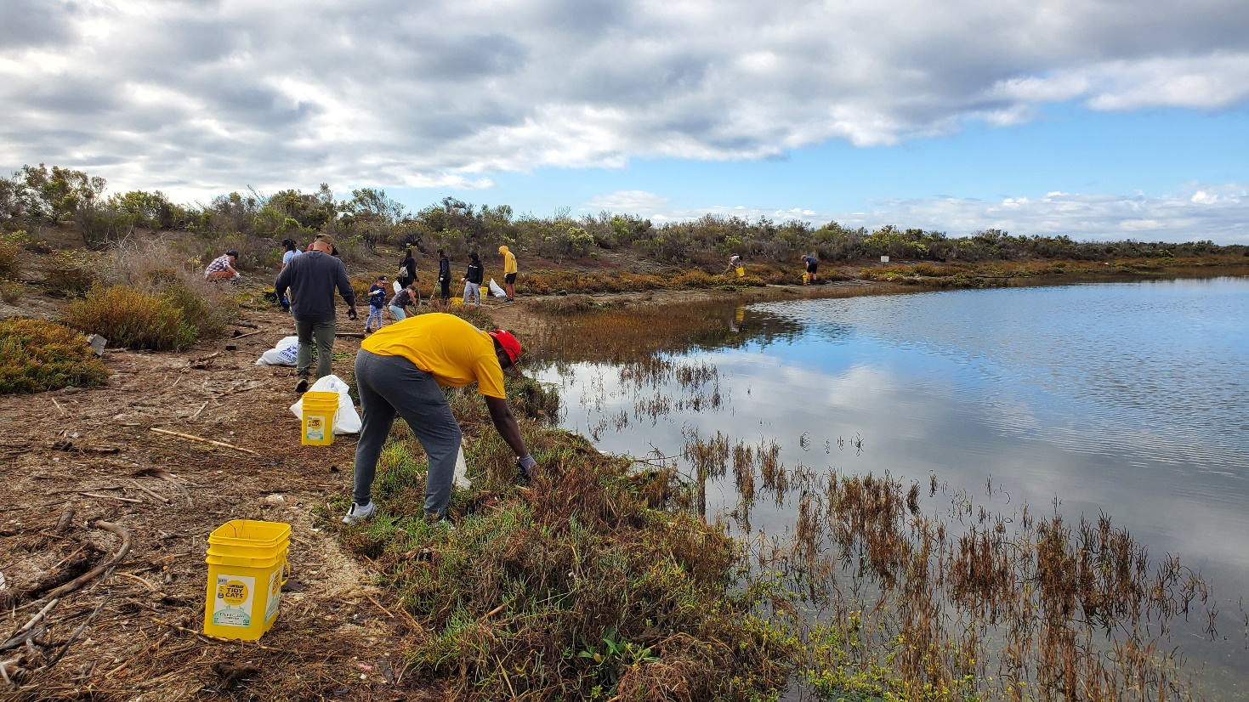
Photo 1. South Bay Sustainable Communities volunteers work to remove trash along the D Street Fill shoreline (November 18, 2023).

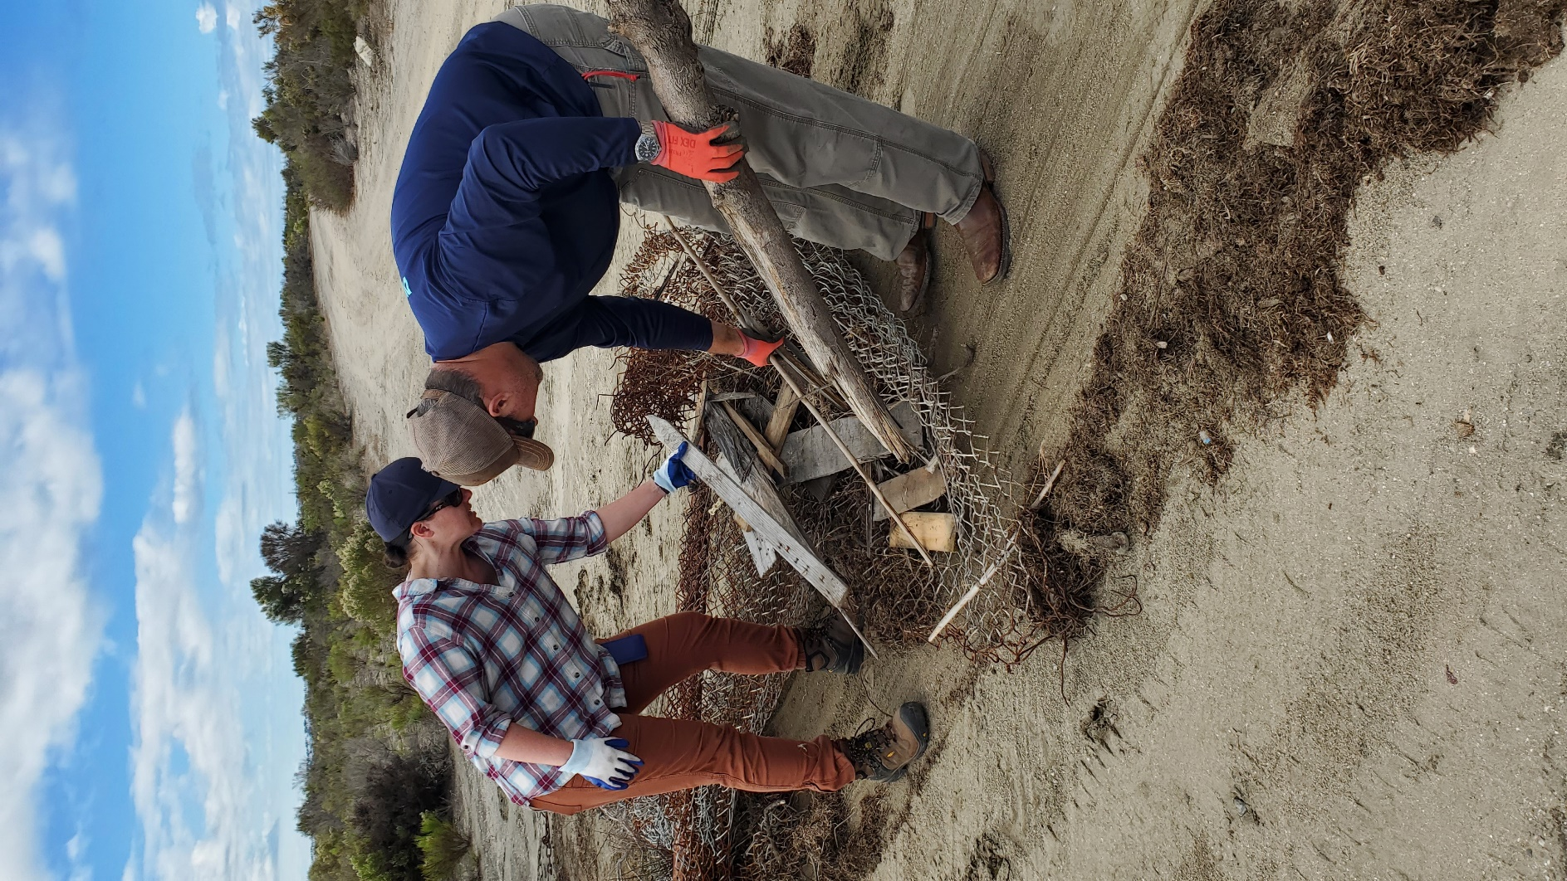
Photo 2. Volunteers remove wood, metal, and fencing material littering the site(November 18, 2023).

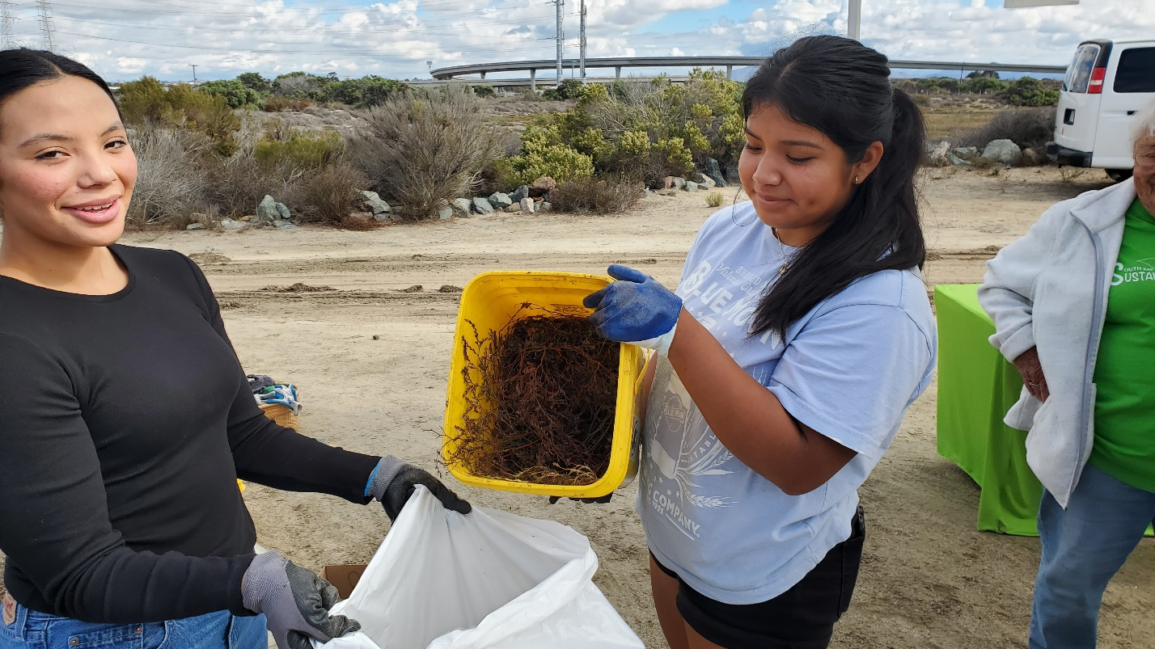
Photo 3. South Bay Sustainable Communities student interns remove several buckets of invasive sea lavender, which was bagged and disposed of offsite (November 18, 2023).

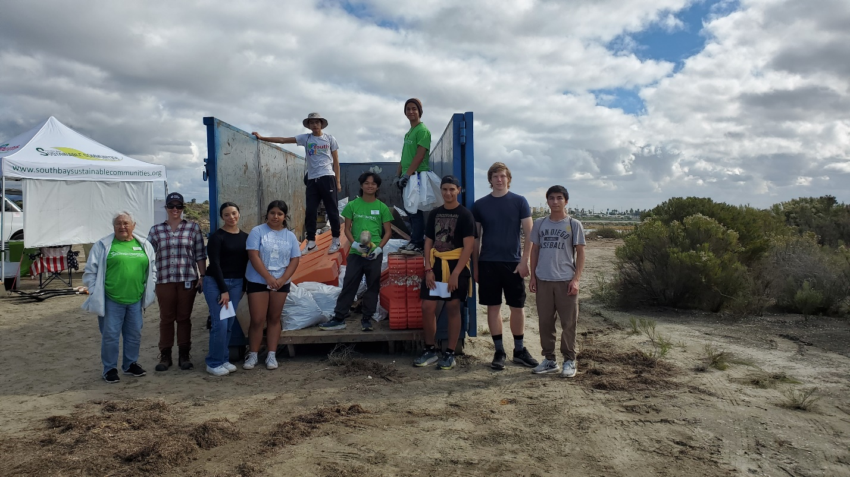
Photo 4. South Bay Sustainable Communities student interns and members of the public removed several large trash items – a successful effort! (November 18, 2023)

Work Anticipated Next Period
This does not need to be task specific but should include a short paragraph or bullet point list of activities anticipated for next quarter.

California least terns will return to the D Street Fill in April 2024. Work anticipated over the next three months will include:
- Additional volunteer event(s) to remove trash and invasive weeds from the site before the 2024 nesting season.
- Wrap up monitoring and management work, including drafting and finalizing the 2023 annual report.

Issues to Note
Please provide a brief description of any issue(s) encountered during the reporting period and any steps taken to address the issue(s).

None.

Photographs & Figures
Photographs and figures are invaluable! Please include photos in the Quarterly Progress Reports and any figures (if applicable). Both photos and figures may be included throughout the document under corresponding tasks or at the end following the Issues to Note section. Photographs taken at the same place or photographic points (photo-points) can assist SANDAG staff in tracking the project’s progress over time.
It is required that Photographs include:
- A before and after comparison sequence from the start to the completion of the project for photo points.
- A brief description of the corresponding tasks, date, and activity in the photograph.
- A copy of each photograph included in the report submitted in a .jpeg or .png file format.
It is required that Figures include:
- A caption with a brief description.
SDMMP Project Page
To receive reimbursement for work conducted within the quarter, submission of Quarterly Progress, Annual, and Final Reports must be added to your project’s Project Page on the SDMMP website. Add any necessary photographs to the photo carousal and fill out the photograph information. Please contact Sarah McCutcheon (smccutcheon@usgs.gov) or Emily Perkins (eperkins@usgs.gov) if you are having trouble accessing or editing your project page.

Project Performance Measures Instructions
SANDAG will utilize the SANDAG Performance Measures to document compliance with the Project. Grantee’s performance will be measured against the Performance Measures (Exhibit D) during the term of the project. More details on Performance Measures and Grant Recovery Plans are outlined in the Grant Agreements.
To access the Project Performance Measures Excel Spreadsheet:
- Simply double-click on the Excel icon located under the Project Performance Measures section.
  - An excel sheet will open, please fill out and then click save.
- Once the Excel spreadsheet is saved, please exit Excel and the spreadsheet will automatically update the icon in the Quarterly Progress Report Word document.
When opening the document with the Project Performance Measures Excel Spreadsheet:
- When you first open the Quarterly Progress Report Template, a warning message will open (image of the warning message below)
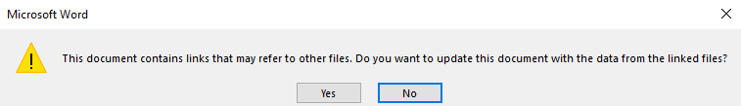
  - Click Yes to update the links in the document.

Performance Measures
Please include the Project’s Performance Measures for each Quarterly Invoice and Progress Report in order to receive reimbursement.

