San Diego Association of Governments
Endangered Avian Nesting Site Stewardship at D-Street Fill
San Diego Unified Port District
Quarterly Progress Report
Reporting Period: July 1 through September 30, 2023
Submission Date: October 21, 2023
SANDAG Contract Number: S1125502

Quarterly Status Report Overview
PLEASE DO NOT CHANGE OR ALTER THE FORMATTING OF THIS DOCUMENT! SANDAG has developed a standardized grant monitoring and tracking program for the Environmental Mitigation Program (EMP) Land Management Grant Program. The purpose is to collect information on individual projects and the grant program as a whole for reporting to the Regional Habitat Conservation Taskforce, SANDAG Policy Advisory Committees, and the SANDAG Board of Directors. SANDAG monitors grantees through invoices, progress reports, performance measures, and designated photograph points. These standardized reporting templates and instructions for submittal are included below.

Work Performed this Period:

Task 1 – Site Preparation
100% complete, see Q2 report.

Task 2 – Management & Monitoring
80% complete.

The Port’s consulting bird biologist (Robert Patton) and his biologists monitored the nesting site for at least three times per week and up to daily during the nesting season. The least tern nesting season had reached its peak by the beginning of this reporting period, with active nesting, several nests containing eggs or chicks, and some chicks old enough to begin fledging. Biologists provided the Port with weekly reports on least tern sightings, the number of nests, number of new nests, number of chicks, predators observed in the area, adults or chicks that appeared to be preyed on, and any other disturbances observed at the D Street Fill, including unauthorized human disturbance. See Table 1 for a report of observations from March to August, 2023. Observations from the previous reporting period are included in the table to accurately convey nesting activity and reproduction numbers.

Throughout July, the D Street Fill was monitored by biologists between one and three times per week, for approximately two hours each visit, to collect data and assess the success of the breeding and nesting season. Least tern sightings remained consistent with the previous month with most adult birds observed in the early morning and then moving offshore to forage for fish. Bird activities shifted from nest building and egg laying to rearing of chicks. During this period of the nesting process, adult birds will leave chicks in the nest while they fly offshore to forage for prey.

Biologists continued to count nests and determine which nests were active, had been abandoned, contained eggs, and had chicks. Biologists also recorded information on the chicks’ health, weight, whether animal tracks were seen near nests, or other signs indicating predators in the area. By the end of July, the nesting season was nearly complete, with a total of 44 nests. The 2022 season recorded 77 nests at D Street Fill which shows the breeding population at the site appears to be decreasing from year to year. In comparison, approximately 8 nests were recorded at the San Diego International Airport (10 nests in 2022) and 59 nests at the Chula Vista Wildlife Reserve (82 nests in 2022).

In August, biologists continued to monitor and report adult bird and nesting activity as the end of the nesting season approached. By mid-August all birds had left the site and migrated south with a few migrating birds observed stopping to rest at the D Street fill. Biologists visited the site regularly until no more activity was observed on at least three visits. This marked the end of the nesting season. Pin flags were used to mark all the nests for GPS mapping. The ceramic tiles placed throughout the site at the beginning of the nesting season were removed and stored for the next season. The biologists will generate an annual report for the season that contains all the monitoring information and a map of the nest sites.

Despite the total number of nests observed, biologists estimate approximately 4 fledglings survived the 2023 nesting season at the D Street Fill. Several active nest and chicks were observed in early July followed by a notable lack of chicks. It is suspected that predation events are the cause of the missing and dead chicks. The low number of fledglings is consistent with previous monitoring years and demonstrates the critical need for monitoring, management, and predator control at the site.

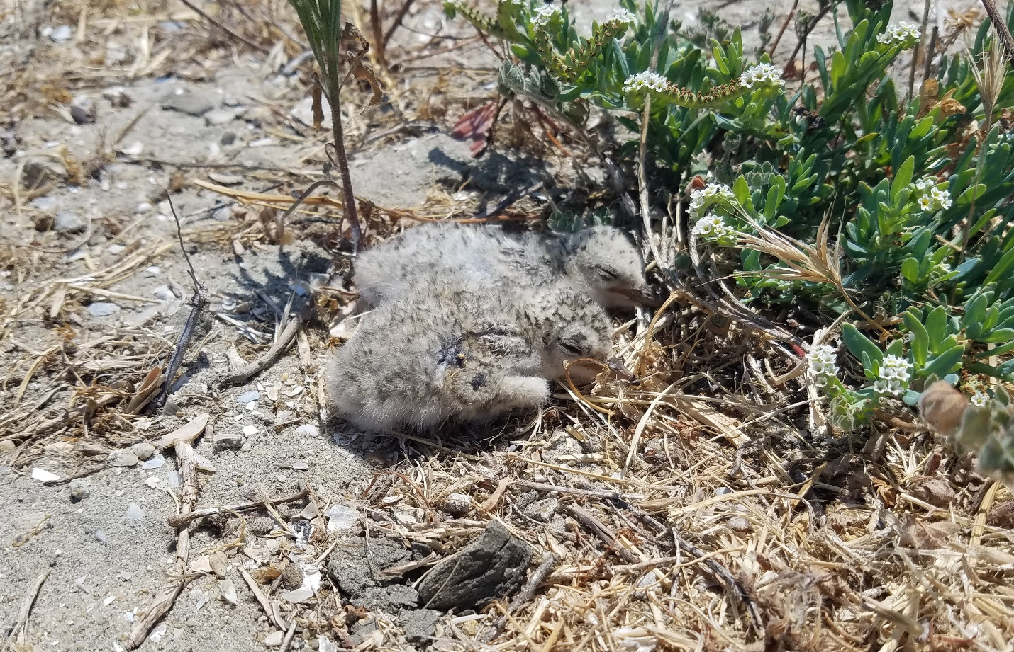
Figure 1. Two least tern chicks at the D Street Fill. Biologists collected morphometric and other data to assess their health.

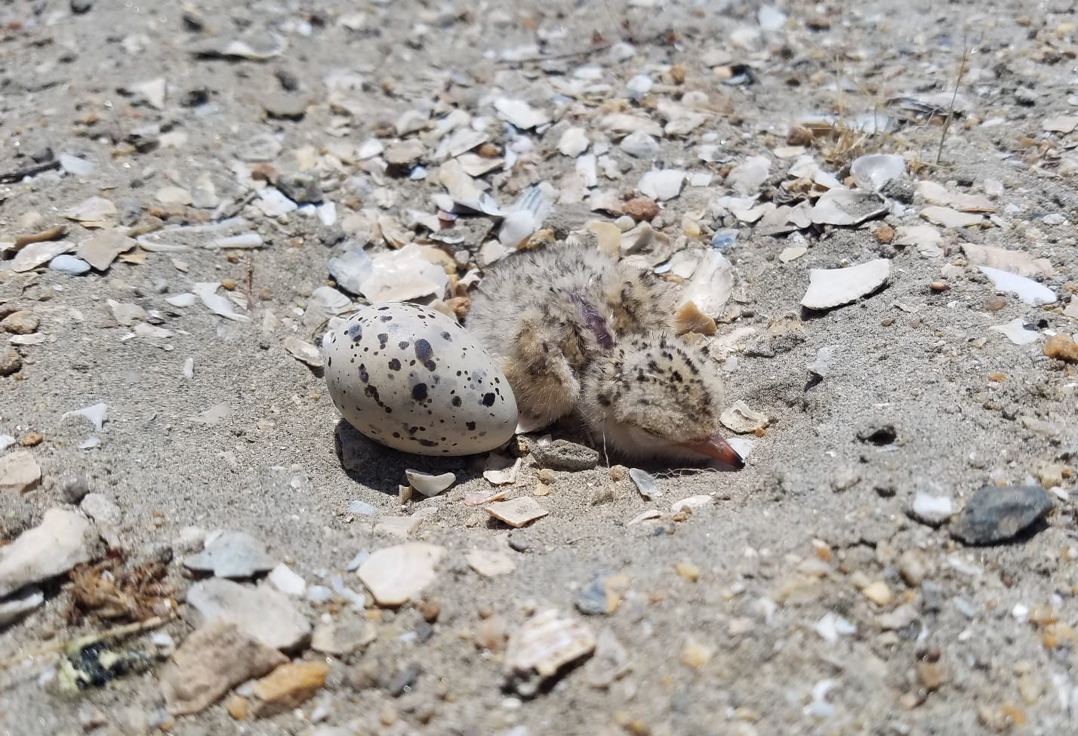
Figure 2. A least tern check and unhatched egg within a nest at the D Street Fill. Both eggs and chicks have camouflaging to blend into their surroundings and avoid predators while adults are away foraging for food.

Table 1. Monitoring results for adult least terns and nests observed at the D Street Fill for the 2023 nesting season. The number of adult terns observed are birds that are on-ground or flying back and forth from the site to the bay (i.e., foraging behavior). Active nests are nests where adults are actively nest-building, nests that contain eggs, adult birds incubating eggs, contain chicks or fledglings, and/or have not been abandoned. New nests are those that have been built within the past observation period (i.e., within the last 1-7 days). The number of chicks and fledglings is the total number of chicks or fledglings found on site during the observation period. Western snowy plover sightings and comments are provided in the “notes” column.
Date | # of adult terns | Total # of nests | # of active nests | # of new nests | # of chicks | # of fledglings | Notes
03-26-2023 | 0 | 0 | 0 | 0 | 0 | 0 | Site walked prior to vegetation management. Recorded predator sightings.
03-27-2023 | 0 | 0 | 0 | 0 | 0 | 0 | Flagged native Nuttall’s lotus and bird nests for avoidance. Recorded predator sightings.
04-02-2023 | 0 | 0 | 0 | 0 | 0 | 0 | Monitored during vegetation removal. Recorded predator sightings.
04-05-2023 | 0 | 0 | 0 | 0 | 0 | 0 | Recorded predator sightings.
05-09-2023 | 28-30 | 0 | 0 | 0 | 0 | 0 | Western snowy plover with 3 chicks in the nesting area. New killdeer nest observed.
05-11-2023 | - | 1 | 1 | 1 | 0 | 0 | Snowy plover and chicks observed again. First least tern nest observed with 1 egg.
05-15-2023 | 30 | 11 | 10 | 5 | 0 | 0 | Snowy plover with 3 checks observed. Possible second plover with 2 chicks seen. Two new killdeer nests.
2023-05-23 | 30 | 19 | 17 | 7 | 0 | 0 | Two depredated adult least terns (peregrine suspected). One nest with 2 eggs depredated (harrier suspected). Snowy plover with 2 chicks observed.
2023-05-30 | 15 | 25 | 22 | 4 | 0 | 0 | Snowy plover with 2 chicks observed. Recorded predator sightings.
06-06-2023 | 15-18 | 28 | 16 | 3 | 4 | 0 | Recorded predator sightings.
06-13-2023 | 15 | 33 | 15 | 5 | 5 | 0 | Toppled decoys reset. Recorded predator sightings.
06-20-2023 | 25-35 | 34 | 10 | 0 | 3 | 0 | Two depredated eggs observed. Recorded predator sightings.
06-27-2023 | 27+ | 38 | 9 | 3 | 0 | 2-3 | 2 nest and 2 eggs possibly depredated. 3 new killdeer nests.
07-03-2023 | 16+ | 38 | 7 | 0 | 2 | 4 (includes 1 banded elsewhere) | Active killdeer nests. Biologists encountered a person and dog trespassing near adjacent Forster’s tern nesting colony.
07-08-2023 | - | - | - | 3 | - | - | Peregrine seen hunting the site. Kayakers in marsh cannels flushing Forster’s terns from nests and chicks.
07-11-2023 | 20+ | 41 | 6 | 0 | 2-3 | 4 | Peregrine and juvenile harrier seen hunting the site. Cat, coyote, and skunk tracks at the site gate.
07-18-2023 | 15+ | 43 | 6 | 1 | 7 | 2-3 | Coyote tracks seen in the site.
07-25-2023 | 12+ | 44 | 1-3 | - | 2 | 5-7 (includes migrants from elsewhere) | Chicks missing from the previous week of monitoring. A female harrier was observed uniting the site on 7/22.
08/01/2023 | 3 | 44 | 0 | 0 | 0 | 3 | No indication of chick presence (presumed last chicks depredated). Three abandoned nests with 4 eggs depredated. Biologists collected remaining abandoned eggs. Marked nests for mapping.
08/03/2023 | 0 | 44 | 0 | 0 | 0 | 0 | No least terns observed over the site, adjacent shoreline, or bay. Monitoring with cease after 3 consecutive sightings of no terns.
08/08/2023 | 0 | 44 | 0 | 0 | 0 | 0 | No least terns observed over the site, adjacent shoreline, or bay.
08/15/2023 | 0 | 44 | 0 | 0 | 0 | 0 | No least terns observed over the site, adjacent shoreline, or bay. Monitoring for the 2023 season ceased.

Task 3 – Predator Management
100% complete.

Predator management was conducted by U.S. Department of Agriculture Animal Plant Health Inspection Services - Wildlife Services. Management (USDA APHIS) actions included routine predator surveys (driving or walking the site perimeter, potential site access points, and adjacent areas that may harbor predators that can access/migrate into the site), discerning immediate and future predator impacts, and implementation of appropriate control. Nuisance avian and mammalian predators were trapped or otherwise removed by legal means.

Biological monitors also work closely with predator control staff to relay information on depredated birds, eggs, and chicks, as well as predator tracks and observations of avian predators at or near the site. USDA APHIS removed several predators from the site throughout the entire nesting season. USDA APHIS staff will compile a report of predator incidences for the Port.

- Task 4 – Invasive Plant Species Control
100% complete.

Port staff and Urban Corps’ Pest Control Advisor reviewed the site to determine the best approach for management of invasive plant species specific to this site. Port staff provided herbicide recommendations based on the Port’s integrated pest management policy, San Diego Bay National Wildlife Refuge policy, and the State of California Proposition 65 List.

Due to extensive rains this year, herbicide was applied later that was ideal for removal of Bermuda grass. Additionally, Bermuda grass enters a state of dormancy during the winter and reduces or ceases access growth. This state can minimize or prohibit the uptake of herbicide. The combination of late application and dormancy meant the herbicide applied had a reduced effect. Due to uncommon change in temperature for this time of year (cooler than usual), a second herbicide application is expected to no be effective and will not be performed. Remaining funds for predator management will be transferred to volunteer efforts.

- Task 5 – Volunteer Events and Environmental Education Outreach
0% complete.

No work was performed under this task during the reporting period. Volunteer events will occur after the nesting season has concluded.

Work Anticipated Next Period
This does not need to be task specific but should include a short paragraph or bullet point list of activities anticipated for next quarter.

California least terns will return to the D Street Fill in April 2024. Work anticipated over the next three months will include:
- Monitoring efforts to GPS map nests and preparation of the 2024 report.
- Volunteer events to remove trash and invasive weeds from the site during the non-nesting season.

Issues to Note
Please provide a brief description of any issue(s) encountered during the reporting period and any steps taken to address the issue(s).

None.

Photographs & Figures
Photographs and figures are invaluable! Please include photos in the Quarterly Progress Reports and any figures (if applicable). Both photos and figures may be included throughout the document under corresponding tasks or at the end following the Issues to Note section. Photographs taken at the same place or photographic points (photo-points) can assist SANDAG staff in tracking the project’s progress over time.
It is required that Photographs include:
- A before and after comparison sequence from the start to the completion of the project for photo points.
- A brief description of the corresponding tasks, date, and activity in the photograph.
- A copy of each photograph included in the report submitted in a .jpeg or .png file format.
It is required that Figures include:
- A caption with a brief description.
SDMMP Project Page
To receive reimbursement for work conducted within the quarter, submission of Quarterly Progress, Annual, and Final Reports must be added to your project’s Project Page on the SDMMP website. Add any necessary photographs to the photo carousal and fill out the photograph information. Please contact Sarah McCutcheon (smccutcheon@usgs.gov) or Emily Perkins (eperkins@usgs.gov) if you are having trouble accessing or editing your project page.

Project Performance Measures Instructions
SANDAG will utilize the SANDAG Performance Measures to document compliance with the Project. Grantee’s performance will be measured against the Performance Measures (Exhibit D) during the term of the project. More details on Performance Measures and Grant Recovery Plans are outlined in the Grant Agreements.
To access the Project Performance Measures Excel Spreadsheet:
- Simply double-click on the Excel icon located under the Project Performance Measures section.
  - An excel sheet will open, please fill out and then click save.
- Once the Excel spreadsheet is saved, please exit Excel and the spreadsheet will automatically update the icon in the Quarterly Progress Report Word document.
When opening the document with the Project Performance Measures Excel Spreadsheet:
- When you first open the Quarterly Progress Report Template, a warning message will open (image of the warning message below)
  - Click Yes to update the links in the document.

Performance Measures
Please include the Project’s Performance Measures for each Quarterly Invoice and Progress Report in order to receive reimbursement.

