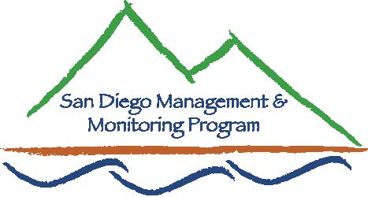

San Diego Centralized Database Meeting
March 15, 2011, 1:00pm – 3:00pm
USGS Conference Room 103, 4165 Spruance Rd, San Diego, CA 92101

Contact Info:
Yvonne C. Moore, Management & Monitoring Coordinator (evemoore99@yahoo.com)
Ron Rempel, Program Director (rrempel2@msn.com)

Agenda

- Introductions and Purpose (1:00-1:05pm)
- To review plans for the San Diego Centralized Database and obtain feedback from stakeholders

- Brief review of existing databases and why USGS-MTX was chosen (1:05-1:15pm)

- USGS overview of MTX (1:15-1:35pm)

- Proposed enhancements to USGS-MTX (1:45-2:00pm)
  - Add to database structure and set data standards
  - Create database templates for delivery of data
  - Create website portal for access to data

- Management fields to be added (2:00-2:15pm)
  - Example template for management data

- Feedback on Outstanding Issues/Questions (2:15-3:00pm)
  - Minimum data fields expected from data collectors and format for data submission - this will become a requirement of TRANSNET EMP contracts.

  - Types of management data to include - weed removal, habitat restoration, fence installation, fence repair, trail installation, etc.

  - How to obtain management data from reserve managers without adding significantly to their workload

  - Other questions/issues from the group

